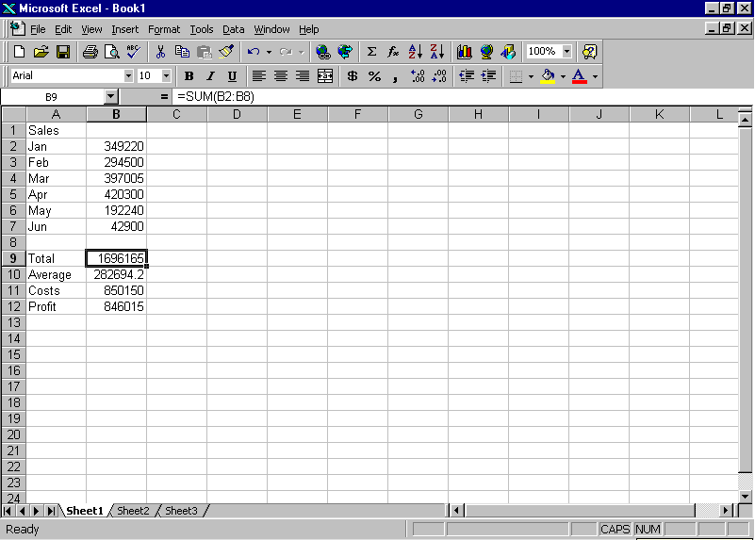
The Formula in the current cell appears here.

The formula in cell B9 is

=SUM(B2:B9)

This means sum (or "total") all the values in the range B2 to B9
B2 is column 2, row 2
B9 is column 2 row 9
The formula to calculate the average sales would be:
=AVERAGE(B2:B9)

To calculate the profit:
=B9-B11
The Current cell is B9
In this example, items in Cells A1 to A12 are "Labels". A Label is just text which is used to describe the adjacent values.
Items in Cells B1 to B12 are "Values". A Value is a number which may be used in a formula to calculate a total or average, etc.
Get a copy of this poster at :http://uk.geocities.com/cpmce/Computing/Posters
A spreadsheet is a program which allows you to enter data into rows and columns and then
to perform calculations on the data.All spreadsheet programs split the screen into rows and columns of boxes or “cells”. Examples of different spreadsheet programs are Microsoft Excel, Quattro, Multimate.
The rows are usually given numbers 1,2,3 etc. and the columns are usually given a letter A, B, C etc.
Each cell can then be referred to by the column letter and the row number, for example the cell in the top left is called cell A1, the cell in column 2 row 40 would be called B40.
The “workspace” actually extends beyond the borders of the screen, so after Z, the columns go to AA, AB etc and then BA to BZ, up to IV. The “cell reference” of the bottom right may be IV65536, although you will never use all of this space!

Computer Applications - The Spreadsheet
Each “workbook” consists of a stack of “worksheets”, which can be accessed using these tabs.
You can view the rest of a large worksheet using the scroll bars.

The Spreadsheet is also excellent for producing graphs and charts.
The chart below was created by selecting the Sales data and then pressing the Chart Wizard Icon.
My Finances
Opening Balance |  | 2,500
 | Jan | Feb | Mar | Apr | May | Jun
Income
Salary | 21,000 | 21,000 | 21,000 | 21,000 | 21,000
Other |  |  |  |  | 2000
 | 21,000 | 21,000 | 21,000 | 21,000 | 23,000
Expenses
Rent | 6,000 | 6,000 | 6,000 | 6,000 | 6,000
Gas | 1,500 | 1,500 | 1,500 | 1,500 | 1,500
Electricity | 4,000 | 4,000 | 4,000 | 4,000 | 4,000
Phone | 2,500 | 2,500 | 2,500 | 2,500 | 2,500
Food | 4,500 | 4,500 | 4,500 | 4,500 | 4,500
Leisure | 2,000 | 2,000 | 2,000 | 2,000 | 2,000
Other |  |  |  | 3,200
Subtotal | 20,500 | 20,500 | 20,500 | 23,700 | 20,500
Balance | 3,000 | 3,500 | 4,000 | 1,300 | 3,800

A spreadsheet is excellent for financial calculations, and for "forecasting"
Try to create a spreadsheet like that on the left, and forecast the balance at the end of the year, given the following assumptions:

You get a pay-rise to $23,500 in August.

You spend $3000 on a wedding gift in July.

Gas costs rise to $1750 in June.

You join a gym in July; the subscription is $1200 per month.

Rent increases to $6500 in October.

You receive a gift of $2000 in October.

You have to pay $4000 for some repairs in July.

You spend $6000 on Christmas gifts in December.

A A B F O R M U L A
B A A U A O B A A A
A A V N S W G A B B
P I E C H A R T E B
R C R T E D A B L B
A O A I E D P A B V
N L G O T R H A C A
G U E N B E X C E L
E M B A B S U M L U
B N B A B S B A L E
How many words relating to spreadsheets can you find in the WordSearch on the right.

The words read across and down only.
You can also draw Pie charts and bar graphs.

