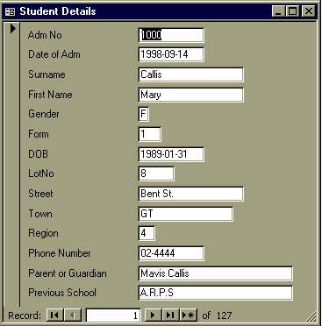
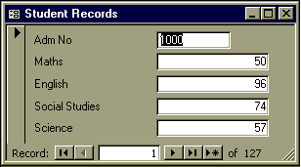
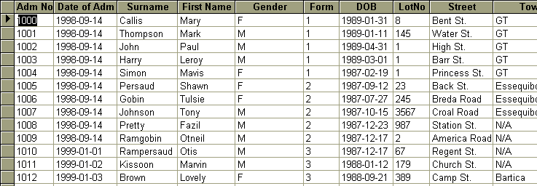
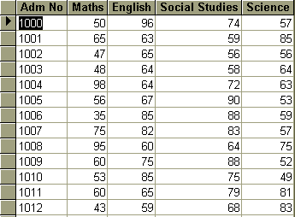
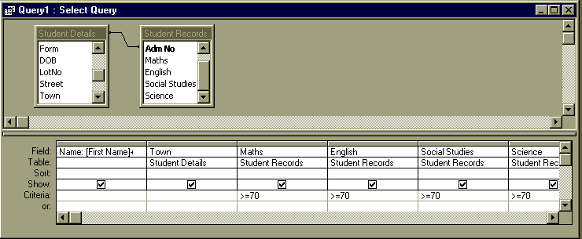
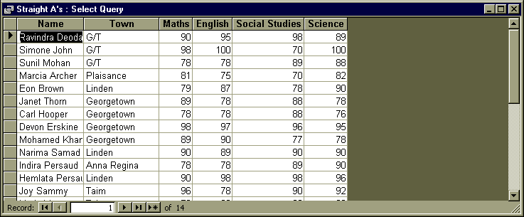
A relational database is a group of tables or files linked by a common field.
In this example, a school has details of students Names, Addresses, Date of birth etc. in a table called Student Details.
This is shown here in Form and Table View.
A bank is another user of relational databases.
The bank would store data on every transaction in the “Transaction File”, and data of customers Names, Addresses, Current Balance etc. in the Customer Accounts file.
The link is the Account Number.
The school has another table called Student Records, which has the results in Maths, English, Social Studies and Science for each student.
The field that links the two tables is the Adm No.
Relational Database
Doing a Relational Query
In this example, we find the full name and home Town of every student who got 70 or more in all four subjects. The names and towns are taken from Student Records and the Marks are taken from Student Records.
As a further illustration, this example uses an expression for the name, ie. Name:[First Name]+“ ”+[Surname]
Result of Query
The query shown here could be linked to a word-processed letter, so that a letter to inform the parent or guardian of the child of the child's excellent results could be sent.
Similarly, another relational database used by a school could be that linking the Student Details and the Student Attendance Records.
A relational query could be performed and then linked to a mail-merge letter to inform parents/guardians of bad attendance.

