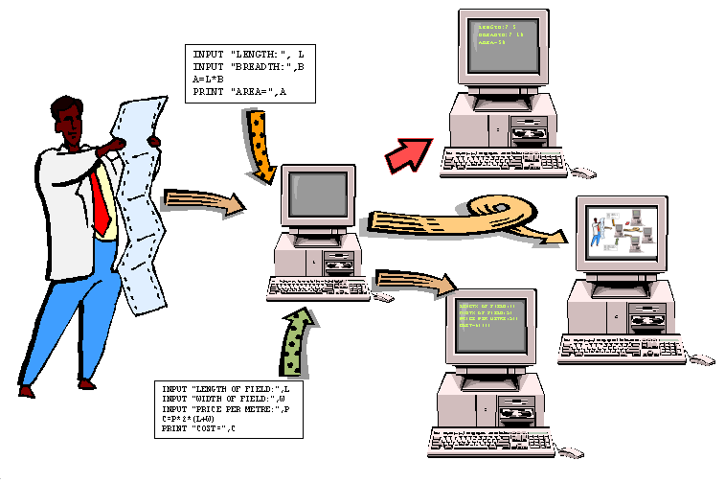
The Computer is a Programmable Machine
INPUT "LENGTH:", L
INPUT "BREADTH:",B
A=L*B
PRINT "AREA=",A
INPUT "LENGTH OF FIELD:",L
INPUT "WIDTH OF FIELD:",W
INPUT "PRICE PER METRE:",P
C=P*2*(L+W)
PRINT "COST=",C
LENGTH:? 5
BREADTH:? 10
AREA=50
LENGTH OF FIELD:40
WIDTH OF FIELD:50
PRICE PER METRE:500
COST=90000
Entering different instructions (or "programs") into the computer causes
it to perform different actions…
Get a copy of this poster at : http://uk.geocities.com/cpmce/Computing/Posters

