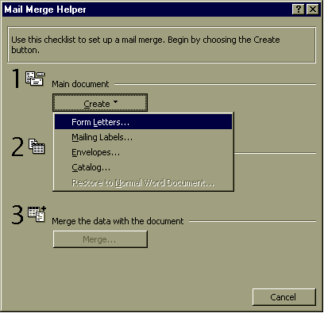
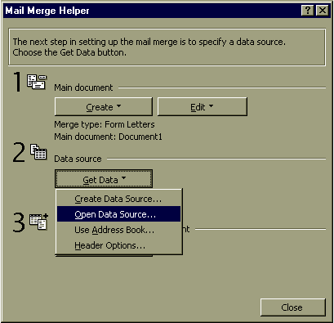
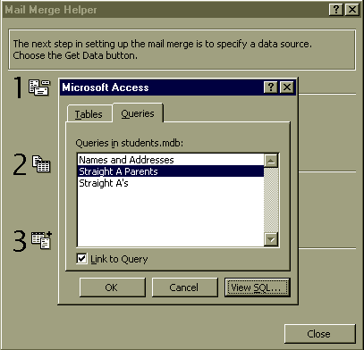
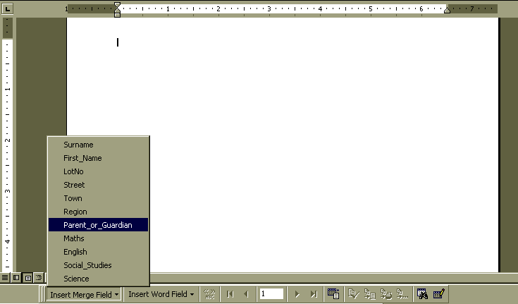
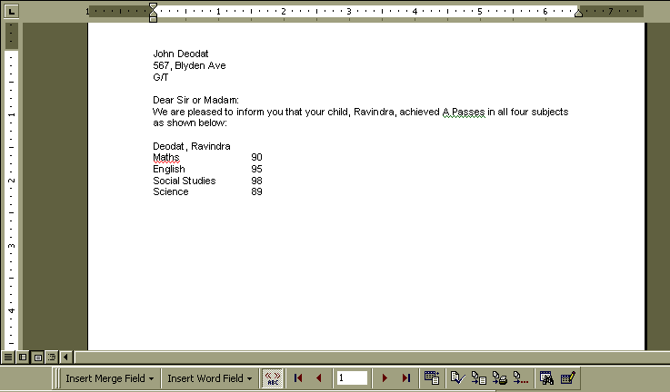
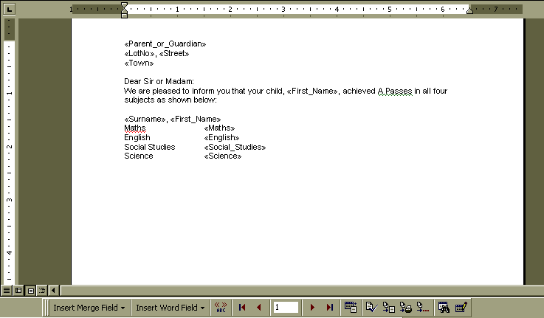
Mail-Merging a Database Table with a Word Processing Document.
An important feature of modern computer applications is the ability to integrate with other applications.
For example, a useful facility in Word Processing packages is the Mail Merge feature.
With Mail Merge, you can send Form Letters, where you create a letter with fields in a database (or even a spreadsheet) table. The letter will then be produced with the fields filled in from the table. So you only have to create one letter, and the computer will produce copies for each recipient.
John Deodat
567, Blyden Ave
G/T

Dear Sir or Madam:
We are pleased to inform you that your child, Ravindra, achieved A Passes in all four subjects as shown below:

Deodat, Ravindra
Maths 90
English 95
Social Studies 98
Science 89

Yours sincerely,

Derek Alcott
Headmaster

345, South Road
G/T

Dear Sir or Madam:
We are pleased to inform you that your child, Simone, achieved A Passes in all four subjects as shown below:

John, Simone
Maths 98
English 100
Social Studies 70
Science 100

Yours sincerely,

Derek Alcott
Headmaster

76, Bent St.
G/T

Dear Sir or Madam:
We are pleased to inform you that your child, Sunil, achieved A Passes in all four subjects as shown below:

Mohan, Sunil
Maths 78
English 78
Social Studies 89
Science 88
Yours sincerely,

Derek Alcott
Headmaster

Joyce archer
23, Games St.
Plaisance

Dear Sir or Madam:
We are pleased to inform you that your child, Marcia, achieved A Passes in all four subjects as shown below:

Archer, Marcia
Maths 81
English 75
Social Studies 70
Science 82

Yours sincerely,

Derek Alcott
Headmaster

Phylis Brown
125, Waini St.
Linden

Dear Sir or Madam:
We are pleased to inform you that your child, Eon, achieved A Passes in all four subjects as shown below:

Brown, Eon
Maths 79
English 87
Social Studies 78
Science 90

Yours sincerely,

Derek Alcott
Headmaster

George Thorn
14, Chandranagar Place
Georgetown

Dear Sir or Madam:
We are pleased to inform you that your child, Janet, achieved A Passes in all four subjects as shown below:

Thorn, Janet
Maths 89
English 78
Social Studies 88
Science 78

Yours sincerely,

Derek Alcott
Headmaster

Carlton Hooper
85, Well Road
Georgetown

Dear Sir or Madam:
We are pleased to inform you that your child, Carl, achieved A Passes in all four subjects as shown below:

Hooper, Carl
Maths 78
English 78
Social Studies 88
Science 76

Yours sincerely,

Derek Alcott
Headmaster

D Eriskine
542, Congress Drive
Georgetown

Dear Sir or Madam:
We are pleased to inform you that your child, Devon, achieved A Passes in all four subjects as shown below:

Erskine, Devon
Maths 98
English 97
Social Studies 96
Science 95

Yours sincerely,

Derek Alcott
Headmaster

I Khan
472, Park Road
Georgetown

Dear Sir or Madam:
We are pleased to inform you that your child, Mohamed, achieved A Passes in all four subjects as shown below:

Khan, Mohamed
Maths 89
English 90
Social Studies 77
Science 78

Yours sincerely,

Derek Alcott
Headmaster

F Singh
6581, Timehri Place
Linden

Dear Sir or Madam:
We are pleased to inform you that your child, Narima, achieved A Passes in all four subjects as shown below:

Samad, Narima
Maths 90
English 89
Social Studies 90
Science 90

Yours sincerely,

Derek Alcott
Headmaster

Rita Persaud
87, No 2 Canal St.
Anna Regina

Dear Sir or Madam:
We are pleased to inform you that your child, Indira, achieved A Passes in all four subjects as shown below:

Persaud, Indira
Maths 78
English 78
Social Studies 89
Science 90

Yours sincerely,

Derek Alcott
Headmaster

W Persaud
15, Enterprise Rd
Linden

Dear Sir or Madam:
We are pleased to inform you that your child, Hemlata, achieved A Passes in all four subjects as shown below:

Persaud, Hemlata
Maths 90
English 98
Social Studies 98
Science 96

Yours sincerely,

Derek Alcott
Headmaster

Sawh Sammy
21T, Howard St.
Taim

Dear Sir or Madam:
We are pleased to inform you that your child, Joy, achieved A Passes in all four subjects as shown below:

Sammy, Joy
Maths 96
English 78
Social Studies 90
Science 92

Yours sincerely,

Derek Alcott
Headmaster
Maria Veerasammy
345H, Ross St.
Tain

Dear Sir or Madam:
We are pleased to inform you that your child, Linda, achieved A Passes in all four subjects as shown below:

Veerasammy, Linda
Maths 72
English 80
Social Studies 90
Science 90

Yours sincerely,

Derek Alcott
Headmaster
As always, the best way to understand this idea is by example.
Imagine that the school has asked you to send out a letter informing the parent or guardian of each child who achieved A passes in all four subjects. All modern Word Processing packages allow Mail Merge. Here we will use Microsoft Word.
First, in database, you create the necessary query, selecting the parent or guardian’s name and address from the Student Details table, and the results ( >= 70) from the Student Records table.
In Word select Tools; Mail Merge
In this case, we are doing a Form Letter, in the Active Window.
Next, Get Data Source.
Word allows you to Create the data source as a table, but this example uses the student's Database, created in Access.
Then, you would click on the Query tab, and select the query, in this case
"Straight A Parents"
(See the poster: "Relational Databases")
You can now write the letter, putting field names where you want the data to be taken from the database.
In Word, you click on the Insert Merge Field button on the Merge Toolbar, which will appear at the bottom (or at the top) of the page.
Click here to advance through each record.
In this case, we would choose Open Data Source.
From the File Dialog box, you would choose Files of type MS Access Databases and select Students.mdb

Click here to switch between viewing the fields and viewing the fields filled in from the data source.
To finish off, go to Tools; Mail Merge and then step 3, "Merge the data with the document".
Get a copy of this poster at : http://uk.geocities.com/cpmce/Computing/Posters

