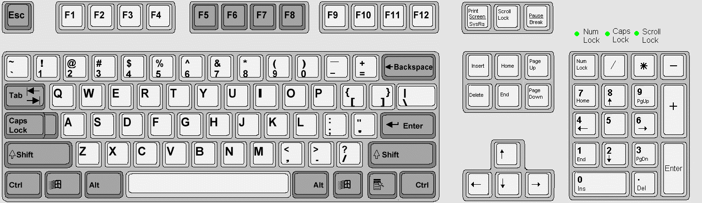
5 The "Enter" key (sometimes called the "Return" key) is used to finish the line being typed, causing the position to move to the start of the next line.
Enter on its own gives a blank line.
Enter is also used to "Enter" commands or instructions or file names: when you have finished, pressing Enter causes the command or filename to be "entered" into the computer, and processed.
1 If the Caps Lock is off (the "normal" position), holding down shift and pressing a key gives a capital letter.
If the Caps Lock is on, shift gives a small (or "common") letter.
Shift also gives the symbols on the tops of some keys: for example, shift 1 gives an "!", shift 4 gives "$" shift 9 gives "(", shift 0 gives ")", shift / gives "?", shift ; gives ":"

The Keyboard
The Keyboard is the standard computer input device. It is the most commonly used device for entering data into the computer, followed closely by the mouse.
The Keyboard is laid out in a QWERTY format, similar to a type-writer. Many of the functions are the same as that of a typewriter keyboard, but the computer keyboard has extra keys, which carry out functions particular to the computer.
2 The Escape key is usually marked "Esc".
This is useful if you make a mistake - Esc will bring you back to the position just before the mistake.
6 The Function keys are marked F1 to F12.
These perform different actions depending on the program. Usually F1 brings up a Help screen. F2 is often used as a shortcut to save the work you have on screen.
3 Backspace deletes letters to the left of the current position.
Delete deletes letters to the right of the current position, or deletes the current cell in a spreadsheet.
9 The Ctrl (or "Control") key works in a similar way to the shift, in that it changes the effect of the key pressed along with it.
For example if you hold down Ctrl and press P, this will usually cause the current page to be printed.

Ctrl-B gives bold ("dark") letters
Ctrl-I gives italics ("slanted") letters.
Ctrl-U gives underlined letters.

11 The cursor (or "navigation") keys are grouped together.
They are used to move around; up, down, left and right, through the document on the screen.
The Page Up (or PgUp) key makes the current screen page move up by a page-length or a screen height. Page Down has the opposite effect.
The Home key will take you to the start of a line, or to the top of a page, depending on the program. The End key takes you to the end of the line.
7 Tab will usually move the cursor to the right by a set amount, perhaps 1 inch, depending on the program settings.
4 Pressing the Insert key usually has the effect of switching between "Insert" and "Typeover" modes, and back again.
If in "Insert" mode, keys pressed will push other letters off to the right.
In "Typeover" mode, keys pressed will replace letters at the current position.
8 The numeric keypad is useful when you have to enter a lot of figures into the computer.
12 The Windows Logo key is another way of bringing up menus without using the mouse - for example, on its own, it activates the Start Menu
1
1
1
1
2
3
4
5
5
6
6
7
8
9
9
10 The Alt (or "Alter") key is similar to the Ctrl key. Using it usually activates the menus. For example, Alt-F will bring up the "File" Menu. Alt-E gives the "Edit" menu.

10
10
11
11
12
12

Get a copy of this poster from : http://uk.geocities.com/cpmce/Computing/Posters

