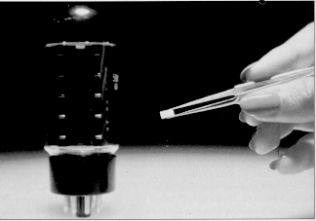
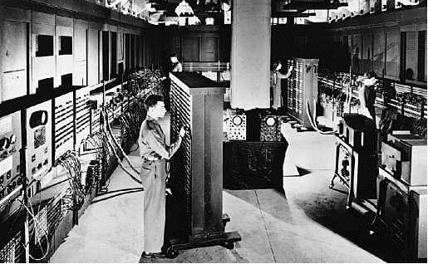
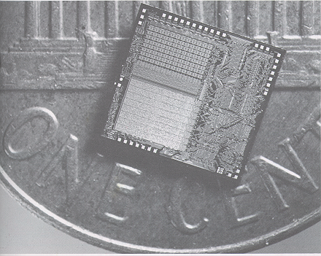
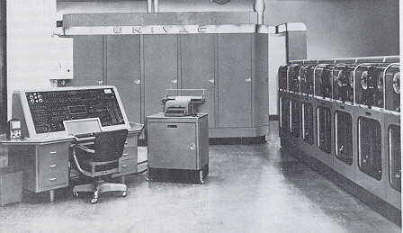
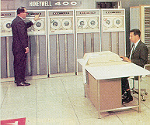
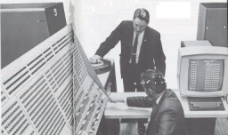
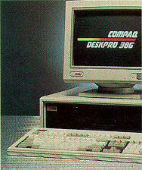
Get a copy of this poster at : http://uk.geocities.com/cpmce/Computing/Posters
The Generations
Since the mid- 1940s there have been 3 major improvements in arithmetic and logic circuitry which have each produced a new ‘Generation’ of computers:

(i) the First Generation using electronic valves,
(ii) the Second Generation using transistors,
(iii) the Third Generation using integrated circuits.
(iv) the large- scale integration (LSI) which made the microprocessor possible marks the Fourth Generation.

The Fifth Generation has been used to describe the future development of computers with “Artificial Intelligence”.
These would be computers which can learn and communicate in plain language.
Some people refer to the new very large-scale integration (VLSI) computers, linked up to the internet as the Fifth Generation.
History of Computers
First Generation (1951-1959)
- Vacuum tubes
- Magnetic tape for external storage - some magnetic drum
- Punched cards for input
- Punched cards and paper for output
- Machine and assembly languages
- Human operators to set switches
- UNIVAC 1 typical example

Second Generation (1959-1965)
- Transistors
- Magnetic core storage
- Magnetic tape most common external storage, magnetic disk introduced
- Punched cards and magnetic tape for input
- Punched cards and paper for output
- High level languages - FORTRAN, COBOL, BASIC, PL/1 and others
- Human operator to handle punched cards
- Honeywell 400 typical example
Third Generation (1965-1971)
- Integrated circuits
- Improved disk storage
- Monitors and keyboards for input and output
- More high-level languages, including RPG and Pascal
- First complete operating systems meant less involvement for human operators
- Family of computers introduced allowing compatibility
- Minicomputers used commercially
- IBM System 360 typical example

Fourth Generation (1971-Present)
- Large Scale Integration and Very Large Scale Integration on silicon chips
- Magnetic disk most common external storage
- Introduction of microcomputer
- Fourth Generation languages emerged - Object Oriented Programming
- Application software for microcomputers becomes popular
- Microcomputers used - Compaq Deskpro 386 typical example
- Burroughs B7700 and HP 3000 (minicomputer) typical examples

Date list – the generations

1945 The First Generation
1945 Mauchly and Eckert, USA. ENIAC is completed. It uses valves for logic and storage.
1945 Von Neumann, USA. A report on computer design describing a stored program computer.
1948 The first transistors of any type.
1949 Wilkes in Cambridge produces EDSAC, a stored program computer which used delay lines for storage.
1951 Computers for commercial sale – Ferranti Mark I.
1951 J. Lyons and Co. produce LEO for commercial data processing.
1954 Printed circuits and a type of transistors suitable for computer circuitry make the Second Generation possible.
1956 The Second Generation
Massachusetts, USA. TX-0, the first transistorized computer.
1959 Transistorized computers delivered to customers.
1959 ‘Hybrid’ integrated circuits. They contain only transistors.
1964 The Third Generation
Computers using simple integrated circuits.
1971 The Fourth Generation
Large- scale integration (LSI): 10 000 elements on one chip.
The INTEL 4004. The first microprocessor.
1976 A 16- bit microprocessor.
1980 VLSI
1988 The 32 Bit Intel 80486
1994 The Intel Pentium.

