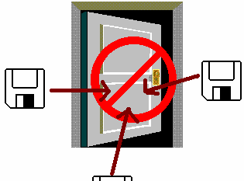

Avoiding Viruses and Virus Hoaxes

The best way to protect against computer viruses is to buy Virus Scanner Software – for example, McAfee

Norton

Antivirus

, or Dr. Solomon’s.

These can often be updated from the internet, as new viruses are been written or discovered every day.

One simple precaution is to forbid the bringing of floppy disks into the computer lab.

Computer Lab

A Hoax Virus is a file which is described as a virus but actually is harmless. If you have email, you may receive a mail telling you not to open a certain mail as it has a virus.
Actually there may be no virus at all.
These hoaxes are often perpetrated by disgruntled customers who want to give certain companies bad publicity with going to the trouble of writing an actual virus program.

You can get a list of viruses and virus hoaxes on the internet at:

http://www.symantec.com


Get a copy of this poster from : http://uk.geocities.com/cpmce/Computing/Posters

