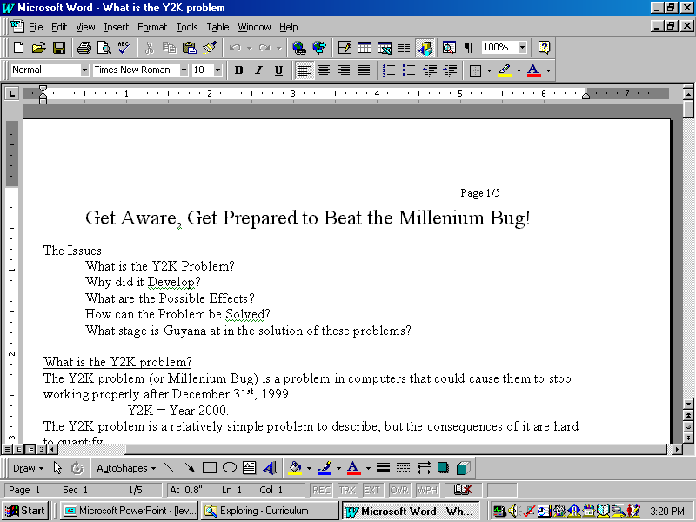
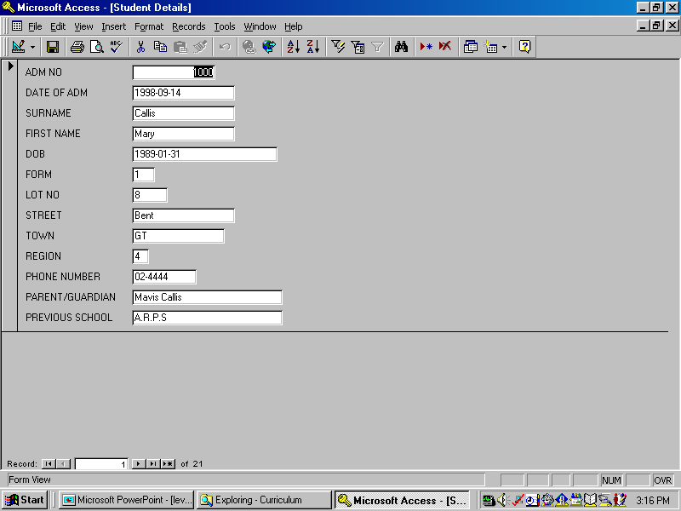
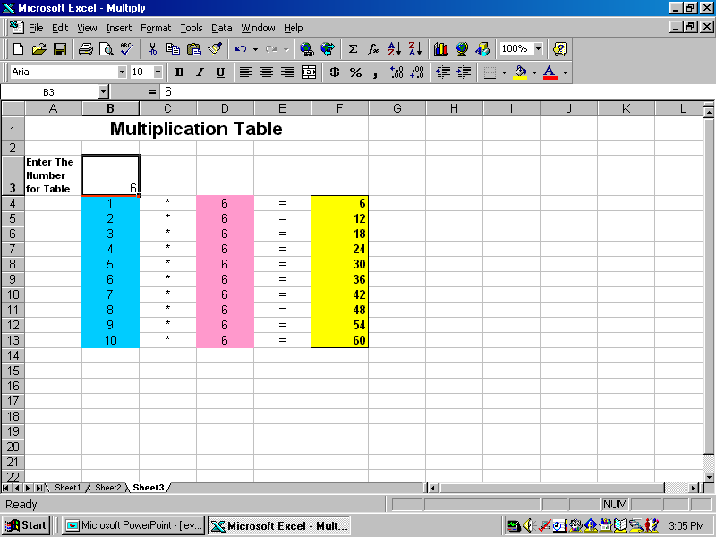
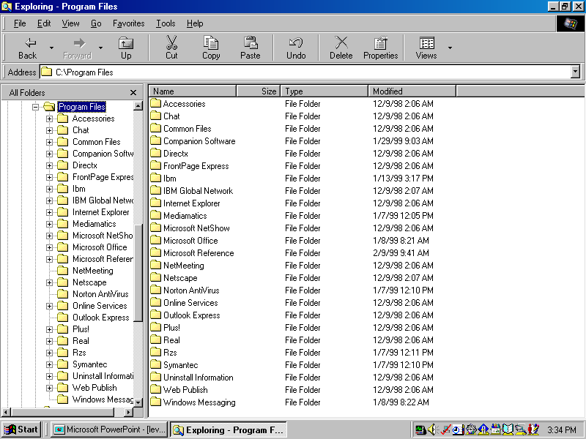
Applications Software is software that you may install on the computer to do particular tasks, such as Word Processing, Database Management, Spreadsheet, Computer Aided Design, Presentations Software, CAL, Drawing Programs, Games, Internet Browsers etc.
Applications Software can be bought from computer dealers, can be custom-written for the company's particular needs or can be written “in-house” by employees of the company.

Applications Software requires System Software to operate.
Word Processing
Database Management
Spreadsheet
On the left is a screen-shot of Windows Explorer, which helps you to find files, organise your files into folders, copy files, move files, rename files, delete files
System Software is software necessary for the computer to operate the hardware and software installed on the system, and to allow file management.
Examples of System Software are Windows, DOS, Unix, Windows Explorer, file utilities such as XTree Gold, memory management software, mouse drivers, device drivers for printers, modems etc.
Terms - System Software & Applications Software
Get a copy of this poster from : http://uk.geocities.com/cpmce/Computing/Posters

