Making Food

Some of the food we eat would not be possible without the aid of bacteria – they carry out reactions that alter some foodstuffs in ways that may change their consistency (e.g. milk to cheese) or their flavour (e.g. chocolate). Some foods (e.g. ‘live’ yoghurt) even have added bacteria that are good to have in the stomach.

Cheese has been made for thousands of years – originally it was the action of bacteria producing acid that caused the separation of a curd from the milk. This curd was either used directly (for soft/cottage cheeses) or compressed for hard cheeses. Modern methods may use rennin instead, either from cow stomachs or produced by genetically modified bacteria (vegetarian rennin).  The coloured ‘veins’ in some cheeses are not bacteria but fungal spores | .
Chocolate is very important to many peoples hearts but it could not be made without bacteria. Bacteria and yeast act to develop the characteristic chocolate flavour from the cacao bean.

Vinegar is made by dripping alcohol (wine, beer or cider for wine, malt or cider vinegar respectively) along a birch branch or similar that contains certain species of bacteria – these turn the alcohol into the mildly acidic vinegar and the result is collected at the bottom of the branch.

Yoghurt is made by the action of bacteria upon milk, fermenting the milk sugar to lactic acid – as well as changing texture and taste this makes the environment unsuitable for other, sometimes dangerous, bacteria. Other bacteria may add different tastes  Nearly everyone has heard of the ‘friendly cultures’ in ‘bio’ yoghurt. Fewer know that these are live bacteria called bifidobacterium. These are normally found in the gut and it is thought by some that consuming them live is healthy. This opinion is not shared by all – some think that it is unlikely to make much difference. | .  yoghurt

In The Kitchen

Bacteria are everywhere – they live on our worktops, on our cutting boards and rolling pins, in our cupboards and, of course, on our food.

Is this bad?

Not necessarily, dangerous bacteria are very rare and are far outnumbered by harmless or helpful bacteria. This means that your worktop will contain a huge mass of harmless bacteria.

If a harmful bacterium were to arrive on your worktop, the well-established harmless bacteria would compete with it for food and space and would probably win – the bacteria in your kitchen (for the most part) actually help to keep your food safe!
Feeding the World

Bacteria themselves can be eaten as food though this seems unpleasant to most people. In many parts of the world there is not so much a shortage of available food, as a shortage of protein – some bacteria comprise up to 50% protein and in many cases it is what nutritionists call ‘complete’ protein – this means it contains all the essential amino acids. ICI actually marketed a bacterial feed called Pruteen, extremely high in proteins – originally it was destined for the human marked but this idea failed and it is now sold as a commercial feed for farm animals.

One of the advantages of bacteria as food is that they can often be fed on waste products (e.g. methane gas) or widely available, non-protein, foodstuffs such as molasses (treacle).

An example of a bacterial food that is consumed by (at least some) people is cyanobacteria – this is a type of bacteria that sometimes grows into long filaments – these are removed from the salt water in which they grow and are left to dry in the sun into ‘mats’ of fibres that can be made into a type of biscuit. One such cyanobacterium is Spirulina, originating in the salty lakes of Chad and Mexico. ‘Health food’ stores sometimes stock this food.

Plant Feeders

All plants and animals need nitrogen – this forms the ‘amino’ part of amino acids and without it we would have none of the vital proteins needed for life. About 80% of the atmosphere is made of nitrogen but as it is, animals and plants cannot make any use of it – to be of use it needs to be in a form known to scientists as ‘fixed’.

There are only three things that can turn atmospheric nitrogen into fixed nitrogen:

Lightning

Manmade methods

Bacteria

Of these, bacteria make at least half the worlds useable nitrogen, and a hundred years ago (before man-made methods) they made about 85-90% of it. Not all bacteria can make useful nitrogen – those that can are called nitrogen fixing bacteria and most can only perform this process if there is no oxygen around.

This is where plants come in. Some plants can form nodules – these are lumps on the roots that surround the nitrogen-fixing bacteria. Inside the nodules are special mechanisms for absorbing oxygen that let the bacteria get on with making useable nitrogen – this goes directly to the plant. When the plant dies or its leaves fall off, the nitrogen gets into the soil and acts as a fertiliser for other plants.
Some plants that can perform this are:
- Clover
- Soya bean
- Lentil
- Pea

These are known as leguminous plants or legumes. They can be grown specifically by farmers in poor soil and they will increase the nitrogen content, acting as a natural fertiliser, if ploughed in. This is one of the main bases for crop rotation – alternating leguminous and non-leguminous crops reduces the need for fertilisers.

Other plants that are not legumes can also harbour nitrogen-fixing bacteria and these include important plants such as:
- Leucaena (An important tree for firewood and fertilising soil in Australia)
- Alder (important in mountainous regions – its nitrogen-fixing bacteria gradually improve the generally poor soil in these regions).
- Bog Myrtle, serves a similar purpose to Alder but in heath and bog land.

Not all nitrogen-fixing bacteria live associated with plants – many live in the soil itself and many more live in the sea. The sea-dwelling ones are thought to be very important but the ones living ‘loose’ in the soil are not, contributing only about 1/100th of the amount of nitrogen that the plant-associated bacteria do.

This explains where plants get their nitrogen, so what about animals?

They get it from simply eating the plants, or eating the plant eaters, or eating animals that have eaten the plant eaters and so on.

Plant Protectors

As well as providing nitrogen for plant food, bacteria can also act as guards for our crops. Each year, insects destroy tens of thousands of tons of food – pesticides can aid in the battle against these creatures but they also poison small animals and are not guaranteed safe for humans.

So what can bacteria do?

A bacterium was discovered in the early 1990’s that contains a poison only toxic to insects. If insects consume the bacteria, they die. Other animals are not affected and the damage can even be limited to certain insects only by carefully choosing the type (strain) of this particular bacteria used.
Grass Chompers
Plants store sugars (carbohydrates) in different forms to animals – this is one of the things that makes plants so much less fattening than animal products – the energy is there but cannot be broken down directly by animals.

This is where bacteria come in. Bacteria live all over our body and especially in the gut. Some animals (all those that only eat grass, leaves and other fibrous plant material) have bacteria that can break down the starch and cellulose into fatty acids that can be used by the animal to make amino acids and other essential products.

Animals that have bacteria that can break down cellulose can use fibrous plants as food
✓

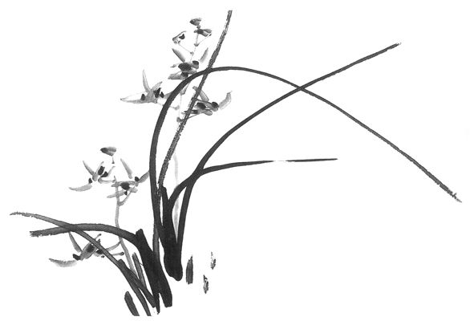

Animals without appropriate bacteria cannot use fibrous plants (e.g. grass) as food

X

The animals that are able to gain nourishment from plants with the aid of bacteria can do so as they have more than one stomach. Cows and similar animals are called ruminants as they have a complex intestinal arrangement with several compartments often referred to as stomachs. One of the compartments, preceding the true stomach (abomasum) is called the rumen and in here the food is mixed with saliva and the bacteria that can degrade cellulose. From here goes to the reticulum where it is turned in to cuds that are regurgitated so the animal can chew the plant material further (‘chewing the cud’). This material is re-swallowed and this time travells into the abomasum to be subjected to normal digestion processes.
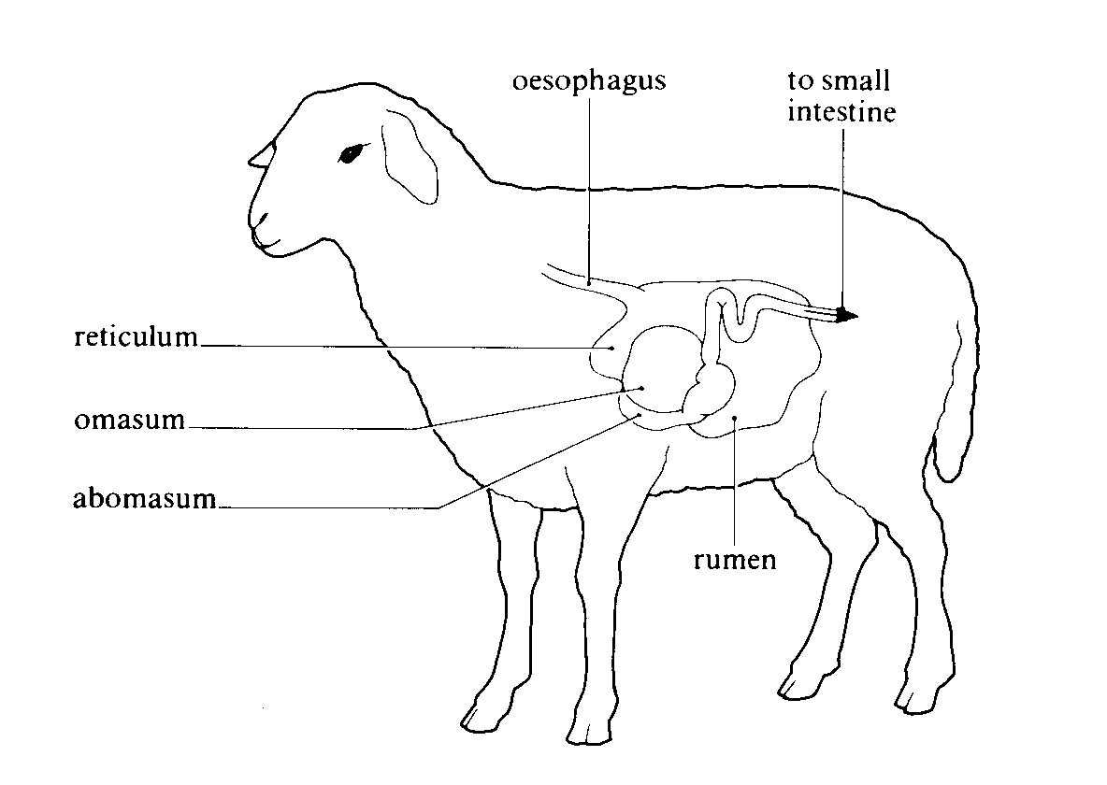
Picture from Soper, Biological Science

It is not only mammals that can do this. At least one bird can too – locals in Venezuela call it the stinky cowbird, due to its cow-like smell. This is due to the bacteria making gasses similar to those of a cow. In this case the bird’s oesophagus (throat) and crop act as the rumen does in cows and sheep.

The bacteria that aid the cowbird are not just good at digesting grass, they can also detoxify powerful plant poisons called alkaloids – these are a major plant defence mechanism against animals and the ability to eat such plants gives the stinky cowbird a greater range of possible food.

A similar ability to this has been used in Australia to allow goats and sheep to eat the leaves of the Leucaena tree, which are normally poisonous to these animals. This tree is widely grown in Australia as it is fast growing and its leaves are packed with nitrogen. This makes them good for the ground when they fall and decompose. It was discovered in the 1980’s that Hawaiian goats could eat the leaves without harm and the bacterium responsible was isolated and put into the rumen of other goats and sheep. Once it had been allowed to grow in numbers, it allowed the animals to safely eat the leaves that were once poisonous to them.


Making Vitamins

Vitamins are only needed in very tiny quantities. The human body does not make its own vitamins and so needs to have them in its diet. The good news is that many of the bacteria in our intestinal tract produce useful vitamins as by-products – we absorb these and so bacteria can help prevent certain deficiency diseases. This is extremely useful if our diet does not contain all the vitamins we need.

This was demonstrated in an experiment in which army volunteers were fed polished rice (no vitamin B₁ content) for two weeks and remained perfectly healthy when they should have contracted beriberi. If their intestinal bacteria were killed by antibiotic treatment, then they developed these diseases within a few days.

Vitamin | Required for | Primary non-bacterial source
B  (many types) | Many functions including:  Red blood cell formation  Nerves  Skin | Liver, kidney heart, eggs, milk, cheese, fish, vegetables, wholemeal flour
C | Skin  Wound Healing | Citrus fruits, green vegetables, tomatoes, potatoes
H | Muscles  Protein synthesis | Yeast, liver, kidney, egg white
K | Blood clotting | Spinach, cabbage, Brussels sprouts
Carotene* | Antioxidant – can be converted to vitamin A | Milk, cabbage, lettuce, carrots
Lysine* | Essential amino acid | Potentially, any protein

*These are not, technically, vitamins but are still vital products produced by some intestinal bacteria.

It is interesting to note that many of the products we buy have added vitamins: margarine and bread being good examples. Many of the vitamins added, together with some of the vitamins found in pills, are produced by bacteria under commercial conditions.
Bacterial Names

I have deliberately left out the names of most of the bacteria discussed in this lecture, the reason for this is that most are long and hard to pronounce. For those who are curious the names are listed below.

Bacterial names are in two parts and written in italic if typed or underlined if handwritten. The first part is what biologists call the genus, this always starts with a capital letter. The second is the species name and this is not capitalised.

All species names are different but some have the same genus names – it is thought that these are related.

An example of this is Escherichia coli. The genus name can be shortened to a single letter such as in E. coli.

Pronunciation Guide

Making Food
Cheese: | Leuconostoc (sev species) | Loo-con-o-stoc
Chocolate: | Many species of Lactic and Acetic bacteria
Vinegar: | Acetobacter species  and Acetomonas species | Ass-ee-toe-back-ter  Ass-ee-toe-mow-nas
Yoghurt: | Lactobacillus bulgaricus | Lack-toe-bass(the fish)-ill-us bul-gary-cuss
Yoghurt: | Streptococcus thermophiles | Strep-toe-coc-us therm-off-ill-es
Feeding the World
Pruteen: | Methylophilus methylotropus | Meth-eye-lof-ill-us meth-eye-low-trow-pus
Plant Feeders
Legumes: | Rhizobium species | Ri-zo-bee-um
Alder: | Frankia species | Frank-ee-a
Bog Myrtle: | Shepherdia species | Shep-erd-ee-a
Plant Protectors
Insect Poisoner | Bacillus thuringiensis | Bass(as the fish)-ill-us  thur-ing-gee-en-sis
Grass Chompers
In rumen: | Bacteroides succinogenes | Back-ter-oy-dees  suck-sin-oj-en-ees
In rumen: | Ruminococcus albus | Room-in-o-coc-us al-bus

Making Food

Further Reading

Power Unseen by Richard Dixon (W. H. Freeman Pub.)
A very readable book divided into short chapters each only a few pages long. The book is ideal for complete non-scientists and gives fascinating insights into the bacterial world and how it has impacted upon our own, including the effect of Bacteria on the founding of Israel, the ozone layer and innovative medical procedures.

The Outer Reaches of Life by John Postgate (Canto - Cambridge University press)
This is an easy-to-understand guide to the more unusual places on earth and what lives there. Places that are too hot or cold; have incredibly high pressures; or have no organic food. The book ends with an excellent section discussing the apparent immortality of bacteria and how they can sense and move about.

Microbes and Man by John Postgate (Cambridge university press)
Less easy than Power Unseen but still well worth looking at – most of the information is easily followed with a few ideas that will be easier to grasp with knowledge of GCSE chemistry. The book is arranged into large sections covering Nutrition, decay and pollution, microbes in society and several other areas.

Biological Science Edited by R. Soper (Cambridge university press)
A superb A level textbook giving greater detail on some of the subjects discussed.

Web Site

A web site is available containing this lecture and three others (Bacteria In Industry, The Wild World of Bacteria; and Other Worlds).

The URL is:

http://www.geocities.com/bacterial_ed/

