Turning a sea urchin decoration.
The sea urchin is an ocean dwelling critter, a description is found below and is from an internet site which you can visit for added detail http://library.thinkquest.org/J001418/urchin.html
Sea Urchins
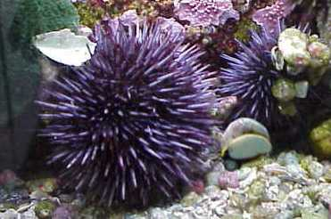
Purple Sea Urchin
The life cycle of a sea urchin starts by spawning directly into the sea. First, the male spurts out his sperm. Then the female comes and spurts out her eggs. If the sperm and eggs touch, then a new baby sea urchin will form. After the male spurts out his sperm, more males and females come and spurt out their sperms and eggs. As a group thing there is a good chance that more baby sea urchins will form.
Sea urchins live in the mid-level or low-level of a tide pool. Sea urchins eat algae off of hard surfaces. Most of the time they eat seaweed. Sometimes they eat bits of plants and small animals. Sea urchins have hundreds of tiny, tubed feet. They have five teeth in the middle of their back side. Sea urchins use these teeth to pull, tear and rip off algae on the rocks.These teeth continue to grow throughout the sea urchin's life.
A sea urchin's size is about 4 inches and they come in many different colors. The most common are purple and light pink.

Diet | seaweed, algae and bits of plants and animals
Size | up to 4 inches ( 10 cm)
Color | purple and light pink
Life Cycle
Predators | Who wants to eat a pincushion?
Neat Facts | They have five teeth.
Types | Caribbean sea urchin, pencil urchin, Slate pencil urchin, purple sea urchin and sea potato
Relatives | star fish and sea cucumber

For our purpose we have a sea urchin’s exoskeleton that has been cleaned of any tissue and is odour-free. Sea urchins come in a variety of colors and size, so select one of pleasing size and color, remembering too that we need to use an appropriate wood for the finial and icecicle. The urchin will form the body of the decoration.

Tools and supplies you will need are:
- an urchin
- a lathe
- gouge and skew and perhaps a bedan,
- a set of callipers or ruler
- chucking method (Jacobs chuck, collets set, or even a scroll chuck)
- an appropriate piece of wood (approx 4 times the height of the urchin is a suitable length)
- a small screw eye
- small drill bit to pre-drill an eye-hole.
- a Dremel tool and small sanding attachment
- clear silicone adhesive (marine type is fast cure and costs ~$3)
- don’t forget safety glasses and a dust mask for sanding/grinding
Measure the bottom opening of the urchin and turn your wood blank between centers to a cylinder slightly larger than the urchin’s bottom opening.
Mark the length you want for the finial, mark about 1” to use for tenons on the finial and icecicle, mark the length of the icecicle.
Turn the tenon area to an appropriate diameter. I use collets and aim for 5/16” (if I goof, the next taraget would be ¼”).
Note that the finial position on the urchin is convex curve so you need to undercut the end of the finial to approximate this curve. I generally make the base of the finial smaller in diameter than the urchin’s bottom opening.
The bottom of the urchin adjacent to the opening is usually slightly concave, so again approximate the portion of the icecicle base to the urchin shape.
Now cut the wood in the center of the tenon separating the finial and the icecicle.
Begin with the finial by gripping the tenon at the head end by your chosen method (I use collets), bring up the tailstock and turn the finial. Move the tailstock. Sand it and apply finish. Using the small drill bit held by a pin-vice or Jacobs chuck drill a hole for the screw eye and then fit the screw-eye.
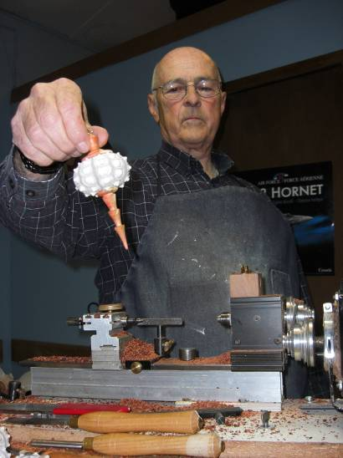
Using the Dremel gently grind off any pimples around the area where the finial will mate (avoid breathing the dust). Apply silicone to the base of the finial, bond the two, and place in a holder so the finial won’t move while the adhesive begins to cure.
Now repeat the operations to make the icecicle. I like to work from the head end towards the tail thus maximizing the strength of the wood before getting to the final thinner areas near the tail which may begin to whip. I don’t like to make too sharp a point on the icecicle as a falling ornament knocked of the tree by my dog might do serious damage (kids too).
After the glue has set you may want to spray the entire unit with a gloss lacquer.
The icecicle can be made as simple or as fancy as you wish, a decorative “ego-stick”. Another idea is to drill out your finial to pass the wires of a small Christmas light through illuminating the urchin from within. Another variation is to mount the urchin up-side-down.

Bob Hewson

