Fee.



Thames Valley Woodturner
A publication of the Thames Valley Woodturners Guild
A chapter of the AAW

Volume 11.4 July/August 2009
Welcome back to the fall season of the Guild
Welcome back from the summer hiatus to the fall season of your Guild. We hope you all have had an enjoyable summer and one filled with pleasures large and small.
Your executive has been working towards presenting you with a schedule of guest turners, skill enhancing seminars and challenges to enhance your turning skills. We will be starting the season off with a presentation by Jack Wallace of the WGO on segmented turning. This will be a “how to” evening so bring your questions!
A seminar is scheduled for October 3 with Al Stirt who will cover balancing the grain, chucking, fluted bowl, slide show, “Sgraffito” platter (decorative platter), square textured platter. Tickets are $40 and a signup sheet and tickets will be available at our September meeting.
During April and May we will have two more very special turners for demonstrations, Curt Theobald in April followed by Bonnie Klein in May.
Realizing the concerns that some may feel in back to back seminars (dictated by our guest’s schedules) we have established an innovative price structure. Each seminar will cost the normal $40 – including lunch, but, if you attend both seminars the combined price will be $65 a saving of $15. Sign-up sheets will be available at the September meeting. It is not necessary to pay this far in advance unless you wish to.
We are in discussion with the London Woodcarvers Guild to participate together in the London wood show with a joint Woodcarving and Woodturning competition. This will enable us to display our turnings in the same area and be judged primarily by turners rather than the general public as was the “People’s Choice” judging. There will be ribbons and cash prizes. As details of judges and class/categories are finalized we will keep the membership informed. We will retain our Guild demonstration and display booth, so in addition to turnings for the competition we will require turnings for display in our booth
While not complete we have the broad outline of our schedule listed later in the newsletter.
Please note the September meeting is delayed until September 10th.to keep clear of the Labour day weekend.
Turning events, Wood shows, and competitions in our region and farther afield

September 2 - 25 in Toronto Ontario Craft Council will be presenting a one man show, their first, with the turnings of Doug Magrath (Gala will be Sept 10 with Doug in attendance). If you are in Toronto this is a must see.
October 3, Al Stirt, brought to you by the TVWTG, London, Ont. Details and costs as they develop.
April 25, 2010 Curt Theobald will be our guest turner for an all day seminar. See Bob to buy tickets or reserve a seat
May 8, 2010 Bonnie Klein will be our guest turner for an all day seminar. See Bob to buy tickets or reserve a seat
February 2010 London Woodshow and competition in conjunction with the London Woodcarvers Guild
Contents
Welcome Back P1
Additions to library P1
Internet sites of interest P1
Treasury P2
Al Stirt Demo/seminar P2
Lathe safety guidelines P2
Summer challenge P3
Show & tell P3
Turning course: An advanced box P4
Visiting turners P4
Binh Pho’s past seminar P5
Memento of Binh’s visit P10
Call for volunteers P10
Updated mentor’s list P10
Calendar P11
For sale & wanted P12 & 13

For a Guild info/policy sheet, call or email
Bob Hewson 66.bobhewson@rogers.com or refer to our web site at: ca.geocities.com/tvwt1@rogers.com/

Additions to the library
New books: Malcolm Tibbetts on segmented turning and David Elseworth on Woodturning
DVDs: None
If you see a good DVD or book title that you feel would be an advantage to the guild, please let John Calver know.
A reminder: Please return your DVDs or videos as soon as you have viewed them so other may rent them as well.
Interesting new or updated Internet sites
When checking out newsgroups there are three main areas to browse, the messages, the photo albums and the files. Messages are the day to day member messages and threads which can also be searched from either the home page or the search box at the top of the message screen. The photo albums are like our monthly “Show & Tell” where members can post picture of their work. Files are usually “how to” files on a topic, project or technique prepared by group participants.
Google, Yahoo and MSN host newsgroups that cover virtually any topic you can imagine
- Visit the AAW’s forum for some great photos of member works including a lot of the big boys and girls. A good forum for sharing info too. http://www.aawforum.org/vbforum/
- For safe operations of the lathe check out the AAW site http://www.woodturner.org/resources/safety.cfm see also the information on wood toxicity sources at http://www.woodturner.org/resources/toxicity.cfm
- For wood info http://www.wood-database.com/wood-identification/ or this one http://hobbithouseinc.com/personal/woodpics/ or this one http://www2.fpl.fs.fed.us/TechSheets/techmenu.html
- For wood toxicity and allergy info http://www.wood-database.com/wood-articles/wood-allergies-and-toxicity/
- Paul Jackson, a long time member of the guild has a new website for his custom woodworking business that may be of interest to the membership: http://www.sandingovation.com/
- To see what is going on in the local woodturning world check out Woodchuckers site http://www.woodchuckers.com/ontmap.htm
- A bit more info on Doug’s show visit the Ontario craft council’s site http://www.craft.on.ca/ or http://www.craft.on.ca/Programs/Exhibitions#upcoming
- Want to see a big turning and lathe to match? http://thedailyworld.com/articles/2009/08/01/local_news/doc4a73cb7f44d9d753860012.txt
- Subscribe to Woodturning Design’s online site http://www.woodturningonline.com/index.php
- A look into the world of segmented woodturning http://www.segmentedwoodturners.org./
- Here is a site that discusses a neat way to dye your turnings, start with the tree. (From “a Penturners paradise) http://ravenstail.com/Gallery/live_dyed.htm
- For the pen turners in the group, have a look at this beauty: http://www.proserpinewoodturners.com/TheBigPen.html
Please use the internet and our site as a resource.
Our website has our recent newsletters, a list of Preferred Suppliers, the Mentor list, and our Guild policy page plus a number of interesting links. We will keep the web site as our most current communication device (if you do not have internet access please let me know and printed copy can be made available to you Ed).
Our web site is http://ca.geocities.com/tvwt1@rogers.com/
New Members
We welcome guests who often become our newest members. If you know a turner that might be interested in our guild, please bring them along.
If you see one of our new members as well as anyone wearing a ‘Visitor’ tag please say “Hi” and make them welcome.
Treasury and Dues
We have $2600 available in the treasury. All expenses are current.
Al Stirt Demonstration
Demo will cover balancing the grain, chucking, fluted bowl, slide show, “Sgraffito” platter (decorative platter), square textured platter. A critique if wanted for a member. In Gary’s estimation “One of the best demonstrators I have seen!”).
Check Al’s internet site at http://www.alstirt.com
Date: Saturday October 3
Location: RCAF association building on Crumlin Rd.
Price: $40 and includes lunch. Tickets available from BobHewson
Lathe Safety Guidelines
(updated March 2009), published by the AAW. http://www.woodturner.org/resources/safety.cfm for this and other safety info.

Safe, effective use of a wood lathe requires study and knowledge of procedures for using this tool. Read, thoroughly understand and follow the label warnings on the lathe and in the owner/operator’s manual. Safety guidelines from an instructor, video or book are also a source of important safety procedures.
1. Always wear safety goggles or safety glasses that include side protectors. Use a full faceshield for bowl, vessel or any turning involving chucks and faceplates.
2. Fine particles from a grinder and wood dust are harmful to your respiratory system. Use a dust mask, air filtration helmet, proper ventilation, dust collection system or a combination of these to deal with this serious issue. Be especially mindful of dust from many exotic woods, spalted woods or any wood from which you notice a skin or respiratory reaction.
3. Wear hearing protection during extended periods of time.
4. Turn the lathe “off” before adjusting the tool rest or tool rest base (banjo).
5. Remove chuck keys, adjusting wrenches and knockout bars. Form a habit of checking for these before turning on the lathe.
6. Tie back long hair, do not wear gloves, and avoid loose clothing, jewelry or any dangling objects that may catch on rotating parts or accessories.
7. When using a faceplate, be certain the workpiece is solidly mounted with stout screws (#10 or #12 sheet metal screws as a minimum). Do not use dry wall or deck screws. When turning between centers, be certain the workpiece is firmly mounted between the headstock driving center and tailstock center.
8. Make certain that the belt guard or cover is in place.
9. Check that all locking devices on the tailstock and tool rest assembly (rest and base) are tight before operating the lathe.
10. Make sure the blank is securely fastened.
11. Rotate your workpiece by hand to make sure it clears the toolrest and bed before turning the lathe “on”. Be certain that the workpiece turns freely and is firmly mounted. A handwheel on the headstock simplifies this process of spinning the lathe by hand before turning on the switch.
12. Be aware of what turners call the “red zone” or “firing zone.” This is the area directly behind and in front of the workpiece - the areas most likely for a piece to travel as it comes off the lathe. A good safety habit is to step out of this zone when turning on the lathe, keeping your hand on the switch in case you need to turn the machine off. When observing someone else turn, stay out of this zone.
13. ALWAYS CHECK THE SPEED OF THE LATHE BEFORE TURNING IT ON. Use slower speeds for larger diameters or rough pieces, and higher speeds for smaller diameters and pieces that are balanced. Always start a piece at a slower speed until the workpiece is balanced. If the lathe is shaking or vibrating, lower the speed. If the workpiece vibrates, always stop the machine to check the reason. As a starting point, consult your operator’s manual for recommended speeds for a particular lathe. Make sure the lathe speed is compatible with the size of the blank.
14. Exercise extra caution when using stock with cracks, splits, checks, bark pockets, knots, irregular shapes, or protuberances. Beginners should avoid these types of stock until they have greater knowledge of working such wood.
15. Hold turning tools securely on the toolrest, holding the tool in a controlled but comfortable manner. Always contact the tool rest with the tool before contacting the wood.
16. When running a lathe in reverse, it is possible for a chuck or faceplate to unscrew unless it is securely tightened or locked on the lathe spindle.
17. Know your capabilities and limitations. An experienced woodturner is capable of lathe speeds, techniques and procedures not recommended for beginning turners.
18. Always remove the tool rest before sanding, finishing or polishing operations.
19. Don’t overreach, keep proper footing and balance at all times.
20. Keep lathe in good repair. Check for damaged parts, alignment, binding of moving parts and other conditions that may affect its operation.
21. Keep tools sharp and clean for better and safer
performance. Don’t force a dull tool. Don’t use a tool for a purpose it was not designed or intended.
22. Consider your work environment. Don’t use a lathe in damp or wet locations. Do not use in presence of flammable liquids or gases. Keep work area well lit.
23. Stay alert. Watch what you are doing, pay close attention to unusual sounds or vibrations - stop the lathe to investigate the cause. Don’t operate machines when you are tired or under the influence of drugs or alcohol.
24. Guard against electric shock. Inspect electric cords for damage. Avoid the use of extension cords.
25. Never leave the lathe running unattended. Turn power off. Don’t leave lathe until it comes to a complete stop.
26. A significant number of accidents to woodturners occur while using saws, especially band and chain saws. Learn and follow the safety guidelines for these machines before operation.

In light of the summer tragedy to a Hamilton area turner please be very careful. Check your lathe speed setting before starting it up, be sure your workpiece is fastened securely and that your wood is sound. If it has known defects be extra vigilant. When starting your lathe be sure to stand out of “the line of fire”!

Remember our summer challenge (for competition at September’s meeting)
A plant stand. Must contain faceplate and spindle turned components. No limitations as to size or material. This should test everyone’s ingenuity.

Show and Tell
Please bring in items for Show and Tell, we all would like to see what’s been going on over the summer months.
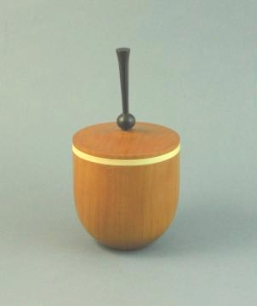
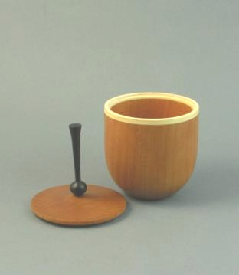
Training course: Advanced box turning
Advanced box turning. Led by John Calver. A beautiful cherry box with a holly insert and a turned finial.
Materials: supplied.
Attendance: limited by availability of lathes.
Date: Sunday Sept 27, 10:00 – 4:00
Cost: $25:00
To sign-up see Scott
Bring a lunch

Visiting turners
For the interest of members we are listing future seminars and visiting turners in the surrounding area as we learn of them:
These are the demonstrators that WGO, GHWG, TVWG and other area guilds or clubs have scheduled or are in the process of arranging. The guilds/clubs have said (or implied) that members of other clubs are welcome to attend, but space may be limited, so if you wish to attend make your wishes known as early as possible, please let Gary Miller know for out-of-town sessions. He will verify that there is space and confirm the fees.
Carpooling may be arranged if there are sufficient numbers. For sessions held in London see Bob Hewson to sign-up and or buy your ticket(s).
As we know more we'll keep the membership apprised and will keep this as an ongoing feature in the newsletter.

Guest turner | Date | Sponsor | Fee | Contact | Comments
Al Stirt | Oct 3, Saturday | TVWTG London | $tba | Gary Miller | Demo of balancing the grain, chucking, fluted bowl, slide show, “Sgraffito” platter (decorative platter), square textured platter. A critique if wanted for a member  Lunch is included.
David Hout - metal spinning (on wood lathe) | Nov 15 | WGO Burlington | $ tba | Gary Miller | A possible workshop or may be able to arrange for him to come to TVWG
Bruce Campbell |  |  |  |  | Under discussion
Curt Theobald | Sunday, April 25, 2010 | TVWTG London | $40 or combined with Bonnie, both for $65 | Gary Miller | Confirmed.
Bonnie Klein | Saturday, May 8, 2010 | TVWTG  London |  | Gary Miller | Confirmed.
  $40 or
  combined
  with Bonnie
  both for $65$tba
Cindy Drozda | Fall 2010? |  |  |  | Under discussion
Bruce Campbell |  |  |  |  | Under discussion

Photos and observations from Binh Pho’s seminar in June
The seminar held by the Guild in June with Binh Pho was an inspiration to us all.
SEVEN LEVELS OF CHANGE & GROWTH
LEVEL ONE
KNOWING “right” from “wrong”
Requires: Being taught, Forgiveness
LEVEL TWO
DOING what’s “right”
Requires: Willpower, Patience, Compliance
LEVEL THREE
DOING the “right” thing “better”
Requires: Practice, Repetition, Commitment
LEVEL FOUR
ELIMINATING distractions from doing “right” more efficiently
Requires: Focus, Discipline
LEVEL FIVE
COPYING how the best do “right”
Requires: Insight, Seeing the Invisible
LEVEL SIX
BEING/DOING “different”
Requires: Experimentation, Vision, Learning from Experience
LEVEL SEVEN
DOING the “impossible”
Requires Faith, Risk of Life, Wanting to be First

Author: Binh Pho
The seminar covered a number of areas of Binh’s personal journey as an artist and immigrant to the US at the end of the US/Vietnamese war.
To start of the review I’d like to draw your attention to the box to the right which outlines his personal growth as a turner which he calls his “Seven Levels of Change and Growth”. Discussion was held on the seven steps and how they might relate to each of us in advancing our skills.

After a few introductory remarks, questions, and answers Binh began his demo with the turning of a thin wall vessel with a ~1/16” wall out of green maple.
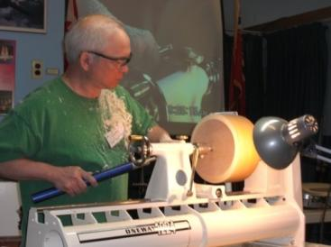
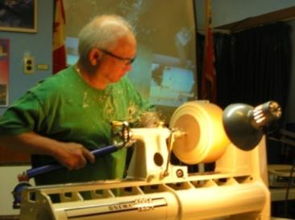
After truing the blank he began removing wood to form the general shape of the exterior of the bowl.
The wood is green, so as he progresses the wood can and does move. Binh’s goal is to turn quickly, accurately and smoothly, there will be no returning to reshape most of the exterior once the wall is down to 1/16” due to movement of the wood as it dries.

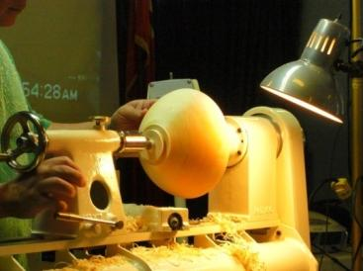
Once the shape is satisfactory and a tenon is turned he is ready to reverse the bowl and begin the hollowing process.

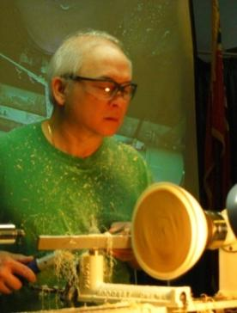
Once the tenon is complete and the bowl’s shape established its time to reverse the bowl. Binh first trues up the edge (it has already moved some) and establishes his rim.

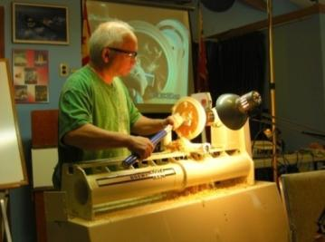
Now it’s time to remove the interior. With his goal of a 1/16” wall he will have to turn in a manner to minimize movement of the wood. He begins by removing wood from the center towards the rim (downhill with the grain). He removes wood to about a depth of one inch – only. He works to the rim and establishes his wall thickness.

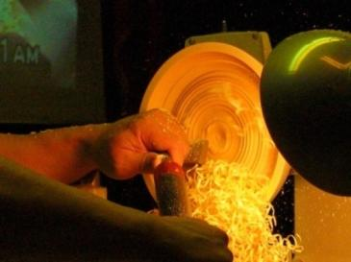
A 100 watt incandescent bulb is set up to shine on the rear edge of the bowl. As the wall is thinned the light shines through in a reddish glow. Any irregularities in uniformity are readily seen as variations in the light’s luminosity (this technique using the light works with wet wood only). Once it is there you go no further, but return to the deepening, an inch at a time. The purpose of nibbling away at the interior is to keep a mass of wood in the center so the wood movement is minimized.

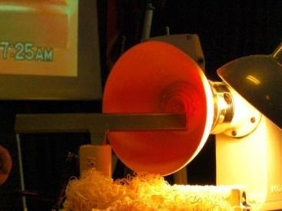
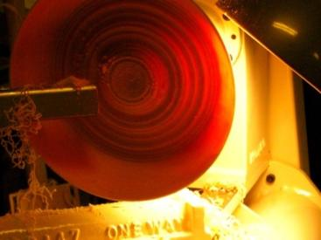
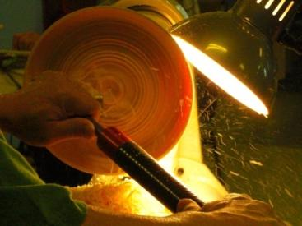

Now that the inside is complete the bowl must be remounted to turn the foot and refine the curve of the base.

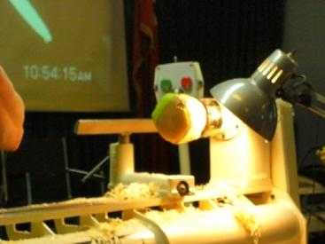
The chuck pad is made from a piece of ABS pipe and adds a soft foam to protect the fragile turning. A vacuum chuck could also be used.

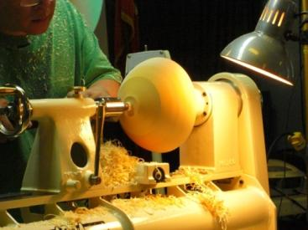
Positioning is aided by the live centre’s position from turning the tenon. With gentle pressure applied the bowl is centered and the final shaping of the foot and the bsae curve are completed.

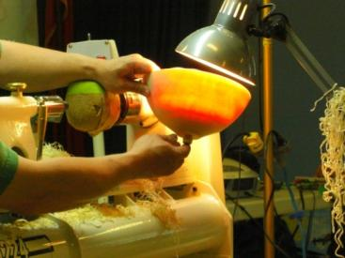
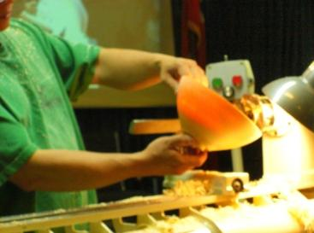
The final shape and translucence of the bowl is shown here. All that remains is to cut off the tenon nub using a chisel or blade.
Then the decorating process can begin.
The bowl was started at 9:22 and completed at 10:58. WOW!

After the bowl turning Binh presented a slide presentation showing and explaining his personal history while living in Vietnam and his subsequent escape to the US and how these experiences relate to his work. The following photos show detail of several of his works which he brought for our interest. The sizes are all within the capability of a lathe with 10 inch swing!
These works have always impressed me when seen in books and magazines, but seeing them up close in the round is a different experience. They are truly works of art!
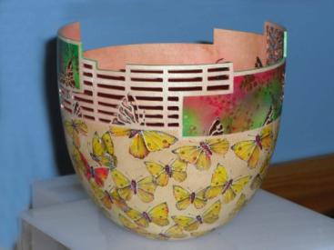


Butterflies are a recurring theme
combined with repeating rectangular
elements Airbrushed detail
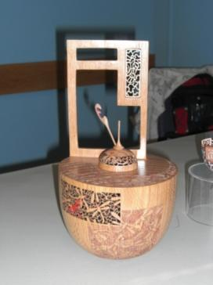
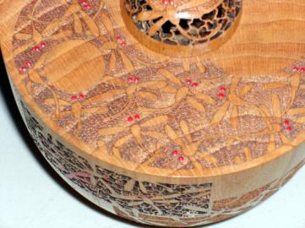

Piercing and woodburning with a touch of color create the required effect.

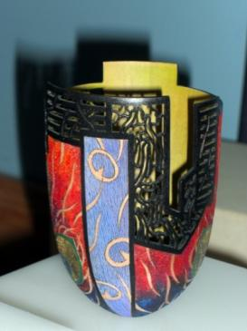
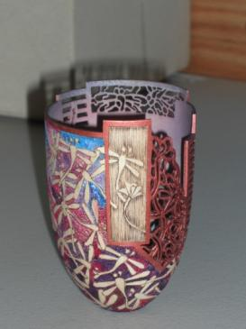

Fully decorated 360^{0.} The interior as well as the exterior with a mix of techniques.

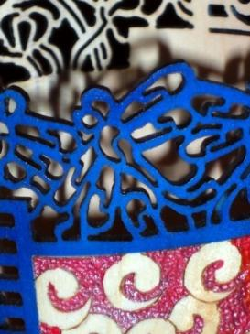
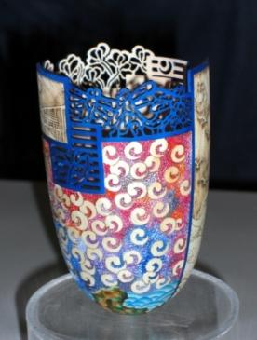

Piercing, texturing, wood removal, and air brushing notice how crisp and precise the detail is



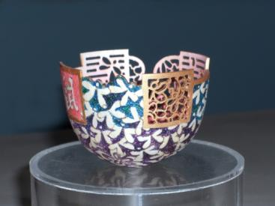

Butterflies

Above, a work in progress

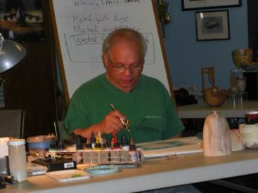
Our afternoon covered texturing, piercing, and air brushing.

Below are examples of the use of masking using masking tape and masking film. Patterns are carefully cut with a small knife and the colors are then airbrushed. The techniques are developed through practice.
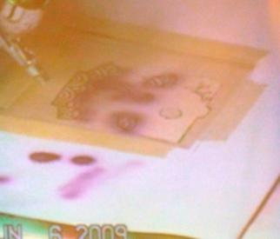
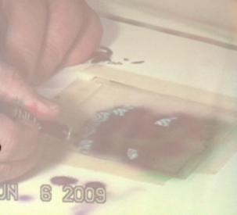
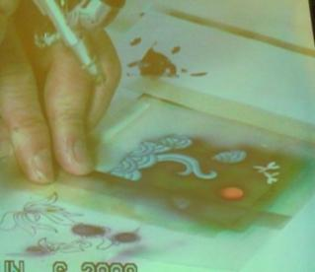
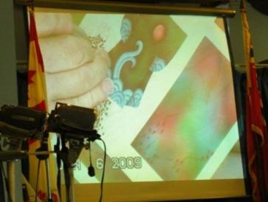

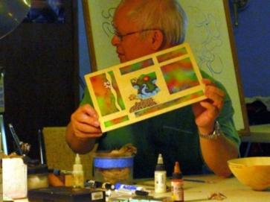
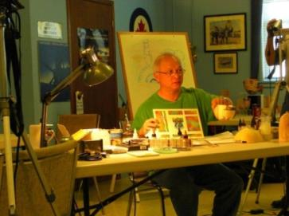
With the masking removed the air-brushed art is revealed. To the right Binh equates the flat demo piece to the work flow he would follow the same steps when working in the round.

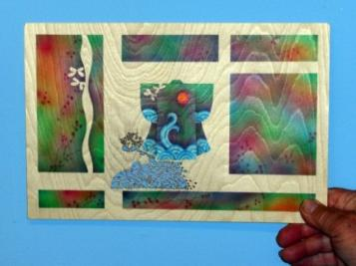
I didn’t get any photos of piercing, but you can see how the piercing adds to the effect. This concluded our day.
To see how this piece turned out when the piercing was completed and the piece signed, see the following item
A couple of technique tips from Binh are:
How to clean the wood fibre burrs after piercing? I use the product made by 3M Radial Bristle Discs ¾” highlighted on page 10 of the Sanding Glove products catalogue.
What finish do I use after to finish my piece? As we know, water based paint will raise the wood grain, so the surface will feel little rough when you touch it. I spray 2 light coats of clear lacquer then use 3M Finishing Film Disc 1000 and 1200 grit (page 13 ), lightly buff the finish with the grain of the wood, it may leave a white powder on the surface….no problem, wipe it off with paper towel or blow off with compress air. If it did not clear all the white dust, spray one more coat of lacquer….this should do it.
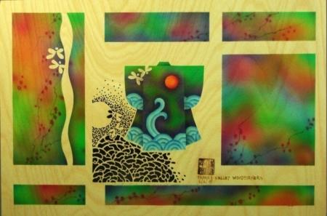
A beautiful memento of Binh Pho’s Demonstration
During Binh’s seminar in June he created a flat art demonstration piece using the graphics, air brush and piercing techniques that he uses in his turned vessels. He has completed and signed and returned it to the Guild and suggested it be used to benefit the Guild. Your executive have opted for a draw.
The art piece will be raffled during our November meeting. Tickets will be available from Bob Hewson for $5 each or 4 for $10. Tickets will be available beginning with the September meeting. Tickets sales are restricted to Guild members plus any outside participants at the June seminar.
We will ask you to put your name and phone number on your draw ticket. You need not be in attendance during the draw to win.

An ongoing call for volunteers
Your guild is growing; we recently passed the 94 member mark, on our way to 100.
Our members’ skill-sets are growing too. Not so our mentor list, it has been stagnant for several years; we could use some new mentors, volunteers who would like to share their skills with other members. To be a mentor you need only offer your skills to other members and be a member of the AAW too (this is required to validate our insurance coverage.
The same call for volunteers is being made for demonstrators. If you have a specialty or a particular turning skill, will you consider sharing it with the guild members? Please see any of the executive to offer your skills by way of a demo. Membership in the AAW is required for demonstrators, if you are not a member your membership will be paid by the Guild as an honourarium.
The month to month operation of the guild requires direction. Your current executive have been in place for a number of years, not necessarily by desire, but rather by need. All members of the executive will gladly step aside for those members wanting to serve.
We currently have an opening for a “training program” co-ordinater to co-ordinate the Training 100 series as well as a member of the program committee to replace Phil Marusiak.
Have you had a skills enhancing learning session with a club Mentor?
To our membership and in particular new members may we remind you that our mentors have skills they are willing to share, its up to you to tie-up with one and make arrangements to move your skill set up a notch.
The Guild is also looking for members who will volunteer their skills to teach and enhance the skills of other members. If you would like to add your name to the mentoring list and wear the “wise owl” on your name-tag please call one of the Guild executive have your name included. You need not be a totally rounded turner to be a mentor, a particular skill you are able to teach is great too (mentors are not prohibited from getting help in a particular area as well).

Look for the wise owl on member’s nametags to identify mentor volunteers. If you need help or advice please feel free to contact any of the members listed below. They have kindly offered their skills through our mentor program.
If you wish to offer your skills through the program please contact Bob Hewson or any of the executive and your name will be added to the list.
Mentor | Topic | Address | Phone
Bob Fenn | Any topic | 49 Susan Ave., London | 519-455-7436
Bob Hewson | Pen & kit turning | 22 – 99 Edgevalley Rd, London | 519-457-6555
Brian McNaughton | Any topic | 192 Vancouver St., London | 519-453-6737
John Calver | Any topic | 59 Glenburnie Cr., London | 519-455-6998
Mario Moran | Any topic | 316 Indian Rd. S., Sarnia | 519-336-0550
Tom Pinches | Any topic | RR #2, Belmont | 519-644-0434
Robbie Bloomfield | Bowls | 443 Regal Drive, London | 519-451-7028
Doreen Bowden | Any topic | 8476 Century Dr., Mount Brydges | 519-264-2361
Rev 8/24/09

2009-2010 season scheduled meetings and other events.

Date | Meeting or events | Shows/events/comments
September 10 | Fall season begins | Note, this is 2nd Thursday, moved from the 3rd due to adjacent long weekend  Segmented turning by Jack Wallace of the WGO. “How to” info!
September 27 | Advance Box turning 203 (9:00 – 4:00) | To sign-up, see Scott
October 1 | Monthly meeting | Robbie Bloomfield – deep or undercut bowls (not finalized)
October 3 | Visiting turner - Confirmed | Al Stirt - Full-Day Demonstration, tickets available $40.
October 24 -26 | Inter-club competition. Black Creek Pioneer Village in Weston
November 5 | Monthly meeting
December 3 | Monthly meeting | Challenge: a Christmas decoration
January 7, 2010 | Monthly meeting
January 11 | Turning 103 - 9:00 – 4:00
February 4 | Monthly meeting
February12 – 14 | London Wood Show and TVWTG turning competition
March 4 | Monthly meeting
April 1 | Monthly meeting
April 19 | Turning 101
April 25 | Visiting turner – Confirmed | Curt Theobald – full day demonstration. Curt’s field is segmentation.  No Sales in tickets as of this time.
May6 | Monthly meeting
May 8 | Visiting turner – Confirmed | Bonnie Klein – full day demonstration.
June 3 | Monthly meeting
June 18 - 20 | AAW Symposium | AAW symposium, which will be in Hartford, Connecticut, USA
July/August | Summer break | Summer break.
September 9 | Return from summer hiatus | Note, this is the 2nd Thursday, moved from the 2nd due to adjacent long weekend
 | Topics in the discussion stages, not yet formalized as to date or content.  Program Ideas and suggestions for guest turners are always welcomed by your committee | -Hand thread-chasing.  -Guest turners or seminars.  -Design? What makes a makes a “good” turning into an “outstand- ing” turning?  -Metal spinning  -A safety night (discussion/panel)  -A “show and sell” table of turnings”, a “show and trade” table for your turnings.  -Future challenge ideas: a pair of “something”, a seed pod turning.  -Shear scraping | -Eccentric spindle turnings  -Bracelet turning  -Turning a ring  -Inlace  -Bird houses  -Finishing the “foot”  -Basic drying of wet wood  -Wine stoppers  -Sharing of advanced techniques turning 201  -Finishing  -Make a home drying cabinet
Note, meetings start at 7:30, doors open at 7:00. Raffle tickets, the library, and the Round table critique will be available between 7:00 and 7:30.
We have booked several guest turners and while firm at this time their schedules could result in changes. We will keep the members informed of changes if they happen.
Items both wanted and for sale
Ads are free for members and run until you sell your item or withdraw your advert. Members can support other members by buying: good deals and good prices!
Please note. The Guild provides a means of connecting buyer and sellers through these ads. It is up to the buyer to ensure the item offered is as stated and the two parties should agree between them as to warranty or guarantee for the item.
To run a new ad in our newsletter or to remove a sold item, call Bob at 519-457-6555 or email him at 66.bobhewson@rogers.com .
We welcome small business card type advertisements at a rate of $30 per year. We print 6-7 issues per year on a non-date-specific schedule. We also upload our newsletters to the internet at http://members.rogers.com/tvwt1/ for viewing in glorious colour.
Wanted
Parts for old lathes
Call: Murray Tyler at 519-225-2854 after 5 PM
For Sale CA Glue for Wood Turners
EM-02 VERY THIN, INSTANT CURE, Able to penetrate between parts, very thin viscosity, allows up to .002” gap fill capability
EM-40 MED-THIN, FAST CURE, General purpose, thin viscosity, allows up to .004” gap fill capability
EM-150 MEDIUM, MEDIUM CURE, Broad use adhesive, medium-thick viscosity, allows up to .006” gap fill capability
EM-600 MEDIUM THICK, MEDIUM CURE, Heavy duty adhesive, medium thick viscosity, allows up to .008” gap fill capability
EM-2000 THICK FILLER, SLOW CURE, Allows maximum time for positioning fixtures. Use to bond fibrous and porous materials. Flowable thick viscosity, allows up to .010” - .020” gap fill capability. Excellent for filling large open cracks, gaps and holes. General manufacturing and repairing tough and uneven materials.
All are available in 2 ¼ oz. bottles bottle which includes 5 detachable long nozzles and an extra top with spout and cap.*
Price: $15.00 (taxes included)
(EM2000 does not include the 5 detachable long nozzles because it is too thick for the nozzles)
Additional long nozzles are priced at 5/$0.25.
ACTIVATOR Instantly cures adhesives. Contains no CFC’s. Mist Pump Sprayer
Price: $10.00 (taxes included) 2 oz. bottle
DE-BONDER Required to un-glue items (example: fingers accidentally glued together)
Price: $10.00 (taxes included) 2oz. bottle
Call: Fred Rodger 519-858-2558 or email at frederick.rodger@sympatico.ca (Fred will bring it to the meeting for you)

This is the most superior CA Glue on the market. Manufactured by the
company that invented CA Glue over 30 years ago

This is the most superior CA Glue on the market Manufactured by the company that invented CA Glue over 30 years ago



For sale
Delta Shaper, stand, reversible, motor c/w 30+ cutters
$450
Call: Bob Fenn, 519-455-7436

For Sale
Jet Mini-lathe (Model JML-1014)
Excellent condition
Tail and headstocks raised 2”
$300
Call Pete at 519-661-7525
Wanted
A larger lathe

Custom work:
I Have a vertical mill & metal lathe to make different turning tools (cutters, sharpening jigs, supports etc. You name it, Similar to the Hunter Tool for hollowing in two different sizes ¼” & 3/8" round, also a square end cuter (all carbide cutters ).
-If you want a curve put in rod it can be done too. You will have to make a drawing if you want a bend put in the rod. Price: $50 straight, $70 bent or curved.
-Aluminum handles to accept the tool is also available (you choose the size).
-See my sharpening jigs at the next guild meeting or call.
-New Custom vacc chuck $95
-Any custom work, please see me.
Call: Al Johnston at 519-679-8718
592 Mapledale Ave. London

Fletchs Fetchings

Supplying unique wood from Africa and Asia.

Turning blanks available for pens, pool cues, bottle stoppers, duck calls, bowls, etc.

Reasonable pricing.
Call Jim Fletcher at 519-633-0538.
Or visit my website www.fletchs-fetchings.com
I also sell on eBay under seller id fletchs_fetchings

For sale: I make and sell cutters for the Stewart system and or boring bars. They are made of hi-speed steel. Available in three sizes, prices are $15, $20, & $25.
Call Mario Moran at 519-336-0550, or see him at the Guild meeting or mario.ada@sympatico.ca
For sale:

Lee Valley Mitre Vise - 2 available unused.
Price - $50.00 for pair.
Call: Alf Buckle at 1-519-271-8489 or email at abuckle@sympatico.ca

CANADIAN ROSENGINE INNOVATIONS

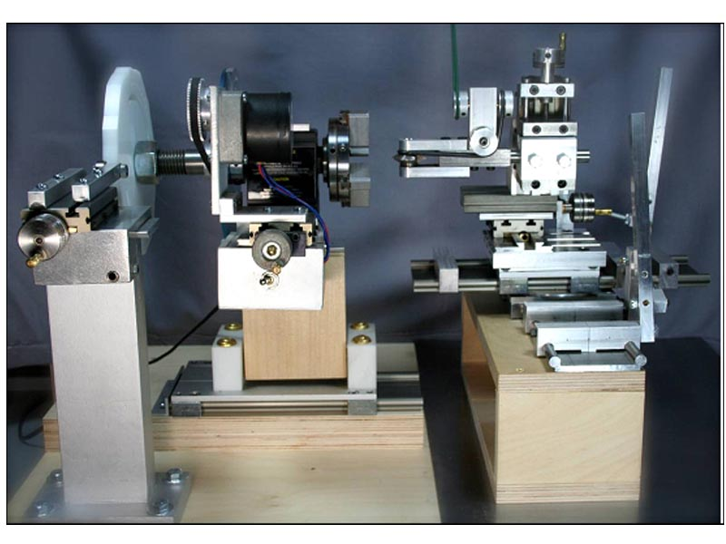
Let us build you an extremely accurate and dependable rose engine:

- 8” radius turning capacity.
- Headstock, X and Y axis movements slide on Delrin linear slides
- Micro adjustment possible using Taig cross slides on rosette tower, timed belt and pulley adjustment and X-Y axis movements.
- Headstock powered by a 1rpm geared motor using geared pulleys and belt.
- Universal cutting frame powered by a Sherline motor and speed controller
- Cutter frame uses 60 degree carbide cutters.
- Magnetic hold down for cutting frame tower allows for infinite positioning of cutter frame
- Headstock has pumping and rocking capabilities.
- Work can be phased by an indexing system which allows 1 degree indexing

Contact John Calver at (519) 455-6998 or woodchuck1@rogers.com for complete details, more pictures and pricing.

