Fee.



Thames Valley Woodturner
A publication of the Thames Valley Woodturners Guild
A chapter of the AAW

Volume 11.3 May/June 2009

Turning events, Wood shows, and competitions in our region and farther afield

September in Toronto. Ontario Craft Council will be presenting a one man show, their first, with the turnings of Doug Magrath – more info in August newsletter.
October 3, Al Stirt, brought to you by the TVWTG, London, Ont. Details and costs in the August newsletter.
Contents
Additions to library P1
Internet sites of interest P1
New members P1
Treasury P1
Picture quality P1
Turnings accepted for AAW P1
May show and tell P2
Tips for turners P2
May meeting – Turning wet wood P3
Training courses P7
Visiting turners P7
June meeting: Fred on Chain saws P8
Tips from Binh Pho P9
A summer challenge P9
The June challenge P9
Volunteers P10
Al Stirt seminar P10
Show & tell – June P11
Calendar P12
For sale & wanted P13 & 14

For a Guild info/policy sheet, call or email
Bob Hewson 66.bobhewson@rogers.com or refer to our web site at: ca.geocities.com/tvwt1@rogers.com/

Additions to the library
New books: None
DVDs: 2008 AAW symposium DVDs
A reminder: Please return your DVDs or videos as soon as you have viewed them so other may rent them as well.
Interesting new or updated Internet sites of interest to members
When checking out newsgroups there are three main areas to browse, the messages, the photo albums and the files. Messages are the day to day member messages and threads which can also be searched from either the home page or the search box at the top of the message screen. The photo albums are like our monthly “Show & Tell” where members can post picture of their work. Files are usually “how to” files on a topic, project or technique prepared by group participants.
Google, Yahoo and MSN host newsgroups that cover virtually any topic you can imagine
New Members
Please welcome our newest members: Peter Gryseels, Eric Huffman, and
Jack Laidlaw,
If you see one of our new members as well as anyone wearing a visitor tag please make them welcome.
Treasury and Dues
We have $2985 available in the treasury. Guest turner seminar costs, Turning 101/102 expenses pending and meeting room rent have been paid.
Improved printed picture quality
I have changed the processing method for the printing of our newsletter. My former process was to print a high quality copy on my printer and use it as the master for photo copies at Staples.
The new method involves direct printing from the digital Word file using laser output at Staples. Not only are the pictures more clear, the process saves me a couple of hours of copying, and folding, and a couple of dollars in cost as well! Hope you enjoy the improvement.
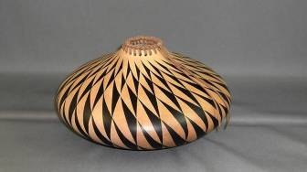
Turnings accepted for display at AAW South West symposium

A laced South West motif hollow vessel is Gary Miller’s entry.

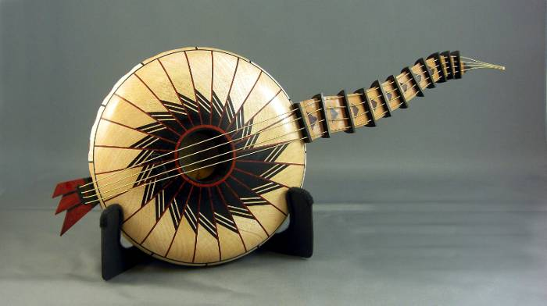
A fanciful musical turning by Bernie Hrytzak has been accepted for display during the 2009 AAW Symposium.
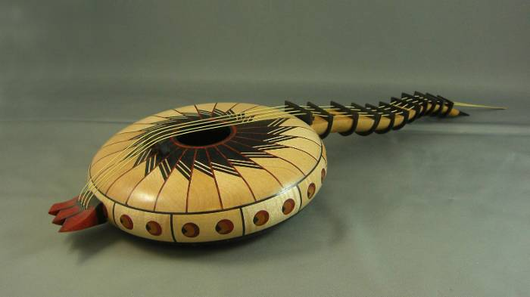
Congratulations to you both!
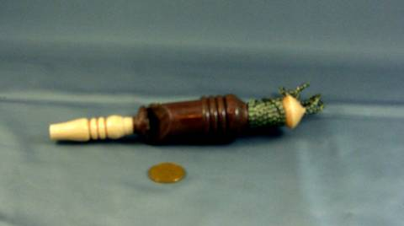
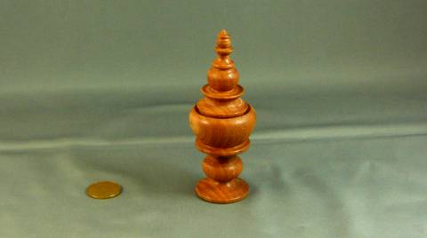
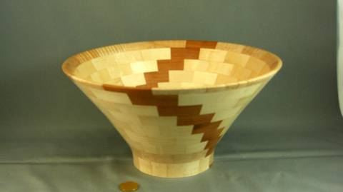
May’s Show and Tell
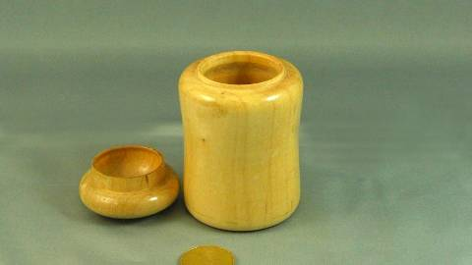
The box to the left was turned during the
turning 103 session earlier in the year and
completed at home

Tips for turners
If you have a tip you would like to share with everyone, please see Scott before the meeting so he can schedule you in.

A new articulating tubing available from Lee Valley in 4” and 2” diameters. Ideal for areas in duct collection where you need a flex hose that stays put and can be returned to its original length when finished

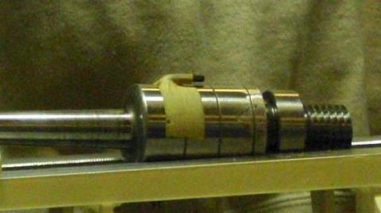
Add a threaded insert to your revolving tailstock. In this case a OneWay that has a ¾ in female to which is added a 3/4x16:1x8 adapter. This enables you to mount a chuck, a faceplate or other holder to the tail end. Also available from Penn State Ind in the USA.


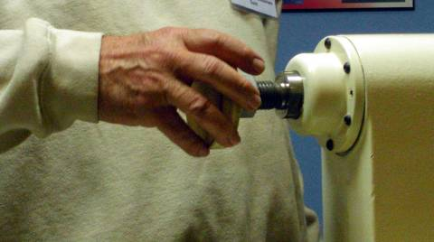
Low cost face plates. Obtain a nut in the proper thread for your lathe and have a steel disc/large washer welded to it. Fasten a piece of sacrificial wood and turn it square. Result, a very low cost faceplate

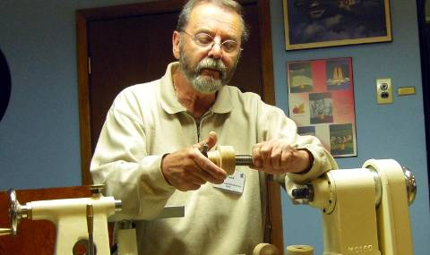
Using a thread cutter a thread may be cut into a chunk of wood, threaded onto the head stock and turned into a true jam chuck, faceplate or any of a number of turning aids.

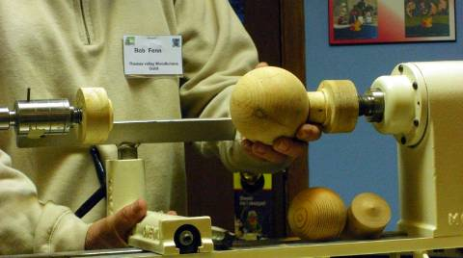
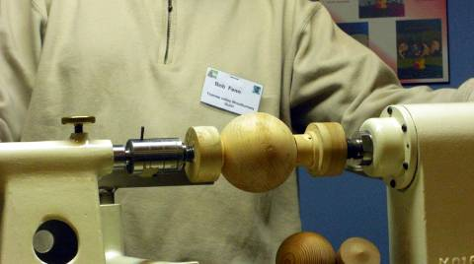
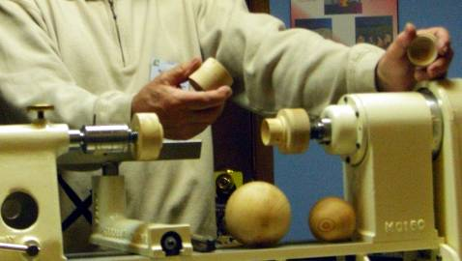
The three photos below combine the two previous ideas into a holder for truing up a turned sphere

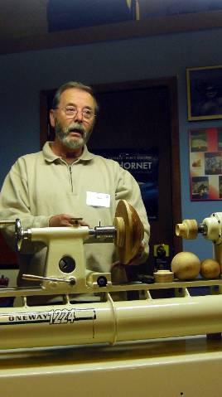
This application shows the use of the same two ideas to hold a bowl for final light cuts

May meeting
Turning Green (wet) Wood
(A presentation by Gary Miller. An injury forced a change in demonstrators and Doug Magrath ably took over the demonstration part of the presentation while Gary continued with the verbal portion)
Why turn green?
I’m sure there are an infinite number of reasons why many turners prefer to turn green wood. One of the most obvious being cost. Every step of processing wood adds to the cost. There’s harvesting, trimming, shipping, initial milling into slabs, cutting to lengths, kiln drying, selecting for different purposes and for those that have selected for turning, bandsawing into bowl blanks or spindle blanks. So, that nice little kiln dried blank you buy at your wood supplier is going to cost you a considerable amount. Green wood can generally be gotten for nothing if you keep your eyes open and approach the municipal arborists for some.
A few other reasons are:
You can select the grain orientation and/or inclusions that you want.
Green wood (especially hardwood) cuts easier (it’s a real pleasure, actually).
You needn’t sharpen as often.
There’s no dust.
Note: while chainsawing; watch out for foreign objects (nails, screws, wire fencing etc.)
And wear safety gear at all times.
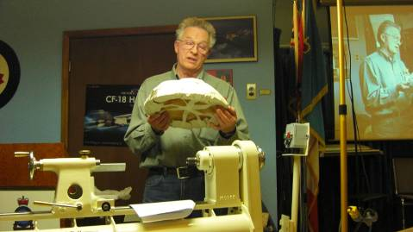
Drying vs. Protection
After chainsawing, billets must be protected from drying out if you are unable to rough turn immediately:
- Plastic bags are O.K. for short term protection. If left too long, mold will form, decay will happen rapidly and the blank could be badly discolored or even made unusable in no time. If necessary to keep for an extended period, remove the blank from the plastic bag every couple of days and turn the bag inside out before putting the blank back in the bag. This will control moisture loss and keep mold from forming.
- Freeze the blanks. If the wood was cut during the winter, it may only be necessary to store it in your garage where it will freeze and remain stable until spring (or use your family freezer if you can get away with it).
- Coat the whole piece with wax emulsion (at least the end grain). It will not retain the moisture indefinitely, only slow down the drying process. Get to the rough turning process as soon as possible.
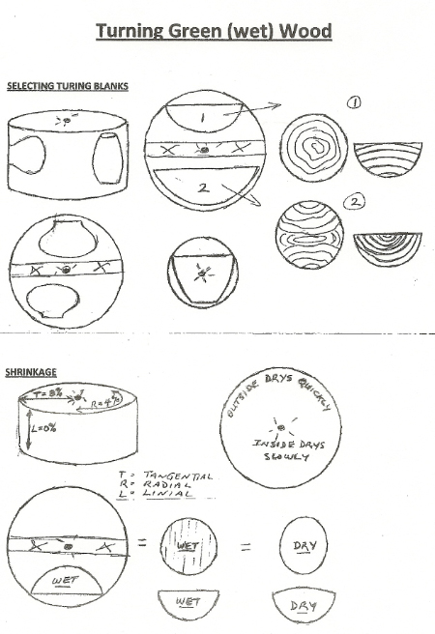
- Ideally, you should rough turn immediately. The rule of thumb is to turn the wall thickness to a consistent 10% of the diameter of the bowl top to bottom (i.e. A 10” bowl will be turned to about 1” thickness). There are a number of ways to control the drying process after turning:
- Place in a cardboard box covered with wet shavings
- Soak for a couple of weeks in Kirkwood Dishwashing Detergent mixed 50% with water. Then put in a cool draft-free place for a couple of months
- Soak in Methyl Hydrate for a few days before placing in suitable drying location for a few weeks
- Boil in water, at least 2 hours and let the blank remain in the water until it has fully cooled. Then place in a suitable drying location for a few weeks. Best do this outdoors.
- Kiln drying in a (commercial or home-built kiln) should only take a couple of weeks.
- Paper wrap and stickers. Use 4 layers of newsprint paper. Wrap from the bottom to the rim (masking tape the folded edges together). Leave the bowl open and store it upside down on a couple of stickers for a few months. Again, in a cool draft-free place.
- Some folks just put the rough turned bowls into a plastic bag and turn the bag inside out every couple of days. The risk is forgetting to do the reversal and losing perfectly good blanks due to mold or decay.
Finish turning
Note: wear a turning mask!!!!!!
When the blank is dry (best to use a moisture meter) check to make sure there are no dangerous “checks”. You don’t want a bowl to blow apart on the lathe. Mount a padded “dome” or appropriate size vacuum chuck as a “driver” on your headstock and place the bowl over it. Bring up the tail stock and find the approximate center by trial and error (rotate the headstock and check to see that the rim is fairly in line). When well centred, tighten up the tailstock and form a chucking spigot. Turn the exterior to the form desired. Any minor tear-out can be removed by shear scraping. Remove the bowl and the “driver”.
Mount the bowl in your scroll chuck. You may have to true up the exterior before finishing the inside. Face off the rim (usually quite uneven due to the drying process). Using a swept-back bowl gouge, finish-turn the inside of the bowl to the desired thickness, checking frequently with calipers to see that it is consistent. You may have to use a conventionally ground bowl gouge to ensure bevel contact is maintained through to the very bottom. If tear-out is a problem, try spraying the inside with water before taking a final cut. Ultimately, you may have to shear scrape the inside to perfect the curve. When you are happy with the inside sand to a finish before reversing.
To finish the foot, you will have to reverse the bowl. This can be done with the “driver” used previously and your tailstock, some kind of jumbo-jaws or (ideally) a vacuum chuck. Turn off the chuck spigot and form the bottom of the bowl (with or without a formal foot). Finish sand. Be sure to make the bottom slightly concave so the bowl will sit evenly on a flat surface and finish it as well as the rest of the bowl. If you used your tail stock, you will have to leave a small (about 1/4”) tendon. This can be removed by hand with a carving gouge (or alternate) and sanded smooth.
Apply your finish of choice and don’t forget to sign and date the bottom.
Enjoy!

Gary Miller

Ongoing; we now follow Doug as he finish turns a pre-dried bowl blank which had originally been originally turned wet and allowed to dry.
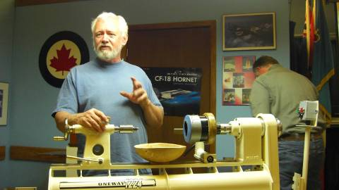
Doug reviews safety and an overview of how he will turn the bowl blank. If you look closely you can see how its shape is distorted during the drying process.
Typically a wet tuned bow is left with a wall thickness of 10 percent of the diameter to give enough leeway to return the bowl to round after drying to approx 6 percent moisture content

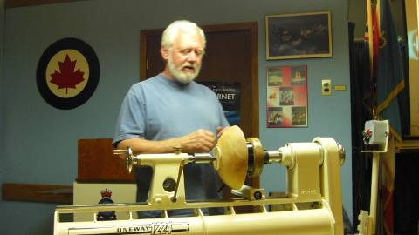
To hold the bowl so the foot can be turned round Doug is using a vacuum chuck on the head end as a holder only (no vacc). On the tail end he has removed the spur from the live center so that he can position the bowl and minimize damage from spur penetration as well as make it easy to adjust the bowl to center it as much as possible. Warpage and shrinkage will vary from piece to piece and good balance will simplify the turning, maximize the diameter, and minimize vibration.

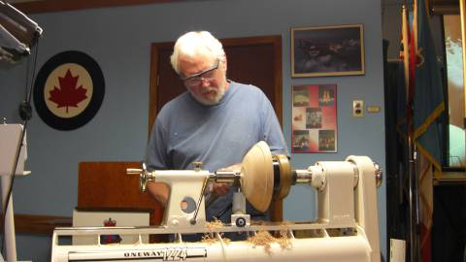
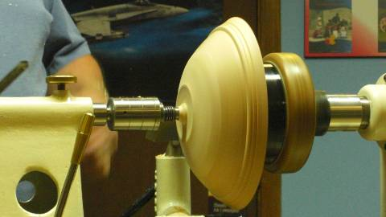
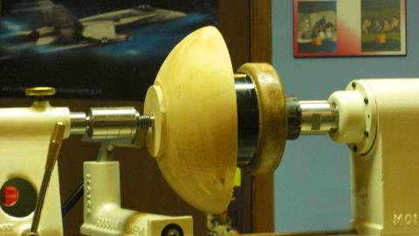
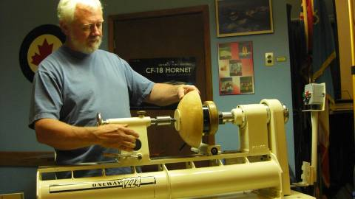
Once satisfied and as true as it can get, lock it down, put on safety gear, stand out of the “line-of-fire” and start the lathe slowly, increasing speed to a point your are comfortable, or which minimizes vibration.

Begin turning the outside of the bowl to refine the shape.
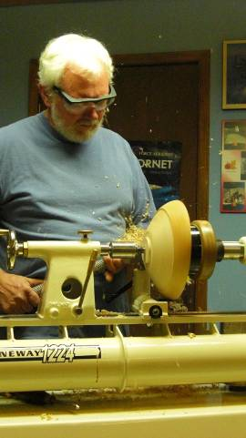
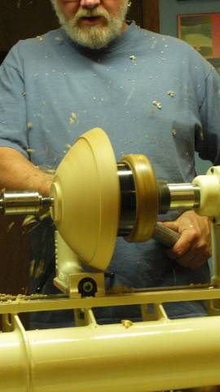
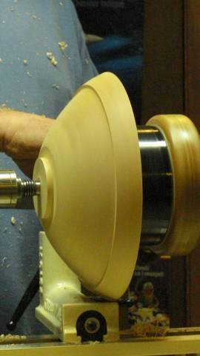
The tenon is turned. Doug uses the smaller set of jaws as his guide targeting the tenon to about the smallest ID + 1/8”. The tenon is cut with at 90 degrees, about one half the depth of the jaws and a flat surface is left adjacent to the tenon. When the chuck grips you want the flat surface pressing against the jaws uniformly to give a tight squared fit

The final external shape is carried out during this phase including shear scraping

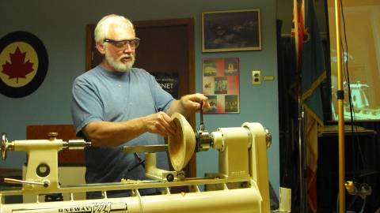
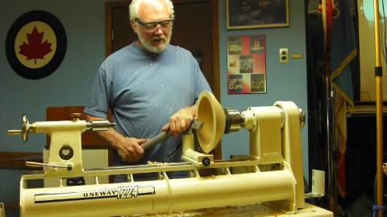
Now it is time for the interior to be hollowed. Ensure a god tight grip on the tenon.
Check for alignment

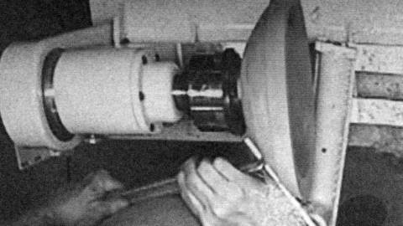
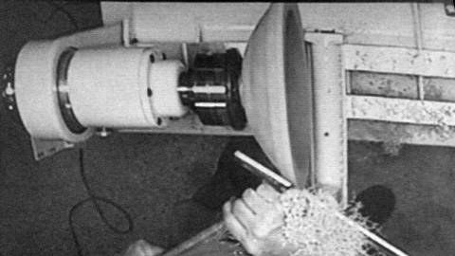
There was slight movement of the wood during and a few minutes cleaning up and re-truing of the outside was necessary before going too far on the interior.

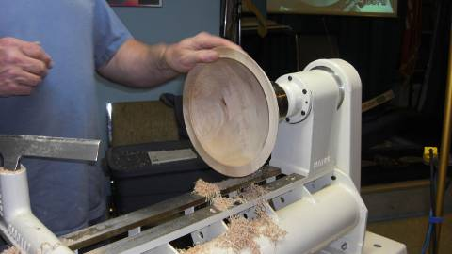
While there is still lots of wood the rim is established and taken to its final shape. This is done at this stage while the mass of the interior is in place, once removed the wood has a tendency to move slightly due to release of internal tensions.

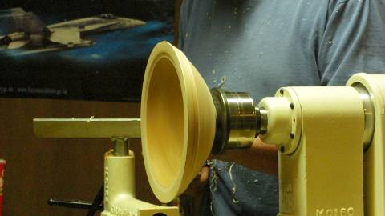
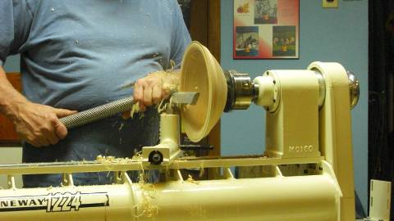
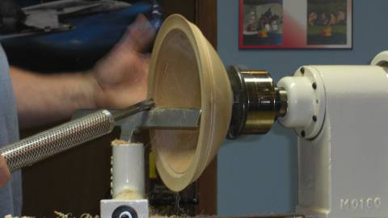
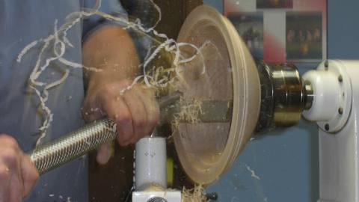
Prior to hollowing the interior many prefer to use a large diameter bit and drill a hole as a depth indicator. This also simplifies working to the center for the novice. Removal of the wood is facilitated by the use of a bowl gouge with the proper angle and cutting shape. A form such as this requires a tool with a sharp angle and a moderate sweep grind.

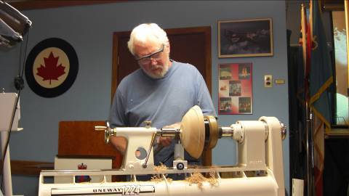
Now to clean up the tenon and form a foot for the bowl to stand on.
The bowl is reversed using a vacuum chuck as a friction holding device at the headstock and centering the bowl using the tail stock (with the center pin removed). Adjustment is carried out to ensure that bowl is well centered. A spherical wooden chuck and a piece of rubber padding would also serve as a friction holding device.

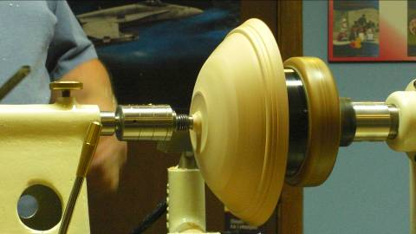
The tenon is removed in stages leaving a “mini” tenon while shaping a foot. Once the foot is established Doug makes it concave and cuts several decorative rings. The remaining “mini” tenon is carefully cut to a minimal diameter, removed and the final cut is made with a gouge. If careful, this step can be done on the lathe, but is not recommended for the faint of heart.
There was a minor lack of concentricity from the mount which was refined with shear scraping before removal. Sanding would normally take care of this minor irregularity. Perhaps we will see this bowl complete with finish at the next meeting.
Training courses and Turning 102 (2nd edition)
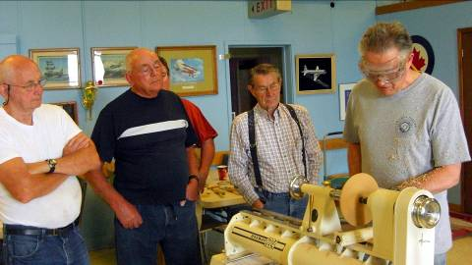
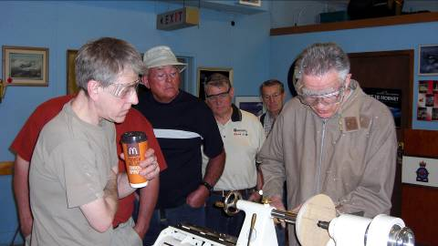
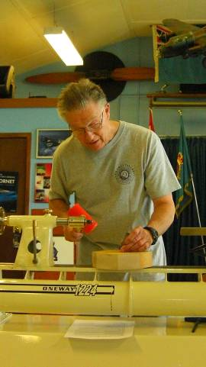
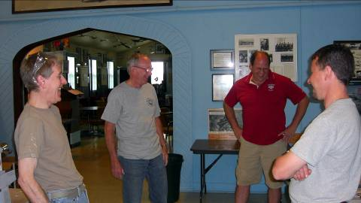
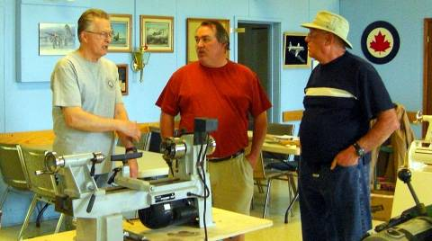

Sunday May 24th we held the 2nd turning 102 session on bowl turning.
Everything went well and some new skills were added, some old ones corrected and a good time was had by all. This popular beginners program covered fundamentals of bowls and was sold out; another will be scheduled in the fall/winter.
Turning 103 program will be a basic turned box, and a second course has not been scheduled yet. The outline from the 1st Turning 103, box making will be covered in a tutorial that will be added to our website.
Turning 104 advanced box turning is planned for the fall.
Please let Scott know of your interest and fill in the “sign-up” sheet.
A somewhat more advanced series of sessions is under development, as above, more info as it becomes available. Input is solicited for topics, content, and presenters for these sessions. The purpose of this series is the sharing of advanced techniques by advanced turners to experienced turners. There will be a chance for the developing turner to learn skills through “hands-on”.
Topics we are considering are: piercing, colouring, pyrography, chattering, rotary tools (texturing), air-brushing. Participants will be required to bring in turned items for the hands-on made of soft maple.
Visiting turners
For the interest of members we are listing future seminars and visiting turners in the surrounding area as we learn of them:
These are the demonstrators that WGO, GHWG and TVWG and other guilds or clubs have scheduled or are in the process of arranging. The guilds/clubs have said (or implied) that members of other clubs are welcome to attend:

Guest turner | Date | Sponsor | Fee | Contact | Comments
David Hout - metal spinning (on wood lathe) | Nov 15 | WGO Burlington | $ tba | Gary Miller | A possible workshop or may be able to arrange for him to come to TVWG
Al Stirt | Oct 3 | London | $tba | Gary Miller | Confirmed for the Saturday
Curt Theobald | April 2010 |  | $tba | Gary Miller | Segmented wizard
Bonnie Klein | May 2010 | TVWTG  London |  | Gary Miller | Date to be finalized, if interested, sign up early, space is limited
  $tba
If anyone would like to attend any of the above please let Gary Miller know. He will ensure that there is space and will confirm the fees. Carpooling can be arranged if there are sufficient numbers.
We hope to announce some great turning sessions for the fall, watch for the next newsletter in August.
June Meeting
Chainsaw Presentation by Fred Roger

Project - Go and harvest some wood.
Go and preview the site, garages, fences, sheds, power lines, CATV lines, telephone lines, damage to other trees, get it hung up in another tree.
Answer the first question – Husqvarn or Stihl – not so much plastic
Electric vs Gas
Get ready to go – see the guy yanking for 50 pulls to get the saw started – learn the starting pattern for your saw – switch on, choke on, two pulls, choke off, pull and it starts. Don’t waste your energy jerking on the saw. Owner’s manuals usually have the starting sequence. New saws have decompression button.
Take a lunch & lots of liquids
Clothes to wear
gloves, long sleeves
hat
Kevlar chaps of pants
Chain saws
Review section on operating and maintenance
2 saws – if one is pinched, rescue with the other
Fuel – oil – 91 0ctane
Extra chain
Broken Chain
Sharpening
Grinder
20 degrees vs 30
Battery Dremel and Inventory of cutters
Files and angle jig
Before you start the saw
Bar and chain removal
Clean the bar groove
Inspect the hammer edges – explain
File or grind the bar
Sprocket vs. round nose relates to cheaper vs. less drag
Grease the sprocket
Grease/oil the bar
Clean the motor
Clean the air filter – otherwise it’s like leaving the choke on
Replace the bar and chain
Grease or oil on the bar
Properly engage the adjuster – make sure it is where it is supposed to be – back off nuts – tighten chain
Thumb tight on wrench
Tightness of the chain, you should be able to lift top of chain about ¼”
Tool Box
Two fuel filters – sawdust – don’t want to dump the gas – run it through
Spark Plug
Adjustor
Brush to clean around the gas tank
Specialized screwdriver
Extra wrenches
Putty knife
Hand soap, bottle water, paper towels, toilette paper, garbage bag, five gallon pail
Tree /Log cutting and clean up
Bags and stand
Rakes, shovel, broom
Cart and ramp
Trailer – trailer tires – 6 ply
Tie down binders, rope
Bottle jacks, car jacks
Two Chain Saws
Mill, treat and preserve the wood on site (less to take home and dispose of.
Once you are ready to start cutting, think about the size of the blanks that you need and that will fit on your lathe
Cut the pith out of the log rounds
Cut the round so that nose of bar is sticking out
Cutting a crotch for feather figure
Cut Blanks on site –
Tarp, rake, lawn bags to clean up your work site
Load blanks for transport
-ramp
- hand cart
- trailer
- binders
A word of caution: You cannot let the chain saw touch the soil.

A couple of tips from Binh Pho’s seminar
How to clean the wood fibre burs after piercing? I use the product made by 3M Radial Bristle Discs ¾” highlighted on page 10 of the Sanding Glove products catalog (see internet).
What finish do I use after finish my piece? As we know, water based paint will raise the wood grain, so the surface will feel little rough when you touch it. I spray 2 light coats of clear lacquer then use 3M Finishing Film Disc 1000 and 1200 grit (page 13 ) lightly buff the finish with the grain of the wood, it may leave a white powder on the surface….no problem, wipe it off with paper towel or blow off with compress air. If it did not clear all the white dust, spray one more coat of lacquer….this should do it.
During his presentation he listed his 7 steps for personal growth as a turner which he calls his “

SEVEN LEVELS OF CHANGE & GROWTH
LEVEL ONE
KNOWING “right” from “wrong”
Requires: Being taught, Forgiveness
LEVEL TWO
DOING what’s “right”
Requires: Willpower, Patience, Compliance
LEVEL THREE
DOING the “right” thing “better”
Requires: Practice, Repetition, Commitment
LEVEL FOUR
ELIMINATING distractions from doing “right” more efficiently
Requires: Focus, Discipline
LEVEL FIVE
COPYING how the best do “right”
Requires: Insight, Seeing the Invisible
LEVEL SIX
BEING/DOING “different”
Requires: Experimentation, Vision, Learning from Experience
LEVEL SEVEN
DOING the “impossible”
Requires Faith, Risk of Life, Wanting to be First”
A full review of Binh’s seminar will be in our next newsletter, watch for it!
A Summer Challenge (for competition at September’s opening meeting)
A plant stand. Must contain faceplate and spindle turned components. No limitations as to size or material.
The June challenge: A turned YoYo. Two classes: an all wood YoYo or a mixed media YoYo.
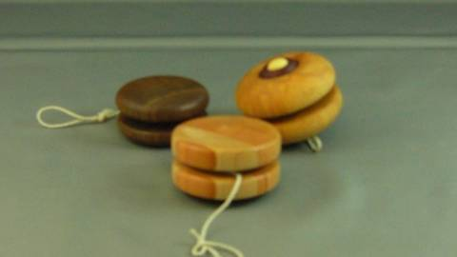
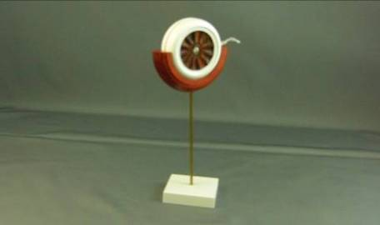
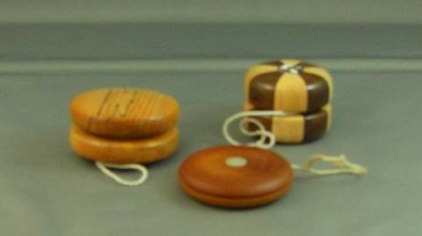
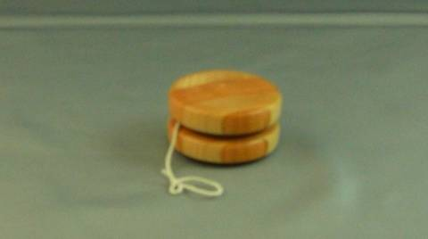

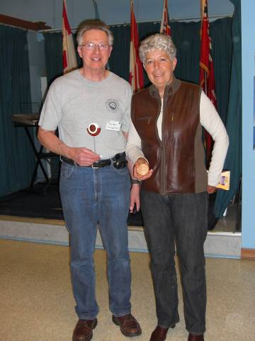
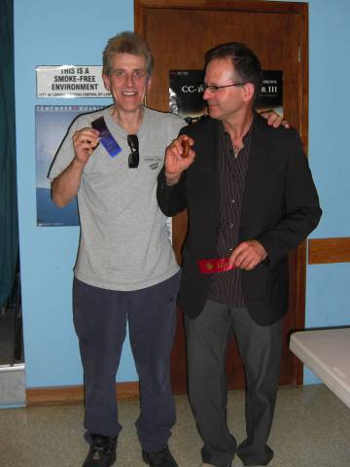
And the winners were:

John Bowden & Nick Braunsch Gary Miller & Jackie Morningstar
An ongoing call for volunteers
Your guild is growing; we recently passed the 90 member mark and hope to exceed 100 after summer’s break. Our members’ skill-sets are growing too. Sadly though not so our with our mentor list, it has been stagnant for several years; we could use some new mentors, volunteers who would like to share their skills with other members.
The same call for volunteers is being made for demonstrators. If you have a specialty or a particular turning skill, will you consider sharing it with the guild members? Please see any of the executive to offer your skills by way of a demo. As a point of interest, mentors and demonstrators must be members of the AAW too for insurance purposes. It is guild policy that the AAW fee will be paid by the guild for those who are now AAW members and are accepted as mentors and demonstrators – a perk!
Please use the internet and our site as a resource.
Our website has our recent newsletters, a list of Preferred Suppliers, the Mentor list, and our Guild policy page plus a number of interesting links. We will keep the web site as our most current communication device (if you do not have internet access please let me know and printed copy of any of the above can be made available to you Ed).
Our web site is http://ca.geocities.com/tvwt1@rogers.com/
Al Stirt Seminar
Al Stirt Seminar confirmed for October 3, details as they unfold.
Newsletter photos
From time to time I have been asked if photos from the newsletter can be made available to members, particularly photos of their turnings. Short answer is “Yes”. I have all the photos from all the newsletters on my computer in digital form, anyone is welcome to a digital copy so long as you can tell me which issue, which page, and which item the photo you want appears.
We have also been asked if we have back copies of the newsletter too, yes, again in digital form.
A possibility exists to make CDs of the photos and newsletters if there is enough interest. The cost would likely be in the $10 range. If interested let me know.
A gallery of turnings on our website would be an interesting feature, but to do so we need the names to attach to a turning. Anyone who is interested in having their work included can start by helping us ID their past work in the newsletters.
Show & Tell from June
(and some mighty fine work it is!)
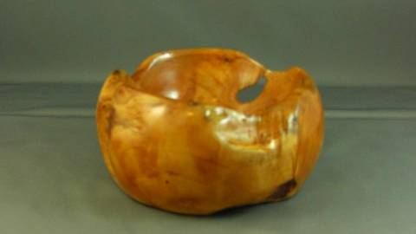

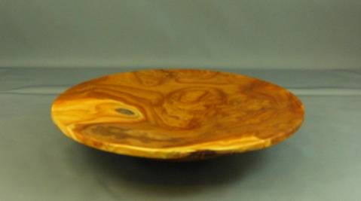
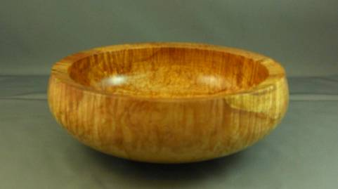

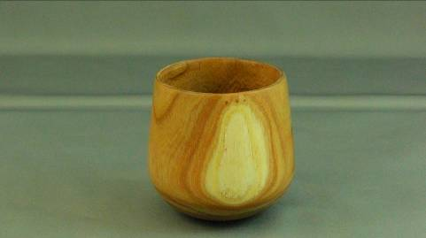

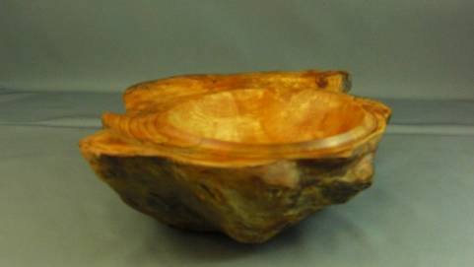
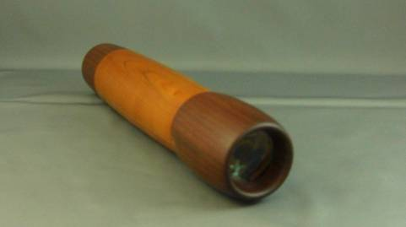
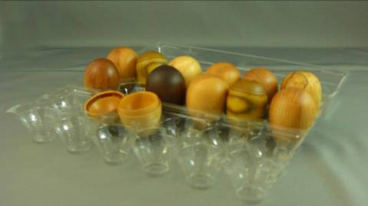
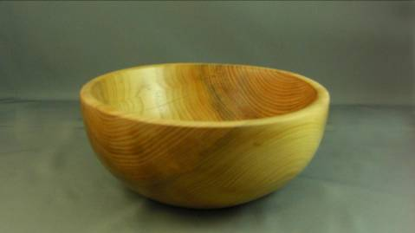
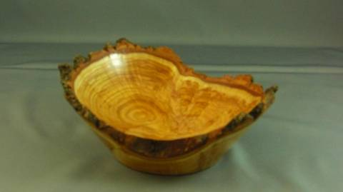
2008-2009 dates for meetings and other scheduled events.
We are looking at several guest turners that may necessitate schedule changes. We will keep the members informed of changes.

Date | Meeting or events | Shows/events/comments
September 4 | Fall season begins | A demo by Bob Fenn of a square turning  Natural edge bowl challenge
October 2 | Monthly meeting | Demo of the rose engines that are being developed by John Calver and Gary Miller. Two different approaches
October 24 -26 | Inter-club competition. Black Creek Pioneer Village in Weston | Inter club competition, 5 categories with 4 skill levels. Details will be reviewed at the September meeting
November 6 | Monthly meeting | Demo by Bob of a Christmas decoration using sea urchins.  Challenge of a “square turning”.  A tool sale, bring in your surplus tools
December 4 | Monthly meeting | Christmas decoration challenge, themed around a turned Christmas gift.  Bernie Hrytzak will demonstrate a variety of embellishments techniques.
January 8, 2009 | Monthly meeting | Air brushing demo by Andrew Gillet, professional air brush artist
January 11 | Turning 103 9:00 – 4:00 | Turn a basic box from soft maple. Bring your own lunch.
February 5 | Monthly meeting | Challenge: free-for-all surface embellishment on a turning.  Bernie will add pyrography as completion of his earlier embellishment techniques session.
February13 – 15 | London Wood Show and TVWTG turning competition | Any turnings from the past 12 months. Categories novice and open. Enter the category you feel comfortable with (novice less than 3 ribbons, open 3 or more 1st place ribbons). A person may place his/her item in a higher category than normal, his/her choice.
March 5 | Monthly meeting | Vacuum chucking how to build a system and how/where to use it.  Will anyone like to volunteer to lead this session?
April 2 | Monthly meeting | A green and thin turning by Doug Magrath.  Challenge: Pyrography embellishment of a turning
April 19 | Turning 101 | Sign-up with Scott
May7 | Monthly meeting | A green and rough turned product and discussion of drying techniques by Gary Miller and Doug Magrath.
May 24 | Turning 102 | Sign-up with Scott – SIGNUP SHEET IS FULL
June 4 | Monthly meeting | Demo and safety aspects of chain sawing by Fred, Patrick & John. No rentals on this night
June 6 (a Saturday) | Guest turner demo  9:00am – 5:00pm | Bhin Pho demo, fee is $40 which will include lunch. Look at his website (under the internet site section). Sign-up now to be sure of a seat.
June 26 – 28 | AAW Symposium | AAW symposium, which will be in Albuquerque, New Mexico.
July/August | Summer break | Summer break.
September | Return from summer hiatus | Segmented turning by Jack Wallace of the WGO. How to info!  Challenge: Plant Stand – faceplate and spindle turning.
 | Topics in the discussion stages, not yet formalized as to date or content.  Program Ideas and suggestions for guest turners are always welcomed by your committee | -Segmented turning open and closed (“how-to” specifics) will be covered in several sessions.  -Hand thread-chasing.  -Guest turners or seminars.  -Design? What makes a makes a “good” turning into an “outstand- ing” turning?  -Metal spinning  -A safety night (discussion/panel)  -A “show and sell” table of turnings”, a “show and trade” table for your turnings.  -Future challenge ideas: a pair of “something”,  -A seed pod turning.  -Shear scraping | -Make a home drying cabinet  -Turning tips learned from experience (to be presented at meeting and published in the newsletters and our website).  -Eccentric spindle turning  -Bracelet turning  -A ring turning  -Inlace  -Bird houses  -Finishing the “foot”  -Basic drying of wet wood  -Wine stoppers  -Eccentric turning  -Sharing of advanced techniques turning 201  -Finishing
Note, meetings start at 7:30, doors open at 7:00. Raffle tickets, the library, and the Round table critique will be available between 7:00 and 7:30.
Items both wanted and for sale
Ads are free for members and run until you sell your item or withdraw your advert. Members can support other members by buying: good deals and good prices!
Please note. The Guild provides a means of connecting buyer and sellers through these ads. It is up to the buyer to ensure the item offered is as stated and the two parties should agree between them as to warranty or guarantee for the item.
To run a new ad in our newsletter or to remove a sold item, call Bob at 519-457-6555 or email him at 66.bobhewson@rogers.com .
We welcome small business card type advertisements at a rate of $30 per year. We print 6-7 issues per year on a non-date-specific schedule. We also upload our newsletters to the internet at http://members.rogers.com/tvwt1/ for viewing in glorious colour.
For sale: I make and sell cutters for the Stewart system and or boring bars. They are made of hi-speed steel. Available in three sizes, prices are $15, $20, & $25.
Call Mario Moran at 519-336-0550, or see him at the Guild meeting or mario.ada@sympatico.ca
For Sale CA Glue for Wood Turners
EM-02 VERY THIN, INSTANT CURE, Able to penetrate between parts, very thin viscosity, allows up to .002” gap fill capability
EM-40 MED-THIN, FAST CURE, General purpose, thin viscosity, allows up to .004” gap fill capability
EM-150 MEDIUM, MEDIUM CURE, Broad use adhesive, medium-thick viscosity, allows up to .006” gap fill capability
EM-600 MEDIUM THICK, MEDIUM CURE, Heavy duty adhesive, medium thick viscosity, allows up to .008” gap fill capability
EM-2000 THICK FILLER, SLOW CURE, Allows maximum time for positioning fixtures. Use to bond fibrous and porous materials. Flowable thick viscosity, allows up to .010” - .020” gap fill capability. Excellent for filling large open cracks, gaps and holes. General manufacturing and repairing tough and uneven materials.
All are available in 2 ¼ oz. bottles bottle which includes 5 detachable long nozzles and an extra top with spout and cap.*
Price: $15.00 (taxes included)
(EM2000 does not include the 5 detachable long nozzles because it is too thick for the nozzles)
Additional long nozzles are priced at 5/$0.25.
ACTIVATOR Instantly cures adhesives. Contains no CFC’s. Mist Pump Sprayer
Price: $10.00 (taxes included) 2 oz. bottle
DE-BONDER Required to un-glue items (example: fingers accidentally glued together)
Price: $10.00 (taxes included) 2oz. bottle
Call: Fred Rodger 519-858-2558 or email at frederick.rodger@sympatico.ca (Fred will bring it to the meeting for you)

This is the most superior CA Glue on the market. Manufactured by the
company that invented CA Glue over 30 years ago

This is the most superior CA Glue on the market Manufactured by the company that invented CA Glue over 30 years ago



For sale
Delta Shaper, stand, reversible, motor c/w 30+ cutters
$450
Call: Bob Fenn, 519-455-7436

For Sale
Jet Mini-lathe (Model JML-1014)
Excellent condition
Tail and headstocks raised 2”
$300
Call Pete at 519-661-7525
Wanted
A larger lathe

Custom work:
I Have a vertical mill & metal lathe to make different turning tools (cutters, sharpening jigs, supports etc. You name it, Similar to the Hunter Tool for hollowing in two different sizes ¼” & 3/8" round, also a square end cuter (all carbide cutters ).
-If you want a curve put in rod it can be done too. You will have to make a drawing if you want a bend put in the rod. Price: $50 straight, $70 bent or curved.
-Aluminum handles to accept the tool is also available (you choose the size).
-See my sharpening jigs at the next guild meeting or call.
-New Custom vacc chuck $95
-Any custom work, please see me.
Call: Al Johnston at 519-679-8718
592 Mapledale Ave. London

Fletchs Fetchings

Supplying unique wood from Africa and Asia.

Turning blanks available for pens, pool cues, bottle stoppers, duck calls, bowls, etc.

Reasonable pricing.
Call Jim Fletcher at 519-633-0538.
Or visit my website www.fletchs-fetchings.com
I also sell on eBay under seller id fletchs_fetchings

Wanted
Parts for old lathes
Call: Murray Tyler at 519-225-2854 after 5 PM
For sale:

Lee Valley Mitre Vise - 2 available unused.
Price - $50.00 for pair.
Call: Alf Buckle at 1-519-271-8489 or email at abuckle@sympatico.ca

**************************************************************************************************************************
Lathe for sale

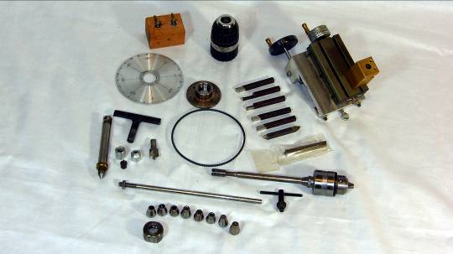
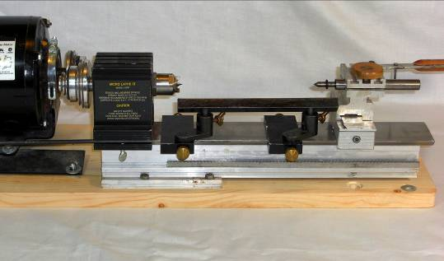
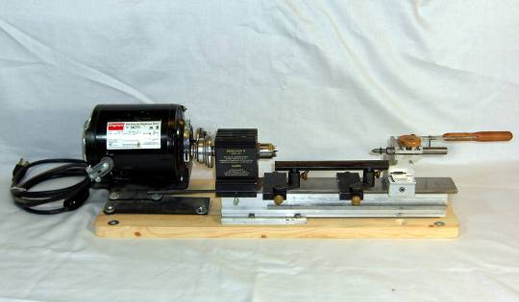
Taig Miniature lathe Cost
Taig Miniature *lathe 285.00
Motor is a ¼ HP Dayton 99.00
Motor mount 10.00
Lathe mounting board 8.25
Extra drive belt incl
Woodworking and Metal working accessories as follows:
Woodturning:
*Faceplate incl
*7/16” cup and spur center incl
*2 1/2” rest and swivel base incl
7” double rest and swivel base 42.50
¼” cup and ½” spur center 19.50
Dead center for using Jacobs chuck in tailstock ??
Centers for use with dead center
Live center 17.40
9 piece collet set 32.00
3/8” Jacobs chuck 39.80
Chuck arbour 12.40
Pen turning mandrel shaft (used with collet) 7.50
Metal-turning:
Carriage and cross slide 89.00
6 piece HSS tool bit set 30.50
Book “The Taig Lathe” 32.50
Total value new $699.35
+ taxes of $91.12 = $790.46**
Items marked with an * come with the woodworking version listing for $285. All other items have been purchased as add-on items.
The Taig lathe is a beauty for pen turning and for smaller wood turnings up to 4 ¼” diameter. Risers are available to increase swing by a further inch should it be required. Length of turnings is limited to 9 ¾”. Speed range is 525 – 5200 rpm, change by a fast and simple belt movement. Headstock has a ¾ x 16 thread. I have added a home built dividing wheel and stop (the wood item on top of the head stock).
The above items equip it for woodturning and basic-metal work. A full set of metal working accessories is available on-line or from Lee Valley Tools. To see its metal capabilities check out the Taig web site forums on Yahoo.
Photos from top: 1) Taig set up for woodturning with long tool rest
2) Closer view of lathe
3) Accessories left to right top: dividing wheel, chuck the fits dead center, carriage, cross slide and tool post, face plate, HSS cutters, dead centre and cups, small woodwork tool rest, spare belt, 3/8” Jacobs chuck and draw bar for use in head stock,
Pen turning mandrel (A), collet set.
I am selling this lathe because I have purchased a larger woodturning lathe and have no further need of the Taig.

Price for ALL OF ABOVE $425
Contact: Bob Hewson, 519-457-6555 or email at 66.bobhewson@rogers.com

*******************************************************************************************************

