Fee.



Thames Valley Woodturner
A publication of the Thames Valley Woodturners Guild
A chapter of the AAW

Volume 11.2 March/April 2009

Turning events, Wood shows, and competitions in our region and farther afield

June 6, Binh Pho, brought to you by the TVWTG, London, Ont. See Gary or Bob for tickets or reservations.
June 26 – 28, AAW symposium, which will be in Albuquerque, New Mexico
September in Toronto. Ontario Craft Council will be presenting a one man show, their first, with the turnings of Doug Magrath
October 3, Al Stirt, brought to you by the TVWTG, London, Ont. Details and costs as they develop.

Contents
Additions to library P1
Internet sites of interest P1
New members P1
Treasury P1
Tips for turners P1
Turning 101 P2
Visiting turners P2
March meeting P3
April meeting P4
Training courses P5
June challenge P5
Summer challenge P5
Pyrography challenge P6
Newsletter photos P6
Show & tell – April P7
“Show and tell” February P6
Calendar P8
For sale & wanted P9 & 10

For a Guild info/policy sheet, call or email
Bob Hewson 66.bobhewson@rogers.com or refer to our web site at: ca.geocities.com/tvwt1@rogers.com/

Additions to the library
New books: None
DVDs: 2008 AAW symposium DVDs remain on order
A reminder: Please return your DVDs or videos as soon as you have viewed them so other may rent them as well.
Interesting new or updated Internet sites of interest to members
When checking out newsgroups there are three main areas to browse, the messages, the photo albums and the files. Messages are the day to day member messages and threads which can also be searched from either the home page or the search box at the top of the message screen. The photo albums are like our monthly “Show & Tell” where members can post picture of their work. Files are usually “how to” files on a topic, project or technique prepared by group participants.
Google, Yahoo and MSN host newsgroups that cover virtually any topic you can imagine
- For info on Segmented woodturning and a symposium held last year and the plan for a AAW segmented chapter. See also the special section on Lincoln Seitzman http://www.segmentedwoodturners.org/index.php
- New site for Ottawa Valley Woodturners http://valleywoodturners.userworld.com
- For those of you who are interested in pens check out this pen gallery site. It will set some higher targets for you http://www.pengallery.com/
- For info and graphics of woods both domestic and exotic http://www.gilmerwood.com/index.html

New Members
Please welcome our newest members: Bill Gough, Kevin McCormack, Paul Napier, Peter Torok, John Bowden, and Otto Finkenzeller,
If you see anyone wearing a visitor tag please make them welcome.
Treasury and Dues
We have $4410 is available in the treasury with rent and guest turner seminar costs and Turning 101/102 expenses pending.
Tips for turners
There were no specific tips presented during the last two meeting.
If you have a tip you would like to share with everyone, please see Scott before the meeting so he can schedule you in.
Turning 101 (2nd edition)
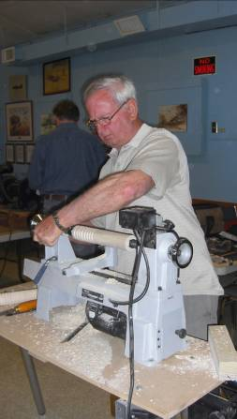
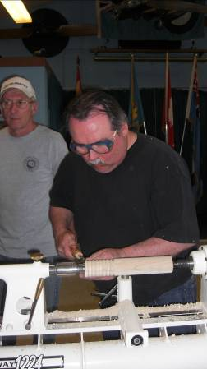
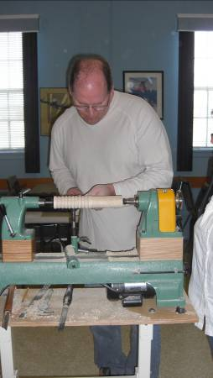
Sunday April 20th we held the 2nd turning 101 session on spindle turning and had 8 participants. Everything went well and some new skills were learned, some old ones unlearned and a good time was had by all.
A special thanks to the mentors and to the students.
Note the concentration by the students in the photos, truly, a beauty to behold!
(Sorry Pat, missed your photo.)

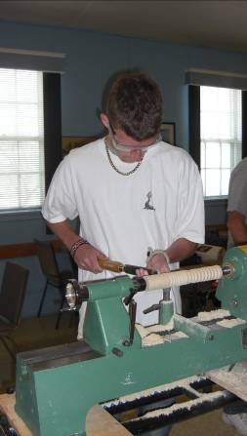
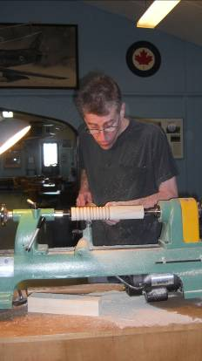
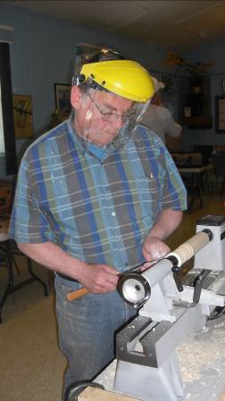

Visiting turners
For the interest of members we are listing future seminars and visiting turners in the surrounding area as we learn of them:
These are the demonstrators that WGO, GHWG and TVWG and other guilds or clubs have scheduled or are in the process of arranging. The guilds/clubs have said (or implied) that members of other clubs are welcome to attend:

Guest turner | Date | Sponsor | Fee | Contact | Comments
David Hout - metal spinning (on wood lathe) | Nov 15 | WGO Burlington | $ tba | Gary Miller | A possible workshop or may be able to arrange for him to come to TVWG
Binh Pho | June 6 | TVWTG London | $40 est. at this time | Gary Miller | Be sure to sign up, space is limited. Tickets are available at Dec meeting until sold-out, see Bob or Gary
Al Stirt | Oct 3 | London | $tba | Gary Miller | Confirmed for the Saturday
Curt Theobald | TBA |  | $tba | Gary Miller
Bonnie Klein | May 2010 | TVWTG  London |  | Gary Miller | Date to be finalized, if interested, sign up early, space is limited
  $tba
If anyone would like to attend any of the above please let Gary Miller know. He will ensure that there is space and will confirm the fees. Carpooling can be arranged if there are sufficient numbers.
As we know more we'll keep the membership apprised and will keep this as an ongoing feature in the newsletter.
March meeting
The topic of this meeting was vacuum chucking presented by Gary miller who showed us his home built system and described the bits and pieces as well as an idea of costs.
A real plus and safety factor he demonstrated was the use of an air storage to act as a vacuum reservoir in case of a power failure or some other cause of loss of vacuum. This safety addition will give you a few seconds before the vacuum fails and your piece goes sail out into your shop.
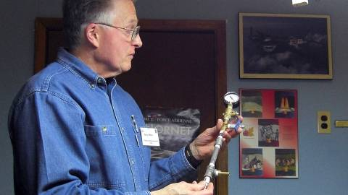
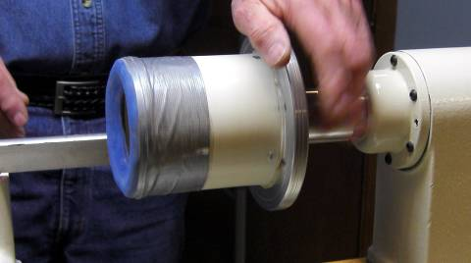
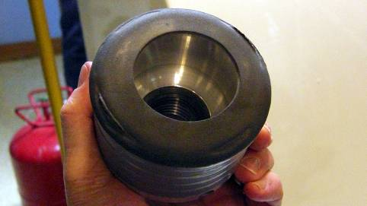
In addition to the “how to” aspects of vacuum chucking Gary also demonstrated how to use it to turn a shallow bowl

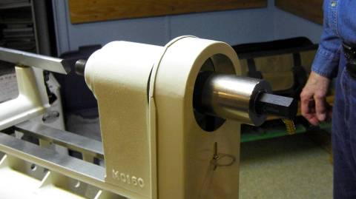
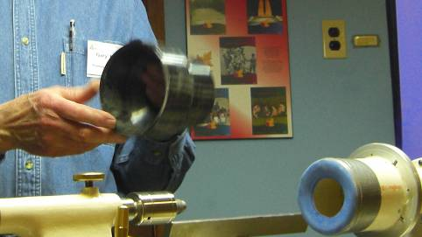
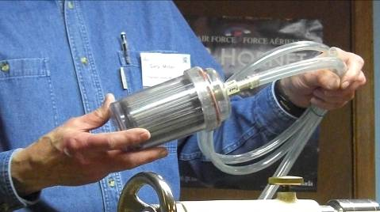
The plumbing tree Home built Vacuum chuck Chuck in place – note the faceplate base

Dust collector ports can be used too The rotating vacuum adapter An moisture/oil trap
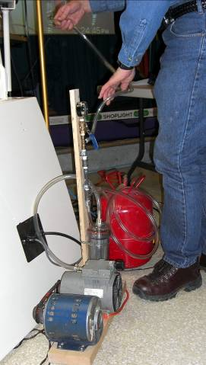
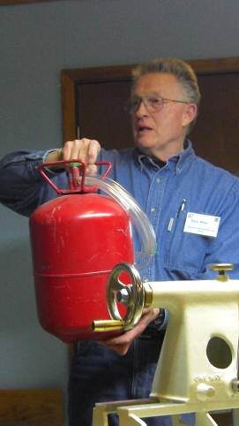
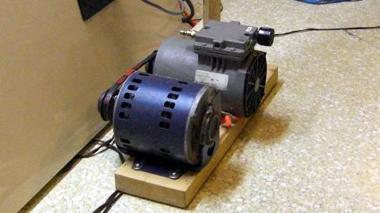

Vacuum pump and motor

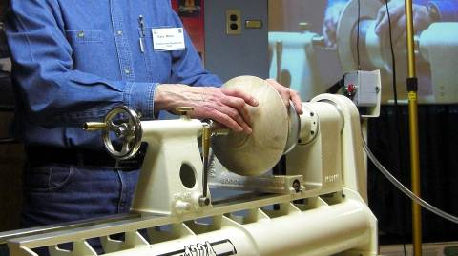
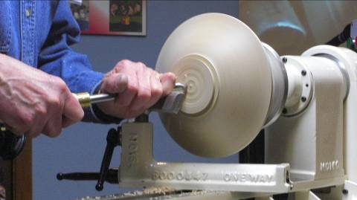
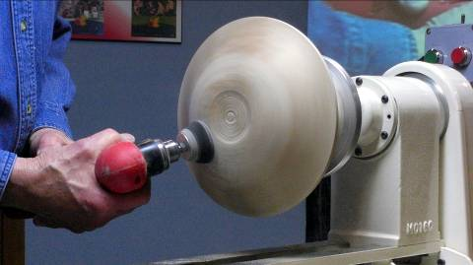
Air tank vacuum back-up Ready to go

Bowl in position using tailstock for locating Turning foot and refining curves Sanding with 90 degree drill

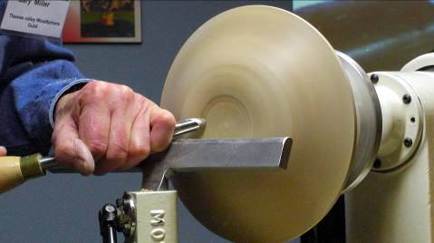
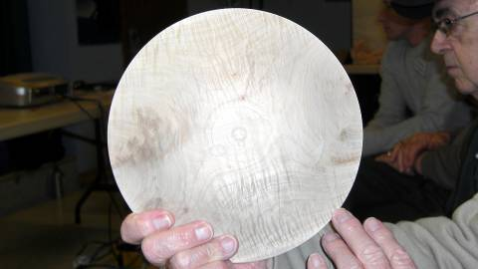

Final work on the foot The completed bowl, ready for finish

Our thanks to Gary for a clear explanation of the materials required to build a vacuum system as well as a demo of both the gripping power of the vacuum system as well as its versatility.
April meeting
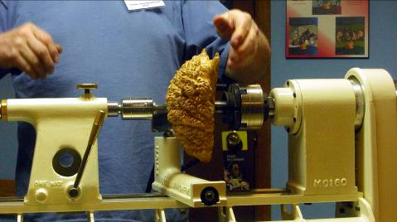
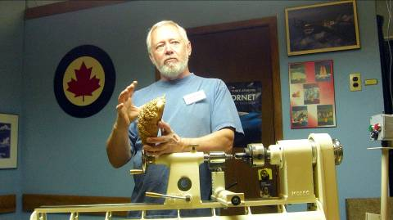
Doug Magrath demonstrated the turning of a shallow bowl using a piece of Malee burl. Rather than turn a conventional natural edge bowl he turned this on as a “natural rim” bowl by careful orientation of the burl to obtain the desires rim from the burl.
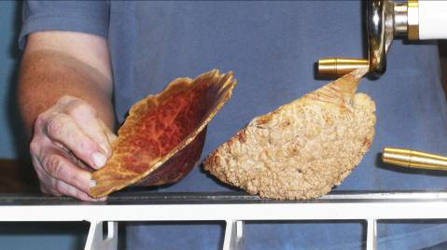
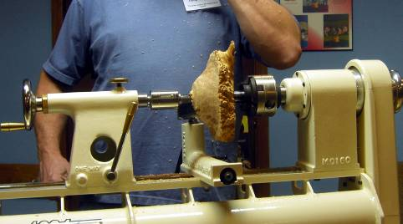
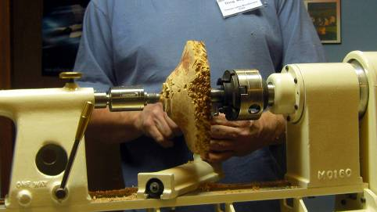
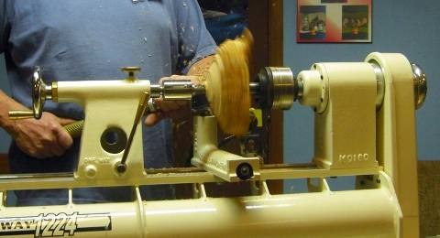
Doug discusses his design concept A similar type bowl showing orientation Burl is located to maximize rim

Removal of the exterior care must be The shape is slowly worked Shape is OK, now time for the inside
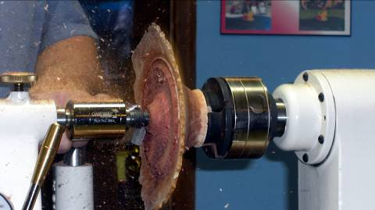
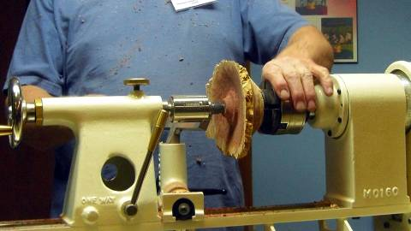
taken to not contact the irregular rim
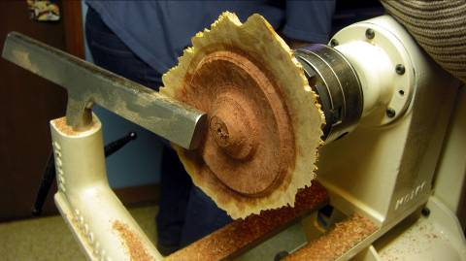
The rim is worked carefully while maintain- Continuing the hollowing and rim Slow and easy cuts are the order
ing a solid mass of “core” to aid stability shaping

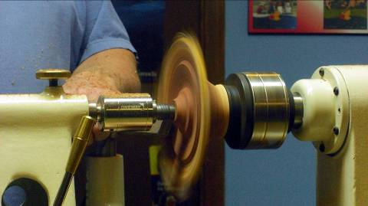
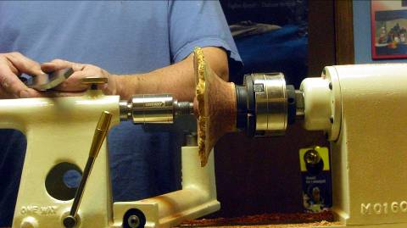

Discussing the finer points of sheer
scraping
It is worth noting too that the burl was considered “Wet” and so will experience some warping and twisting, but the burl is inherently more stable than regular wet wood due to its irregular grain.
Our thanks for an excellent demo and explanation of both technique and the design philosophy behind this project go to Doug.

A draw was held for the turning by Jack DeVos during his demonstration last year. Tickets were $5 each, 4 for $10. The draw raised $485 and the turning was won by Al Johnson.
Training courses
Turning 101 – This popular beginning program covering spindle turning and basic safety will be repeated. Our spring session was held April 19th*. The next session of turning 101 will likely take place in the fall.
Turning 102 planned for May 24th*. This popular beginners program will cover fundamentals of bowls is sold out; another will be scheduled in the fall/winter.
Turning 104 advanced box turning is planned for the fall.
*Neither date falls on the Easter or Victoria holidays

Turning 103 program will be a basic turned box, and a second course has not been scheduled yet. The outline for the 1st Turning 103, box making is covered in a separate tutorial that will be added to our website.
Please let Scott know of your interest and fill in the “sign-up” sheet.
A somewhat more advanced series of sessions is under development, as above, more info as it becomes available. Input is solicited for topics, content, and presenters for these sessions. The purpose of this series is the sharing of advanced techniques by advanced turners to experienced turners. There will be a chance for the developing turner to learn skills through “hands-on”.
Topics we are considering are: piercing, colouring, pyrography, chattering, rotary tools (texturing), air-brushing. Participants will be required to bring in turned items for the hands-on made of soft maple.
A June challenge
A turned YoYo. Two classes: an all wood YoYo or a mixed media YoYo. Judging will be based on performance of the YoYos. (There are numerous sites on the web for tips on “special” YoYos.)
A Summer Challenge (for competition at September’s opening meeting)
A plant stand. Must contain faceplate and spindle turned components. No limitations as to size or material.

Call for volunteers
Your guild is growing; we recently passed the 90 member mark and hope to exceed 100 after the London Wood Show. Our members’ skill-sets are growing too. Not so our mentor list, it has been stagnant for several years; we could use some new mentors, volunteers who would like to share their skills with other members.
The same call for volunteers is being made for demonstrators. If you have a specialty or a particular turning skill, will you consider sharing it with the guild members? Please see any of the executive to offer your skills by way of a demo.
Please use the internet and our site as a resource.
Our website has our recent newsletters, a list of Preferred Suppliers, the Mentor list, and our Guild policy page plus a number of interesting links. We will keep the web site as our most current communication device (if you do not have internet access please let me know and printed copy of any of the above can be made available to you Ed).
Our web site is http://ca.geocities.com/tvwt1@rogers.com/
Al Stirt Seminar
Al Stirt Seminar confirmed for October 3, details as they unfold.
Newsletter photos
From time to time I have been asked if photos from the newsletter can be made available to members, particularly photos of their turnings. Short answer is “Yes”. I have all the photos from all the newsletters on my computer in digital form, anyone is welcome to a digital copy so long as you can tell me which issue, which page, and which item the photo you want appears.
We have also been asked if we have back copies of the newsletter too, yes, again in digital form.
A possibility exists to make CDs of the photos and newsletters if there is enough interest. The cost would likely be in the $10 range. If interested let me know.
A gallery of turnings on our website would be an interesting feature, but to do so we need the names to attach to a turning. Anyone who is interested in having their work included can start by helping us ID their past work in the newsletters.

“Show and Tell” from March’s meeting
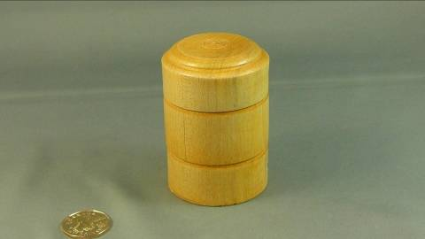

A box from the box turning seminar (turning 103)

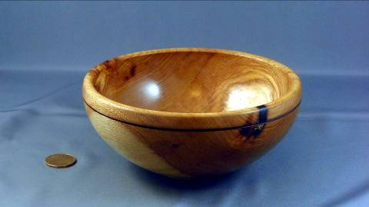
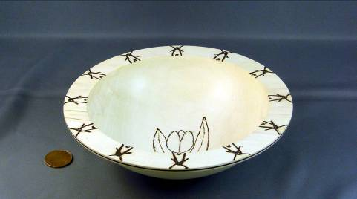
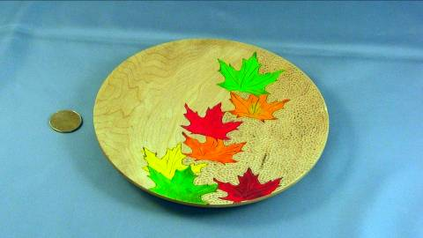
^{April’s Pyrography challenge}

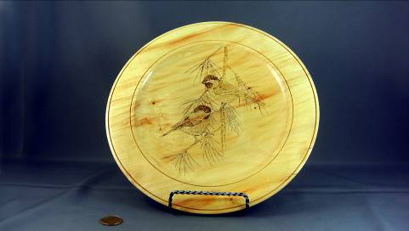
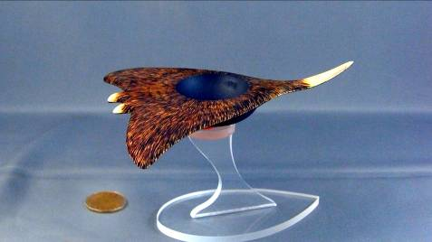

“Show and Tell” from April’s meeting
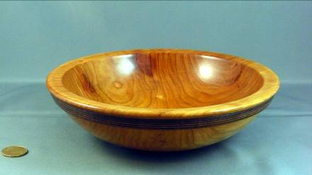
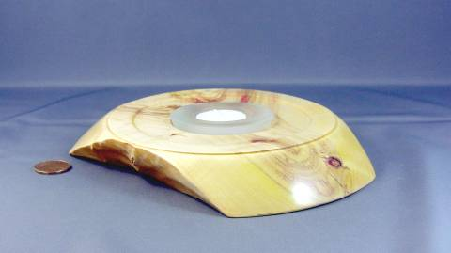
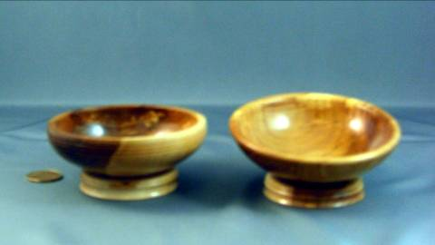
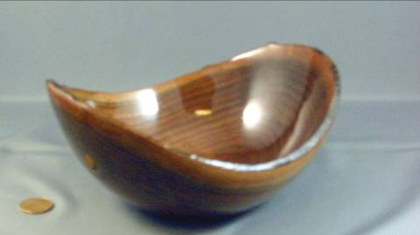
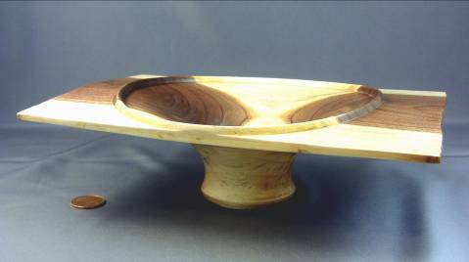
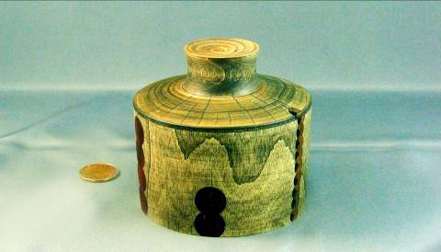
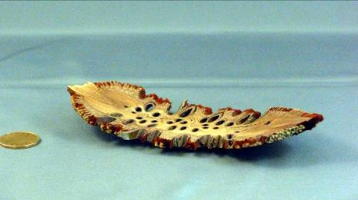
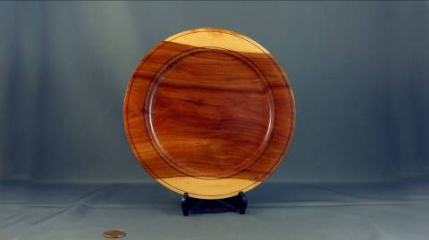
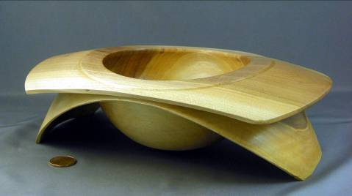
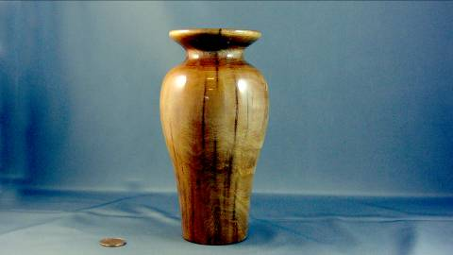

2008-2009 season’s dates for meetings and other scheduled events.
We are looking at several guest turners that may necessitate schedule changes. We will keep the members informed of changes.

Date | Meeting or events | Shows/events/comments
September 4 | Fall season begins | A demo by Bob Fenn of a square turning  Natural edge bowl challenge
October 2 | Monthly meeting | Demo of the rose engines that are being developed by John Calver and Gary Miller. Two different approaches
October 24 -26 | Inter-club competition. Black Creek Pioneer Village in Weston | Inter club competition, 5 categories with 4 skill levels. Details will be reviewed at the September meeting
November 6 | Monthly meeting | Demo by Bob of a Christmas decoration using sea urchins.  Challenge of a “square turning”.  A tool sale, bring in your surplus tools
December 4 | Monthly meeting | Christmas decoration challenge, themed around a turned Christmas gift.  Bernie Hrytzak will demonstrate a variety of embellishments techniques.
January 8, 2009 | Monthly meeting | Air brushing demo by Andrew Gillet, professional air brush artist
January 11 | Turning 103 9:00 – 4:00 | Turn a basic box from soft maple. Bring your own lunch.
February 5 | Monthly meeting | Challenge: free-for-all surface embellishment on a turning.  Bernie will add pyrography as completion of his earlier embellishment techniques session.
February13 – 15 | London Wood Show and TVWTG turning competition | Any turnings from the past 12 months. Categories novice and open. Enter the category you feel comfortable with (novice less than 3 ribbons, open 3 or more 1st place ribbons). A person may place his/her item in a higher category than normal, his/her choice.
March 5 | Monthly meeting | Vacuum chucking how to build a system and how/where to use it.  Will anyone like to volunteer to lead this session?
April 2 | Monthly meeting | A green and thin turning by Doug Magrath.  Challenge: Pyrography embellishment of a turning
April 19 | Turning 101 | Sign-up with Scott
May7 | Monthly meeting | A green and rough turned product and discussion of drying techniques
May 24 | Turning 102 | Sign-up with Scott – SIGNUP SHEET IS FULL
June 4 | Monthly meeting | Chain saw demo and safety aspects by Fred, Patrick & John.
June 6 (a Saturday) | Guest turner demo  9:00am – 5:00pm | Bhin Pho demo, fee is $40 which will include lunch. Look at his website (under the internet site section). Sign-up now to be sure of a seat.
June 26 – 28 | AAW Symposium | AAW symposium, which will be in Albuquerque, New Mexico.
July/August | Summer break | Summer break.
September | Return from summer hiatus | Segmented turning by Jack Wallace of the WGO. How to info!
 | Topics in the discussion stages, not yet formalized as to date or content.  Program Ideas and suggestions for guest turners are always welcomed by your committee | -Segmented turning open and closed (“how-to” specifics) will be covered in several sessions.  -Hand thread-chasing.  -Guest turners or seminars.  -Design? What makes a makes a “good” turning into an “outstand- ing” turning?  -Metal spinning  -A safety night (discussion/panel)  -A “show and sell” table of turnings”, a “show and trade” table for your turnings.  -Future challenge ideas: a pair of “something”,  -A seed pod turning.  -Shear scraping | -Make a home drying cabinet  -Turning tips learned from experience (to be presented at meeting and published in the newsletters and our website).  -Eccentric spindle turning  -Bracelet turning  -A ring turning  -Inlace  -Bird houses  -Finishing the “foot”  -Basic drying of wet wood  -Wine stoppers  -Eccentric turning  -Sharing of advanced techniques turning 201  -Finishing
Note, meetings start at 7:30, doors open at 7:00. Raffle tickets, the library, and the Round table critique will be available between 7:00 and 7:30.
Items both wanted and for sale
Ads are free for members and run until you sell your item or withdraw your advert. Members can support other members by buying: good deals and good prices!
Please note. The Guild provides a means of connecting buyer and sellers through these ads. It is up to the buyer to ensure the item offered is as stated and the two parties should agree between them as to warranty or guarantee for the item.
To run a new ad in our newsletter or to remove a sold item, call Bob at 519-457-6555 or email him at 66.bobhewson@rogers.com .
We welcome small business card type advertisements at a rate of $30 per year. We print 6-7 issues per year on a non-date-specific schedule. We also upload our newsletters to the internet at http://members.rogers.com/tvwt1/ for viewing in glorious colour.
For sale: I make and sell cutters for the Stewart system and or boring bars. They are made of hi-speed steel. Available in three sizes, prices are $15, $20, & $25.
Call Mario Moran at 519-336-0550, or see him at the Guild meeting or mario.ada@sympatico.ca
For sale:

Lee Valley Mitre Vise - 2 available unused.
Price - $50.00 for pair.
Call: Alf Buckle at 1-519-271-8489 or email at abuckle@sympatico.ca

For sale
Bandsaw – Craftex 15”
Includes fence, ¾ hp motor, plus Hi-Level accessory bearings.
Used for about 1 year, cost $488 new
Sell: $350
Call Gord Tallman at 519-455-4526

FOR SALE
4" Dust Collector accessories. All in great shape, some new. ASKING 1/2 PRICE. Would prefer to sell all together but will consider pieces. Make me an offer on the bunch.
QUANTITY TYPE SIZE $ NEW COST ea
15 S/S CLAMPS 4" .79
1 "Y" 5"X4"X4" 8.50
3 "Y" 4"X4"X4" 8.50
5 ELBOWS 4"X4" 7.99
1 T" 4"X4"X4" 8.50
1 REDUCER 5"X4" 5.99
3 BLAST GATES 4" 5.50
2 SPLICE (coupler) 4" 6.50
1 END CAP 4" (forgot)
1 JOINTER HOOD 4" 3.99
Call: Gary Miller at 519-858-2445

For sale
Imported floor model drill press, 5/8 chuck 3/4 hp
Price: Asking $150
Call Rob Williamson at 519-672-2998 or email robriw@hotmail.com



For sale
Delta Shaper, stand, reversible, motor c/w 30+ cutters
$450
Call: Bob Fenn, 519-455-7436

Wanted
Parts for old lathes
Call: Murray Tyler at 519-225-2854 after 5 PM

Fletchs Fetchings

Supplying unique wood from Africa and Asia.

Turning blanks available for pens, pool cues, bottle stoppers, duck calls, bowls, etc.

Reasonable pricing.
Call Jim Fletcher at 519-633-0538.
Or visit my website www.fletchs-fetchings.com
I also sell on eBay under seller id fletchs_fetchings

Wanted: Used lathe.

I have a young lad who is interested in learning to turn and is looking for a used lathe for $200 or less.
Call: Paul Spicer at 519-633-7901

Custom work:
-I Have a vertical mill & metal lathe to make different wood turning tools (cutters, sharpening jigs, supports etc. you name it, similar to the Hunter Tool for hollowing), two different sizes ¼ & a new 3/8" round also a square end cuter (all carbide cutters ).
-If you want a curve put in rod it can be done too. You will have to make a drawing if you want a bend put in the rod.
Price: $40 straight, $60 bent or curved.
-An aluminum handle (you choose the size) to accept the tool is also available. Any custom work, please see me.
-See my sharpening jigs at the next guild meeting or call.
Call: Al Johnston at 519-679-8718
592 Mapledale Ave. London

For Sale CA Glue for Wood Turners

EM-02 VERY THIN, INSTANT CURE, Able to penetrate between parts, very thin viscosity, allows up to .002” gap fill capability
EM-40 MED-THIN, FAST CURE, General purpose, thin viscosity, allows up to .004” gap fill capability
EM-150 MEDIUM, MEDIUM CURE, Broad use adhesive, medium-thick viscosity, allows up to .006” gap fill capability
EM-600 MEDIUM THICK, MEDIUM CURE, Heavy duty adhesive, medium thick viscosity, allows up to .008” gap fill capability
EM-2000 THICK FILLER, SLOW CURE, Allows maximum time for positioning fixtures. Use to bond fibrous and porous materials. Flowable thick viscosity, allows up to .010” - .020” gap fill capability. Excellent for filling large open cracks, gaps and holes. General manufacturing and repairing tough and uneven materials.
All are available in 2 ¼ oz. bottles bottle which includes 5 detachable long nozzles and an extra top with spout and cap.*
Price: $15.00 (taxes included)
(EM2000 does not include the 5 detachable long nozzles because it is too thick for the nozzles)
Additional long nozzles are priced at 5/$0.25.
ACTIVATOR Instantly cures adhesives. Contains no CFC’s. Mist Pump Sprayer
Price: $10.00 (taxes included) 2 oz. bottle
DE-BONDER Required to un-glue items (example: fingers accidentally glued together)
Price: $10.00 (taxes included) 2oz. bottle
Call: Fred Rodger 519-858-2558 or email at frederick.rodger@sympatico.ca (Fred will bring it to the meeting for you)

This is the most superior CA Glue on the market. Manufactured by the
company that invented CA Glue over 30 years ago

This is the most superior CA Glue on the market Manufactured by the company that invented CA Glue over 30 years ago

TAKE YOUR TURNING TO A NEW LEVEL
Let us build you a cost effective and reliable Rose Engine which:
1. Has a 7” turning radius
2. Rocks on brass bushings
3. Pumps on a linear slide
4. Is built entirely from baltic birch plywood
5. Has a 1”- 8 tpi spindle which rotates on self aligning bearings
6. Headstock spindle rotates with a 1rpm gear head motor with geared pulleys and positive cog belt drive.
7. Has a 60 position indexing wheel
8. A universal cutting frame which can rotate 90 degrees
9. Powered by a 1/4 hp variable speed motor mounted on a cutting frame tower
10. Comes with an 8 bump phasing rosette and one other basic rosette
Note: Rose engine does not include cross slide or vertical milling slide
For complete details and pricing, contact:
garywmiller@rogers.com
woodchip1@rogers.com

