Fee.



Thames Valley Woodturner
A publication of the Thames Valley Woodturners Guild
A chapter of the AAW

Volume 11.1 January/February 2009

Turning events, Wood shows, and competitions in our region and farther afield

March 28 – 29, Totally Turning symposium with Jimmy Clewes, Rolly Munro, Michael Mocho, Molly Winton, and more. Saratoga N.Y. presented by the Adirondack Woodturners Association. For full info http://totallyturning.com/about.htm
June 6, Bhin Pho, brought to you by the TVWTG, London, Ont. See Gary or Bob for tickets or reservations.
June 26 – 28, AAW symposium, which will be in Albuquerque, New Mexico
September in Toronto. Ontario Craft Council will be presenting a one man show, their first, with the turnings of Doug Magrath
October 3, Al Stirt, brought to you by the TVWTG, London, Ont. Details and costs as they develop.

Contents
Additions to library P1
Internet sites of interest P1
New members P1
Treasury P1
Visiting turners P1
January meeting P2
February meeting P2
Training courses P3
Tips for turners P4
Call for volunteers P5
Newsletter photos P5
London wood show P5
“Show and tell” February P6
London wood show winners P7
Activity at the show P8
Embellishment challenge P9
“Show and tell” January P9 & 12
Calendar P10
For sale & wanted P11 & 12

For a Guild info/policy sheet, call or email Bob Hewson or refer to our web site at: ca.geocities.com/tvwt1@rogers.com/

Additions to the library
New books: None
DVDs: 2008 AAW symposium DVDs remain on order
Interesting new or updated Internet sites of interest to members
When checking out newsgroups there are three main areas to browse, the messages, the photo albums and the files. Messages are the day to day member messages and threads which can also be searched from either the home page or the search box at the top of the message screen. The photo albums are like our monthly “Show & Tell” where members can post picture of their work. Files are usually “how to” files on a topic, project or technique prepared by group participants.
Google, Yahoo and MSN host newsgroups that cover virtually any topic you can imagine
- For the carbide rotary chisels check out http://www.rotarychisel.com/info.html
- Interested in stainless bottle stoppers for making turned bottle stoppers? Check this site for a new vendor. If interested in a purchase let Bob know and perhaps we can co-ordinate a volume discount http://www.dfi-stainless-steel.com
- For some background on Al Stirt we refer you to http://www.goldentrianglewoodturners.org/newsletters/GTW_Newsletter_08_April.pdf
- Totally Turning symposium http://totallyturning.com/about.htm

New Members
Please welcome our newest members Gerald Hikele, Alan Siderious,
Toni Silverstone, and Dan Kelly.
We expect to see a number of guests as a result of interest from the wood show. If you see anyone wearing a visitor tag please make them welcome.
Treasury and Dues
Dues are due by the January meeting. The fee for 2009 remains at $35, the best deal in London! Please see Bob or mail a cheque to him at 22 – 99 Edgevalley Rd, London, N5Y 5N1 (Please note cheques to be made out to John Calver our treasurer)
We have $3586 available in the treasury after outstanding items. We purchased for $600, a third lathe and accessories, a General variable speed mini (purchased from Jack DeVos, virtually unused).
Visiting turners
For the interest of members we are listing future seminars and visiting turners in the surrounding area as we learn of them:
These are the demonstrators that WGO, GHWG and TVWG and other guilds or clubs have scheduled or are in the process of arranging. The guilds/clubs have said (or implied) that members of other clubs are welcome to attend:

Guest turner | Date | Sponsor | Fee | Contact | Comments
David Hout - metal spinning (on wood lathe) | Nov 15 | WGO Burlington | $ tba | Gary Miller | A possible workshop or may be able to arrange for him to come to TVWG
Bhin Pho | June 6 2009 | TVWTG London | $40 est. at this time | Gary Miller | Be sure to sign up, space is limited. Tickets are available at Dec meeting until sold-out, see Bob or Gary
Bonnie Klein | Fall 2009 | TVWTG  London |  | Gary Miller | Date to be finalized, if interested, sign up early, space is limited
  $tba
Al Stirt | Oct 3, 2009 | London | $tba | Gary Miller | Confirmed for the Saturday
John Jordan | TBA |  | $tba | Gary Miller
If anyone would like to attend any of the above please let Gary Miller know. He will ensure that there is space and will confirm the fees. Carpooling can be arranged if there are sufficient numbers.
As we know more we'll keep the membership apprised and will keep this as an ongoing feature in the newsletter.
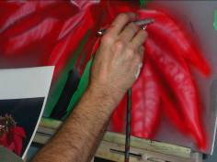
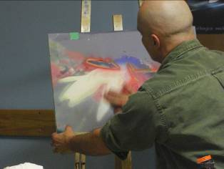
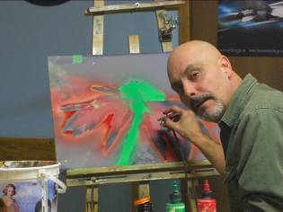
January meeting
Air brush artist Andrew Gillet was our featured demonstrator for January’s meeting. Andrew was approached because of the general interest in the use of the air brush in the decorating of woodturnings.

His demo was to familiarize us with the equipment needed to begin air-brushing and to offer us a demonstration of the basics and how the color effects can be built and how blending is accomplished through the use of masks.
While you would not be expected to walk away with a in-depth understanding of air brush techniques we hope that his demo has piqued your curiosity and that if interested you may wish to follow up with him and one of his painting seminar/classes which are held at the Market building on Talbot Street.
Basic equipment required is an air brush, single or dual action, and a compressor capable of air delivery in the 20 – 30 psi range with a moisture/oil trap.
February meeting
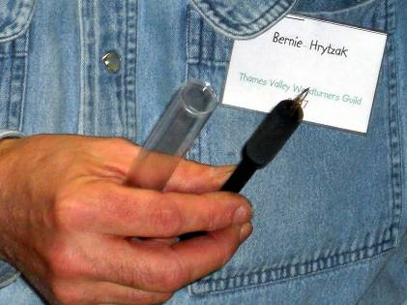
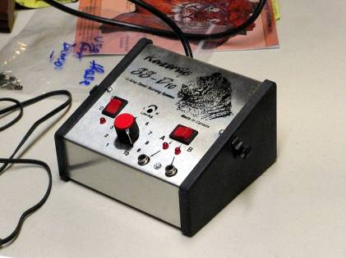
Bernie Hrytzak continued with part 2 of his embellishment techniques. This time he demonstrated a number of techniques in pyrography or woodburning.
Equipment required is a controlled power source to power a resistance type burning pen. Bernie’s kit was a dual pen unit by Razortip a company for Saskatchewan. An assortment of burning pens or a pen capable of using interchangeable tips (nibs).
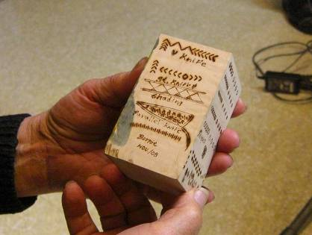
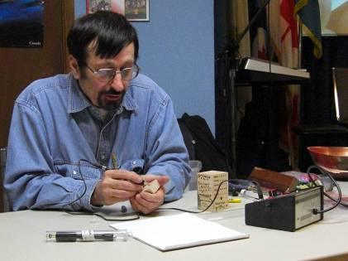
There are other brands i.e. Detailer. There are other pens with plug-in tips. There are units that use “do-it-yourself” tips although the factory made tips are usually preferred. The techniques used are relatively easy to learn and require practice to develop the necessary control. Special tips are available and can be custom made to assist in repetitive designs.
Once the needed skills are learned it then becomes a matter of deciding where and how or if indeed pyrography will enhance your turning. The following pictures show the equipment, the tips, some of the techniques and the results you can achieve.
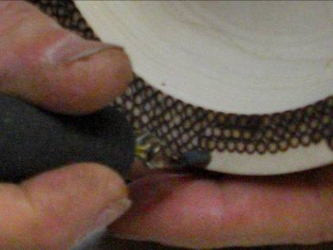
Shown to the right is a “special” tip that allows a circular pattern to be imprinted.

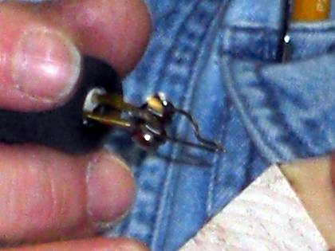
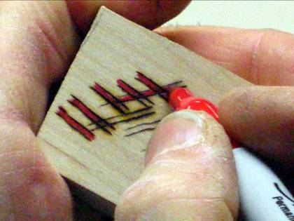
This is a pen that will hold a variety of burner tips that will enable parallel line patterns to be developed as show on the right hand picture.

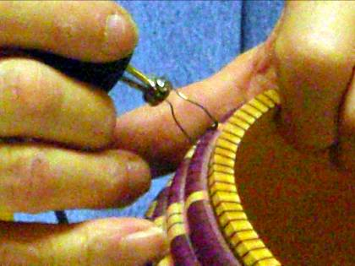
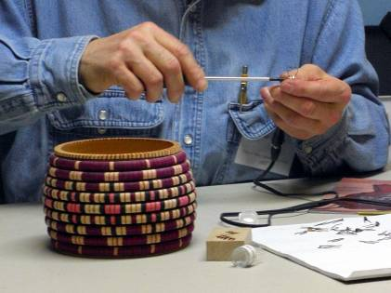
The basket weave is being simulated by use of another “special” tip shaped to the basket’s row profile. Once the design is burned-in color is added to complete the design.
The cost of the equipment can vary from a basic soldering-iron type burner, to single burner units like the Razortip or Detailer branded sets. Burner pens come in a variety of styles and costs, so shop around and ask some of us who have used different model what we think about them.

The February challenge was to embellish a turning. No restrictions. The winners were: 1st Mario Moran, 2nd Eric Deckert, and 3rd Leo Van Der Loo. Congratulations to both the winners and those who rose to the challenge. The entries are shown later in the newsletter.
Training courses
Turning 101 – This popular beginning program covering spindle turning and basic safety will be repeated, planning for Spring (after the wood show) April 19th*.
Turning 102 planned for May 24th*. This popular beginners program will cover fundamentals of bowls.
*Neither date falls on the Easter or Victoria holidays

Turning 103 program will be a basic turned box, and a second course has not been scheduled yet. The outline for the 1st Turning 103, box making is covered in a separate tutorial that will be added to our website.
Please let Scott know of your interest for the “sign-up” sheet.
A somewhat more advanced series of sessions is under development, as above, more info as it becomes available. Input is solicited for topics, content, and presenters for these sessions. The purpose of this series is the sharing of advanced techniques by advanced turners to experienced turners. There will be a chance for the developing turner to learn skills through “hands-on”.
Topics we are considering are: piercing, colouring, pyrography, chattering, rotary tools (texturing), air-brushing. Participants will be required to bring in turned items for the hands-on made of soft maple.

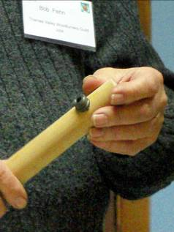
Tips for turners
#10For decorative holes in a rim use a drill bushing and insert (Lee Valley) mounted through a dowel the size of your tool rest, these can also control a lamp auger if you don't have a hollow tail stock

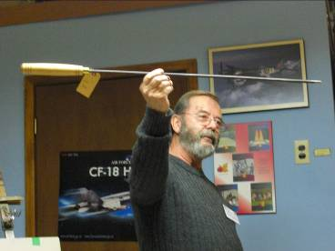
#11 An auger for deep holes in spindles - originally for lamp turners

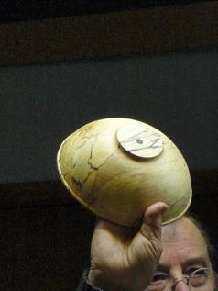
#12 If you have a break-through in the bottom of a bowl as you turn off the foot, don’t worry, you can turn it into a design feature by turning a small decorative plug for the bottom

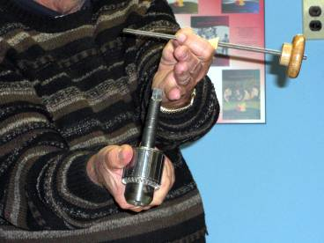
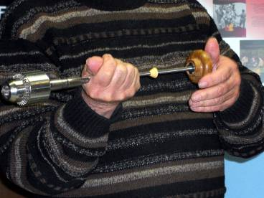
#14 Don't lose the Morse taper/ chuck from your lathe. Hold it in place with a draw bar.

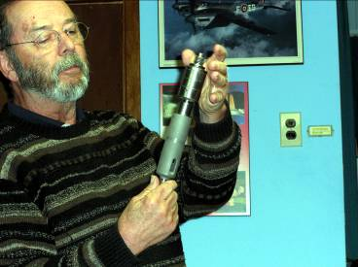
#15 Adapters are available to go from one Morse taper to another size taper (from Busy Bee or Tool and Cutter)

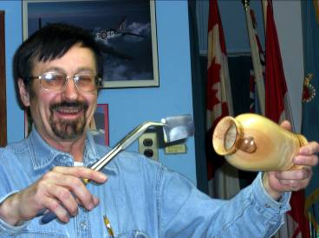
#16 Bernie shows a way to sand inside a hollow vessel by gripping a folded sheet of sandpaper in the jaws of a pair of needle nose pliers. This technique gives you good reach without fear of damage or getting your fingers or hand trapped. Medical surplus forceps are also a good tool to use (available at Forest City Surplus along with long needle nose pliers.

If you have a tip you would like to share with everyone, please see Scott before the meeting so he can schedule you in.

A definition: Chatoyance. In gemology, chatoyancy (or chatoyance) is an optical reflectance effect seen in certain gemstones. Coined from the French "oeil de chat", meaning "cat's eye", chatoyancy arises either from the fibrous structure of a material, as in tiger eye quartz, or from fibrous inclusions or cavities within the stone, as in cat's eye chrysoberyl. The effect can be likened to the sheen off a spool of silk: the luminous streak of reflected light is always perpendicular to the direction of the fibres. For a gemstone to show this effect best it must be cut en cabochon, with the fibers or fibrous structures parallel to the base of the finished stone. Faceted stones are less likely to show the effect well.
Gem species known for this phenomenon include the aforementioned quartz, chrysoberyl, beryl (especially var. aquamarine), tourmaline, apatite, moonstone and scapolite. Glass optical cable can also display chatoyancy if properly cut, and has become a popular decorative material in a variety of vivid colors.
Chatoyancy can also be used to refer to a similar effect in woodworking, where certain finishes will cause the wood grain to achieve a striking three-dimensional appearance.
This is often seen in Maple. A search of the web will give you lots of info on how to apply your finish to bring out the Chatoyance in your piece.
Ed
Call for volunteers
Your guild is growing; we recently passed the 90 member mark and hope to exceed 100 after the London Wood Show. Our members’ skill-sets are growing too. Not so our mentor list, it has been stagnant for several years; we could use some new mentors, volunteers who would like to share their skills with other members.
The same call for volunteers is being made for demonstrators. If you have a specialty or a particular turning skill, will you consider sharing it with the guild members? Please see any of the executive to offer your skills by way of a demo.
Please use the internet and our site as a resource.
Our website has our recent newsletters, a list of Preferred Suppliers, the Mentor list, and our Guild policy page plus a number of interesting links. We will keep the web site as our most current communication device (if you do not have internet access please let me know and printed copy of any of the above can be made available to you Ed).
Our web site is http://ca.geocities.com/tvwt1@rogers.com/
Al Stirt Seminar
Al Stirt Seminar confirmed for October 3, details as they unfold.
Newsletter photos
From time to time I have been asked if photos from the newsletter can be made available to members, particularly photos of their turnings. Short answer “Yes”. I have all the photos from all the newsletters on my computer in digital form, anyone is welcome to a digital copy so long as you can tell me which issue, which page, and which item the photo you want appears.
We have also been asked if we have back copies of the newsletter too, yes, again in digital form.
A possibility exists to make CDs of the photos and newsletters if there is enough interest. The cost would likely be in the $10 range. If interested let me know.
A gallery of turnings on our website would be an interesting feature, but to do so we need the names to attach to a turning. Anyone who is interested in having their work included can start by helping us ID their past work in the newsletters.

London Wood Show
An excellent wood show presentation was put on by the TVWTG. There was a good turnout of entries and enthusiastic interest from the public.
Your executive wishes to thank all the members who contributed their time and effort at the show for set-up, take-down, talking to the public, to those who demonstrated their talents at the booth and a special thanks to Mario for his demonstration at the show’s seminar stage.
The winners of the “People’s Choice Awards” this year were:
Novice class:
1st place rosette and $75 to Roy McGhee for walnut vessel
2nd place rosette and $50 to Paul Jackson for a nested set of 4 maple bowls
3rd place Rosette and $25 to Roy McGhee for a Catalpa vessel
HM rosette (honourable mention) to Mike D’Avirro
Open class:
1st place rosette and $75 to Bernie Hrytzak for a hollow vessel
2nd place rosette and $50 to Mario Moran for a segmented vessel
3rd place Rosette and $25 to Doreen Bowden for a set of 3 nested burl bowls
HM rosette (honourable mention) to Jackie Morningstar for a natural edge bowl
HM rosette (honourable mention) to Leo Van Der Loo for a walnut bowl

Congratulations to the winners and entrants. The field this year was nothing short of amazing, I can’t wait to see what is turned for 2010!
Photos of the winning entries and other photos of the booth appear elsewhere in this issue.

Show and Tell from February’s meeting
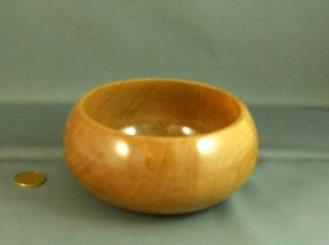
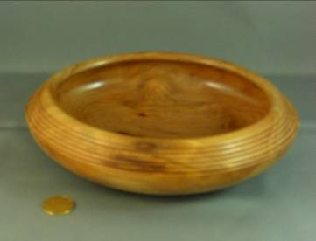
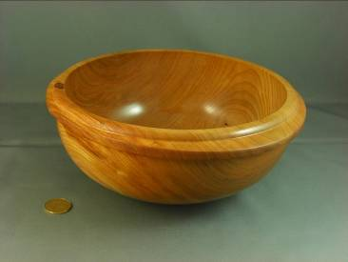
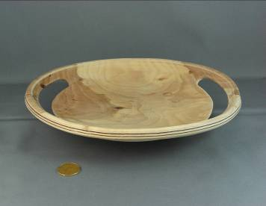
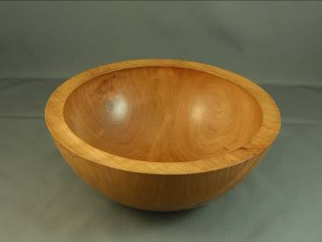

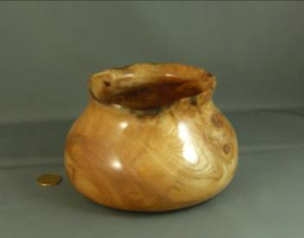

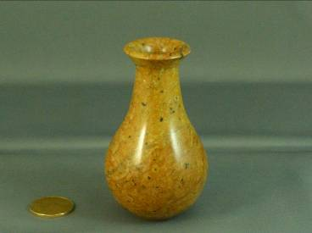

The camera doesn’t lie, or does it? The upper left bowl if you look carefully is oval, not round, and the lower left vessel is not wood, but rather is turned from soapstone.

Winners at the 2009 London Wood Show “People’s Choice Awards”

Open class
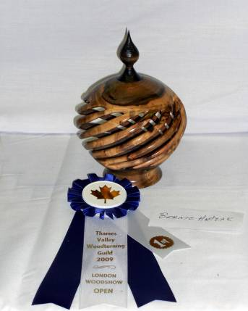
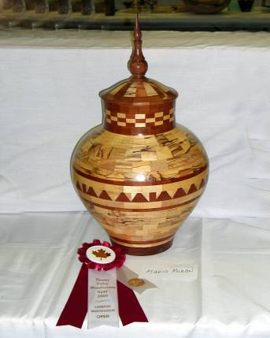
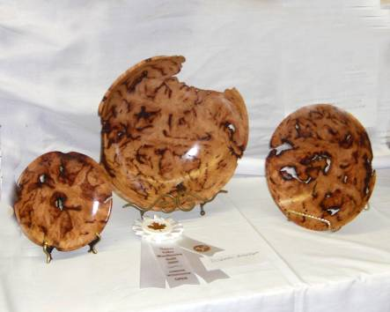

1st Bernie Hrytzak 2nd Mario Moran 3rd Doreen Bowden
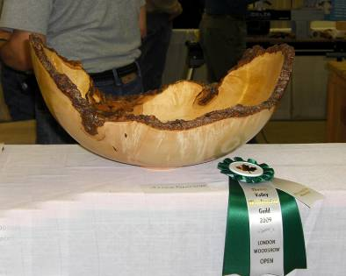
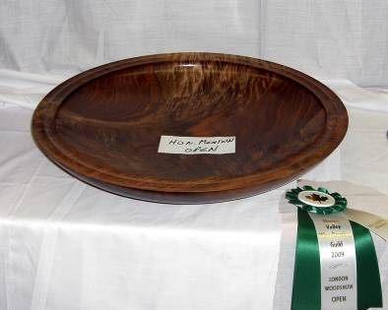

HM Jackie Morningstar HM Leo Van Der Loo

Novice Class

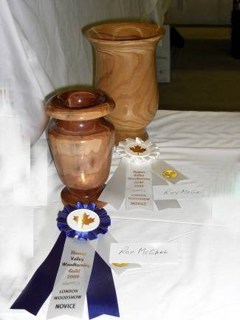
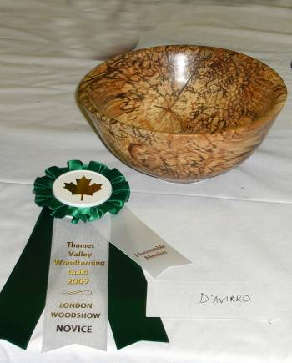
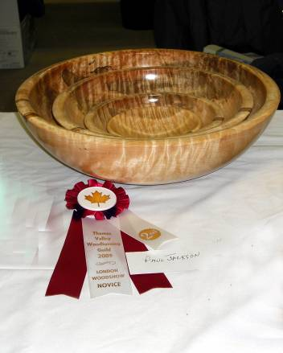

1st and 3rd Roy McGhee 2nd Paul Jackson HM Mike D’Avirro

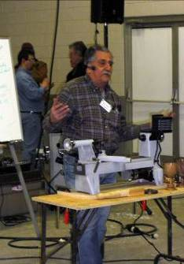
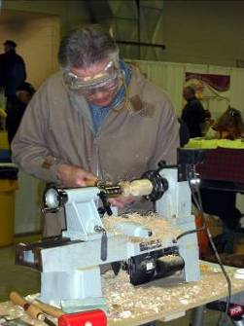
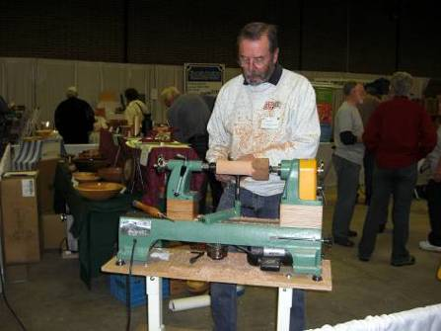
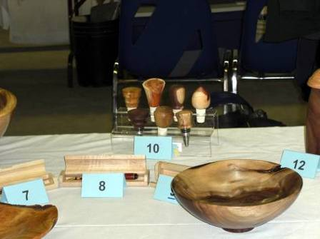
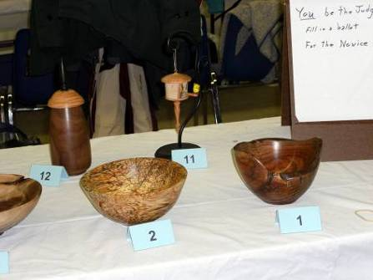
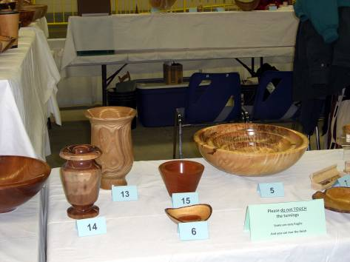
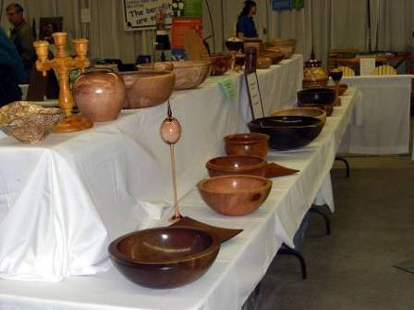
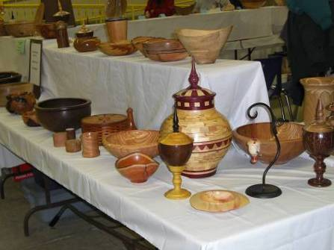
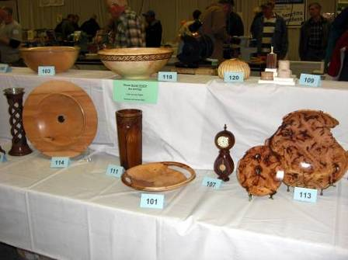
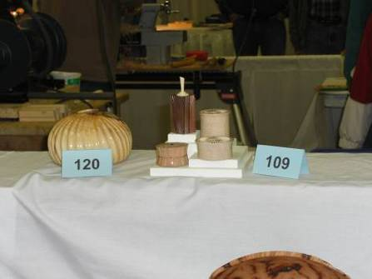
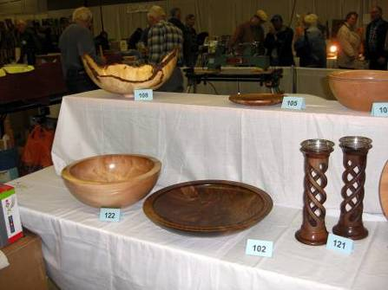
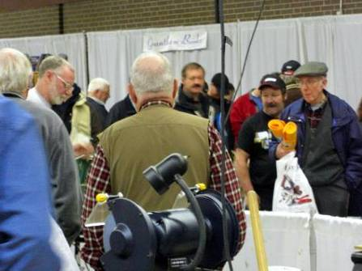
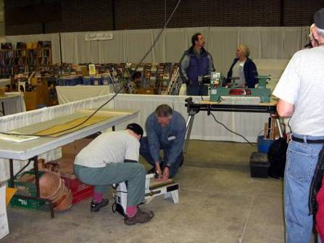
Activity at the Guild’s booth at the 2009 London Wood Show
Many activities occur at the booth during the show. Set-up starts it off with many hands making it easy. Displays of turnings are set up for competition and show with a view towards display and the safety of the turnings from grubby hands, most often adults – not kids!
Demonstrations to captivate the on-lookers were conducted by members while other talked to interested people. As a matter of interest there were 27 prospective new members on the sign-up sheet plus many who took our club info with them.
Mario put on a demo in the seminar centre attended by many.

The February Embellishment challenge
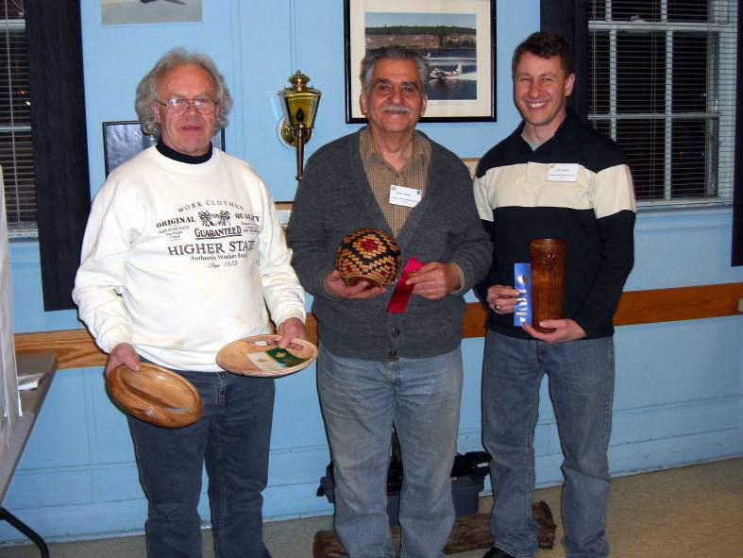
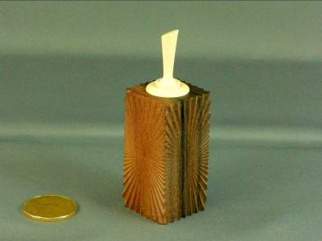
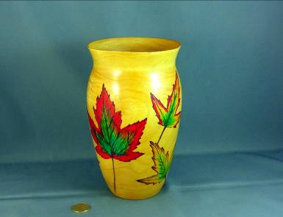
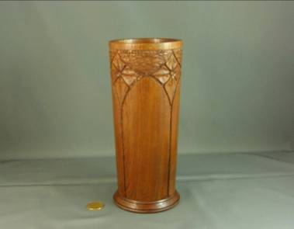
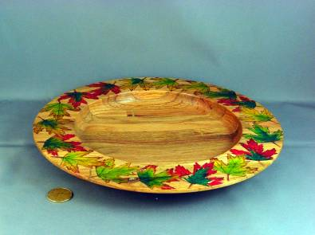
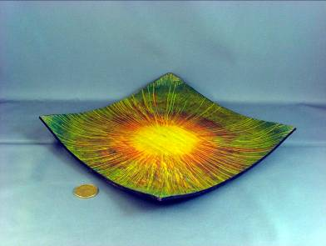
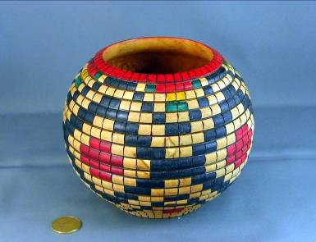

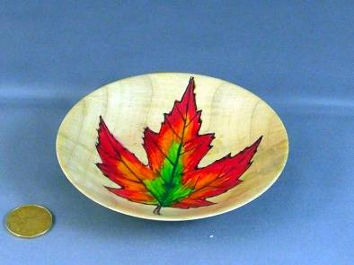

____________________________________________________________________

“Show and Tell” from January’s meeting
(more on page 12)

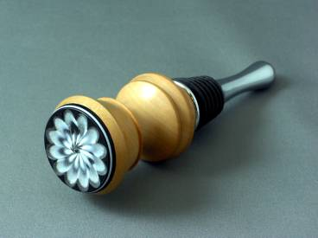
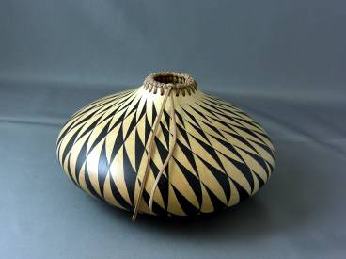
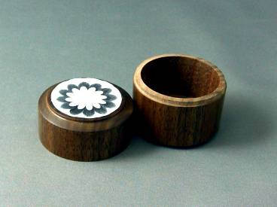

2008-2009 season’s dates for meetings and other scheduled events.
We are looking at several guest turners that may necessitate schedule changes. We will keep the members informed of changes.

Date | Meeting or events | Shows/events/comments
September 4 | Fall season begins | A demo by Bob Fenn of a square turning  Natural edge bowl challenge
October 2 | Monthly meeting | Demo of the rose engines that are being developed by John Calver and Gary Miller. Two different approaches
October 24 -26 | Inter-club competition. Black Creek Pioneer Village in Weston | Inter club competition, 5 categories with 4 skill levels. Details will be reviewed at the September meeting
November 6 | Monthly meeting | Demo by Bob of a Christmas decoration using sea urchins  Challenge of a “square turning”  A tool sale, bring in your surplus tools
December 4 | Monthly meeting | Christmas decoration challenge, themed around a turned Christmas gift.  Bernie Hrytzak will demonstrate a variety of embellishments techniques.
January 8, 2009  NOTE this is 2nd Thursday | Monthly meeting (date change is because Jan 1st Thursday, a busy day for the Air Force Association) | Air brushing demo by Andrew Gillet, professional air brush artist
January 11 | Turning 103 9:00 – 4:00 | Turn a basic box from soft maple. Bring your own lunch.
February 5 | Monthly meeting | Challenge: free for all surface embellishment on a turning.  Bernie will add pyrography as completion of his earlier embellishment techniques session.
February13 – 15 | London Wood Show and TVWTG turning competition | Any turnings from the past 12 months. Categories novice and open. Enter the category you feel comfortable with (novice less than 3 ribbons, open 3 or more 1st place ribbons). A person may place his/her item in a higher category than normal, his/her choice.
March 5 | Monthly meeting | Vacuum chucking how to build a system and how/where to use it.  Will anyone like to volunteer to lead this session?
April 2 | Monthly meeting | A green and thin turning,  Challenge: Pyrography embellished of a turning
May7 | Monthly meeting | A green and rough turned product and discussion of drying techniques  Wine stoppers, several different techniques and demonstrators
June 4 | Monthly meeting | Chain saw demo and safety aspects.
June 6 (a Saturday) | Guest turner demo  9:00am – 5:00pm | Bhin Pho demo, fee is $40 which will include lunch.  Look at his website under the internet site section).  Sign-up now to be sure of a seat.
June 26 – 28 | AAW Symposium | AAW symposium, which will be in Albuquerque, New Mexico.
July/August | Summer break | Summer break.
 | Topics in the discussion stages, not yet formalized as to date or content.  Program Ideas and suggestions for guest turners are always welcomed by your committee | -Segmented turning open and closed (“how-to” specifics) will be covered in several sessions.  -Hand thread-chasing.  -Guest turners or seminars.  -Design? What makes a makes a “good” turning into an “outstand- ing” turning?  -Metal spinning  -A safety night (discussion/panel)  -A “show and sell” table of turnings”, a “show and trade” table for your turnings.  -Future challenge ideas: a pair of “something”, a seed pod turning.  -Sharing of advanced techniques turning 201 | -A repeat of Turning 101 & 102, a for post wood show, express your interest  -Make a home drying cabinet  -Turning tips learned from experience (a number will be presented at each meeting and published in the newsletters and on our website).  -Eccentric spindle turning  -Bracelet turning  -A ring turning  -Inlace  -Bird houses  -Finishing the “foot”  -Basic drying of wet wood  -Wine stoppers  -Eccentric turning

Note, meetings start at 7:30, doors open at 7:00. Raffle tickets, the library, and the Round table critique will be available between 7:00 and 7:30.
Items both wanted and for sale
Ads are free for members and run until you sell your item or withdraw your advert. Members can support other members by buying: good deals and good prices!
Please note. The Guild provides a means of connecting buyer and sellers through these ads. It is up to the buyer to ensure the item offered is as stated and the two parties should agree between them as to warranty or guarantee for the item.
To run a new ad in our newsletter or to remove a sold item, call Bob at 519-457-6555 or email him at 66.bobhewson@rogers.com .
We welcome small business card type advertisements at a rate of $30 per year. We print 6-7 issues per year on a non-date-specific schedule. We also upload our newsletters to the internet at http://members.rogers.com/tvwt1/ for viewing in glorious colour.
For sale: I make and sell cutters for the Stewart system and or boring bars. They are made of hi-speed steel. Available in three sizes, prices are $15, $20, & $25.
Call Mario Moran at 519-336-0550, or see him at the Guild meeting or mario.ada@sympatico.ca
For sale:

Lee Valley Mitre Vise - 2 available unused.
Price - $50.00 for pair.
Call: Alf Buckle at 1-519-271-8489 or email at abuckle@sympatico.ca

For sale
Bandsaw – Craftex 15”
Includes fence, ¾ hp motor, plus Hi-Level accessory bearings.
Used for about 1 year, cost $488 new
Sell: $350
Call Gord Tallman at 519-455-4526

FOR SALE
4" Dust Collector accessories. All in great shape, some new. ASKING 1/2 PRICE. Would prefer to sell all together but will consider pieces. Make me an offer on the bunch.
QUANTITY TYPE SIZE $ NEW COST ea
15 S/S CLAMPS 4" .79
1 "Y" 5"X4"X4" 8.50
3 "Y" 4"X4"X4" 8.50
5 ELBOWS 4"X4" 7.99
1 T" 4"X4"X4" 8.50
1 REDUCER 5"X4" 5.99
3 BLAST GATES 4" 5.50
2 SPLICE (coupler) 4" 6.50
1 END CAP 4" (forgot)
1 JOINTER HOOD 4" 3.99
Call: Gary Miller at 519-858-2445

For sale
Imported floor model drill press, 5/8 chuck 3/4 hp
Price: Asking $150
Call Rob Williamson at 519-672-2998 or email robriw@hotmail.com

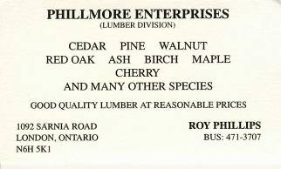

For sale
Makita 12” thickness planer c/w extra blades and stand
$350
Imported jointer 6” with stand c/w extra blades
$350
Delta Shaper, stand, reversible, motor c/w 30+ cutters
$450
Call: Bob Fenn, 519-455-7436

Fletchs Fetchings

Supplying unique wood from Africa and Asia.

Turning blanks available for pens, pool cues, bottle stoppers, duck calls, bowls, etc.

Reasonable pricing.
Call Jim Fletcher at 519-633-0538.
Or visit my website www.fletchs-fetchings.com
I also sell on eBay under seller id fletchs_fetchings

Wanted
Parts for old lathes
Call: Murray Tyler at 519-225-2854 after 5 PM

For sale: Burls
Contact Jerry Schne or Ken Burger
23234 Thomson Line
Rodney, Ont

Call 519-785-2403 or 519-785-0533 cell

Custom work:
-I Have a vertical mill & metal lathe to make different wood turning tools (cutters, sharpening jigs, supports etc. you name it, similar to the Hunter Tool for hollowing), two different sizes ¼ & a new 3/8" round also a square end cuter (all carbide cutters ).
-If you want a curve put in rod it can be done too. You will have to make a drawing if you want a bend put in the rod.
Price: $40 straight, $60 bent or curved.
-An aluminum handle (you choose the size) to accept the tool is also available. Any custom work, please see me.
-See my sharpening jigs at the next guild meeting or call.
Call: Al Johnston at 519-679-8718
592 Mapledale Ave. London

For Sale CA Glue for WoodTurners

EM-02 VERY THIN, INSTANT CURE, Able to penetrate between parts, very thin viscosity, allows up to .002” gap fill capability
EM-40 MED-THIN, FAST CURE, General purpose, thin viscosity, allows up to .004” gap fill capability
EM-150 MEDIUM, MEDIUM CURE, Broad use adhesive, medium-thick viscosity, allows up to .006” gap fill capability
EM-600 MEDIUM THICK, MEDIUM CURE, Heavy duty adhesive, medium thick viscosity, allows up to .008” gap fill capability
EM-2000 THICK FILLER, SLOW CURE, Allows maximum time for positioning fixtures. Use to bond fibrous and porous materials. Flowable thick viscosity, allows up to .010” - .020” gap fill capability. Excellent for filling large open cracks, gaps and holes. General manufacturing and repairing tough and uneven materials.
All are available in 2 ¼ oz. bottles bottle which includes 5 detachable long nozzles and an extra top with spout and cap.*
Price: $15.00 (taxes included)
(EM2000 does not include the 5 detachable long nozzles because it is too thick for the nozzles)
Additional long nozzles are priced at 5/$0.25.
ACTIVATOR Instantly cures adhesives. Contains no CFC’s. Mist Pump Sprayer
Price: $10.00 (taxes included) 2 oz. bottle
DE-BONDER Required to un-glue items (example: fingers accidentally glued together)
Price: $10.00 (taxes included) 2oz. bottle
Call: Fred Rodger 519-858-2558 or email at frederick.rodger@sympatico.ca (Fred will bring it to the meeting for you)

This is the most superior CA Glue on the market. Manufactured by the
company that invented CA Glue over 30 years ago

This is the most superior CA Glue on the market Manufactured by the company that invented CA Glue over 30 years ago

Service available: Laser engraving by “Laser in Motion”
Set up charge $20 + small cost per item.
Call: John Korzec at 519-870-1819

Wanted: Used lathe.

I have a young lad who is interested in learning to turn and is looking for a used lathe for $200 or less.
Call: Paul Spicer at 519-633-7901

”Show and Tell” January (continued)
