Fee.



Thames Valley Woodturner
A publication of the Thames Valley Woodturners Guild
A chapter of the AAW

Volume 10.6 November/December 2008

Turning events, Wood shows, and competitions in our region and farther afield

February 6, 7 & 8 The Arizona Woodturners Association’s 3rd Desert Woodturning Roundup at the Mesa Convention Center, Mesa, AZ. details: www.desertwoodturningroundup.com
February 13 – 15 London’s Woodshow is coming, time to start making your submissions
June 6, Bhin Pho, brought to you by the TVWTG, London, Ont. See Gary or Bob for tickets or reservations.
June 26 – 28, AAW symposium, which will be in Albuquerque, New Mexico
September in Toronto. Ontario Craft Council will be presenting a one man show, their first, with the turnings of Doug Magrath
Contents
Additions to library P1
Internet sites of interest P1
New members P1
Treasury P2
Visiting turners P2
Dixie pins P2
November meeting P2
December meeting P2
Sea Urchin challenge P4 & 12
2008 SOFA Expo P4
Training courses P5
Tips for turners P6
Elections & call for volunteers P7
Square turning challenge P8
Show & Tell for Novembers P8
Winners from Woodstock show P9
Calendar P10
For sale P11 & 12
For a Guild info/policy sheet, call or email Bob Hewson or refer to our web site at: ca.geocities.com/tvwt1@rogers.com/

Additions to the library
New books: TURNING FULL CIRCLE by David Springett
ELLSWORTH ON TURNING by David Ellsworth
DVDs: 2008 AAW symposium DVDs remain on order
Interesting new or updated Internet sites of interest to members
When checking out newsgroups there are three main areas to browse, the messages, the photo albums and the files. Messages are the day to day member messages and threads which can also be searched from either the home page or the search box at the top of the message screen. The photo albums are like our monthly “Show & Tell” where members can post picture of their work. Files are usually “how to” files on a topic, project or technique prepared by group participants.
Google, Yahoo and MSN host newsgroups that cover virtually any topic you can imagine
- Check out the gallery http://www.bowlturner.com/gallery.html
- Interested in music boxes, check this source of manufactures of boxes and movements http://www.musicalmovements.com/
New Members
Please welcome our newest members Dave Norris, Emile Thibault, Rick Wilfong, and Joe Wallace
Treasury and Dues
Dues are due by the January meeting. The fee for 2009 remains at $35, the best deal in London! Please see Bob or mail a cheque to him at 22 – 99 Edgevalley Rd, London, N5Y 5N1 (Please note cheques to be made out to John Calver our treasurer)
We have $2559 available in the treasury after outstanding items.
Please use the internet and our site as a resource.
Our website has our recent newsletters, a list of Preferred Suppliers, the Mentor list, and our Guild policy page plus a number of interesting links. We will keep the web site as our most current communication device (if you do not have internet access please let me know and printed copy of any of the above can be made available to you Ed).
Our web site is http://ca.geocities.com/tvwt1@rogers.com/
Visiting turners
For the interest of members we are listing future seminars and visiting turners in the surrounding area as we learn of them:
These are the demonstrators that WGO, GHWG and TVWG and other guilds or clubs have scheduled or are in the process of arranging. The guilds/clubs have said (or implied) that members of other clubs are welcome to attend:

Guest turner | Date | Sponsor | Fee | Contact | Comments
David Hout - metal spinning (on wood lathe) | Nov 15 | WGO Burlington | $ tba | Gary Miller | A possible workshop or may be able to arrange for him to come to TVWG
Kurt Hertzog - well known all around turner and pen specialist | Jan 2009 | WGO Burlington | $tba | Gary Miller
Bhin Pho | June 6 2009 | TVWTG  London | $40 est at this time | Gary Miller | Be sure to sign up, space is limited. Tickets are available at Dec meeting until sold-out, see Bob or Gary
Bonnie Klein | Fall  2009 | TVWTG  London |  | Gary Miller | Date to be finalized, if interested, sign up early, space is limited
  $tba
Al Stirt | Oct 2009 | LONDON | $tba | Gary Miller | Tentative date
John Jordan | TBA |  | $tba | Gary Miller
If anyone would like to attend any of the above please let Gary Miller know. He will ensure that there is space and will confirm the fees. Carpooling can be arranged if there are sufficient numbers.
As we know more we'll keep the membership apprised and will keep this as an ongoing feature in the newsletter.
Dixie pins
Dixie pins are now in, see Gary at the meeting (exact change would be appreciated) if you didn’t get yours at the last meeting.
November meeting
A demo by Bob Hewson of the turning of a Christmas decoration using a sea urchin as the feature. Bob demonstrated using his Taig miniature lathe. At the conclusion of the demo there were a number of Sea Urchins for purchase by members from the club at cost. Turning a Sea urchin is the basis of the December Challenge of a turned decoration or turned gift.
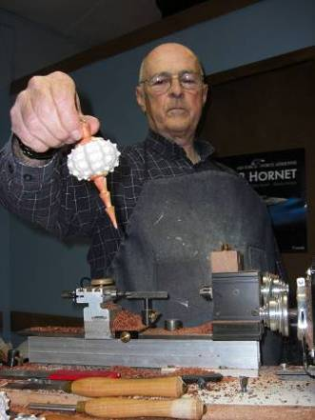
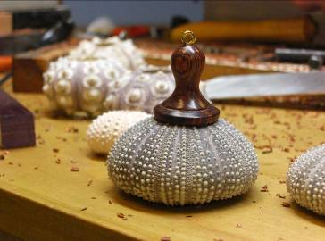
To aid in the urchin project Bob uploaded a project outline to the web-site.
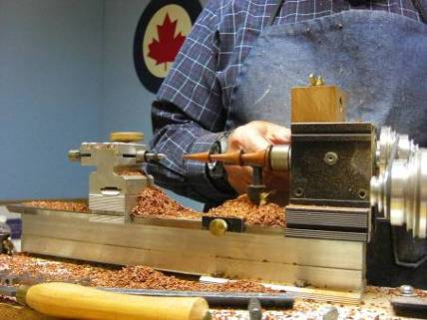
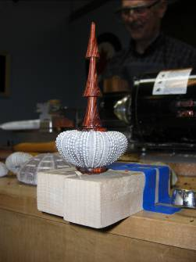

Photos show from Left to Right turning the icecicle, the urchin with the finial attached with silicone adhesive, the icecicle attached with silicone curing, finished urchin decoration

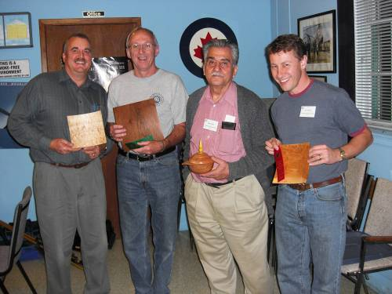
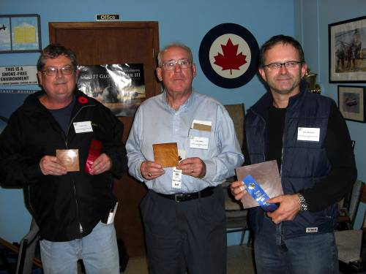
November’s challenge was a square turning inspired by Bob Fenn’s earlier demonstration. The happy winners are shown below and all entries are shown later in the newsletter.

December meeting
Bernie Hrytzak demonstrated a number of techniques to decorate your turned pieces. A number of photos follow along with a brief description of the technique used. A number of tools not always found in the toolbox of a turner are used and where possible a source of the tool or cutter is given.

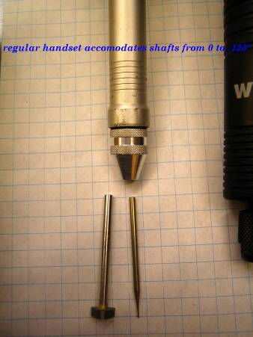
Photo beginning clockwise is a “Wecheer” rotary tool similar to the Foredom or Large Dremel, but lower cost. It is available from Chipping Away in Kitchener.
Available with both a large (for ¼” bits and burrs as well as a smaller hand piece for 1/8” burrs (shown). Bits shown are carbide, available from

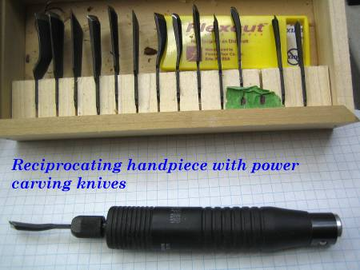
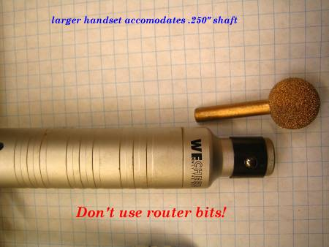
There are carving hand pieces for the Wecheer/Foredom/Dremel tools that convert rotary motion to impact enabling the tools to power carve with chisels such as the “Flexsteel” chisels. Also suitable are the carbide “Kutzall” burrs such as the ball type shown.

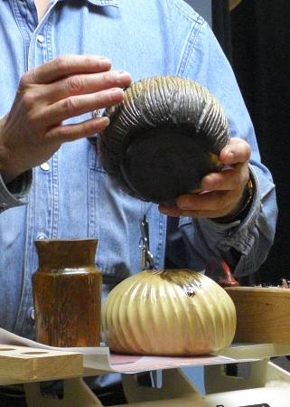
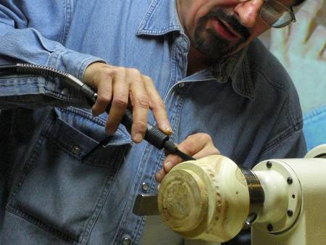
Using the powered impact chisel you can easily add decorative fluting or other texture such as shown on the vessel base.

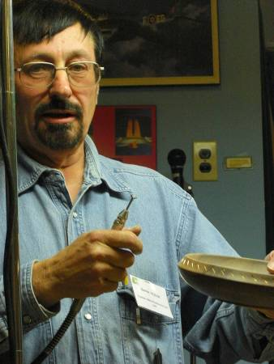
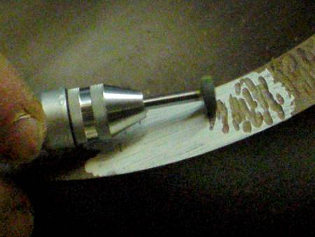

Using the rotary motion with a carbide cutter interesting texture can be added, in this case to the rim.

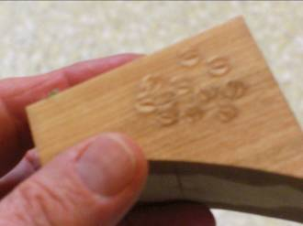
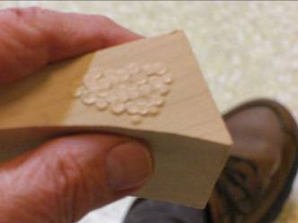

An embossing technique that will develop a raised pattern is done by using a round screw head that has been slightly modified to break the sharp edges of the slot. The tool is then pounded into the wood leaving a depressed impression of the tool. Then a small amount of the surface is sanded (or carefully turned) down to the level of the depressed impression, being careful not to remove the impression. Water is than applied to the depressed pattern that will then swell or expand back to its original level resulting in a raised or embossed pattern.
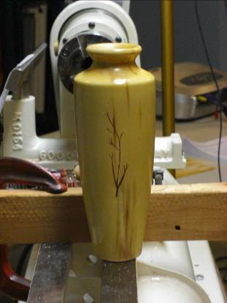
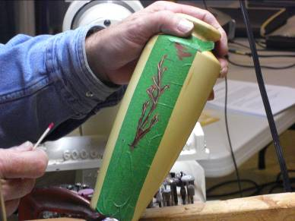
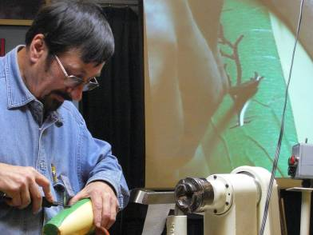
Using the veining chisel and reciprocating hand piece he decorates a vase. Bernie begins by masking the area to be decorated then drawing a design on the masking tape. He then uses a veining power chisel and cuts through the pattern with the cutter.
After the design is cut into the vessel the incision is colored with acrylic paint much like you would if using a stencil. This could also be finished with an inlace or a inlay material. The tape is removed and the finished design is revealed.

Bernie will show pyrography techniques at a future demo.

The Sea Urchin decoration challenge winners are shown below and the entries appear later in the newsletter.

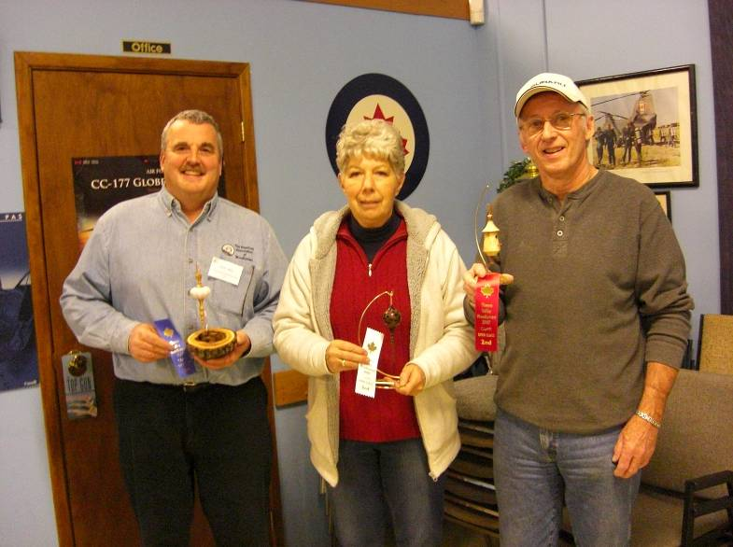

The 2008 “SOFA” EXPOSITION

On Nov 8/07, my wife and myself traveled to Chicago for the “Sculpture Objects and Functional Art” being held at the Navy Pier on the waterfront. We got to Michigan City, Indiana at 9PM and stopped there for the night. The next morning it took us one hour to drive into Chicago. The show opened at 11:00 AM and since we were approx. one hour early, were able to park within 20 steps of the SOFA exhibition entrance! The show was just as fascinating as last year and since I had my wife with me, had someone to discuss the artworks with. It took much longer this year and we walked around from11:00 until 5:00 PM and could have stayed longer if not for concern with freeway traffic at rush hour (which turned out to be no problem at all). We had dinner at an Italian place that nite in Michigan City and drove back to Chatham on Sunday. I found this to be an excellent way of including my better half in my passion for turning and in both of us gaining an appreciation of the arts.
The glassworks were just as impressive this year and I could say that I did not recognize anything from last year, it was all new. The prices were on the average higher than last year by maybe 20%, although last year wasn’t a bargain either!
We spent a lot of time at the woodturning galleries (Del Mano and Radkova) and I talked to most of the turners that were there. Incredibly, 2 of the turners (whom I met in the last year) recognized me from over 40 feet away! The turners that I met were Harvey Fein, Michael Hosoluk, David Nittman, David Ellesworth, Don Derry, Hans Weissflog, Bill Hunter and Cindy Drodza. They all have their style and are very inspiring to talk to. This year I was more bold and took pictures (even though this was advertised as not allowed) since a lot of people were taking pictures with no one objecting. So I have quite a few of the more noteworthy on file along with prices and comments that I later inserted digitally.
The first turning picture shows a cherry burl that is hollow and approximately 4 feet tall that was done by David Ellsworth and had an asking price of $75,000! The next one is taken with Bill Hunter of California who has been turning and turning out incredible artworks for 30 years, he sold at least 5 artworks in Chicago with price tags of $45,000 and higher. On the furniture side is this rocking chair of wavy maple by well known Sam Maloof which listed for $60,000! The highest price we saw was this glass form with a large sunflower petal in the middle (all glass of course), it weighed 1100 lbs, and the price was a cool one million dollars. The last picture shows a tabletop art form of ~ 2 dozen egg shells broken, painted and glued together going for a low of $3,000, don’t throw those egg shells away!
We had time to take in a demonstration by David Ellsworth of how to turn a green bowl out of maple, he makes it look effortless as he doesn’t stop to check wall thickness as he turns and when he did take it off the lathe, just passed it around without looking at it. I suspect he has done several thousand bowls! One thing that was new to me was he used a jam chuck to drive the open side of the bowl held between the tailstock to finish the bottom as close as he could get to the tailstock point (within ~1/8”) and then held a skew for final cutting off as he turned off the lathe and completed the cut-off just as the lathe stopped and he grabbed the loose bowl.

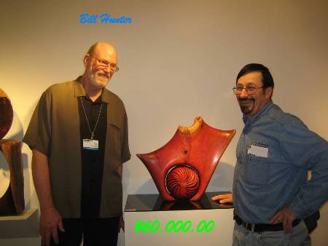
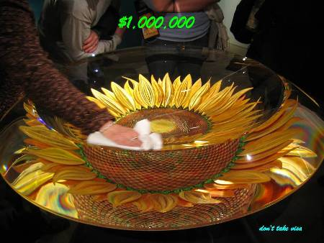
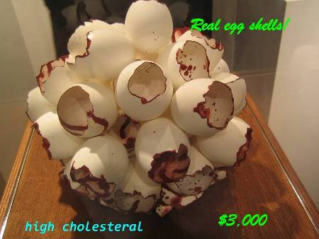
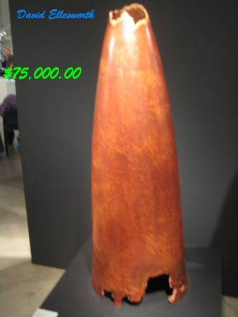
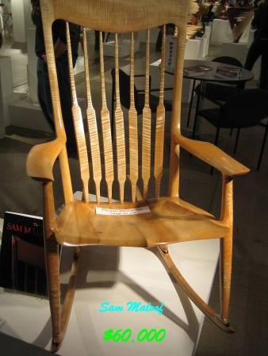

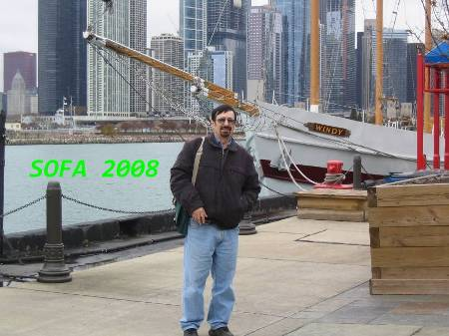

Literature is available if anyone is interested and I have many more pictures if you care to see more.

Written by: Bernie Hrytzak Nov.16 / 08
Training courses
Turning 101 – This popular beginning program covering spindle turning and basic safety will be repeated, anticpated for Spring (after the wood show)
Turning 102 - This popular beginning program covering fundamentals of bowls
Dates as they become available, planning is geared for spring, probably after the London Wood Show.
The turning 103 program will be a basic turned box, scheduled for January 11th.
Please let Scott know of your interest for the “sign-up” sheet.
A somewhat more advanced series of sessions is under development, as above, more info as it becomes available. Input is also being solicited for topics, content, and presenters for these sessions. The purpose of this series is the sharing of advanced techniques by advanced turners to experienced turners. There will be a chance for the developing turner to learn skills through “hands-on”.
Topics we are considering are: piercing, colouring, pyrography, chattering, rotary tools (texturing), air-brushing. Participants will be required to bring in turned items for the hands-on made of soft maple.

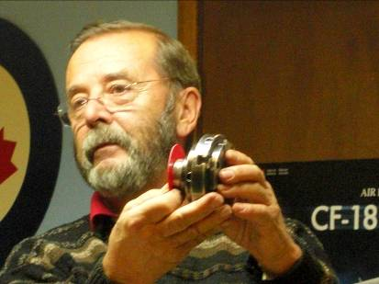
Tips from experienced turners
#5 Use a plastic washer to prevent your chuck from getting too tight on your spindle. If you don’t use a washer and do get too tight a simple rap on the tommy-bar at an oblique angle should free it up.

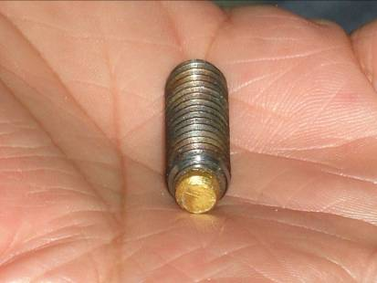
#6 Ever use your lathe in reverse? You stand a good chance of spinning the chuck and turning off, and turning them into a missile unless you use a grub screw to tighten the chuck to the spindle. This raises another potential problem of damaging the spindle thread if using a steel grub screw. The answer is a grub screw with a brass insert to prevent damaging the spindle’s thread. This special grub screw can be had through Fastenall on Clark Side Rd for approx $8.

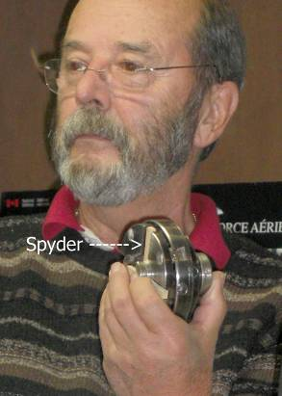

#7 Make a lathe spyder from waste wood to act as a spacer between your turning and the chuck (of particular benefit when re-chucking a finished item).

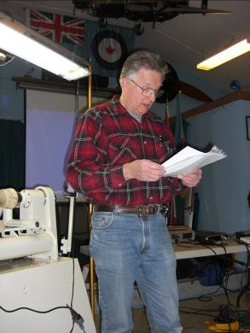
#8 Turning speed
The following is a reprint of information developed by Dave Nish and presented by Gary
How to Determine safe Lathe Speed
By Dale Nish
The selected lathe speed should allow the blanks to be turned with little or no vibration, allowing the tools to produce a clean surface.
Vibration is usually caused by speeds high enough to cause the unbalanced blank to vibrate the lathe, as the piece is trying to fly off the lathe due to centrifugal force and the lathe holding system is keeping the piece in place. The vibration is caused by the workpiece being unbalanced in weight. Unbalanced work can be caused by a turning blank not being centered properly on a face plate or chuck, square stock not being centered on the drive centre and revolving centre or stock which may be unbalanced due to one area of the blank being heavier than another, usually due to moisture differences in the wood. Another common cause of vibration is turning blanks which are physically unbalanced, such as natural edged bowls from logs or burls. Low speeds are needed to reduce the vibration until the work becomes balanced, then speeds can be increased for more efficient turning.
Suggested Turning Speeds
I have found from experience that appropriate speeds can be determined using a simple formula. This method works for me, and I use it all the time to determine lathe speeds when I begin to set up to turn a piece.
D = Diameter of stock in inches
6,000 to 9,000 – just numbers (constants) used to determine lowest speed or highest speed
Formula: D (inches) X RPM = 6,000 to 9,000 or, RPM = 6,000 (or 9,000)
Example: A bowl blank is 8 inches in diameter
Minimum RPM = 6,000 = 750 RPM
Maximum RPM = 9,000 = 1125 RPM
If the lathe is a step pulley drive system, choose a setting around 750 RPM to 1100 RPM, favouring the lower end until the work is in balance.
If the lathe has a variable speed control system, set it around 750 RPM until the work is turned round, then increase the speed, but I wouldn’t recommend going above 1100 RPM.
Several years ago I visited a friend who had been turning large lamps and platters which he was selling at craft shows. He had retired from the construction industry and was involved in a “useful hobby” and he was quite successful. He and his wife travelled to shows in their motor home and were enjoying retirement. He was in his shop turning 20” platters glued up from different species of colourful woods. T he joinery showed a few heavy glue lines and the occasional small gap, but the quality was good enough for the customers he was selling to. I mentioned that 800 RPM was much too fast for platters that size, and turning outboard with a light floor stand was dangerous in itself. He didn’t feel that either the lathe speed or the floor stand was causing any difficulty and his comment was, “I’ve never had any problem”. A few weeks later one of the platters disintegrated while he was turning it and he suffered severe head injuries from which he never fully recovered. When I last saw him, he was in a wheel chair, on an oxygen bottle and was watching his shop being sold at a garage sale. This was an accident that never needed to happen. In more than 45 years of teaching, mostly woodworking and turning classes, I’ve never seen a smart accident.
Now, let’s look at the small diameter works, as there are large numbers of small capacity lathes owned by woodturners. Most will have a maximum swing of 8 inches and as noted previously, small bowls of 8 inches can be safely turned at around 750 RPM if held securely in a chuck or on a faceplate.
Six inch bowls will require a speed from 1000 to 1500 RPM
Five inch bowls require a speed from 1200 to 1800 RPM
Three inch stock from 2000 to 3000 RPM
Stock 2” or smaller in diameter usually will be turned at speed 3000 or higher, often at the top speed which the lathe will turn. However, caution must be practiced at all times and if the lathe speed seems too high, slow it down. Never turn at a speed at which you don’t feel comfortable.
All speeds suggested are for stock which is sound, no defects or checks, and has not been laminated.
NOTE: Face protection is a MUST at any speed.

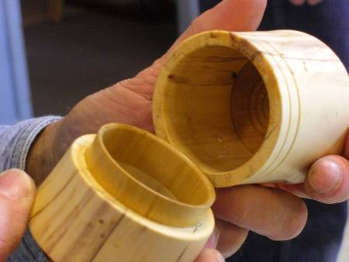
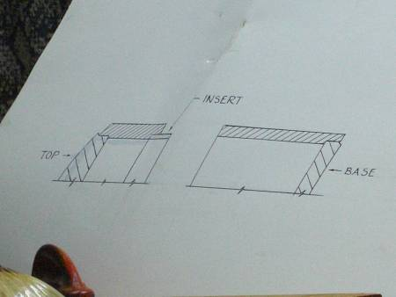
#9 Use inserts in soft or punky spalted wood. To prevent tear-out and poor end grain cutting in spalted wood use an insert to strengthen the lip area or the base area. This technique is also excellent for maximizing grain match in turned boxes. The example shown has an insert in the bottom as well as an insert for the box joint.

Elections
A call for volunteers to stand for office failed to produce and new candidates. Fortunately your existing executive have indicated a willingness to serve another year and thus your executive for 2009 remains in place for 2008
Call for Volunteers
Your guild is growing; we recently passed the 90 member mark and hope to exceed 100 after the London Wood Show. Our members’ skill-sets are growing too. Not so our mentor list, it has been stagnant for several years; we could use some new mentors, volunteers who would like to share their skills with other members.
The same call for volunteers is being made for demonstrators. If you have a specialty or a particular turning skill, will you consider sharing it with the guild members? Please see any of the executive to offer your skills by way of a demo.

Your Guild’s Executive wishes You and yours
a happy and prosperous 2009
Happy turning!

November’s “Square turning” challenge

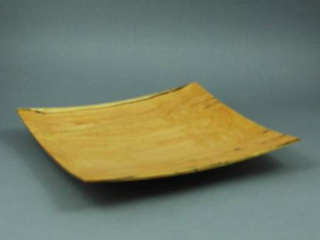
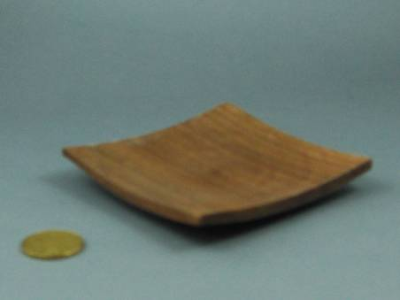
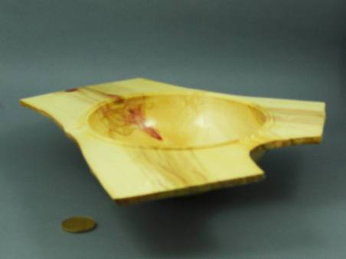
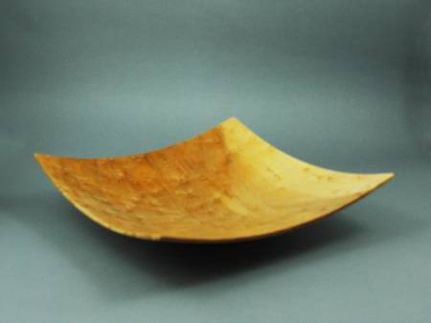
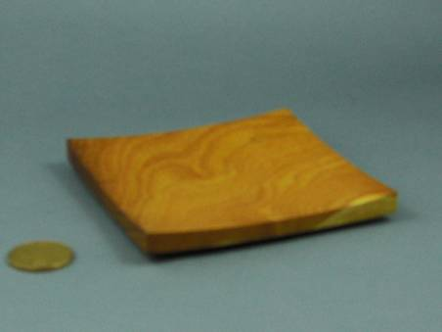
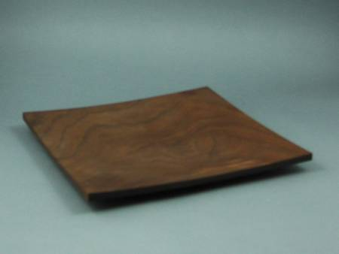
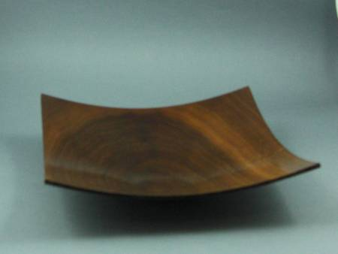
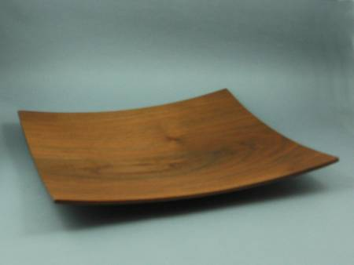

Our apologies for several out of focus shots. In future we will endeavor to include a coin for size reference and also improve our camera focusing.
Ed

Show and Tell exhibit for November
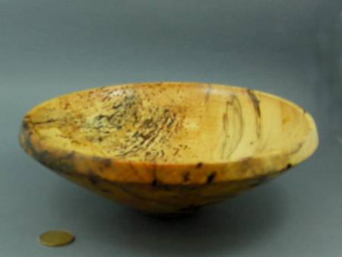
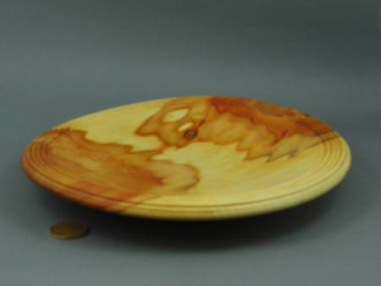
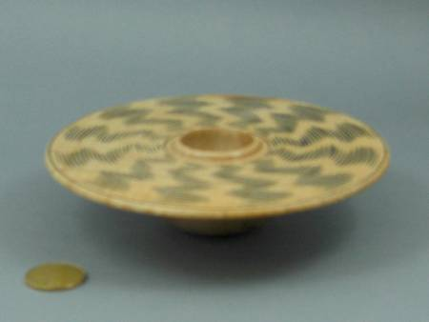
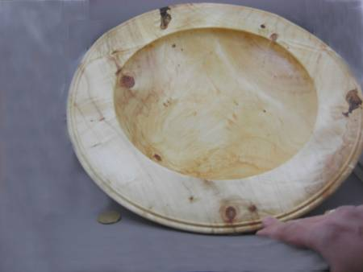
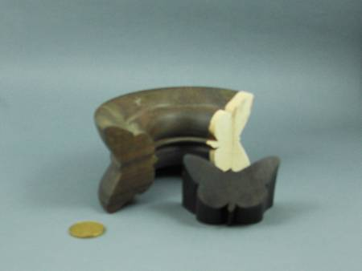

Winners from Woodstock Wood Show in October
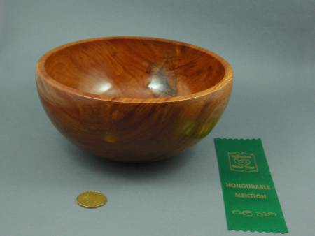
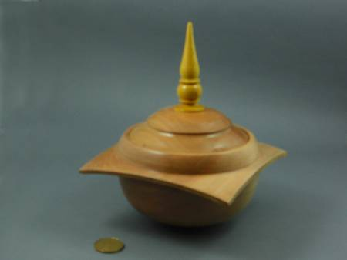
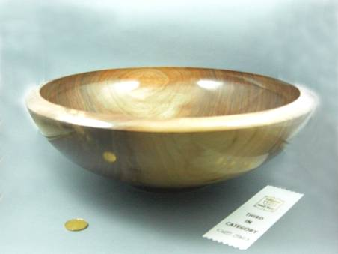
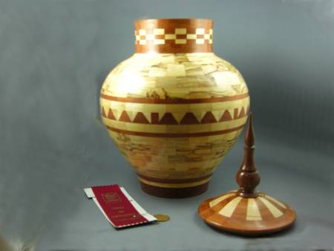
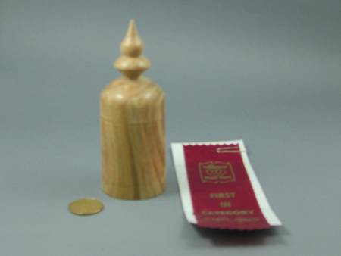
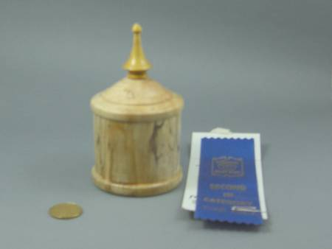
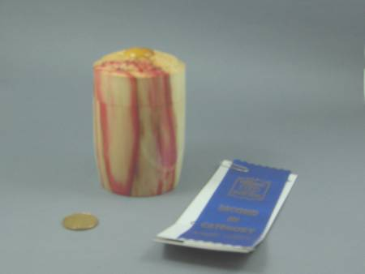
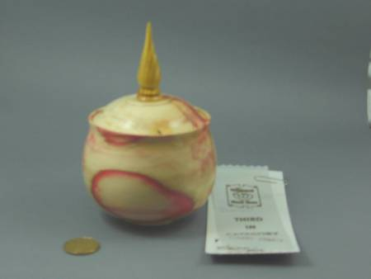
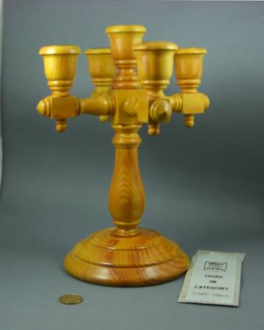
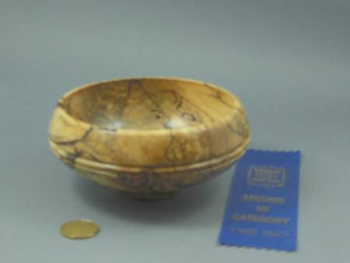
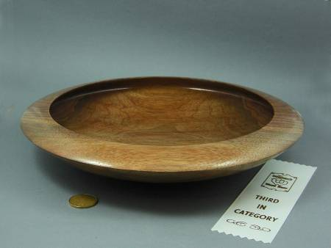
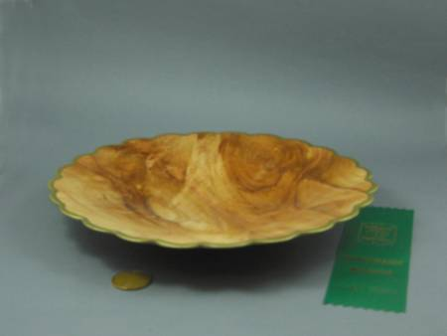
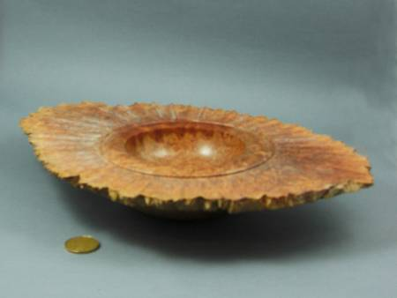
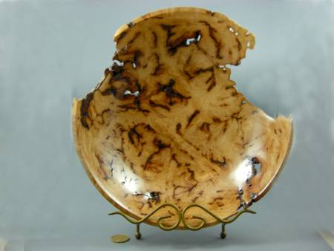
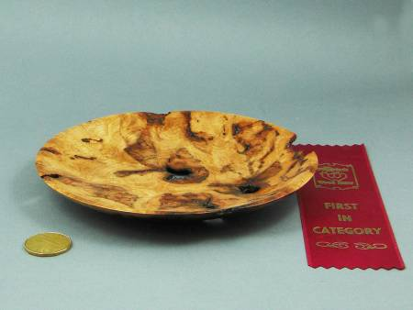
The 2008-2009 seasons’ dates for meetings and other scheduled events.
We are looking at several guest turners that may necessitate schedule changes. We will keep the members informed of changes.

Date | Meeting or events | Shows/events/comments
September 4 | Fall season begins | A demo by Bob Fenn of a square turning  Natural edge bowl challenge
October 2 | Monthly meeting | Demo of the rose engines that are being developed by John Calver and Gary Miller. Two different approaches
October 24 -26 | Inter-club competition. Black Creek Pioneer Village in Weston | Inter club competition, 5 categories with 4 skill levels. Details will be reviewed at the September meeting
November 6 | Monthly meeting | Demo by Bob of a Christmas decoration using sea urchins  Challenge of a “square turning”  A tool sale, bring in your surplus tools
December 4 | Monthly meeting | Christmas decoration challenge, themed around a turned Christmas gift.  Bernie Hrytzak will demonstrate a variety of embellishments techniques.
January 8, 2009  NOTE this is 2nd Thursday | Monthly meeting (date change is because Jan 1st Thursday, a busy day for the Air Force Association) | Air brushing demo by Andrew Gillet, professional air brush artist
January 11 | Turning 103 9:00 – 4:00 | Turn a basic box from soft maple. Bring your own lunch.
February 5 | Monthly meeting | Challenge: free for all surface embellishment on a turning.  Bernie will add pyrography as completion of his earlier embellishment techniques session.
February13 – 15 | London Wood Show and TVWTG turning competition | Any turnings from the past 12 months. Categories novice and open. Enter the category you feel comfortable with (novice less than 3 ribbons, open 3 or more 1st place ribbons). A person may place his/her item in a higher category than normal, his/her choice.
March 5 | Monthly meeting | Vacuum chucking how to build a system and how/where to use it.  Will anyone like to volunteer to lead this session?
April 2 | Monthly meeting | Off-center spindle turning by John Calver  Challenge: Pyrography embellished of a turning
May7 | Monthly meeting | Wine stoppers, several different techniques and demonstrators
June 4 | Monthly meeting | Chain saw demo and safety aspects.
June 6 (a Saturday) | Guest turner demo  9:00am – 5:00pm | Bhin Pho demo, fee is $40 which will include lunch.  Look at his website under the internet site section).  Sign-up now to be sure of a seat.
June 26 – 28 | AAW Symposium | AAW symposium, which will be in Albuquerque, New Mexico.
July/August | Summer break | Summer break.
 | Topics in the discussion stages, not yet formalized as to date or content.  Program Ideas and suggestions for guest turners are always welcomed by your committee | -Segmented turning open and closed (“how-to” specifics) will be covered in several sessions.  -Hand thread-chasing.  -Guest turners or seminars.  -Design? What makes a makes a “good” turning into an “outstand- ing” turning?  -Metal spinning  -A safety night (discussion/panel)  -A “show and sell” table of turnings”, a “show and trade” table for your turnings.  -Future challenge ideas: a pair of “something”, a seed pod turning.  -Sharing of advanced techniques turning 201 | -A repeat of Turning 101 & 102, a for post wood show, express your interest  -Make a home drying cabinet  -Turning tips learned from experience (a number will be presented at each meeting and published in the newsletters and on our website).  -Eccentric spindle turning  -Bracelet turning  -A ring turning  -Inlace  -Bird houses  -Finishing the “foot”

Note, meetings start at 7:30, doors open at 7:00. Raffle tickets, the library, and the Round table critique will be available between 7:00 and 7:30.
Items both wanted and for sale
Ads are free for members and run until you sell your item or withdraw your advert. Members can support other members by buying: good deals and good prices!
Please note. The Guild provides a means of connecting buyer and sellers through these ads. It is up to the buyer to ensure the item offered is as stated and the two parties should agree between them as to warranty or guarantee for the item.
To run a new ad in our newsletter or to remove a sold item, call Bob at 519-457-6555 or email him at 66.bobhewson@rogers.com .
We welcome small business card type advertisements at a rate of $30 per year. We print 6-7 issues per year on a non-date-specific schedule. We also upload our newsletters to the internet at http://members.rogers.com/tvwt1/ for viewing in glorious colour.
For sale: I make and sell cutters for the Stewart system and or boring bars. They are made of hi-speed steel. Available in three sizes, prices are $15, $20, & $25.
Call Mario Moran at 519-336-0550, or see him at the Guild meeting or mario.ada@sympatico.ca
For Sale:

Lee Valley Mitre Vise - 2 available unused.
Price - $50.00 for pair.
Call: Alf Buckle at 1-519-271-8489 or email at abuckle@sympatico.ca

For Sale
Bandsaw – Craftex 15”
Includes fence, ¾ hp motor, plus Hi-Level accessory bearings.
Used for about 1 year, cost $488 new
Sell: $350
Call Gord Tallman at 519-455-4526

Custom work:
-I Have a vertical mill & metal lathe to make different wood turning tools (cutters, sharpening jigs, suports etc. you name it, similar to the Hunter Tool for hollowing), two different sizes ¼ & a new 3/8" round also a square end cuter (all carbide cutters ).
-If you want a curve put in rod it can be done too. You will have to make a drawing if you want a bend put in the rod.
Price: $40 straight, $60 bent or curved.
-An aluminium handle (you choose the size) to accept the tool is also available. Any custom work, please see me.
-See my sharpening jigs at the next guild meeting or call.
Call: Al Johnston at 519-679-8718
592 Mapledale Ave. London

For Sale
Imported floor model drill press, 5/8 chuck 3/4 hp
Price: Asking $150
Call Rob Williamson at 519-672-2998 or email robriw@hotmail.com


For Sale
Mankita 12” thickness planer c/w extra blades and stand
$350
Imported jointer 6” with stand c/w extra blades
$350
Delta Shaper, stand, reeves, motor c/w 30+ cutters
$450
Call: Bob Fenn, 519-455-7436

For Sale
A King ch900 lathe, complete with cabinet, this is a multi -speed lathe, without changing belt
A swivel head
With base with wheels for moving around if needed
Price: $450.00
I also have a Beaver/Delta antique lathe for sale that I have brought back to life, early 1950
Price: $200.00 complete with stand
Call John McGuire at 519-659-6810
106 Mark St.,
London, On

Fletchs Fetchings

Supplying unique wood from Africa and Asia.

Turning blanks available for pens, pool cues, bottle stoppers, duck calls, bowls, etc.

Reasonable pricing.
Call Jim Fletcher at 519-633-0538.
Or visit my website www.fletchs-fetchings.com
I also sell on eBay under seller id fletchs_fetchings

Wanted
Parts for old lathes
Call Murray Tyler at 519-225-2854 after 5 PM
FOR SALE
4" Dust Collector accessories. All in great shape, some new. ASKING 1/2 PRICE. Would prefer to sell all together but will consider pieces. Make me an offer on the bunch.
QUANTITY TYPE SIZE $ NEW COST ea
15 S/S CLAMPS 4" .79
1 "Y" 5"X4"X4" 8.50
3 "Y" 4"X4"X4" 8.50
5 ELBOWS 4"X4" 7.99
1 T" 4"X4"X4" 8.50
1 REDUCER 5"X4" 5.99
3 BLAST GATES 4" 5.50
2 SPLICE (coupler) 4" 6.50
1 END CAP 4" (forgot)
1 JOINTER HOOD 4" 3.99
Call: Gary Miller at 519-858-2445

***************************************************************************************
Sea Urchin decoration Challenge
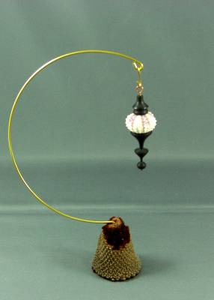
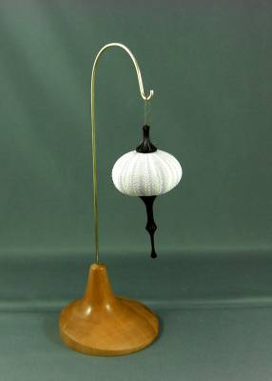
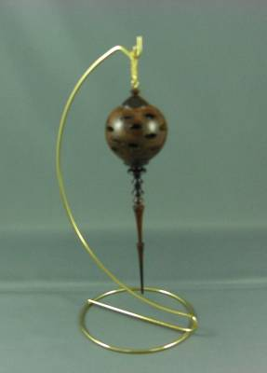
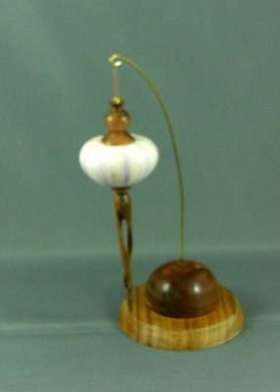
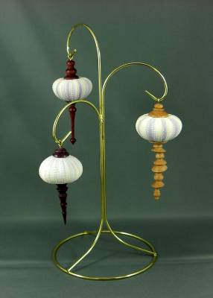
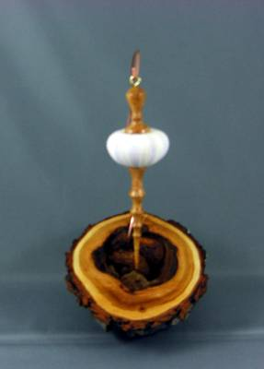
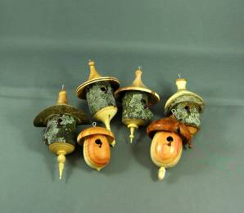
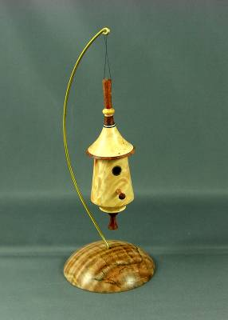
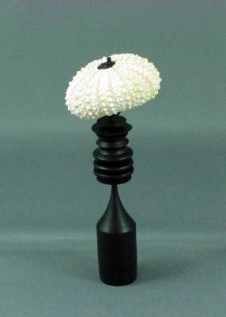

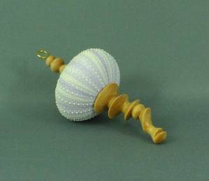

This is a great collection of urchins with both whimsical and imaginative interpretations. Congratulations on a challenge well done!

