Fee.



Thames Valley Woodturner
A publication of the Thames Valley Woodturners Guild
A chapter of the AAW

Volume 10.5 September/October 2008

Turning events, Wood shows, and competitions in our region and farther afield

February 6, 7 & 8, 2009 The Arizona Woodturner's Association’s 3rd Desert Woodturning Roundup at the Mesa Convention Center, Mesa, AZ. details: www.desertwoodturningroundup.com
February 13 – 15 London’s Woodshow is coming, time to start making your submissions
June 26 – 28, 2009 AAW symposium, which will be in Albuquerque, New Mexico
September, 2009 in Toronto. Ontario Craft Council will be presenting a one man show, their first, with the turnings of Doug Magrath
Contents
Additions to library P1
Internet sites of interest P1
New members P1
Treasury P2
Tips from experienced turners P2
Visiting turners P2
Dixie pins P3
September meeting P4
Natual bowl challenge P4, 7 & 8
October meeting P5
Training courses P5
One man show P5
Elections P6
Show & Tell P8
Calendar P9
For sale P10, 11, & 10
For a Guild info/policy sheet, call or email Bob Hewson or refer to our web site at: ca.geocities.com/tvwt1@rogers.com/

Additions to the library
2008 AAW symposium DVDs are on order
Interesting new or updated Internet sites of interest to members
When checking out newsgroups there are three main areas to browse, the messages, the photo albums and the files. Messages are the day to day member messages and threads which can also be searched from either the home page or the search box at the top of the message screen. The photo albums are like our monthly “Show & Tell” where members can post picture of their work. Files are usually “how to” files on a topic, project or technique prepared by group participants.
Google, Yahoo and MSN host newsgroups that cover virtually any topic you can imagine
- Tribute to Frank Sudol http://www.woodturner.org/sym/sym2007/photos/Banquet/FrankSudolTribute.pdf
- Interested in old tools? Check this site out http://www.owwm.com/home.aspx
- To review the work of Bhin Pho check out his site at http://www.wondersofwood.net/ also check out the Minnesota club’s newsletter for a “day with Bhin Pho” to further whet your appetite http://mnwoodturners.com/newsletters/June2003.pdf more details in the calendar.
- The site’s name is self-explanatory http://www.woodenpottery.com/collections.htm
- Turnings by Kurt Hertzog, a future demonstrator at WGO http://www.kurthertzog.com/
New Members
Please welcome our newest member, Dave Norris.
Treasury
We have $1913 available after outstanding items.
Show and Tell, Critique, and Round Table
The critique feature has been discontinued as a regular feature. While of interest to some members it is felt by your executive that the general membership does not wish to participate in a public critique.
The round table discussion prior to the meeting will continue for those of you who wish a more private form of feedback on their work.
“Show and Tell” is back, bring as many as you like, but please due to time constraints only two turning per member or guest should be reviewed/discussed.
Please use the internet and our site as a resource.
Our website has our recent newsletters, a list of Preferred Suppliers, the Mentor list, and our Guild policy page plus a number of interesting links. We will keep the web site as our most current communication device (if you do not have internet access please let me know and printed copy of any of the above can be made available to you Ed).
Our web site is http://ca.geocities.com/tvwt1@rogers.com/
Tips from experienced turners
#1 Lubricate your banjo to ease adjustment (from Bob Fenn)
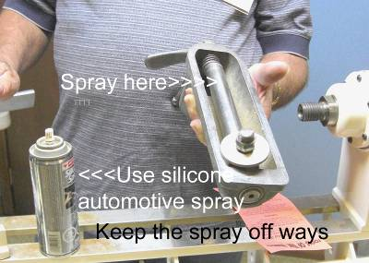
Lubricate the central rod to simplify smooth movement and adjustment. Bob recommends a silicone spray but cautions you not to get the spray on the base of the banjo or the ways of your lathe. If you inadvertently spray the ways or bottom of the banjo the banjo will slide easily rather than lock firmly into place.

#2 Attach a smooth hard rod to the edge of your tool rest (from Bob Fenn)
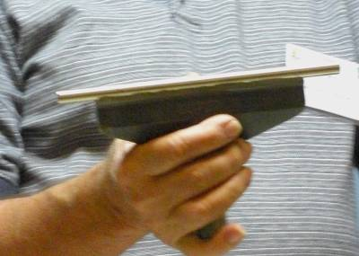
The top of the tool rest is easily nicked and becomes anything but smooth making fine finishing cuts more difficult. Many simply file out the tool nicks, but they are soon repeated. Next time, smooth the top and band a hardened steel Dixie pin to the rest using 5 minute epoxy resin. Be sure the pin has been slightly abraded on the side to be bonded and that the rest is also clean and abraded. Start with a few dabs of the epoxy and when cure add a complete fillet.
Dixie pins have been ordered in the past for members by Gary Miller who has agreed to do so again. A $10 deposit for each pin is required with a final price known at the time of receipt (usually it’s within a buck or two). These pins are priced at cost plus shipping, no profit for the club. The pins are also great for custom turning tools and available in several diameters. See Gary for more info on the supply of Dixie pins.
#3 To create a 3 point chisel (from Bob Fenn)
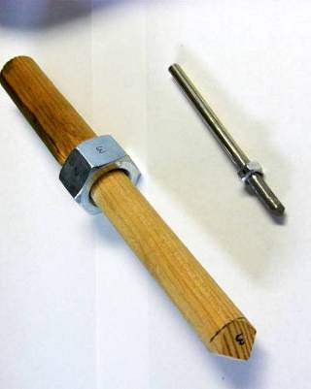
To create a 3 point chisel with equal sides, slide a hex nut onto the steel rod*. The nut should be tight on the rod (not allowed to turn. Drill, ream, or wrap with tape of glue in place with CA glue.
When grinding the 3 points lay flat side of the nut on your grinder’s tool rest, rotate to every-other flat to produce the three sides.
*use a “Dixie” pin or even steel drill rod. Drill rod should be hardened if you wish to get useful lie before re-sharpening.

#4 Face plates chisel (from Bob Fenn)
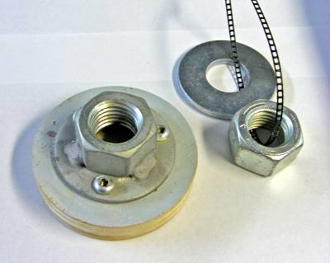
Face plates can be made with a nut (appropriate thread may be non-standard & available through FACCA Fasteners or Fastenall on Clarke Side Rd) welded to a flat washer. Drill the washer for 3 or 4 screws to attach a wood disc. Face of the attached disc to true up with the lathe’s spindle. Its my experience that the nut and washer weld is never true.

Visiting turners
For the interest of members we are listing future seminars and visiting turners in the surrounding area as we learn of them:
These are the demonstrators that WGO, GHWG and TVWG and other guilds or clubs have scheduled or are in the process of arranging. The guilds/clubs have said (or implied) that members of other clubs are welcome to attend:

Guest turner | Date | Sponsor | Fee | Contact | Comments
David Hout - metal spinning (on wood lathe) | Nov 15 | WGO Burlington | $ tba | Gary Miller | A possible workshop or may be able to arrange for him to come to TVWG
Kurt Hertzog - well known all around turner and pen specialist | Jan 2009 | WGO Burlington | $tba | Gary Miller
Doug Fisher |  | WGO  Burlington |  | Gary Miller
Bhin Pho | June 6 2009 | TVWTG  London | $40 est at this time | Gary Miller | Be sure to sign up, space is limited
Bonnie Klein | Fall  2009 | TVWTG  London |  | Gary Miller | Date to be finalized, if interested, sign up early, space is limited
  $tba
Al Stirt | TBA |  | $tba | Gary Miller
John Jordan | TBA |  | $tba | Gary Miller
If anyone would like to attend any of the above please let Gary Miller know. He will ensure that there is space and will confirm the fees. Carpooling can be arranged if there are sufficient numbers.
As we know more we'll keep the membership apprised and will keep this as an ongoing feature in the newsletter.
Dixie pins
Dixie pins are on order with the supplier.
September meeting
The fall season was launched with a slightly modified format. As usual the doors open at 7:00, and the library will be open as will the opportunity to buy raffle tickets. Also during this pre-meeting period the Round Table group will meet in the other room. The meeting will commence at 7:30.
A welcome and business session will be led by Scott.
The main event will be held (demo etc.)
A new feature, “2 Tips for turners” will be presented, either as a separate item preceding the demo or as an integral part of the demo. These tips are meant to be of interest to both the novice as well as the experienced turner. We have a number of topics on hand, but we also solicit the membership’s input both as to topic as well as to present a tip(s). The first two offerings appear on pg 1.
After the demo/main event, we will vote for the “challenge” followed by the “Show and Tell” discussion while the votes are counted. We are not limiting “Show and Tell” items for display, but we will ask that the turners limit their discussion to two items only in the interest of brevity.
We will dispense with the formal break.
Last item is to draw for the raffle.
We ask that anyone leaving before the formal end of the meeting do so quietly.
Demo of a square turning technique by Bob Fenn
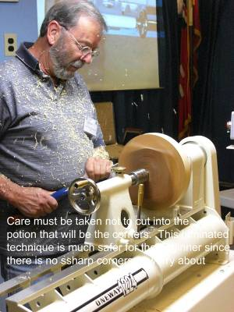
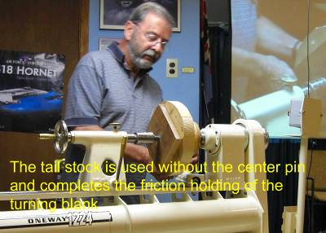
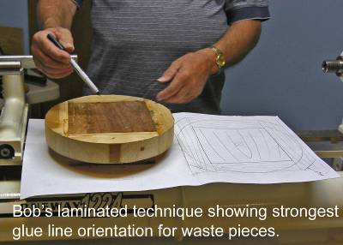
Bob demonstrated a technique for the turning of a shallow square walnut bowl and described both preparation and execution using

simple techniques.
The preparation for turning was carried out by machining a square piece of walnut, than gluing spruce waste pieces to enable a band sawn circular blank. Gluing is carefully done to maximize the strength of the glue joints. Care is taken to mark the center – an “off- center” square turning would not be desirable.
Bob utilized friction to hold his blank. A wooden friction plate is used at the headstock. The tail stock center is used without the center pin to minimize the depth of penetration of the foot.
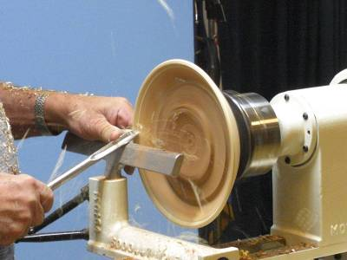
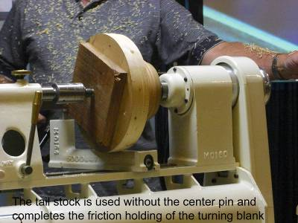
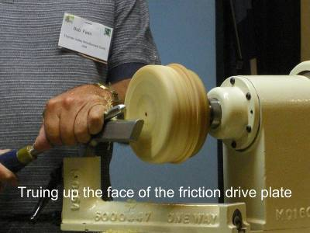

The live center and friction plate is all that is necessary to hold the blank.
The outside of the shallow turning is completed and a tenon turned for later use while turning the interior. Care must be taken to ensure a proper curve and to stop at the corners so as to not round them.
The sanding would also be done at this point.
The piece is reversed and the tenon is gripped by a scroll chuck.
The interior is carefully turning with attention to maintaining a uniform wall which will be reflected in the square side of the turning.
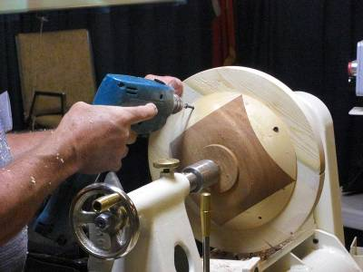
You may have noticed several holes in the waste wood used to surround the walnut. Now is the time to turn off the foot and finish the bottom. A wooden faceplate is used and the turning is fastened to the face plate with screws through the aforementioned holes in the waste wood.
Once completed and finishes the waste wood is carefully removed using a band saw and/or a belt sander.
This project will form the challenge for November – A square turning.

Natural edge bowl challenge

Novice
1st Geoff Miller
2nd Mike D’Avirro
3rd Geoff Miller
HM Nick Braunsch
HM Paul Jackson
Open
1st John Van Kessel
2nd Jackie Morningstar
3rd Jackie Morningstar
HM Leo Van der Loo

Congratulations to the ribbon recipients and to all who rose to the challenge, AWSOME work!

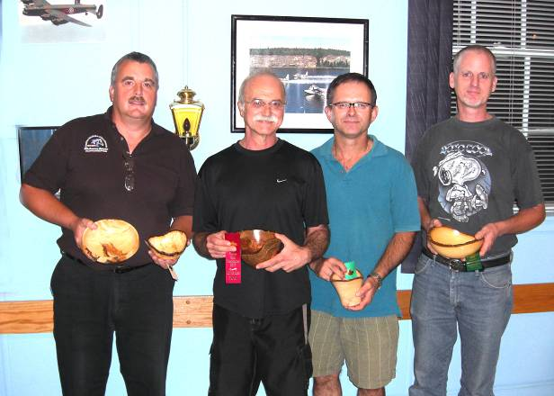
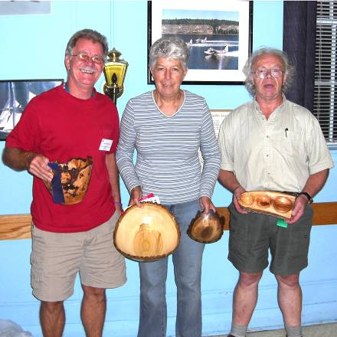

Photos of the challenge entries follow later in the newsletter.

October meeting
This meeting featured examples of Rose engine for ornamental turning as developed by Gary Miller, John Calver and Al Johnson. As I was not at the meeting pictures of the units will have to suffice along with a description on rose engines from on-line Wickepedia at http://en.wikipedia.org/wiki/Rose_engine_lathe.
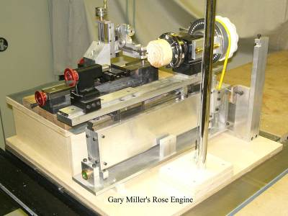
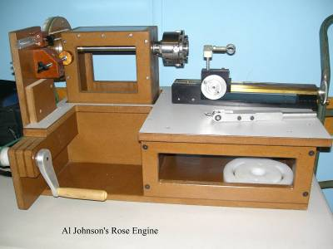
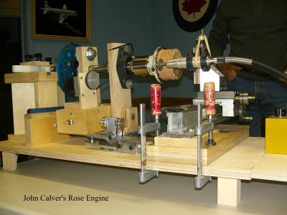

Gary Miller’s engine John Calver’s engine Al Johnson’s engine
Rose engine lathe From Wikipedia, the free encyclopedia
A rose engine lathe is a specialized kind of ornamental lathe. The headstock rocks back and forth with a rocking motion or along the spindle axis in a pumping motion, controlled by a rubber moving against a rosette or cam-like pattern mounted on the spindle, while the lathe spindle rotates. Rose engine work can make flower patterns, as well as convoluted, symmetrical, multi-lobed organic patterns. The patterns it produces are similar to that of a Spirograph, in metal. No other ornamental lathe can produce these "rose" patterns.
Engine work is easier than a high-gloss finish, especially in recessed areas, and is often found inside the casing of expensive watches. It sometimes confused with "jewel finishes," a much cheaper process of making swirly marks in metal made by attaching an abrasive pad to a power drill. Jewel finishes used to be common on stereo faceplates and automobile interiors.
[edit] See also: Engine turnings
[edit] References
A catalog and history of Holtzapffel lathes

Training courses
Turning 101,– This popular beginning program covering spindle turning and basic safety will be repeated,
Turning 102 - This popular beginning program covering fundamentals of bowls
dates as they become available, planning is geared for spring, probably after the London Wood Show.
The turning 103 program will be a basic turned box, scheduled for November 23rd .
Please let Scott know of your interest for the “sign-up” sheet.
A somewhat more advanced series of sessions is under development, as above, more info as it becomes available. Input is also being solicited for topics, content, and presenters for these sessions. The purpose of this series is the sharing of advanced techniques by advanced turners to experienced turners. There will be a chance for the developing turner to learn skills through “hands-on”.
Topics we are considering are: piercing, colouring, pyrography, chattering, rotary tools (texturing), air-brushing. Participants will be required to bring in turned items for the hands-on made of soft maple.
One man show, the first by the Ontario Craft Council
The Ontario Craft Council will be presenting a one man show, their first, with the turnings of Doug Magrath. For this showing Doug is on the lookout for any unique pieces of wood to turn unique items. If you are aware of anything that might fit the bill please contact Doug, he is in the market… He is partial to burls or historic woods from Ontario, and prefers to turn green.
He may be reached at 519-432-0557.
Woodstock Wood Show winners
Gary Miller 1st in Artistic, 1st in Containers and bowls, 1st in Seniors for a total of three ribbons
Mario Moran 1st in laminated (segmented), 1st & 2nd in miniature, 2nd and 3rd in vessels and containers and a 3rd in artistic, all in the open class, a total of six ribbons
Doreen Bowden a 1st in nesting bowls and an Honorable mention in scalloped edge bowl, both in the amateur category for a total of two ribbons.
Jackie Morningstar a 2nd in decorative, 3rd in Bowls, 3rd in artistic, a 3rd in platters, for a total of four ribbons all in amateur
Quite a showing, congratulations to you all! We have asked the winners to bring their entries and ribbons in to the November meeting.
Elections
Elections are coming up. Is anyone willing to run, for any office? Before saying NO, please read the following and give it some thought…

(The following was taken from a guild newsletter but it applies to all guilds, including ours. Please give it some consideration – Gary)
A Reminder to all members
By Jim Johnson (GVWG
Volunteers are the backbone of the Wood Turners Guild. Without volunteers the guild would cease to exist. Virtually every member of the guild needs to volunteer in one form or another.

You may wonder what you can do for the guild as a volunteer. The responsibilities range from demonstrations at meetings, participating in outside functions such as the local wood show, to help on a monthly basis with set-up of the hall, and clean up at the end other meeting. As you can see some of these jobs are onetime events which require several hours of work, while others are monthly commitments that take only a few minutes. The choice is up to you as to how you can help the guild with these tasks.

Please step forward and commit yourself to whatever you feel comfortable with doing. If you have never done a job before, we will teach you how to do it. There is something for everyone, no matter their skill level or amount of time to offer. We hope we can count on every member to do their part and volunteer.

There will be a sign-up sheet that you can commit to at the next meeting.

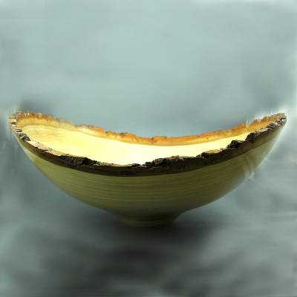
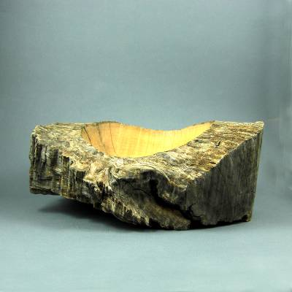
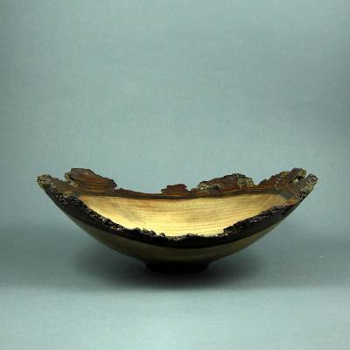
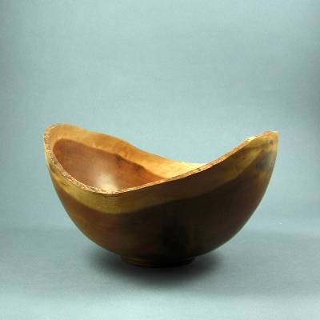
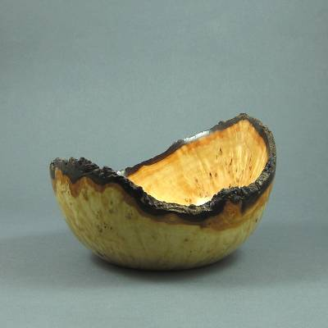
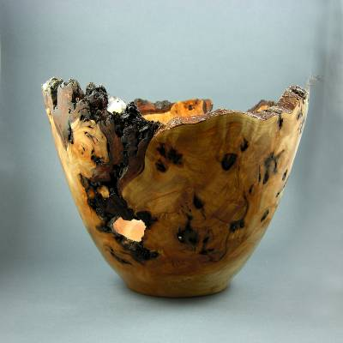
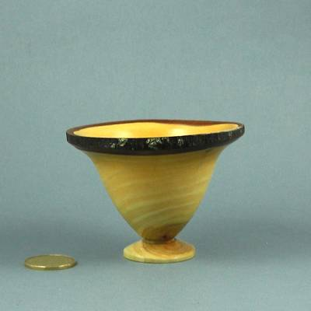
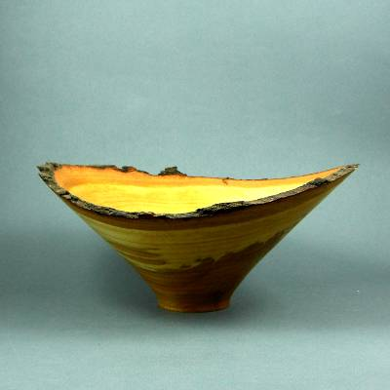
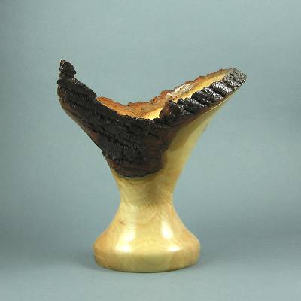
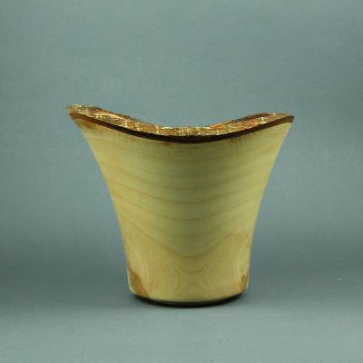

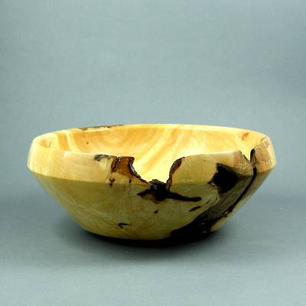
More “Natural Edge” challenge bowls are on the next page
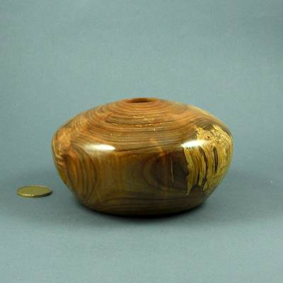
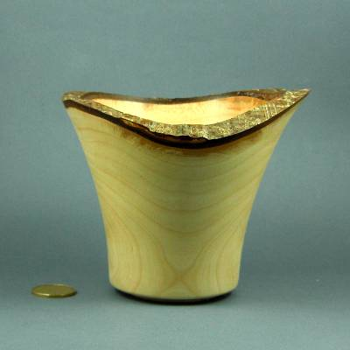
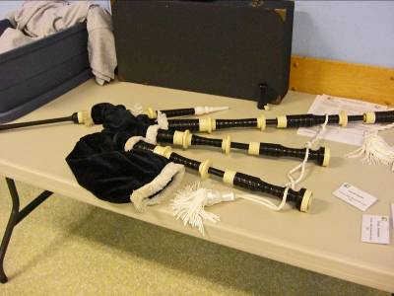
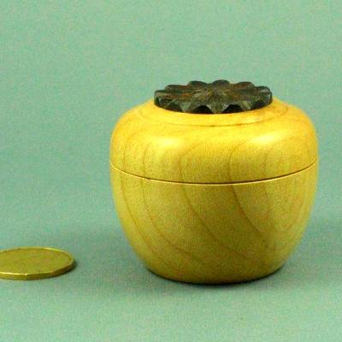
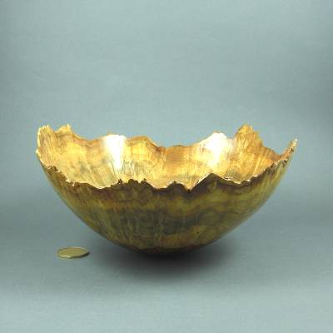
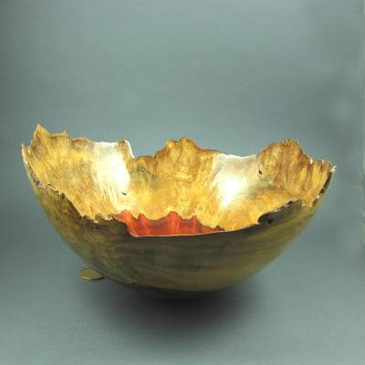
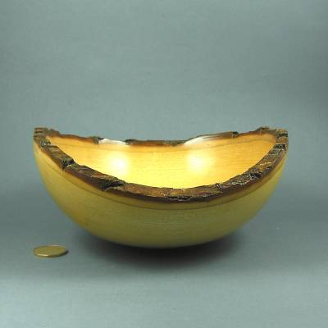
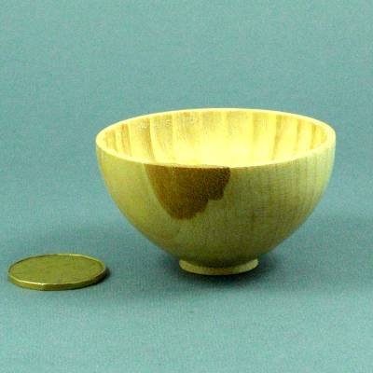

The preceding are the September “Natural Edge” Bowl entries

The four turnings are the “Show and Tell items for September

***********************************************************************************************************************
The 2008-2009 season’s dates for meetings and other scheduled events.
We are looking at several guest turners that may necessitate schedule changes. We will keep the members informed of changes.

Date | Meeting or events | Shows/events/comments
September 4 | Fall season begins | A demo by Bob Fenn of a square turning  Natural edge bowl challenge
October 2 | Monthly meeting | Demo of the rose engines that are being developed by John Calver and Gary Miller. Two different approaches
October 24 -26 | Inter-club competition. Black Creek Pioneer Village in Weston | Inter club competition, 5 categories with 4 skill levels. Details will be reviewed at the September meeting
November 6 | Monthly meeting | Demo by Bob of a Christmas decoration using sea urchins  Challenge of a “square turning”  A tool sale, bring in your surplus tools
November 23 | Turning 103 | Turn a basic box
December 4 | Monthly meeting | Christmas decoration challenge.  Show and tell themed around a turned Christmas gift.  Bernie Hrytzak, demo on a variety of embellishments.
January 8 | Monthly meeting | Tentative – Air brushing demo.
February 5 | Monthly meeting | Open
February13 – 15 | London Wood Show and TVWTG turning competition | Open
March 5 | Monthly meeting | Open
April 2 | Monthly meeting | Open
May7 | Monthly meeting | Open
June 4 | Monthly meeting | Chain saw demo and safety aspects.
June 6 (a Saturday) | Guest turner demo  9:00am – 5:00pm | Bhin Pho demo, details as they develop. Fee is expected to be ~$40 which will include lunch.  Look at his website for an idea of this turner’s skills (see internet site section).  Sign up now to be sure of a seat.
June 26 – 28 | AAW Symposium | AAW symposium, which will be in Albuquerque, New Mexico.
July/August | Summer break | Summer break.
 | Topics in the discussion stages, not yet formalized as to date or content.  For the fall and beyond.  Program Ideas and suggestions for guest turners are always welcomed by your committee | -Segmented turning open and closed (“how to” specifics) will be covered in several sessions.  -Hand thread-chasing.  -Guest turners or seminars.  -Design? What makes a makes a “good” turning into an “outstanding turning?  -Wine stoppers.  -A safety night (discussion/panel)  -A “show and sell” table of turnings”, a “show and trade” table for your turnings.  -Vacuum chucking how to build a system and how/where to use it.  -Future challenge ideas: a pair of “something”, a seed pod turning.  -Utilize home chucking techniques where appropriate in Guild demos.  -Sharing of advanced techniques  -A repeat of Turning 101, a possibility for post wood show, express your interest  -A Turning 202 seminar  -Turning tips learned from experience (a number will be presented at each meeting and published in the newsletters and on our website  -Airbrushing

Note, meetings start at 7:30, doors open at 7:00. Raffle tickets, the library, and the Round table critique will be available between 7:00 and 7:30.
Items both wanted and for sale
Ads are free for members and run until you sell your item or withdraw your advert. Members can support other members by buying: good deals and good prices!
Please note. The Guild provides a means of connecting buyer and sellers through these ads. It is up to the buyer to ensure the item offered is as stated and the two parties should agree between them as to warranty or guarantee for the item.
To run a new ad in our newsletter or to remove a sold item, call Bob at 519-457-6555 or email him at 66.bobhewson@rogers.com .
We welcome small business card type advertisements at a rate of $30 per year. We print 6-7 issues per year on a non-date-specific schedule. We also upload our newsletters to the internet at http://members.rogers.com/tvwt1/ for viewing in glorious colour.
For sale: I make and sell cutters for the Stewart system and or boring bars. They are made of hi-speed steel. Available in three sizes, prices are $15, $20, & $25.
Call Mario Moran at 519-336-0550, or see him at the Guild meeting or mario.ada@sympatico.ca
Wanted
Parts for old lathes
Call Murray Tyler at 519-225-2854 after 5 PM

For Sale:

Lee Valley Mitre Vise - 2 available unused.
Price - $50.00 for pair.
Call: Alf Buckle at 1-519-271-8489 or email at abuckle@sympatico.ca

For Sale
Craftsman router, electronic, variable speed, adjusts in 1/32” & 1/64” increments
Only used 5 times, cost $115
Sell $60
Bandsaw – Craftex 15”
Includes fence, ¾ hp motor, plus Hi-Level accessory bearings.
Used for about 1 year, cost $488 new
Sell $350
Call Gord Tallman at 519-455-4526

For Sale

A friend of a friend has some walnut lumber for sale. There is about 338 board feet of 5/4, 7/4 and 8/4 of widths from 6" to 12" and 12' long. It has been air drying for 6 years and is roughly 10% moisture. If anyone is interested, they can contact him direct.
Charlie Minett 1-519-272-0667
email is charlesp@minett.com

For Sale
General 15 inch bandsaw model 490-1
It has seen little use, runs like a charm.
Price: Asking $1500.
Imported floor model drill press, 5/8 chuck 3/4 hp
Price: Asking $150
Call Rob Williamson at 519-672-2998 or email robriw@hotmail.com
For Sale:*
I can make a tool similar to the Hunter Tool Company’s hollowing tool, two different sizes ¼ & 3/8" with carbide cutters.
All the member has to do is turn a handle for the tool.
If they want a bend or curve in rod it can be done too. They will have to make a drawing if they want a bend put in the rod.
Price: $40 straight, $50 bent or curved
An aluminum handle to accept the tool is also available, ready to go 1” dia x 15” length.
See my sharpening jigs at the next meeting.
Call: Al Johnston at 519-679-8718
592 Mapledale Ave. London

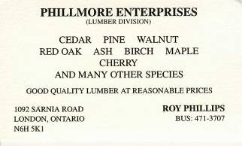

For Sale:
14" Delta Bandsaw, Model# 28-206. This machine is only 3 years old and is in "like new" condition

Price: is asking $500.00
Call: Marlene Legault (519)-369-1031 (Durham) or Email at: marlenelegault@sympatico.ca

For Sale
A King ch900 lathe, complete with cabinet, this is a muti -speed lathe, without changing belt
A swivel head
With base with wheels for moving around if needed
Price: $450.00
I also have a Beaver/Delta antique lathe for sale that I have brought back to life, early 1950.
Price: $200.00 complete with stand
Call John McGuire at 519-659-6810.
106 Mark St.
London, On
Fletchs Fetchings

Supplying unique wood from Africa and Asia.

Turning blanks available for pens, pool cues, bottle stoppers, duck calls, bowls, etc.

Reasonable pricing.
Call Jim Fletcher at 519-633-0538.
Or visit my website www.fletchs-fetchings.com
I also sell on eBay under seller id fletchs_fetchings

For Sale: Down Draft Sanding table
Down Draft Sanding Table 39" - Portable for sale.
Reason for selling, I'm building this feature into my new workbench and I will not require the portable.
It is the 39" Busy Bee Model that has a regular price of $199 and is currently on sale for $148.
The link to the listing on the Busy Bee website is as follows and includes a photo: http://busybeetools.ca/cgi-bin/picture10?&NETID=1037020719081960152&NTITEM=CT121
Price: $95
Call Fred at 519-858-2558
or email frederick.rodger@sympatico.ca
For Sale:
General Mfg. 260-20VD, 20” Wood Lathe
2HP / 220 Volt / single Phase Motor
Complete with all General Mfg. supplied accessories -
(Live Centre, Spur Centre. 4” Tool Rest, 12” Tool Rest, 3” Inboard Faceplate, 6” Inboard Faceplate, Faceplate Wrench)
PLUS
General Mfg. Bed Gap-Filler, 3” Outboard Faceplate
Plus
Oneway Mfg. Rotary Vacuum Fitting,
Robert Sorby Modular 6” Tool Rest
Robert Sorby Modular 9” Tool Rest
Robert Sorby internal bowl rest (S - shaped in plan)
Robert Sorby external bowl rest (Reverse S-shaped in plan)
Custom Moveable Stop/Start Control Box
Purchased NEW - May, 2003
Excellent Condition
$3,500 OBO
Call: John Andruskiw - Oshawa
Phone: (905) 579-2257, e-mail jandruskiw@rogers.com

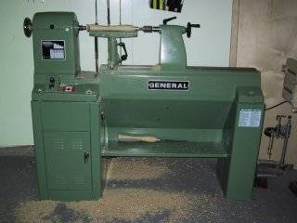

Help Wanted

I wonder if you can post a request to the membership.
The wheels in my 10" band saw are plastic and want o replace them with metallic ones. It is a Rockwell that I bought more than 20 years ago and it is the work horse in my shop
If anybody knows where to get them it would be a good help.
Maybe they could see me at the meeting if they have any information.
Thanks,
Mario Moran

For sale

11 old English tuning chisels by Robert Sorby
Skews 1 ¼” and 1”
Gouges ½”, ¾”, 1” some deep and some shallow “U”
Several unhandled.

Several “Forstner” bits 5/16”, 1”, 1 ½”, 1 ¾”

Auger bits, 5/8” and 4/4”

Call: Shelly Paulocik
519-349-2743 (Lakeside)

Lathe for Sale
This lathe comes from a guy who now lives in Mexico and has contacted one of the other guilds
The wood lathe that he has to sell:
Union Graduate Lathe and I believe it is a 30 inch bed.
I have a number of accessories for the lathe but am not sure as to the extent of the equipment since I have been absent for some time. I know that I have inboard and outboard face plates and several rests. As I mentioned the unit was bought and never really put into use as we were moving from Acton to Kendal, Ontario almost immediately.
I am interested in selling the unit as my son is in the process of selling the property. If anyone has an interest I can be contacted at dadriver@aol.com.
In the meantime I will continue to determine the fair market value of the lathe.
The lathe is similar to below but I think this might be a 42" that is pictured.
Thank you again for you kind assistance,
David Wharton
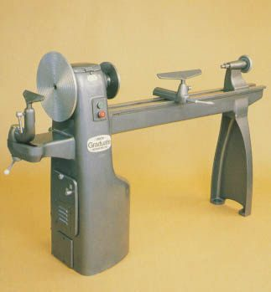
View full size

FOR SALE
4" Dust Collector accessories. All in great shape, some new. ASKING 1/2 PRICE. Would prefer to sell all together but will consider pieces. Make me an offer on the bunch.
QUANTITY TYPE SIZE $ NEW COST ea
15 S/S CLAMPS 4" .79
1 "Y" 5"X4"X4" 8.50
3 "Y" 4"X4"X4" 8.50
5 ELBOWS 4"X4" 7.99
1 T" 4"X4"X4" 8.50
1 REDUCER 5"X4" 5.99
3 BLAST GATES 4" 5.50
2 SPLICE (coupler) 4" 6.50
1 END CAP 4" (forgot)
1 JOINTER HOOD 4" 3.99
Call: Gary Miller at 519-858-2445
For Sale:
-8" Craftex grinder with a Oneway Wolverine grinding jig. The system has two balanced Oneway grinding wheels and Oneway balancing system. The system originally cost in excess of $350.00. Buy the complete system for only $125.00.
-1/3hp electric motor mounted with an on/off switch. $25.00
Call: John Calver at 519-455-6998 or email woodchip1@rogers.com
For Sale:

General model 260 lathe.

Price $3,000 OBO

Call: Jackie Morningstar at 519-264-2970

