.



Thames Valley Woodturner
A publication of the Thames Valley Woodturners Guild
A chapter of the AAW

Volume 10.4 May June 2008

Turning events, Wood shows, and competitions in our region and farther afield

February 6, 7 & 8, 2009 The Arizona Woodturner's Association’s 3rd Desert Woodturning Roundup at the Mesa Convention Center, Mesa, AZ. details: www.desertwoodturningroundup.com
June 26 – 28, 2009 AAW symposium, which will be in Albuquerque, New Mexico

Contents
Additions to library P1
Internet sites of interest P1
New members P1
Guest turner returns P1
Definition of an artist P2
AAW symposium in Richmond Va P2
Bernie”s tips P2
Visiting turners P3
Turning 101 P3
March meeting P3
April meeting (drum turning) P4
Calendar P6
Show and tell P7
For sale P7 & 8
For a Guild info/policy sheet, call or email Bob Hewson or refer to our web site at: ca.geocities.com/tvwt1@rogers.com/

Turning events, Wood shows, and competitions in our region and farther afield

February 6, 7 & 8, 2009 The Arizona Woodturner's Association’s 3rd Desert Woodturning Roundup at the Mesa Convention Center, Mesa, AZ. details: www.desertwoodturningroundup.com
June 26 – 28, 2009 AAW symposium, which will be in Albuquerque, New Mexico

Contents
Additions to library P1
Internet sites of interest P1
New members P1
Guest turner returns P1
Definition of an artist P2
AAW symposium in Richmond Va P2
Bernie”s tips P2
Visiting turners P3
Turning 101 P3
March meeting P3
April meeting (drum turning) P4
Calendar P6
Show and tell P7
For sale P7 & 8
For a Guild info/policy sheet, call or email Bob Hewson or refer to our web site at: ca.geocities.com/tvwt1@rogers.com/

Turning events, Wood shows, and competitions in our region and farther afield

February 6, 7 & 8, 2009 The Arizona Woodturner's Association’s 3rd Desert Woodturning Roundup at the Mesa Convention Center, Mesa, AZ. details: www.desertwoodturningroundup.com
June 26 – 28, 2009 AAW symposium, which will be in Albuquerque, New Mexico

Contents
Fall season starts P1
Additions to library P1
Internet sites of interest P1
New members P1
Mandolin by Bernie P2
Visiting turners P3
Old working lathe P3
Jack de Vos seminar P3
May meeting P4
June meeting P5
Show & Tell P7
Bernie”s tips P7
Calendar P8
For sale P9 & 10
For a Guild info/policy sheet, call or email Bob Hewson or refer to our web site at: ca.geocities.com/tvwt1@rogers.com/

Fall season starts Thursday, September 4th at 7:30, doors open at 7:00
Tonight’s program includes a demo by Bob Fenn of a square turning.
Remember too this is the night of the Natural Edged Bowl Challenge.
Please feel free to bring in examples of turning you may have completed during the summer for the “Show and Tell” table.
My apologies for the timing of this issue of the newsletter, it’s just been a busy summer, something else always seemed to come ahead of it.
Additions to the library
Cindy Drozda’s “Fabulous Finial Box” (DVD) and “Elegant Finials” (DVD),
Mike Mahoney’s “Hollow Forms and Urns, A Workshop” (DVD), Relief carved embellishments by Tony Cortese.
Interesting new or updated Internet sites of interest to members
When checking out newsgroups there are three main areas to browse, the messages, the photo albums and the files. Messages are the day to day member messages and threads which can also be searched from either the home page or the search box at the top of the message screen. The photo albums are like our monthly “Show & Tell” where members can post picture of their work. Files are usually “how to” files on a topic, project or technique prepared by group participants.
Google, Yahoo and MSN host newsgroups that cover virtually any topic you can imagine
- Segmented turnings http://www.islandspinner.com/gregs_website_011.htm
- Segmented turnings – Curt Theobald http://www.curttheobald.com/index.htm
- Pedigree Woodcrafts in Utah. A new (to me at least) supplier of pen making stuff as well as turning tooling http://pedigreewoodcrafts.com/
- Several tool reviews that may be of interest to our members http://www.onlinetoolreviews.com/
- I was doing a little surfing and looking at “You Tube” and was surprised at what I found by searching rose engine, wood turning, miniature woodturning and woodturning tools. Have a look you may be amazed too. http://www.youtube.com/results?search_query=rose+engine&search_type=
- For those interested in miniature turning, this site will challenge you http://www.rjtminiatures.com/wood_bowls_vases_new.html
New Members
Please welcome 2 new members Frank Dyer and Harold Blythe.
The addition of Frank and Harold brings our membership total to 90, perhaps we will surpass 100 members by the end of the 2009 London Wood Show.
Treasury
We have $2,050 available after outstanding items.
Show and Tell, Critique, and Round Table
The critique feature has been discontinued as a regular feature. While of interest to some members it is felt by your executive that the general membership does not wish to participate in a public critique.
The round table discussion prior to the meeting will continue for those of you who wish a more private form of feedback on their work.
“Show and Tell” is back, please one turning per member or guest.
The following article is reprinted with permission from the Chatham Daily News

Locally-made mandolin in exhibit; one of only 42 pieces accepted worldwide

Posted By BOB BOUGHNER
Bernie Hrytzak, of Chatham, checks the sound quality on his handmade mandolin, which will be featured at three exhibits in the U.S. this summer and fall. The retired engineer designed and built the round-body instrument.
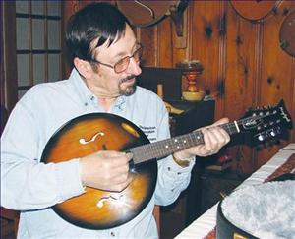
A retired Chatham-area professional engineer has made it big time in the ever-growing world of wood turning.
A wooden mandolin, designed and meticulously pieced together by Bernie Hrytzak, has qualified for a juried exhibit in June by the Association of American Wood Turners.
The exhibit will be at Gallery 5 in Richmond, Virginia. The exhibit will also be displayed this summer in St. Paul, Minn., and in Oklahoma.
Hrytzak's mandolin, which he frequently handles with plastic gloves to prevent scratching, is a full-size, playable instrument.
The requirements for entry into the exhibit were extremely high and Hrytzak's mandolin was one of only 42 successful pieces accepted from around the world.
"I'm very pleased,'' said Hrytzak, one of more than 10,000 members of the Association of American Wood Turners. He also holds membership in the Thames Valley Wood Turners' Guild in London.
"I've been interested in woodworking all my life,'' said Hrytzak, who spent much of his engineering career with Siemens.
He said he discovered the pleasures of turning bowls and vases from different kinds of wood more than four years ago.
"Retirement at the end of 2006 provided more time to devote to my passion,'' he said.
He said much of the wood he uses to create objects is found in Chatham-Kent. "The maple on the back of my mandolin came from a maple tree that fell in my front yard,'' said the Eastlawn Drive resident.
Hrytzak said in order to be recognized in wood turning circles, it's not enough to be just a good wood turner. "It's also necessary for a wood turner to explore his or her own artistic quality,'' he said.
He first began working on round musical instruments last year and the mandolin is his second piece of work. The first was a round guitar, which he designed and turned out by hand.
"The design of my round mandolin is based on lathe turning and the wood I used is cedar with a selected number of growth rings and with specific orientation for proper sound board characteristics,'' he said.
Hrytzak said a rich sound is produced by using specific shape profiles to the soundboard and backboard of the eight-string instrument.
The maple neck of the instrument was lathe turned and then profiled to meet playing requirements.
The finish, included shading and edging and the application of more than 35 coats of liquid plastic.
"She's a beauty, if I do say so myself,'' he said.”I would value her at several thousands of dollars.''
Hrytzak plans to travel to Virginia in mid-June to see firsthand his mandolin on exhibit at Gallery 5.
He's also planning to build other string instruments with his unique style and is considering a how-to-do video showing his technique to others.
BOB BOUGHNER PHOTO
Article ID# 1045025
Please use the internet and our site as a resource.
Our website has our recent newsletters, a list of Preferred Suppliers, the Mentor list, and our Guild policy page plus a number of interesting links. We will keep the web site as our most current communication device (if you do not have internet access please let me know and printed copy of any of the above can be made available to you Ed).
Our web site is http://ca.geocities.com/tvwt1@rogers.com/
Visiting turners
For the interest of members we are listing future seminars and visiting turners in the surrounding area as we learn of them:
These are the demonstrators that WGO, GHWG and TVWG and other guilds or clubs have scheduled. The guilds/clubs have said (or implied) that members of other clubs are welcome to attend:

Guest turner | Date | Sponsor | Fee | Contact | Comments
Peter Exton - highly acclaimed turner | Sept 18 | WGO Burlington | $tba
David Hout - metal spinning (on wood lathe) | Nov 15 | WGO Burlington | $ tba |  | A possible workshop or may be able to arrange for him to come to TVWG
Kurt Hertzog - well known all around turner and pen specialist | Jan 2009 | WGO Burlington | $tba
Doug Fisher |  | WGO  Burlington
Bhin Pho | June 6 2009 | London | $tba
If anyone would like to attend any of the above please let Gary Miller know. He will ensure that there is space and will confirm the fees. Carpooling can be arranged if there are sufficient numbers.
As we know more we'll keep the membership apprised and will keep this as an ongoing feature in the newsletter.
An old working wood lathe
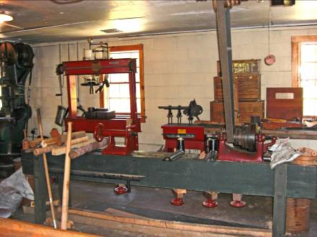
Photo of a lathe made during the early 1800’s. About a 20 inch throw and an 8 foot bed
It is powered by overhead leather belts with power derived from a water wheel draining water from the Erie Canal into the Maumee River, just outside of Toledo, Ohio.
During the winter when the canal is frozen the power is derived from a coal fired boiler.
The drive system develops 90bhp, and 1000foot pounds of torque.
Besides operating the tools in the workshop there is a sawmill attached as well as a grist mill on the second floor operated by the same drive system.
A fully operating set of locks and a canal boat pulled by a pair of mules and operated by period re-enactors runs past the mill.
An old water powered electric generator is out of service since it operated on a non-standard 48 hertz frequency.
All equipment is fully restored and operational.
Report on the Jack de Vos demonstration
Jack began his demonstration by discussing the characteristics of the Walnut blank that he would be using. He had already turned a dovetail on the base end which would be used to hold the piece while he did the initial shaping. He pointed out how the grain was oriented and the fact that the wood had a “shake” or split following the grain of an unknown depth. Based on these observations he decided which end would be the top of the finished piece. He also encouraged turners to draw what they are going to make before starting to turn and about what constitutes pleasing proportions and referenced the “golden mean”.
He then discussed the procedure he would be using and reinforced his explanations by drawing some details on cardboard. It would be his intent to turn a vase form with a very small opening at top. He would create the illusion of turning it in the conventional way (hollowed through the top) but, in fact, was going to hollow it from beneath and obscure this by plugging the hole in the base with a “plug” cut from the same wood and location and matching the grain.
Jack roughed the shape of the vase then refined the raised neck and turned a dovetail a little beyond the neck with which he would mount the vase in a chuck to turn the “plug” and hollow the bottom. He also drilled into the neck about 1.5” and, using a gouge, opened up the hole in the neck a little and tapered the hole to approximately follow the shoulder of the vase. He finish turned the body of the vase and power sanded out any minor imperfections. He emphasized the need to mark the bottom of the vase and the rough shaped plug for later grain matching. He then parted off the plug with the original dovetail intact. He then hollowed the vessel with his home-built, shielded hook, hollowing device. His hollowing tool had an outrigger to counter torque and catches. The outrigger had adjustable “springy” thickness gauges attached to it. He demonstrated how these were put to use as he came close to turning to the final wall thickness.
When it was hollowed to his satisfaction he carefully prepared the base to receive the plug. He pointed out that there would be a small chamfer between the plug and the base to help obscure the glue line. He cut half of the chamfer into the base. He then placed the plug into the chuck and, with frequent checks, turned it to fit the hole in the base of the vase with a tight fit. He then cut the other half of the chamfer into the plug. Aligning the grain, he then glued the vase to the plug (which was still mounted in the chuck), bringing up the tail stock to ensure perfect alignment. After the CA glue cured, he reverse mounted the vase and turned off the dovetail near the neck, refined the final shape and finished sanding the vase. He then parted it off.
Jack used a piece of plastic sewer pipe (mounted in the chuck) with an inset rounded wooden edge and a piece of router mat to hold the vase between it and the tail stock to finish off the bottom of the base.
Jack's second part of the demo consisted of carving a highlight into the vase. It is a swirling groove that follows the grain from the top opening to near the bottom. It starts very narrow at the opening, growing in width through the girth and narrowing again as it virtually disappears toward the bottom. Jack used a Dremel for this procedure and cleaned up the edges of the groove with small files which had had some faces or edges ground smooth to eliminate any possibility of damaging adjacent sides. He then used various small burrs to texture the bottom of the groove. He pointed out that when doing gallery pieces he turns the walls thinner (1/8” to 3/16”) and would actually perforate the groove in some places. Although he didn't do it in the demo, he often gilds the textured areas and applies contrasting shades of color into the texture.
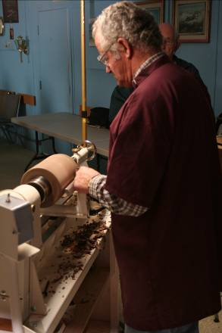
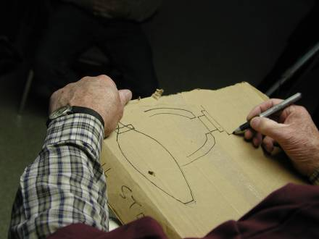
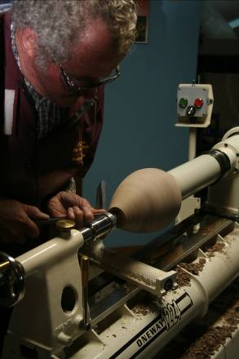
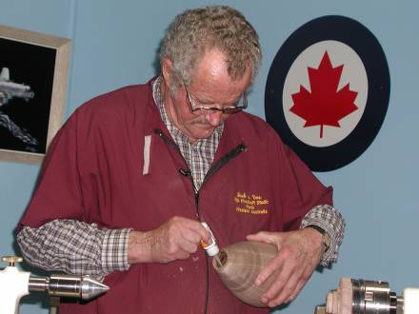
Jack wound up his day by doing a brief slide show. He showed pictures of some of his prize-winning pieces matched with where in nature he found his inspiration for them.
Always a good idea to have a plan of Preparing his bottom plug hole,
action using CA glue

Jack preparing the walnut Detailing the plug to
blank disguise it.
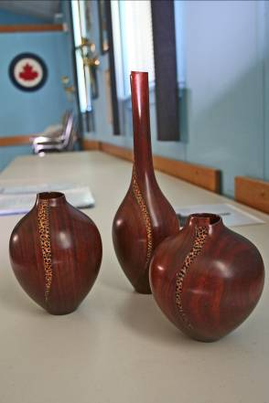
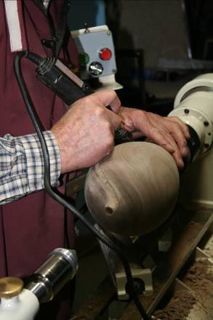
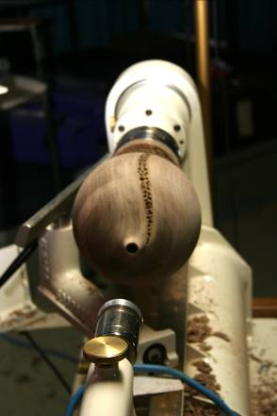
Photos left to right. After laying out the pattern Jack uses a rotary tool to pierce the vessel.
The three examples of his pierced vessel made from Australian Jarrah.
We have other photos of his demo which can be made available, space limits precluded their inclusion in this issue.

It was an entertaining and inspiring day for all who attended. Our thanks to Jack for sharing his skills.
Written by Gary Miller

May meeting
May meeting was our pen challenge
John Van Kessel demonstrated the natural edged bowl technique and the challenge to turn a natural edged bowl will be held at our fall meeting on September 4th.
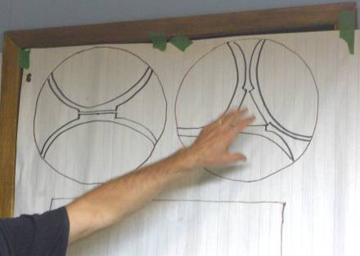
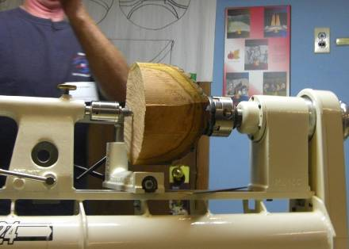
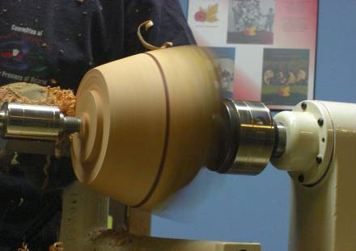
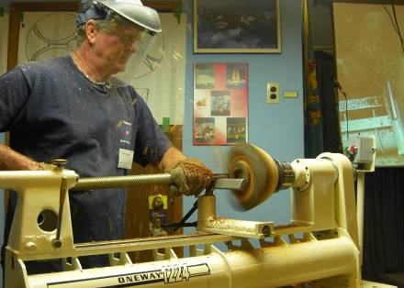
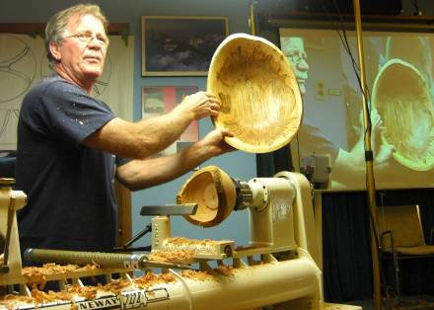
From top left to right,
John explains how to visualize the bowl in the log
After the blank is cut circular on the band-saw it is securely fastened to the chuck and tail stock
Shaping begins. A tenon is cut for internal shaping. Watch the “air”, it can reach out and bite the unwary turner!
From bottom left to right,
Hollowing out. Note the mask and gloves that john wears for safety!
John has completed the rough turning and will set the piece aside to dry before final turning, sanding and finishing. His finished bowl shows how careful planning can emphasize the grain pattern.
Pen turning challenge
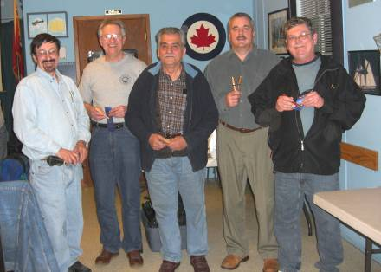
During our May meeting we held the pen turning challenge. Space does not permit details of all entries, but they will be posted on the web site. The winners are shown in the accompanying picture.

June meeting
Our June meeting was a bonus meeting, an extension meeting of what used to be our usual season and replaced our former BBQ. The extra meeting was well attended and Fred Roger did his usual bang-on presentation on his huge winged sculptural turning.
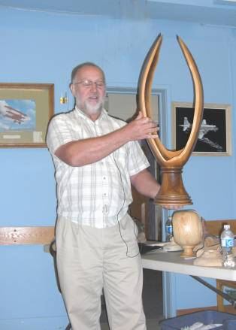
Fred Rogers gave us a presentation on the design of his “winged freeform”. This turning was made from a large walnut crotch and utilized most tricks and techniques in a turner’s repertoire. He traced out for us the process from harvesting the tree, determining the correct axis to align the “block”. Being such a large piece in the raw it required considerable effort just to raise it to lathe height. Mounting it was another challenge requiring special shop-built jigs
Once turning began the wet wood wandered in form as it gave up water. Special hollowing tools were used; care was taken to watch for the “air” image so as not to let it bite him.
Considerable hand sanding and finishing resulted in the prize winning piece you see. Nice job Fred, thanks for sharing with us.

Show and tell
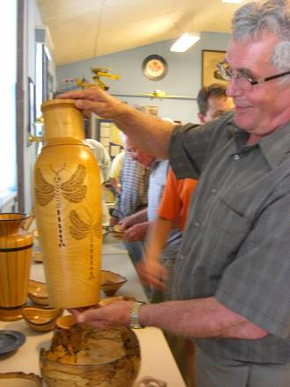
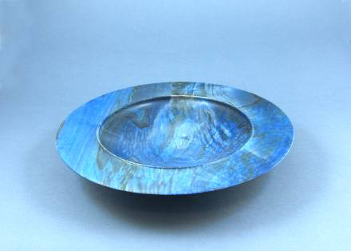
A number of natural edged bowls were on display, brought in for the “Natural edge bowl” challenge. Unfortunately the challenge is in September so these items will be held for the next issue and the September challenge. There were in addition a number of items which are shown below
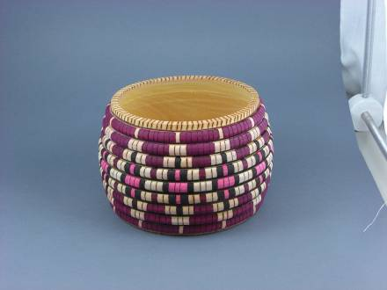
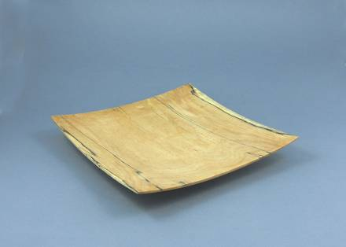
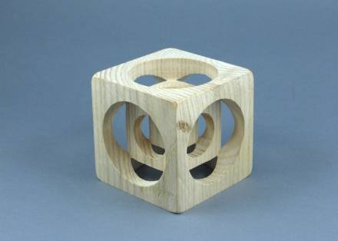
Bernie’s Tips
Topic: Turning Blank Safety.
Details
When selecting green wood (or any wood), one must ensure that the piece is sound and has no defects hidden within. Crotch wood (place where two limbs meet) is usually selected because of the “flame” pattern that is displayed when the part is turned cross axis as in a bowl. The part is oriented so that the inside material becomes the bottom of the bowl, so that in this manner, the flame pattern remains in the bottom after the bowl is finish turned.
Safety considerations
It is especially necessary to be very careful with this type of wood because a fault line can be present along the intersection where the two limbs meet or the material might have a rotten spot where water got in over the years. The other possibility is that the bark actually grows and meets inside resulting in a very weak bond. The parts can separate during turning a sever injury can result personally. The attached photographs show a 12” part that was turned and a major part of the blank separated and was propelled across the shop, luckily with no major consequence.
Recommendation
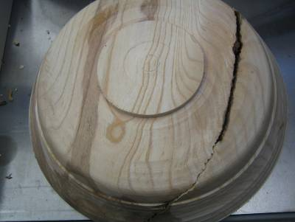
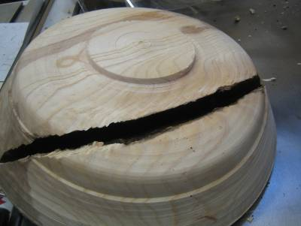
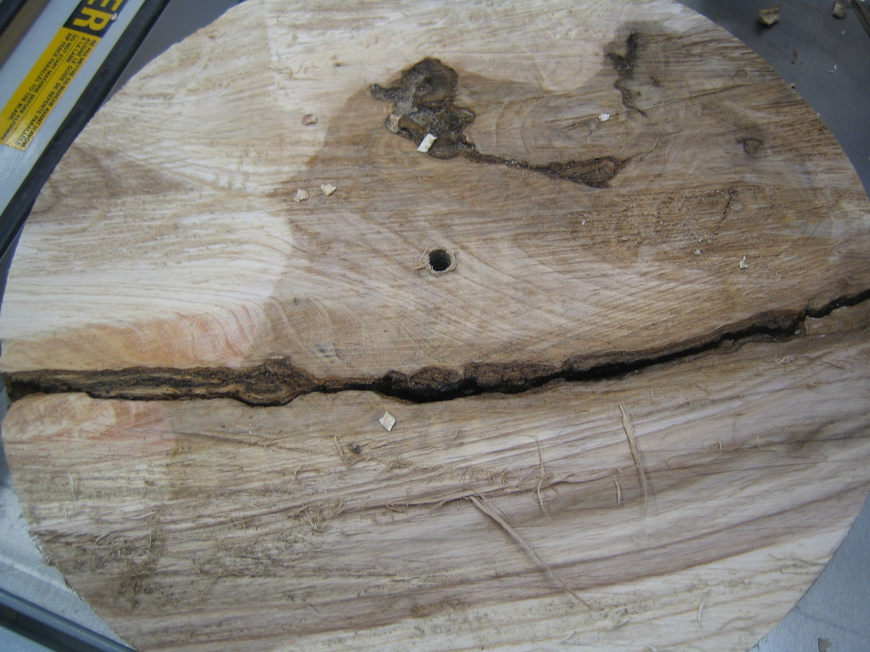
I would discard any wood that shows signs of cracks or bark inclusions, and even if you have a considered “suitable” piece stop, frequently during turning to recheck the integrity of the blank.

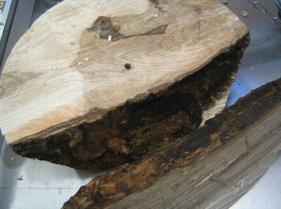
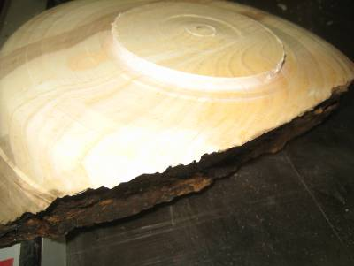

by Bernie Hrytzak ©
To review all of Bernie’s tips check http://www.berniestips.com/

The 2008-2009 seasons’ dates for meetings and other scheduled events.
We are looking at several guest turners that may necessitate schedule changes. We will keep the members informed of changes.

Date | Meeting or events | Shows/events/comments
September 4 | Fall season begins | A demo by Bob Fenn of a square turning  Natural edge bowl challenge
October 2 | Monthly meeting | Demo of the rose engines that are being developed by John Calver and Gary Miller. Two different approaches.
October 24 -26 | Inter-club competition. Black Creek Pioneer Village in Weston | Inter club competition, 5 categories with 4 skill levels. Details will be reviewed at the September meeting.
November 6 | Monthly meeting | Demo by Bob of a Christmas decoration using sea urchins.  Challenge of a square turning.  A tool sale, bring in your surplus tools
December 4 | Monthly meeting | Christmas decoration challenge.  Show and tell themed around a turned Christmas gift  Open
January 8, 2009 | Monthly meeting | Open
February 5, 2009 | Monthly meeting | Open
February13 – 15, 2009 | London Wood Show and TVWTG turning competition | Open
March 5, 2009 | Monthly meeting | Open
April 2, 2009 | Monthly meeting | Open
May7, 2009 | Monthly meeting | Open
June 4, 2009 | Monthly meeting | Open
June 6 (a Saturday), 2009 | Guest turner demo | Binh Pho demo, details as they develop
June 26 – 28, 2009 | AAW Symposium | AAW symposium, which will be in Albuquerque, New Mexico
July/August 2009 | Summer break | Summer break
 | Topics in the discussion stages, not yet formalized as to date or content.  For the fall and beyond.  Program Ideas and suggestions for guest turners are always welcomed by your committee | -Segmented turning open and closed (“how to” specifics) will be covered in several sessions  -Hand thread-chasing  -Guest turners or seminars  -Design? What makes a makes a “good” turning into an “outstanding turning?  -Wine stoppers  -A safety night (discussion/panel)  -A “show and sell” table of turnings”, a “show and trade” table for your turnings  -Vacuum chucking how to build a system and how/where to use it  -Future challenge ideas: a pair of “something”, a seed pod turning  -Utilize home chucking techniques where appropriate in Guild demos  -Sharing of advanced technique  -A repeat of Turning 101, a possibility for post wood show, express your interest  -A Turning 202 seminar

Note, meetings start at 7:30, doors open at 7:00. Raffle tickets, the library, and the Round table critique will be available between 7:00 and 7:30.
Items both wanted and for sale
Ads are free for members and run until you sell your item or withdraw your advert. Members can support other members by buying: good deals and good prices!
Please note. The Guild provides a means of connecting buyer and sellers through these ads. It is up to the buyer to ensure the item offered is as stated and the two parties should agree between them as to warranty or guarantee for the item.
To run a new ad in our newsletter or to remove a sold item, call Bob at 519-457-6555 or email him at 66.bobhewson@rogers.com .
We welcome small business card type advertisements at a rate of $30 per year. We print 6-7 issues per year on a non-date-specific schedule. We also upload our newsletters to the internet at http://members.rogers.com/tvwt1/ for viewing in glorious colour.
For sale: I make and sell cutters for the Stewart system and or boring bars. They are made of hi-speed steel. Available in three sizes, prices are $15, $20, & $25.
Call Mario Moran at 519-336-0550, or see him at the Guild meeting or mario.ada@sympatico.ca
Wanted
Parts for old lathes
Call Murray Tyler at 519-225-2854 after 5 PM

For Sale:

Lee Valley Mitre Vise - 2 available unused.
Price - $50.00 for pair.
Call: Alf Buckle at 1-519-271-8489 or email at abuckle@sympatico.ca

For Sale
Craftsman router, electronic, variable speed, adjusts in 1/32” & 1/64” increments
Only used 5 times, cost $115
Sell $60
Bandsaw – Craftex 15”
Includes fence, ¾ hp motor, plus Hi-Level accessory bearings.
Used for about 1 year, cost $488 new
Sell $350
Call Gord Tallman at 519-455-4526

For Sale

A friend of a friend has some walnut lumber for sale. There is about 338 board feet of 5/4, 7/4 and 8/4 of widths from 6" to 12" and 12' long. It has been air drying for 6 years and is roughly 10% moisture. If anyone is interested, they can contact him direct.
Charlie Minett 1-519-272-0667
email is charlesp@minett.com

For Sale
General 15 inch bandsaw model 490-1
It has seen little use, runs like a charm.
Price: Asking $1500.
Imported floor model drill press, 5/8 chuck 3/4 hp
Price: Asking $150
Call Rob Williamson at 519-672-2998 or email robriw@hotmail.com

For Sale:*
I can make a tool similar to the Hunter Tool Company’s hollowing tool, two different sizes ¼ & 3/8" with carbide cutters.
All the member has to do is turn a handle for the tool.
If they want a bend or curve in rod it can be done too. They will have to make a drawing if they want a bend put in the rod.
Price: $40 straight, $50 bent or curved
An aluminum handle to accept the tool is also available, ready to go 1” dia x 15” length.
See my sharpening jigs at the next meeting.
Call: Al Johnston at 519-679-8718
592 Mapledale Ave. London



For Sale:
14" Delta Bandsaw, Model# 28-206. This machine is only 3 years old and is in "like new" condition

Price: is asking $500.00
Call: Marlene Legault (519)-369-1031 (Durham) or Email at: marlenelegault@sympatico.ca

For sale

11 old English tuning chisels by Robert Sorby
Skews 1 ¼” and 1”
Gouges ½”, ¾”, 1” some deep and some shallow “U”
Several unhandled.

Several “Forstner” bits 5/16”, 1”, 1 ½”, 1 ¾”

Auger bits, 5/8” and 4/4”

Call: Shelly Paulocik
519-349-2743 (Lakeside)

For Sale
A King ch900 lathe, complete with cabinet, this is a muti -speed lathe, without changing belt
A swivel head
With base with wheels for moving around if needed
Price: $450.00
I also have a Beaver/Delta antique lathe for sale that I have brought back to life, early 1950.
Price: $200.00 complete with stand
Call John McGuire at 519-659-6810.
106 Mark St.
London, On
Fletchs Fetchings

Supplying unique wood from Africa and Asia.

Turning blanks available for pens, pool cues, bottle stoppers, duck calls, bowls, etc.

Reasonable pricing.
Call Jim Fletcher at 519-633-0538.
Or visit my website www.fletchs-fetchings.com
I also sell on eBay under seller id fletchs_fetchings

For Sale:
General Mfg. 260-20VD, 20” Wood Lathe
2HP / 220 Volt / single Phase Motor
Complete with all General Mfg. supplied accessories -
(Live Centre, Spur Centre. 4” Tool Rest, 12” Tool Rest, 3” Inboard Faceplate, 6” Inboard Faceplate, Faceplate Wrench)
PLUS
General Mfg. Bed Gap-Filler, 3” Outboard Faceplate
Plus
Oneway Mfg. Rotary Vacuum Fitting,
Robert Sorby Modular 6” Tool Rest
Robert Sorby Modular 9” Tool Rest
Robert Sorby internal bowl rest (S - shaped in plan)
Robert Sorby external bowl rest (Reverse S-shaped in plan)
Custom Moveable Stop/Start Control Box
Purchased NEW - May, 2003
Excellent Condition
$3,500 OBO
Call: John Andruskiw - Oshawa
Phone: (905) 579-2257, e-mail : jandruskiw@rogers.com

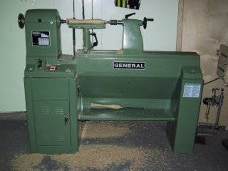
For Sale: Down Draft Sanding table
Down Draft Sanding Table 39" - Portable for sale.
Reason for selling, I'm building this feature into my new workbench and I will not require the portable.
It is the 39" Busy Bee Model that has a regular price of $199 and is currently on sale for $148.
The link to the listing on the Busy Bee website is as follows and includes a photo: http://busybeetools.ca/cgi-bin/picture10?&NETID=1037020719081960152&NTITEM=CT121
Price: $95
Call Fred at 519-858-2558
or email frederick.rodger@sympatico.ca
Help Wanted

I wonder if you can post a request to the membership.
The wheels in my 10" band saw are plastic and want o replace them with metallic ones. it is a Rockwell that I bought more than 20 years ago and it is the work horse in my shop
If anybody knows where to get them it would be a good help.
Maybe they could see me at the meeting if they have any information.
Thanks,
Mario Moran

