.



Thames Valley Woodturner
A publication of the Thames Valley Woodturners Guild
A chapter of the AAW

Volume 10.3 March April 2008
Turning events, Wood shows, and competitions in our region and farther afield

May 24 Jack de Vos seminar at RCAF Association

June 20 – 22 Symposium at Richmond Virginia, AAW 2008

Contents
Additions to library P1
Internet sites of interest P1
New members P1
Guest turner returns P1
Definition of an artist P2
AAW symposium in Richmond Va P2
Bernie”s tips P2
Visiting turners P3
Turning 101 P3
March meeting P3
Young member…. P4
April meeting (drum turning) P4
Calendar P6
Show and tell P7
For sale P7 & 8
For a Guild info/policy sheet, call or email Bob Hewson or refer to our web site at: ca.geocities.com/tvwt1@rogers.com/


Additions to the library
puzzles, boxes, and threaded inserts
Woodturning Trickery by Springett and Davenport
2 new DVDs on Cindy Drozda turner extraordinaire
Interesting new or updated Internet sites of interest to members
When checking out newsgroups there are three main areas to browse, the messages, the photo albums and the files. Messages are the day to day member messages and threads which can also be searched from either the home page or the search box at the top of the message screen. The photo albums are like our monthly “Show & Tell” where members can post picture of their work. Files are usually “how to” files on a topic, project or technique prepared by group participants.
Google, Yahoo and MSN host newsgroups that cover virtually any topic you can imagine
- Artistic Wood and Tool Supply. Found this company at the Toronto Wood Show. He has a varied supply of pen blanks, burls, and wood. http://artisticwoodandtoolsupply.com/zen-cart/index.php
- Jack de Voss can be found at http://jackdevos.com/ and to see some of his work check out the galleries he exhibits in at http://jackdevos.com/general.cgi
- Check out some of the work at the del Mano Gallery in California “Turned Wood – Small Treasures 2008” http://www.delmano.com/exhibitions/2008/mainExhibitions/TurnedWoodSmallT3/exhibition_01.htm

New Members
Please welcome David Purvis.
Treasury
We have $2250 less prize money, to be distributed to the Wood Show winners
Guest turner returns
Jack de Vos is visiting North America and will visit family in London. We hope to see him at our May meeting. Jack has kindly consented to put on a demo/seminar for us on May 24th, a Saturday. Mark your calendars and be sure to sign-up. I saw Jack`s session at Burlington during his last visit and I know you will find it a Saturday well spent.
To see some of Jack’s current work check his web site at http://jackdevos.com/ .

Correction
The ribbons in the novice category photos for 1st and 3rd were mixed up and the winner of Novice was Paul Jackson. The previous newsletter on the web has a correction added for the record.’

Definition of an artist
While visiting galleries on my recent vacation in Florida I came across the following sign:
"A person who works with their hands is a labourer; a person who works with their hands and their brain is a craftsman; but a person who works with their hands, their brain and their heart is an artist."
Attributed to Louis Nizer, American Lawyer 1902 - 1994

Please use the internet and our site as a resource.
Our website has our recent newsletters, a list of Preferred Suppliers, the Mentor list, and our Guild policy page plus a number of interesting links. We will keep the web site as our most current communication device (if you do not have internet access please let me know and printed copy of any of the above can be made available to you Ed).
Our web site is http://ca.geocities.com/tvwt1@rogers.com/
AAW 2008 Symposium at Richmond Virginia
It might be a good idea to advise our members that if they are going to the AAW Symposium they had better get their room reservations right away. The Richmond Marriott is already sold out.
The alternate is the Omni Richmond Hotel (3 blocks away) and they still have some rooms. Mention the AAW Symposium to get the special room rate of $119/night (single or double). Call 1-804-344-7000.
If anyone who is going would let Gary know, he may be able to organize a carpool(s).
Note: members of the AAW can register for the Symposium on line at AAW's web site and there's a discount before May 15/08.
For more info check out the AAW site at http://www.woodturner.org/sym/sym2008/
Bernie’s Tips
Topic: Thickness measurement of large items (i.e. a platter)
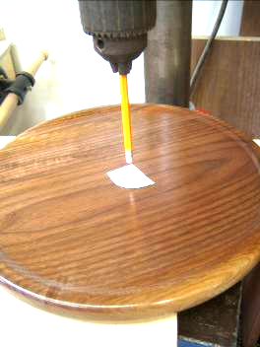
Details:
There are times when one turns an object such as a large platter (or bowl) where because of the size (or shape), it is not possible to use the calipers we have on hand. One quick method is to chuck a pencil in a drill press (sharpened end into the chuck), then place a flat piece of wood on the bed of the drill press and position the object to be measured under the pencil.

Measurement method
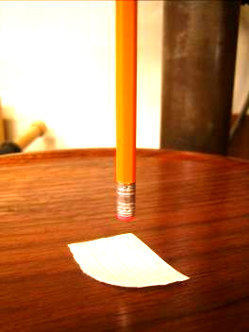
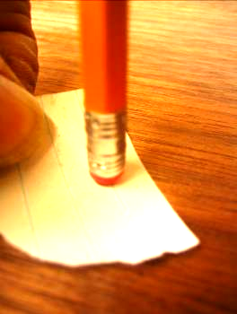
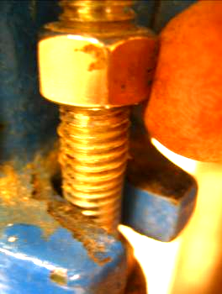
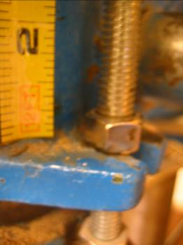
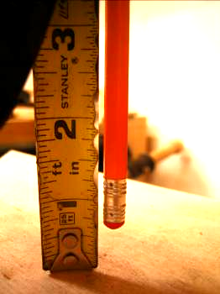
Place a piece of paper in the area to be measured and bring the chuck (pencil) down until it lightly touches the paper. Now with this light pressure maintained, adjust the stop nut on the drill press so that when it is bottomed out, you can just feel slight resistance when moving the paper.
Remove the item being measured and again bring the pencil down until the stop nut bottoms out, while holding a tape measure (or other convenient device) against the gap and read the length of the gap, in example shown, we read 5/8”. This is your thickness of the item measured from the extreme bottom to the top in the area where you held the paper. For items that have a (designed) profile on the bottom resulting in thickness variation, one would have to repeat this process as many times as necessary to get a good understanding of the thickness profile.
Considerations
The paper thickness is in the order of 0.005”, so does not contribute appreciably to error.
Don’t forget to allow for any undercuts underneath the object being measured to get the true thickness of the bottom.
One could also use a small dowel instead of a pencil, however, I find that the rubber tip of the pencil is less likely to leave marks if too much pressure is applied accidentally.
by Bernie Hrytzak
© 2008
Visiting turners
For the interest of members we are listing future seminars and visiting turners in the surrounding area as we learn of them:
These are the demonstrators that WGO, GHWG and TVWG and other guilds or clubs have scheduled. The guilds/clubs have said (or implied) that members of other clubs are welcome to attend:

Guest turner | Date | Sponsor | Fee | Contact | Comments
Nick Cook an Honorary Lifetime Member of the AAW, a nationally renowned woodturner, a must see nickcookwoodturner.com/ | Demos, May 17 - 18 Hands-on May 19 - 20 | Northwestern Michigan Woodturning Club, in Traverse City, Michigan | $80US 2 day demo,  $80US/day for hands- on | Please contact Lyle Jamieson for registration and info lyle@lylejamieson.com or call 231-947-2348 | 2 day Demonstration on May 17-18. The two day demo is $80.00, & includes lunches both days.  We have limited space for Nick's hands-on sessions May 19-20. The cost for hands-on is $80.00 per day. First-come-first-served. A check holds a lathe for you.
Jack de Vos - artistic turner | May 24 | TVWTG  RCAF clubhouse | $35.00 lunch included | Gary Miller  519-858-2445  garywmiller@rogers.com | May offer private workshop during his stay. Price not yet determined
Peter Exton - highly acclaimed turner | Sept 18 | WGO Burlington | $tba
David Hout - metal spinning (on wood lathe) | Nov 15 | WGO Burlington | $ tba |  | A possible workshop or may be able to arrange for him to come to TVWG
Kurt Hertzog - well known all around turner and pen specialist | Jan 2009 | WGO Burlington | $tba
If anyone would like to attend any of the above please let Gary Miller know. He will ensure that there is space and will confirm the fees. Carpooling can be arranged if there are sufficient numbers.
As we know more we'll keep the membership apprised and will keep this as an ongoing feature in the newsletter.
Turning 101 - Faceplate Turning
The second training session was held on April 20th, from 10AM to 4PM. A safety review was held at 9:30.
I was able to drop in and witnessed an enthusiastic group working on roughing out a bowl.
From all reports the session was an unqualified success. Watch for more classes to come.
March meeting
A demonstration by Bob on pen turning. Bob covered the pen making process from start to finish using a European style pen (often referred to as a Mt Blanc style pen). A hand out was available in limited number and has also been added to our web site, For those without web access that would like a copy, let Bob know.
Young member is doing it from the ground up!
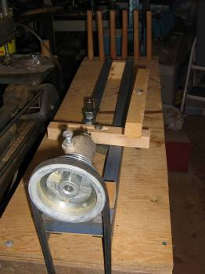
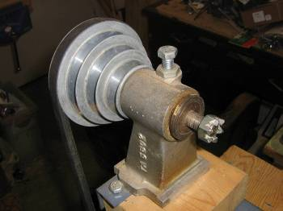
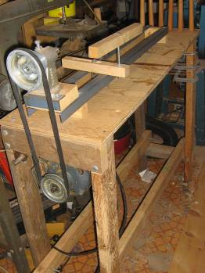
James Potter built this lathe as his public school science project.
He designed the lathe bed with bed rails. The gap matches my Beaver Lathe as does the height of the head stock screw such that parts are interchangeable between the 2 lathes. The motor is off of an old table saw. The arbor in the head stock is a table saw arbor turned 180 degrees.
James ground his own spur drive. We are trying to adapt threads to allow for additional accessories to fit such as face plates.
The tail stock has yet been completed. We are not sure how to mount a center into or onto a threaded rod. All commercial tail stocks seem to utilize Morse tapers.
Any thoughts from the experience of the guild would be appreciated.
See you.
PJP
I am sure suggestions and comments would be appreciated by James, I know several members have worked on their own wooden home-built lathes and must have experiences to share with him.
Ed

April meeting
Drum Turning Demo by Gary Miller
Purpose:
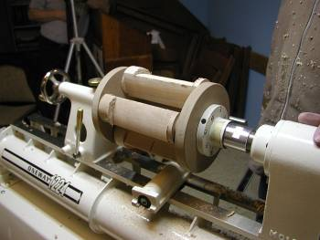
A method of producing multiple identical faceted pieces (eg. Salt and Pepper shakers)
Procedure:
Making a Template
- Using a 3 1/4” X 3 1/4” X ¾” piece of MDF, mark the centre and draw lines on the face from side to side through centre (ie. 90 degrees apart)
- With a compass draw a 1 1/2” rad. Circle (ie. 3” dia.)
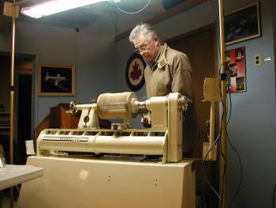
- With compass at the same setting, very precisely place the point on a face line where it intersects the circle and mark a point to either side on the circle. Move the compass to the 2 new points and repeat and again at the 2 newest points. This will create six equidistant points around the perimeter of the circle.
- Draw 6 lines through the centre connecting opposite points through the centre. Place the compass point at centre, draw a 1” dia. Circle
- Carefully drill a 3/8” hole through the centre
- Carefully drill a ¼” hole at a location where the 1” circle intersects a line.
- Drill 2 more ¼” holes at the intersection points at equidistant intervals (ie. 3 holes in total, 120 degrees apart)
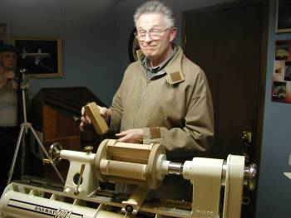
Note: it is best to mark the drill locations with an awl to ensure precise drilling (it’s critical) and use brad point drills to ensure the hole stays on centre.
- Cut the square into a 3” hex (set mitre saw to 30 degrees) leaving edges of about 1 ¼” at right angles to each of the ¼” holes/face lines
- Extend both ends of the face lines across edges using a small square
- With a grind stone rotate a 3/8” steel rod at 45 degrees creating a chamfer on the end
- Cut off a piece 1 1/16” long
- Glue into the BACK of the template hole leaving just under 3/8” exposed (med density CA glue)
Drum Flanges
- Cut 2 pieces of ¾” MDF to 8” X 8”. Double adhesive tape them together with a compass draw 5 circles on one side:
#1 the diameter of your face plate (ideally 3” but no bigger)
#2 7 ¼” dia
#3 7” dia.
#4 4 ¾” dia.
#5 3 ¾” dia.
- Bandsaw at the 7 ¼” circle
- Screw on the face plate using #10 sheet metal screws, 5/8” into the MDF using circle #1 as a guide for centering
- Turn to 7” on the lathe DO NOT SEPARATE YET!
- Using the lathe’s index feature and the tool rest, mark 2 lines across the face at 90 degrees through centre
- Extend lines across the edges with a small square
- Using a drill press, drill 3/8” holes where circle #4 and the face lines intersect (4 holes)
- Place the template into one hole and align the edge lines so that the ¼” hole is facing inside centre and drill ¼” hole to 3/8” deep
- Repeat for the remaining holes
- Number the edge lines on both discs for alignment and then separate the discs
- Cut 8 3/8” steel pins: chamfer the end of a 3/8” steel rod and cut a pin 1 1/16” long. Repeat for remaining pins. Do the same for 8 ¼” steel pins 1” long
- Glue the pins into the INSIDE surfaces of the 2 discs. The 3/8” pins should leave a little less than 3/8” exposed. The ¼” pins at a full ¼” exposed
- Drill 3 equidistant holes around the perimeter of a fender washer. Carefully centre it on the outside disc and screw it into place (if possible, do it on the lathe with a live centre holding it in place). The hole in the fender washer should be no bigger than the contact surface on your live centre.
Preparing the workpieces
- Turn 4 cylinders approximately 10” X 3”
- If you are going to make pepper grinders or boxes, you must make partial parting cuts at this time (where top and bottom shoulders meet and at each end - at least ½” in from the ends of the cylinders). Cuts should be about 9/16” deep. Use a 1/6” parting tool.
- Using the lathe’s indexing feature and the tool rest, draw 3 equidistant lines the length of each cylinder (120 degrees apart).
- Chuck a cylinder (lightly) and centre it with the live centre. Drill a 3/8” hole, 3/8” deep on centre. Do this on both ends of each cylinder
- Place the drilling template into the 3/8” hole carefully lining up template and cylinder lines. Drill the first ¼” hole, 3/8” deep. Insert a ¼” pin into the hole to keep it firmly located, then drill the remaining 2 holes
- Repeat #4 & #5 for both ends of each workpiece
- Turn chuck-mounting dovetails on both ends of each piece (must be bigger than the hole locations but still leave a shoulder for the chuck to register against)
Turning
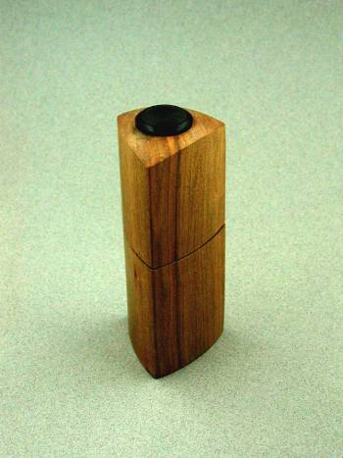
- Place the 4 cylinders on the headstock disc aligning 3/8” and ¼” holes on the pins. Use a deadblow hammer to tap into place. Mount the other disc on the other end, again aligning the holes and pins and tap into place. The fit should be tight enough to mount the whole assembly onto the lathe spindle. Bring up the tailstock and tighten firmly with the live centre in place against the fender washer.
- Bring the tool rest to about ¼” of cylinders and turn the first facet with a roughing gouge down to BUT NOT PAST the register lines on the cylinders (they must remain visible). Final cuts should be shearing cuts done very slowly to get the smoothest possible surface (use a skew if preferred).
- Disassemble then rotate each cylinder in the same direction to the next pin location and reassemble
- Turn the next facet as in #3. Repeat for the 3rd facet.
Option
After turning your basic facets, turn to a desired profile keeping at least one section of each register line visible to ensure uniformity of form
Disassemble and mount one of the cylinders on your chuck and finish turning, hollowing, etc. To Completed shaker
the final product (box or grinder etc) using standard procedures

The 2007-2008 seasons’ dates for meetings and other scheduled events

Date | Meeting or events | Shows/events/comments
Sept 6, 2007 | 1st Fall Meeting | Meeting at the Royal Canadian Air Force Association. Gary Miller will demo his self-designed articulated arm for hollowing of vessels. Remember show and tell. Remember to bring in your turned tool handle from the BBQ.
Sept 28 – 30 1 | Woodstock wood show | Woodstock Fairgrounds  Turning competition. To enter contact the show office (check page 1 under shows section).
Oct 4 | Monthly meeting | Sharpening clinic combined with a tool/wood sale. Challenge is a turned hollow form.
Nov 1 | Monthly meeting | Christmas themed demo of a “lattice” topped box by John Calver.
Dec 6 | Monthly meeting | Christmas challenge: A turned box.  A demo by Mario Moran of a candle stick holder. He will have a design hand-out.  Annual elections
Jan 3, 2008 | Monthly meeting | Candlestick challenge – your choice
Jan 20 (Sunday)  Feb 3 (Sunday) | Turning 101 | Turning 101 begun on the 20th and completed on the 3rd due to a scheduling conflict at the RCAF Association
Feb 2 - 4 | Chatham Wood show | While the Guild does not participate, some of you may wish to visit the show
Feb 7 | Monthly meeting | Threaded box – Demo by Doug Magrath
Feb 8 – 10 | London’s Wood show | No show sponsored turning competition this year however a Guild turning competition will be again held in the form of a “People’s Choice Award” for novice and open. Prize money is donated by the Guild, entry to members only
March 6 | Monthly meeting | Pen turning demo by Bob Hewson  Challenge “Rough and smooth” Interpretation of rough and smooth is left to the member’s imagination and creativity
April 3 | Monthly meeting | Drum turning demo (not a musical drum but rather multiple turning by Gary Miller)
April 10 | Turning 101 | Faceplate turning 10 – 4
May 8 Please note date change to the 2nd Thursday | Monthly meeting | Pen challenge.  Natural edge bowl with John VanKessel
May 24 | Demo/seminar | Jack de Vos will conduct a seminar/demo at the Royal Canadian Air Force Association. The fee is $35 lunch will be provided and is included
June 5 | Monthly meeting | This will be an extension meeting of our usual season  Fred Rogers will present on his sculptural turning
Jun 27 - 30 | 2008 AAW symposium, Virginia | AAW symposium is in Richmond Virginia. If anyone goes to the symposium we would appreciate a review and some photos for the newsletter
 | Topics in the discussion stages, not yet formalized as to date or content.  For the fall and beyond.  Program Ideas and suggestions for guest turners are always welcomed by your committee | -Segmented turning open and closed (“how to” specifics) will be covered in several sessions  -Hand thread-chasing  -Guest turners or seminars  -Design? What makes a makes a “good” turning into an “outstanding turning?  -Wine stoppers  -A safety night (discussion/panel)  -A “show and sell” table of turnings”, a “show and trade” table for your turnings  -Vacuum chucking how to build a system and how/where to use it  -Future challenge ideas: a square turning, a pair of “something”, a seed pod turning  -Utilize home chucking techniques where appropriate in Guild demos

Note, meetings start at 7:30, doors open at 7:00

Show and Tell turnings from April’s meeting

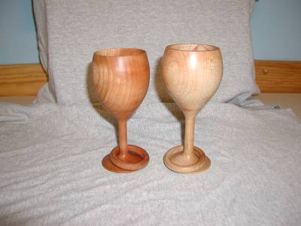
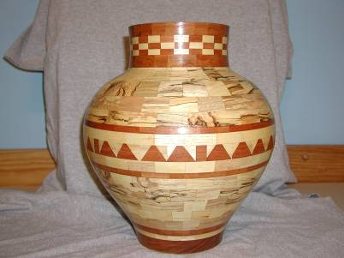
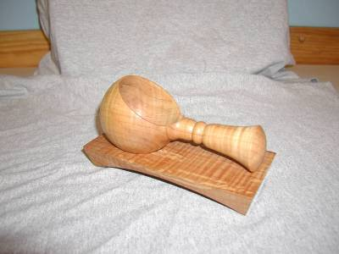
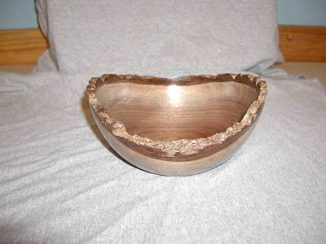
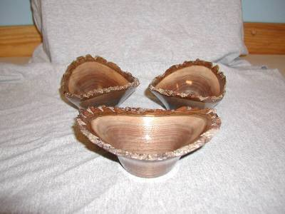
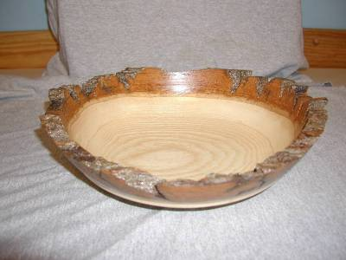
Items both wanted and for sale
Ads are free for members and run until you sell your item or withdraw your advert. Members can support other members by buying: good deals and good prices!
Please note. The Guild provides a means of connecting buyer and sellers through these ads. It is up to the buyer to ensure the item offered is as stated and the two parties should agree between them as to warranty or guarantee for the item.
To run a new ad in our newsletter or to remove a sold item, call Bob at 519-457-6555 or email at 66.bobhewson@rogers.com .
We welcome small business card type advertisements at a rate of $30 per year. We print 6-7 issues per year on a non-date-specific schedule. We also upload our newsletters to the internet at http://members.rogers.com/tvwt1/ for viewing in glorious colour.
For sale: I make and sell cutters for the Stewart system and or boring bars. They are made of hi-speed steel. Available in three sizes, prices are $15, $20, & $25.
Call Mario Moran at 519-336-0550, or see him at the Guild meeting or mario.ada@sympatico.ca
Wanted
Parts for old lathes
Call Murray Tyler at 519-225-2854 after 5 PM

For Sale:

Lee Valley Mitre Vise - 2 available unused.
Price - $50.00 for pair.
Call: Alf Buckle at 1-519-271-8489 or email at abuckle@sympatico.ca
For Sale
Craftsman router, electronic, variable speed, adjusts in 1/32” & 1/64” increments
Only used 5 times, cost $115
Sell $60
Bandsaw – Craftex 15”
Includes fence, ¾ hp motor, plus Hi-Level accessory bearings.
Used for about 1 year, cost $488 new
Sell $350
Call Gord Tallman at 519-455-4526

For Sale

A friend of a friend has some walnut lumber for sale. There is about 338 board feet of 5/4, 7/4 and 8/4 of widths from 6" to 12" and 12' long. It has been air drying for 6 years and is roughly 10% moisture. If anyone is interested, they can contact him direct.
Charlie Minett 1-519-272-0667
email is charlesp@minett.com

For Sale
General 15 inch bandsaw model 490-1
It has seen little use, runs like a charm.
Price: Asking $1500.
Imported floor model drill press, 5/8 chuck 3/4 hp
Price: Asking $150
Call Rob Williamson at 519-672-2998 or email robriw@hotmail.com

For Sale:*
I can make a tool similar to the Hunter Tool Company’s hollowing tool, two different sizes ¼ & 3/8" with carbide cutters.
All the member has to do is turn a handle for the tool.
If they want a bend or curve in rod it can be done too. They will have to make a drawing if they want a bend put in the rod.
Price: $40 straight, $50 bent or curved
An aluminum handle to accept the tool is also available, ready to go 1” dia x 15” length.
See my sharpening jigs at the next meeting.
Call: Al Johnston at 519-679-8718
592 Mapledale Ave. London



For Sale:
14" Delta Bandsaw, Model# 28-206. This machine is only 3 years old and is in "like new" condition

Price: is asking $500.00
Call: Marlene Legault (519)-369-1031 (Durham) or Email at: marlenelegault@sympatico.ca

For sale

11 old English tuning chisels by Robert Sorby
Skews 1 ¼” and 1”
Gouges ½”, ¾”, 1” some deep and some shallow “U”
Several unhandled.

Several “Forstner” bits 5/16”, 1”, 1 ½”, 1 ¾”

Auger bits, 5/8” and 4/4”

Call: Shelly Paulocik
519-349-2743 (Lakeside)

For Sale:
Kelton Hollowing Rig,
purchased in July of 2006 from Lee Valley, used approx. 7 months until I upgraded to One Way equipment in March/2007 and it wouldn’t fit the new lathe. Rig includes: 53B01.60 Sm Hollowing rig (good for up to 16” swing lathe)
53B01.61 Sm Laser guide
86K78.50 Laser pointer
Cost with taxes is $395.52
Asking $285 reduced to $250
Call Bernie Hrytzak at 1-519-352-7921 or see me at the next club meeting
For Sale
A King ch900 lathe, complete with cabinet, this is a muti -speed lathe, without changing belt
A swivel head
With base with wheels for moving around if needed
Price: $450.00
I also have a Beaver/Delta antique lathe for sale that I have brought back to life, early 1950.
Price: $200.00 complete with stand
Call John McGuire at 519-659-6810.
106 Mark St.
London, On
Fletchs Fetchings

Supplying unique wood from Africa and Asia.

Turning blanks available for pens, pool cues, bottle stoppers, duck calls, bowls, etc.

Reasonable pricing.
Call Jim Fletcher at 519-633-0538.
Or visit my website www.fletchs-fetchings.com
I also sell on eBay under seller id fletchs_fetchings

