.



Thames Valley Woodturner
A publication of the Thames Valley Woodturners Guild
A chapter of the AAW

Volume 10.2 February 2008 & London Wood Show

Turning events, Wood shows, and competitions in our region and farther afield
Feb 29 – Mar 2 Canadian Home workshop show at the Toronto International Centre (canadianhomeworkshop.com/)
March 21 -26 Ottawa Valley Woodturners are hosting Jimmy Clewes for a workshop and demos. A Friday workshop @ $125.00. Two days of demos, Sat & Sunday @ $45.00 each day. For added info contact George Bell 819-281-4833 home or 613-314-1014 cell
May 24 Jack de Vos seminar at RCAF Association
June 20 – 22 Symposium at Richmond Virginia, AAW 2008

Contents
Additions to library P1
Internet sites of interest P1
New members P1
Guest turner returns P1
AAW symposium in Richmond Va P2
Bernie”s tips P2
Visiting turners P2
Turning 101 P3
February meeting P3
London Wood show P4
Show and tell P4
Winner of Peoples” choice P5
Calendar P6
Wood show activities P7
For sale P8 & 9
For a Guild info/policy sheet, call or email Bob Hewson or refer to our web site at: ca.geocities.com/tvwt1@rogers.com/

Additions to the library
All Screwed Up by John Berkley, a book on wood puzzles, boxes, and threaded inserts
Woodturning Trickery by Springett and Davenport

Interesting new or updated Internet sites of interest to members
When checking out newsgroups there are three main areas to browse, the messages, the photo albums and the files. Messages are the day to day member messages and threads which can also be searched from either the home page or the search box at the top of the message screen. The photo albums are like our monthly “Show & Tell” where members can post picture of their work. Files are usually “how to” files on a topic, project or technique prepared by group participants.
Google, Yahoo and MSN host newsgroups that cover virtually any topic you can imagine
Johannes Michelsen’s site. This turner turns wooden hats and conducts training workshops in Vermont. An interesting site http://www.woodhat.com
- Want some how to videos on general woodworking? Check out this site http://www.woodmagazine.com/wood/file.jsp?item=video/player&temp=yes
- Dennis Laidler’s blog site. Worth a look http://dennislaidler.blogspot.com/2007/02/pics-for-aaw-magasine.html
- Truffles, an intriguing site of small works http://www.truffuls.com/
- Bernie’s tips are also found at http://www.berniestips.com/
- Turned boxes, kaleidoscopes, and tops, decorated using a home built rose engine http://www.knappstudios.com/Boxes.htm
- Thomas Riven’s site, another box maker
- http://www.thomasirven-art.net/mywork/gallery/gallery.html
- Nick Cook, see section re visiting turners. Nick’s site includes a number of how-to turning articles he has written http://www.nickcookwoodturner.com/
- Woodturning artist Nick Agar's large-scale, multi-textured turned wood sculptures are seen on his site. A multi-talented turner from the UK. http://turningintoart.com/demos.php

New Members
Please welcome 4 new and 1 returning member; Bruce McCann, Mike Grover, Eric Thompson, Scott Tucker, and Jack Hackney.

Dixie pins were available at our February meeting.
If anyone who ordered the Dixie pins didn’t pick them up at the February meeting please contact Gary.

Guest turner returns
Jack de Vos is visiting North America and will visit family in London. We hope to see him at our May meeting. Jack has kindly consented to put on a demo/seminar for us on May 24th, a Saturday. Mark your calendars and be sure to sign-up. I saw Jack`s session at Burlington during his last visit and I know you will find it a Saturday well spent. Detail will be disseminated as we finalize them.
To see some of Jack’s current work check his web site at http://jackdevos.com/

Please use the internet and our site as a resource.
Our website has our recent newsletters, a list of Preferred Suppliers, the Mentor list, and our Guild policy page plus a number of interesting links. We will keep the web site as our most current communication device (if you do not have internet access please let me know and printed copy of any of the above can be made available to you Ed).
Our web site is http://ca.geocities.com/tvwt1@rogers.com/

AAW 2008 Symposium at Richmond Virginia
It might be a good idea to advise our members that if they are going to the AAW Symposium they had better get their room reservations right away. The Richmond Marriott is already sold out.
The alternate is the Omni Richmond Hotel (3 blocks away) and they still have some rooms. Mention the AAW Symposium to get the special room rate of $119/night (single or double). Call 1-804-344-7000.
If anyone who is going would let Gary know, he may be able to organize a carpool(s).
Note: members of the AAW can register for the Symposium on line at AAW's web site and there's a discount before May 15/08.
For more info check out the AAW site at http://www.woodturner.org/sym/sym2008/

Bernie’s tips
Bernie’s tips are published in the newsletter and can also be reviewed as a group at his web site at http://www.berniestips.com/

Visiting turners
For the interest of members we are listing future seminars and visiting turners in the surrounding area as we learn of them:
These are the demonstrators that WGO, GHWG and TVWG and other guilds or clubs have scheduled. The guilds/clubs have said (or implied) that members of other clubs are welcome to attend:

Guest turner | Date | Sponsor | Fee | Contact | Comments
Lyle Jamieson - turner/sculpture | Sat, March 1st | WGO  Burlington | $40.00 | Gary Miller | Plus workshops on Feb 24th and 25th (25th is full)
Don Geiger Woodturning Event | Sunday, April 20 | Sponsored by the Lockport Woodworkers & the Pembroke Woodturners Guild | $20 US | Lance Kanaby 716-316-3969, Clarence, NY Lkanaby@buffnet.net or Rich Mialki 716-694-5430, N. Tonawanda, NY Mialkisr@roadrunner.com | Pembroke High School Auditorium, Routes 77 & 5 in Corfu, NY, 14036
Nick Cook an Honorary Lifetime Member of the AAW, a nationally renowned woodturner, a must see nickcookwoodturner.com/ | Demos, May 17 - 18 Hands-on May 19 - 20 | Northwestern Michigan Woodturning Club, in Traverse City, Michigan | $80US 2 day demo,  $80US/day for hands- on | Please contact Lyle Jamieson for registration and info lyle@lylejamieson.com or call 231-947-2348 | 2 day Demonstration on May 17-18. The two day demo is $80.00, & includes lunches both days.  We have limited space for Nick's hands-on sessions May 19-20. The cost for hands-on is $80.00 per day. First-come-first-served. A check holds a lathe for you.
Jack de Vos - artistic turner | May 24 | TVWTG  RCAF clubhouse | $35.00 lunch included | Gary Miller | May offer private workshop during his stay. Price not yet determined
Peter Exton - highly acclaimed turner | September 18 | WGO Burlington | $tba
David Hout - metal spinning (on wood lathe) | November 15 | WGO Burlington | $ tba |  | A possible workshop or may be able to arrange for him to come to TVWG
Kurt Hertzog - well known all around turner and pen specialist | January 2009 | WGO Burlington | $tba
If anyone would like to attend any of the above please let Gary Miller know. He will ensure that there is space and will confirm the fees. Carpooling can be arranged if there are sufficient numbers.
As we know more we'll keep the membership apprised and will keep this as an ongoing feature in the newsletter.


Turning 101
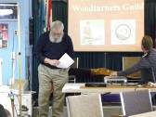
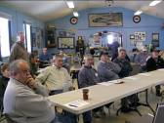
The turning 101 program is coming together and the first session was scheduled for Sunday Jan 20th.
There were 12 members who signed on for the program. We had 6 lathes, the club’s Oneway, our General mini and four members’ minis.
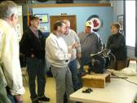
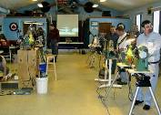
The meeting began and we concluded the theory, safety, and overview of tools ably by Phil. Bob F followed with a sharpening overview. It was at this time that a glitch developed… We learned of a conflict in scheduling and that the meeting facility was double booked with a large birthday gathering due at 12:00. We completed the sharpening demo, beat a hasty retreat and clean-up and were out by 12:00.
We rebooked for Feb 3rd with apologies to the students, instructors and support people.

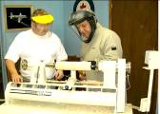
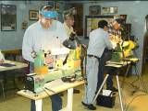
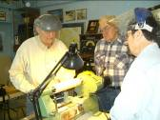
Turning 101 continued on the 3rd.
Set up with 6 lathes, this day concentrated on the basics. The use of the roughing gouge, the parting tool, spindle gouge and skew.
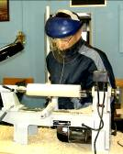
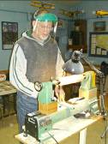
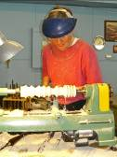
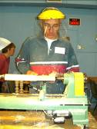
The drill was to smooth down a square maple billet then size it, followed by an exercise turning beads. The beads were then cut off and coves cut.
The 1st project was to turn a spurtle. Handouts for a dibbler and honey dipper were available for home practice.
At the conclusion seminar evaluations were handed out for feedback which will be incorporated into the next Turning 101 and 102.
All in all a successful event.
Note, if anyone wants a copy of any picture file for themselves of these or any other picture in this or past newsletter let bob know.
Ed

FEBRUARY meeting
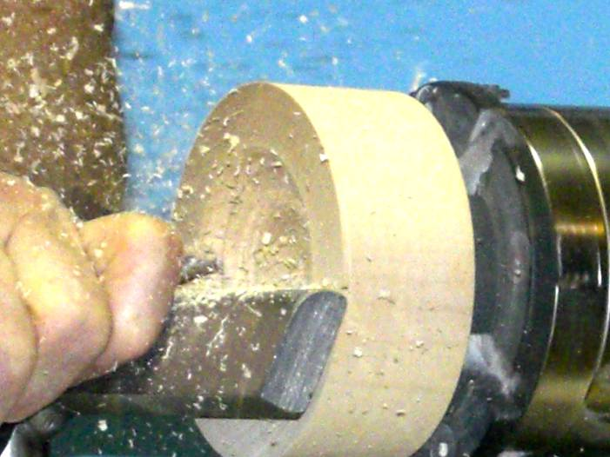
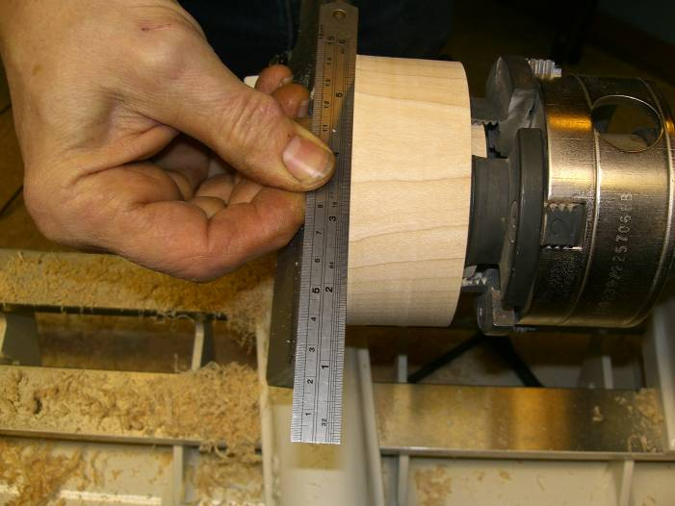
Doug Magrath demonstrated box turning and the addition of a cut thread with a further embellishment of an ebony lid insert.
Doug's technique for turning a box is conventional i.e. turn a cylinder, add a tenon to each end, split the cylinder into a top and bottom using the golden mean or other pleasing proportion. Label pieces for later match
Doug's method usually departs from most of us as he is a production turner and often used wood that requires drying. He puts his "box blanks" in his kiln for later finished turning.
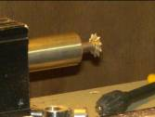
Beginning the finished turning he often opts for a rounded cavity since it is faster and somewhat easier than a more common cylindrical cavity. Care is taken to ensure a flat edge and sufficient wall to which he will later cut a thread.
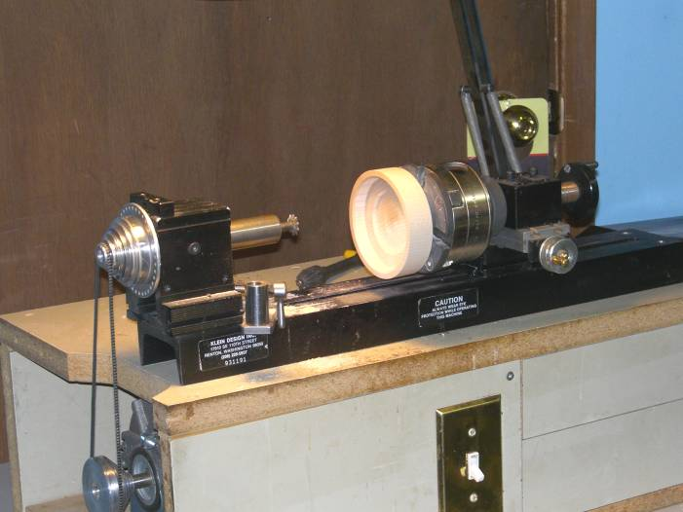
The threading of the box was accomplished using his small Bonnie Klein lathe and thread cutting jig. (During our jig night a similar Bonnie Klein jig was shown by John and designed to fit his General. Al Johnston also showed a home built threading jig).
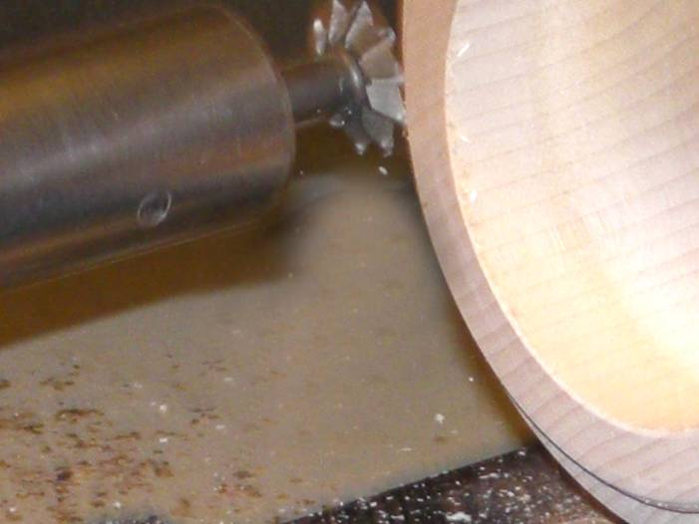
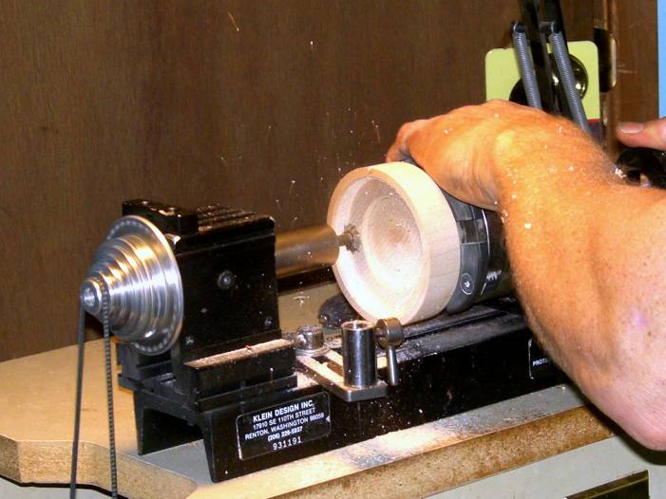
There are three essential parts to a threading jig 1st a holding method that will enable the item being threaded to rotate and advance into the cutter at a known rate i.e. 16 threads per inch. 2nd a method to move the item towards or away from the cutter and 3rd a high speed cutter to cut the thread.
Once the thread is cut into the box base and top it can be adjusted for final grain match
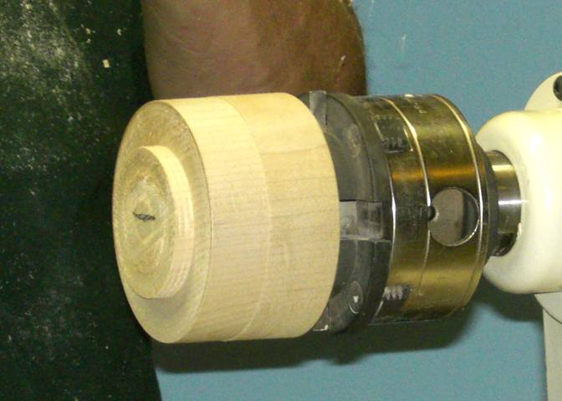
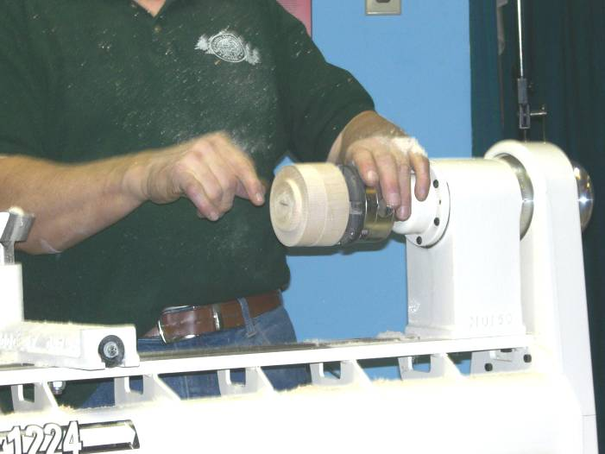
Generally the thread cutting required a hard close grain wood, many tropical exotics are ideal. Using domestics is possible by toughening the thread areas with CA glue or by inserting a ring of dense exotic into the base and top and cutting the threads in the exotic.
A Special insert for the top made from a piece of found ebony will add interest to what may be a very plain box made of domestic wood.
For further info on thread cutting and or box making there are several good books in our library and many sites on the internet, several listed under the internet sites section elsewhere in the newsletter.

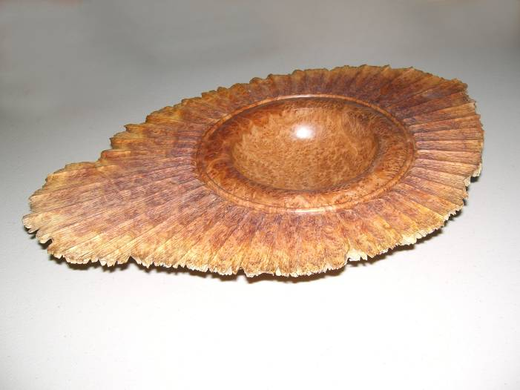
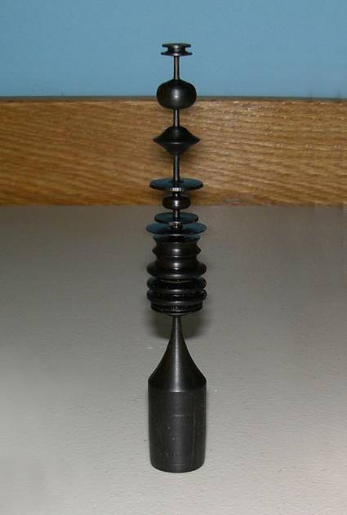
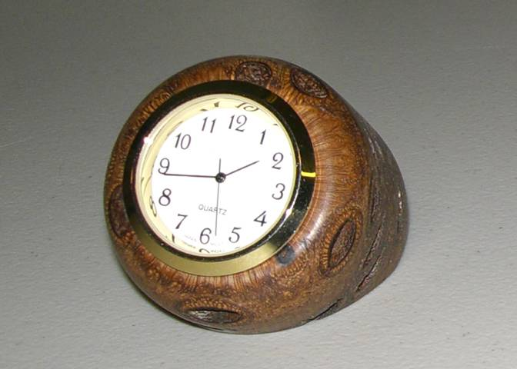
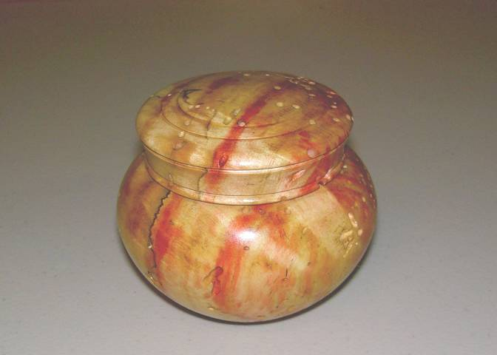
Show and tell from the February meeting follows:
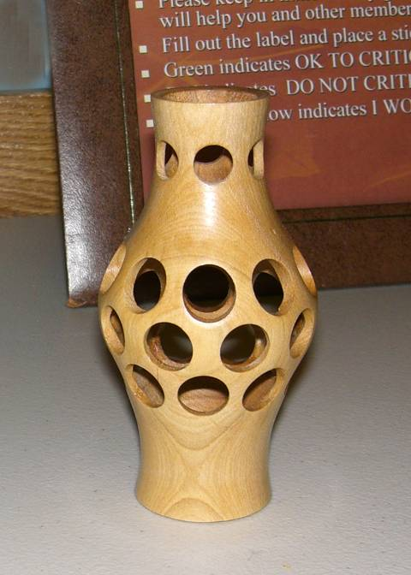

London Wood Show 2007
General exhibit photos are elsewhere in the newsletter.
First, heartfelt thanks to Tom for his work in making our booth happen! Thanks too to those who manned (womanned ☺) the booth, demonstrated and helped in the take down. Thanks to those that brought in turnings for viewing and judging. Thanks to Gary for the photos. Our participation as a guild doesn’t just happen, it takes a lot of hard work before, during, and after. I’m sure though that those involved enjoyed it too.
There was a good showing of turnings and the shows organizer Art Bacon was heard to say it was our (Guilds) best showing yet.
While we had a good showing of entries comments suggest that some of the “Show only” table’s turnings were worthy of competition… Our competition turners numbered 19 this year, up from last year!


The winners of the People’s Choice Awards were:

Open:

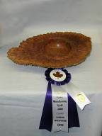
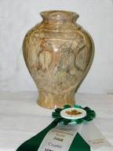
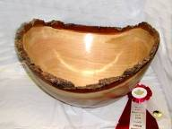

1st Gary Miller 2nd Paul Spicer 3rd Eric Deckert HM Bernie Hrytzak
$75 award $50 award $25 award

Novice:
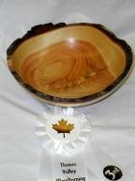
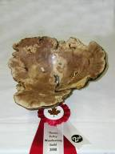
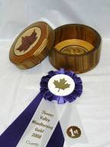

1st Fred Simpson 2nd Robbie Bloomfield 3rd Paul Jackson
$75 award $50 award $25 award

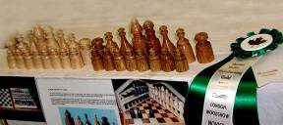

HM Mike Malone

Congratulations to all!
The 2007-2008 seasons’ dates for meetings and other scheduled events

Date | Meeting or events | Shows/events/comments
Sept 6, 2007 | 1st Fall Meeting | Meeting at the Royal Canadian Air Force Association. Gary Miller will demo his self-designed articulated arm for hollowing of vessels. Remember show and tell. Remember to bring in your turned tool handle from the BBQ.
Sept 28 – 30 1 | Woodstock wood show | Woodstock Fairgrounds  Turning competition. To enter contact the show office (check page 1 under shows section).
Oct 4 | Monthly meeting | Sharpening clinic combined with a tool/wood sale. Challenge is a turned hollow form.
Nov 1 | Monthly meeting | Christmas themed demo of a “lattice” topped box by John Calver.
Dec 6 | Monthly meeting | Christmas challenge: A turned box.  A demo by Mario Moran of a candle stick holder. He will have a design hand-out.  Annual elections
Jan 3, 2008 | Monthly meeting | Candlestick challenge – your choice
Jan 20 (Sunday)  Feb 3 (Sunday) | Turning 101 | Turning 101 begun on the 20th and completed on the 3rd due to a scheduling conflict at the RCAF Association
Feb 2 - 4 | Chatham Wood show | While the Guild does not participate, some of you may wish to visit the show
Feb 7 | Monthly meeting | Threaded box – Demo by Doug Magrath
Feb 8 – 10 | London’s Wood show | No show sponsored turning competition this year however a Guild turning competition will be again held in the form of a “People’s Choice Award” for novice and open. Prize money is donated by the Guild, entry to members only
March 6 | Monthly meeting | Pen turning demo by Bob Hewson  Challenge “Rough and smooth” Interpretation of rough and smooth is left to the member’s imagination and creativity
April 3 | Monthly meeting | Drum turning demo (not a musical drum but rather multiple turning by Gary Miller
May 8 Please note date change to the 2nd Thursday | Monthly meeting | Pen challenge.  Natural edge bowl with John VanKessel
May 24 | Demo/seminar | Jack de Vos will conduct a seminar/demo at the Royal Canadian Air Force Association. The fee will be $35 lunch will be provided
June 5 | Monthly meeting | This will be an extension meeting of our usual season
Jun 27 - 30 | 2008 AAW symposium, Virginia | AAW symposium is in Richmond Virginia (date to be announced). If anyone goes to the symposium we would appreciate a review and some photos for the newsletter
 | Topics in the discussion stages, not yet formalized as to date or content.  For the fall and beyond.  Program Ideas and suggestions for guest turners are always welcomed by your committee | -Segmented turning open and closed (“how to” specifics) will be covered in several sessions  -Hand thread-chasing  -Guest turners or seminars  -Design? What makes a makes a “good” turning into an “outstanding turning?  -Wine stoppers  -A safety night (discussion/panel)  -A “show and sell” table of turnings”, a “show and trade” table for your turnings  -Vacuum chucking how to build a system and how/where to use it  -Future challenge ideas: a square turning, a pair of “something”, a seed pod turning  -Utilize home chucking techniques where appropriate in Guild demos

Note, meetings start at 7:30, doors open at 7:00
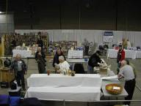
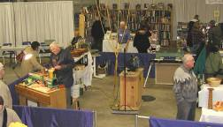
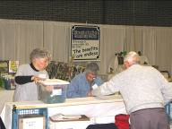
Your Guild at the London Wood Show
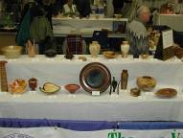
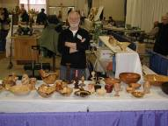
Bare space slowly fills up to make our excellent display and demonstration center. Lots of volunteer effort made our exhibit “the best showing yet” according to Art Bacon organizer of the show.
What a great showing of support and exhibition of turnings.
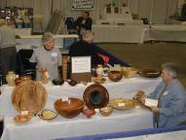
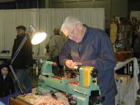
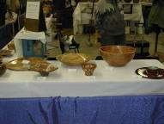

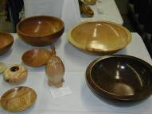
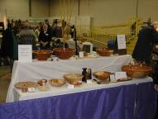
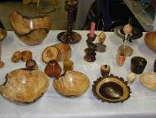

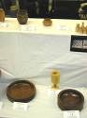
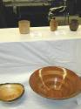
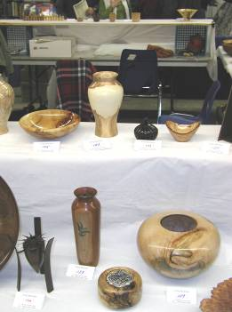
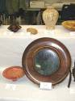
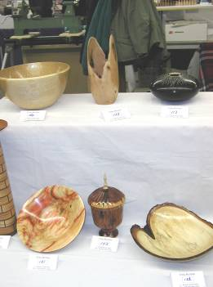
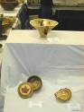
SPECIALTHANKS to everyone who participated and helped out by showing their work, talking to the public and demonstrating
Items both wanted and for sale
Ads are free for members and run until you sell your item or withdraw your advert. Members can support other members by buying: good deals and good prices!
Please note. The Guild provides a means of connecting buyer and sellers through these ads. It is up to the buyer to ensure the item offered is as stated and the two parties should agree between them as to warranty or guarantee for the item.
To run a new ad in our newsletter or to remove a sold item, call Bob at 519-457-6555 or email at 66.bobhewson@rogers.com .
We welcome small business card type advertisements at a rate of $30 per year. We print 6-7 issues per year on a non-date-specific schedule. We also upload our newsletters to the internet at http://members.rogers.com/tvwt1/ for viewing in glorious colour.
For sale: I make and sell cutters for the Stewart system and or boring bars. They are made of hi-speed steel. Available in three sizes, prices are $15, $20, & $25.
Call Mario Moran at 519-336-0550, or see him at the Guild meeting or mario.ada@sympatico.ca
Wanted
Parts for old lathes
Call Murray Tyler at 519-225-2854 after 5 PM

For Sale:

Lee Valley Mitre Vise - 2 available unused.
Price - $50.00 for pair.
Call: Alf Buckle at 1-519-271-8489 or email at abuckle@sympatico.ca
For Sale
Craftsman router, electronic, variable speed, adjusts in 1/32” & 1/64” increments
Only used 5 times, cost $115
Sell $60
Bandsaw – Craftex 15”
Includes fence, ¾ hp motor, plus Hi-Level accessory bearings.
Used for about 1 year, cost $488 new
Sell $350
Call Gord Tallman at 519-455-4526

For Sale
A friend of a friend has some walnut lumber for sale. There is about 338 board feet of 5/4, 7/4 and 8/4 of widths from 6" to 12" and 12' long. It has been air drying for 6 years and is roughly 10% moisture. If anyone is interested, they can contact him direct.
Charlie Minett 1-519-272-0667
email is charlesp@minett.com

For Sale
General 15 inch bandsaw model 490-1
It has seen little use, runs like a charm.
Price: Asking $1500.
Imported floor model drill press, 5/8 chuck 3/4 hp
Price: Asking $150
Call Rob Williamson at 519-672-2998 or email robriw@hotmail.com
Wanted
We have had a request from someone looking to have a spiral pole turned for a horse for a carousel (definably out of my league). I told them that I would let the club know to see if anyone can help him.
Call: Ted Thompson 519-273-6865 or
email charles_thompson_8@sympatico.ca



For Sale:*
I can make a tool similar to the Hunter Tool Company’s hollowing tool, two different sizes ¼ & 3/8" with carbide cutters.
All the member has to do is turn a handle for the tool.

If they want a bend or curve in rod it can be done too. They will have to make a drawing if they want a bend put in the rod.
Price: $40 straight, $50 bent or curved
An aluminum handle to accept the tool is also available, ready to go 1” dia x 15” length.

See my sharpening jigs at the next meeting.

Call: Al Johnston at 519-679-8718
592 Mapledale Ave. London

For Sale:
Kelton Hollowing Rig,
purchased in July of 2006 from Lee Valley, used approx. 7 months until I upgraded to One Way equipment in March/2007 and it wouldn’t fit the new lathe. Rig includes: 53B01.60 Sm Hollowing rig (good for up to 16” swing lathe)
53B01.61 Sm Laser guide
86K78.50 Laser pointer
Cost with taxes is $395.52
Asking $285 reduced to $250
Call Bernie Hrytzak at 1-519-352-7921 or see me at the next club meeting
For sale
*Delta grinder with 2 x 7” aluminum oxide (white) wheels
Price $75
*Beading tools, 3/8” and ¼” available. price $22 each
*Spindle gouge ½” HSS Sorby. Price $30
*¼ and 3/8 tool bits, Price $2 each
*6” random orbit multi-speed right angle grinder (Porter Cable, $200 new). Price $110
Call: Bob Fenn 519-455-7436
For sale

11 old English tuning chisels by Robert Sorby
Skews 1 ¼” and 1”
Gouges ½”, ¾”, 1” some deep and some shallow “U”
Several unhandled.

Several “Forstner” bits 5/16”, 1”, 1 ½”, 1 ¾”

Auger bits, 5/8” and 4/4”

Call: Shelly Paulocik
519-349-2743 (Lakeside)

