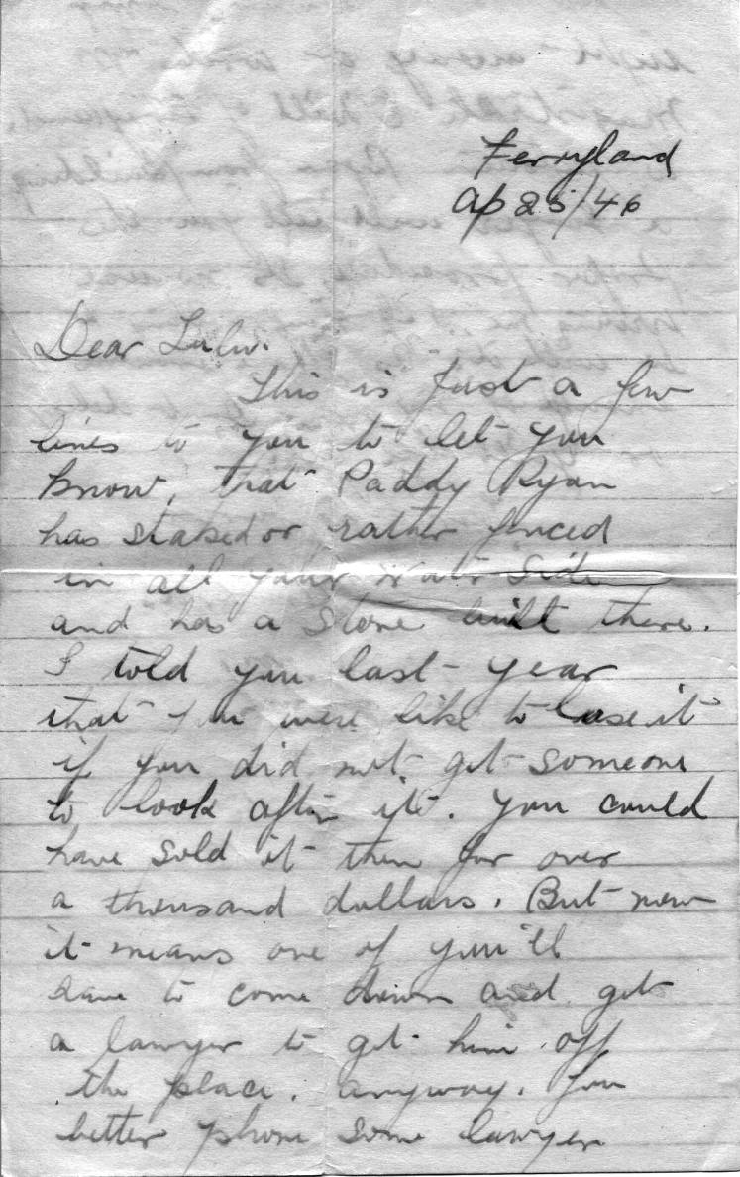 | Ferryland  Ap 25/46  Dear Lulu.  This is just a few  Lines to you to let you know that Paddy Ryan  has staked or rather fenced in all your Water Side  and has a Store built there.  I told you last year  that you were like to lose it if you did not get someone to look after it. You could have sold it then for over  a thousand dollars. But now it means one of you’ll  have to come down and get  a lawyer to get him off  the place. Anyway, you  better phone some lawyer

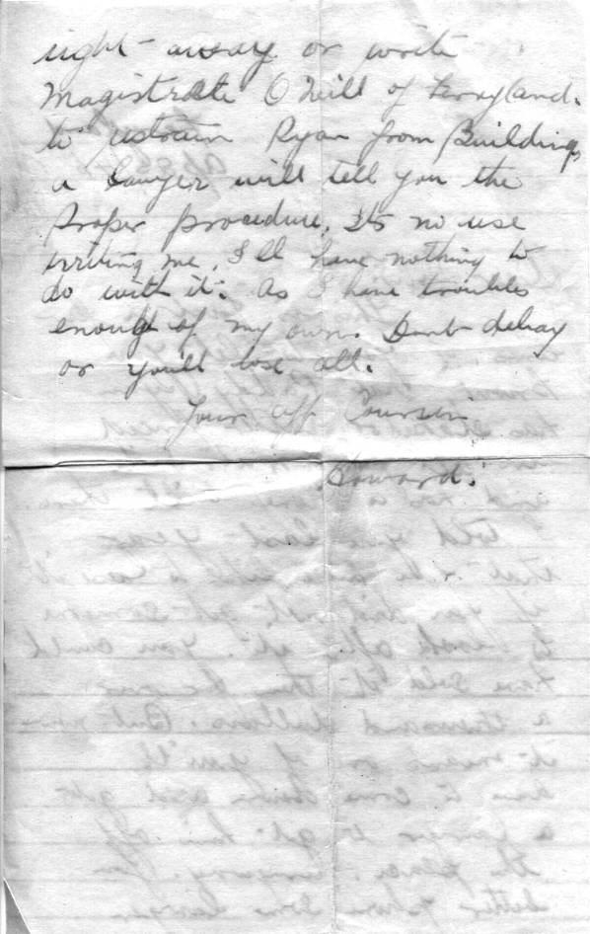 | right away or write  Magistrate O’Neill of Ferryland  To restrain Ryan from building.  A lawyer will tell you the  Proper procedure. Its no use  writing me. I’ll have nothing to do with it, as I have troubles enough of my own. Don’t delay or you’ll lose all.  Your aff. Cousin  Howard

