Maneki Neko
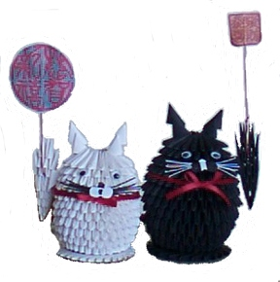
There are two different kinds of Maneki Neko. One raises its left paw. The other raises its right paw. The legend specified that the one with its left paw up invited customers or people, and the one with its right paw up invited money or good fortune. The origin of this legend was not clear.

According to the research done by Maneki Neko Club, about 60% of Maneki Nekos have their left paws up. The majority of Maneki Nekos made in earlier times seem to have their left paws up. The left paw up, which invited customers, might be the original pose of Maneki Neko. However, people's lust for money in modern day Japan reflects the increasing number of Maneki Nekos with its right paw up. The height of the paw has a meaning, also. The range of height could be anywhere from around the mouth to well over the tip of the ear. The legend says that the higher the paw, the farther the Maneki Neko invites the customers or the fortune.

White Maneki Neko
The most popular color is white. Since the image of white is purity, some theories point out that the White Maneki Neko indicates purity by its white color.

Black Maneki Neko
You will see quite a few black Maneki Nekos. They are the talismans against evil. This belief might have originated from the legend of the magical black cat. The black Maneki Neko has gained popularity among the ladies to ward off stalkers.

