Send Payment Made Out To:

Order Form
www.geocities.com/zraveneyes/
www.zravineyes@yahoo.com
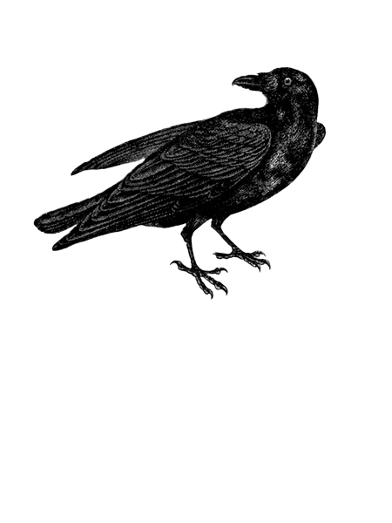

Stacey Palermo
P.O. Box 250
Bowmansville, NY 14026

For U.S. Postal Orders Please Print Out This Form

Books Available: Quantity

$9.95 Ravin’s Lair

SUB-TOTAL $
GIFT WRAPPING $ 5.00
SHIP/HANDLING $ 2.00 (If ordering more than one book, please e-mail for quote)
TOTAL PRICE $

METHOD OF PAYMENT: Check Money Order
(Cash or C.O.D. not accepted)

PLEASE PRINT

YOUR NAME:

YOUR ADDRESS:

CITY & STATE: ZIP CODE:

SHIPPING ADDRESS IF DIFFERENT

YOUR NAME:

YOUR ADDRESS:

CITY & STATE: ZIP CODE:

Gift wrapping is available for an additional fee. Please make note of special occasion, i.e. birthday…
Special Instructions, if any:

