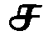  s (initial, middle)  ch (double, after t) | 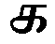  k (initial, double)  g (middle, end) | 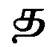  t |   t (initial, double)  d (middle, end) |   p (initial, double)  b (middle, end)
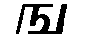  ng | 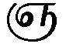  gn | 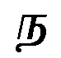  n (initial, middle) | 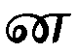  n (middle, end) | 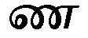  nn (middle, end)
  v | 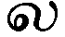  l |   ll |   m | 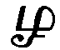  rl
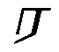  r | 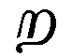  rr |   y
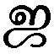  j | 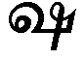  ss | 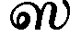  s | 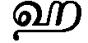  h | 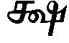  ks

 | initial  short vowels | initial  long vowels | short vowels | long vowels | examples
a | 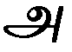 | 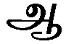 |  | 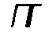 | pa
i | 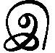 | 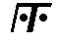 | 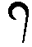 |  |   pi
u | 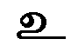 |  |  |  | 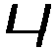  pu
e | 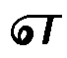 | 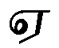 | 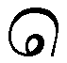 | 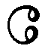 |   pe
o | 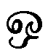 | 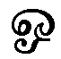 | 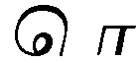 | 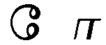 | 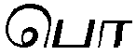  po
ai | 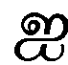 |  | 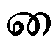 |  |   pai
au |  |  |  |  |   pau

Variations
si |  | ti |  | ti |  |  | rri |  |  | k\s\up5(–) |  |  | rl\s\up5(–)
su |  | 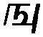  ngu |  | vu |  |  |   yu |  |  | ku |  |  | tu
  llu |  | 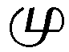  mu |  |   rlu |  |  | 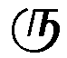  ru |  |  | tu |  |  | gnu
nu |  | nu |  | nnu |  |  | lu |  |  |   rru
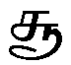  s\s\up5(–) |  | 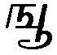  ng\s\up5(–) |  | v\s\up5(–) |  |   y\s\up5(–) |  |  | 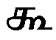  k\s\up5(–) |  |  | 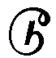  t\s\up5(–)
ll\s\up5(–) | m\s\up5(–) |  | rl\s\up5(–) |  | r\s\up5(–) |  |  | 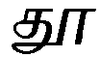  t\s\up5(–) |  |  | gn\s\up5(–)
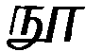  n\s\up5(–) | n\s\up5(–) |  | nn\s\up5(–) |  | l\s\up5(–) |  |  |   rr\s\up5(–)

m\s\up5(–)m\s\up5(–) = uncle | R\s\up5(–)m\s\up5(–) | amm\s\up5(–) = mother
n\s\up5(–)n = I | p\s\up5(–)ni = water | Indiy\s\up5(–) = India
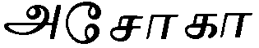  As\s\up5(–)k\s\up5(–) |  | ain\s\up5(–) = mirror

