KOREAN

k | n | t | r, l | m | p | s | c | ng (final)
k’ |  | t’ |  |  | p’ |  | 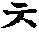  c’ | 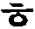  h
gg |  | dd |  |  | bb | ss | jj

a | eo | oo | u | eu | i | ae | 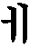  ei
ya | yeo | yoo | yu |  |  | yae | 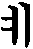  yei
 |  | 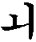  oi | 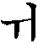  ui | 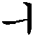  ui
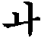  wa | 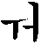  we |  |  |  |  | 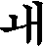  wae | 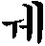  wei

  Alice | 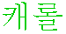  Carol |   Charles | 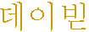  David | 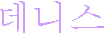  Dennis
  Helen |   Henry |   James | 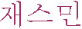  Jasmine | 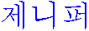  Jennifer
  John |   Julia | 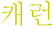  Karen | 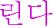  Linda | 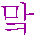  Mark
  Martin | 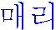  Mary |   Michael | 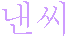  Nancy | 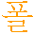  Paul
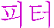  Peter | 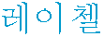  Rachel |   Richard | 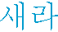  Sarah |   Thomas

an nyeong ha sim ni kka  (Are you doing peacefully?) | ban gap seum ni da  (delighted to meet you) | chom to wa chu sei yo  (please help me)
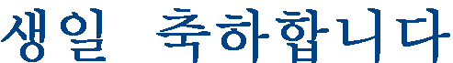  sang il chuk ha ham ni ta (happy birthday) | kam sa ham ni da  (thank you) | an nyeong hi gyei sei o  (good bye)

www.vellumstudio.com/vsvs/pkn.htm “Learn Korean at Home”
soback.kornet.nm.kr/~pixeline/heeyun/hangul.html “Survival Hangul – The Korean Language”

