Hiragana
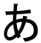 | 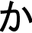 | 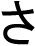 | 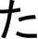 | 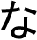 | 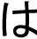 | 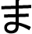 | 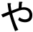 | 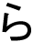 | 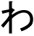
a | ka | sa | ta | na | ha | ma | ya | ra | wa
 | 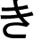 |  | 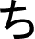 |  | 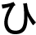 | 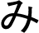 |  |  | 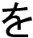
i | ki | shi | chi | ni | hi | mi |  | ri | o
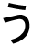 |  | 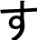 |  | 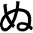 | 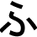 | 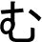 | 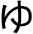 | 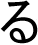
u | ku | su | tsu | nu | fu | mu | yu | ru
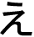 | 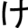 |  |  | 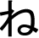 |  |  |  | 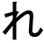
e | ke | se | te | ne | he | me |  | re
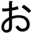 |  | 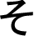 |  |  | 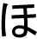 | 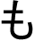 | 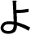 | 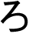 | 
o | ko | so | to | no | ho | mo | yo | ro | n

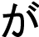 | 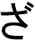 | 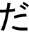 |  | 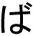 | 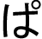
ga | za | da |  | ba | pa
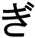 |  | 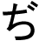 |  | 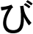 | 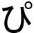
gi | ji | ji |  | bi | pi
 | 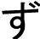 |  |  | 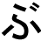 | 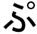
gu | zu | zu |  | bu | pu
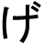 |  | 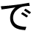 |  |  | 
ge | ze | de |  | be | pe
 | 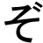 |  |  | 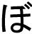 | 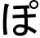
go | zo | do |  | bo | po
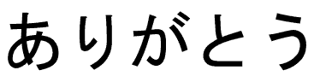  Arigat\s\up5(–) (Thank you) |  |  | 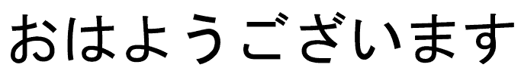  Ohay\s\up5(–)gozaimasu (Good morning)
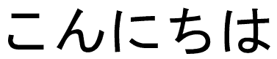  Konnichiwa (Good day) |  |  | 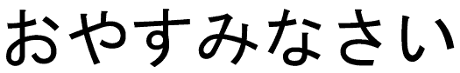  Oyasuminasai (Good night)
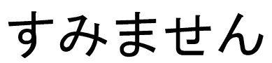  Sumimasen (Excuse me) |  |  | 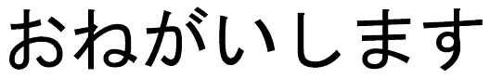  Onegai Shimasu (Please)
Katakana
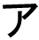 | 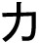 | 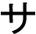 | 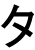 | 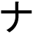 |  |  |  | 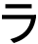 | 
a | ka | sa | ta | na | ha | ma | ya | ra | wa
 |  |  | 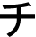 |  |  | 
i | ki | shi | chi | ni | hi | mi |  | ri
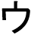 | 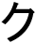 | 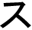 |  | 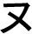 |  | 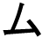 |  | 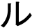
u | ku | su | tsu | nu | fu | mu | yu | ru
 | 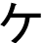 | 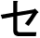 | 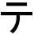 | 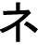 |  | 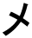 |  | 
e | ke | se | te | ne | he | me |  | re
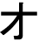 |  |  |  |  | 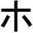 |  |  |  | 
o | ko | so | to | no | ho | mo | yo | ro | n

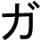 | 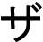 | 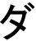 |  |  | 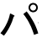
ga | za | da |  | ba | pa
 |  | 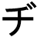 |  |  | 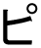
gi | ji | ji |  | bi | pi
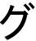 | 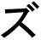 |  |  | 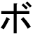 | 
gu | zu | zu |  | bu | pu
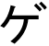 | 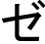 | 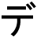 |  |  | 
ge | ze | de |  | be | pe
 |  | 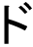 |  | 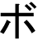 | 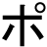
go | zo | do |  | bo | po
  Hanbaga (Hamburger) |  |  | 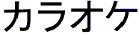  Karaoke
  Konpyuta (Computer) |  |  |   Pachinko
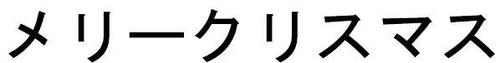  Merikurisumasu (Merry Christmas) |  |  | 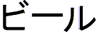  Biru (beer)
Kanji
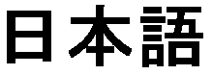  Nihongo (Japanese language) | 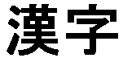  Kanji (Chinese characters)
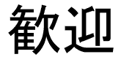  Kangei (welcome) | 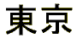  T\s\up5(–)ky\s\up5(–)
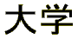  Daigaku (University) | 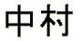  Nakamura
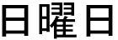  Nichi y\s\up5(–)bi (Sunday) | 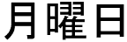  Getsu y\s\up5(–)bi (Monday)
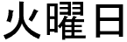  Ka y\s\up5(–)bi (Tuesday) | 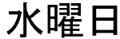  Sui y\s\up5(–)bi (Wednesday)
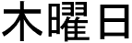  Moku y\s\up5(–)bi (Thursday) | 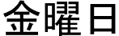  Kin y\s\up5(–)bi (Friday)
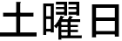
Do y\s\up5(–)bi (Saturday)

Otanj\s\up5(–)bi omedet\s\up5(–) gozaimasu (Happy Birthday)

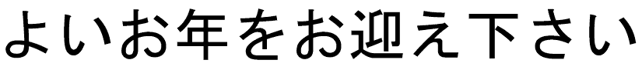
Yoi otoshi o omukae kudasai (Happy New Year)

Ref: www.saigoninfo.com/japan/e621.html “Japanese Language”
www.geocities.com/ale_palan/japanese.html “Japanese Page”

