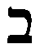bet (house) | 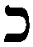final: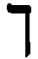kaf (palm of the hand) | final:nun (sea serpent) | 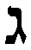gimel (throw stick) | 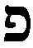final:pey (mouth)
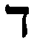dalet (door) | 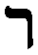resh (head) | zayin (arrow) | vav (hook) | yod (hand)
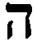hey (behold) | 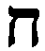het (length of rope) | 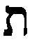tav (mark) | 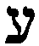ayin (eye) | 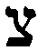final: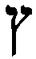  tsade (grasshopper)
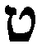tet (ball of twine) | 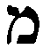final: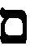  mem (water) | 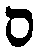samekh (fish) | 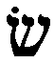sin | 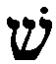shin (hills)
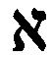alef (ox) | 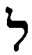lamed (peasant’s crook) | 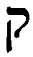qof (monkey)

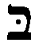b | v | 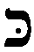k | kh | 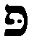p | f

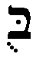bu | 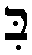bi |  | 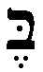be | 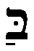ba
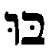b\s\up5(–) | 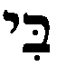b\s\up5(–) | 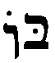b\s\up5(–) | 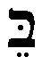b\s\up5(–) | 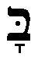b\s\up5(–)

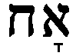  akh = brother | 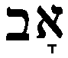  av = father |  | 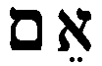  em = mother |  | 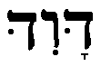  David |  | 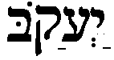  Jacob
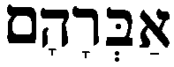  Abraham |  | 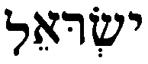  Israel |  |  |  | 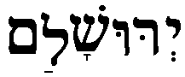  Jerusalem
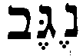  negev |  | 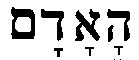  haadam = the man |  |  |  | 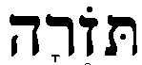  torah
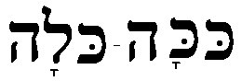  coca cola |  |  |  | 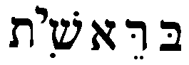  breshit = in the beginning

