final | middle | initial | alone | final | middle | initial | alone
 | 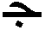 |  |   jam | 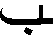 |  |  | 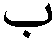  bin
 |  |  |   ham |  |  |  |   tin
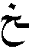 |  |  | 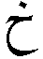  khan | 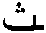 |  |  | 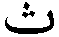  thin
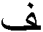 |  |  | 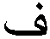  fake | 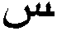 |  |  | 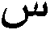  sick
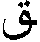 |  |  | 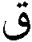  quake | 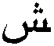 |  |  | 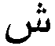  sheikh
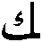 |  |  | 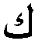  kick |  |  |  |   sick
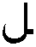 |  |  |   lake | 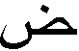 |  |  | 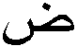  dick
 |  |  | 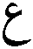  guttural  stop | 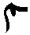 |  |  | make
 |  |  | 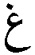  gate |  |  |  |   nick
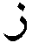  zoo |   rule | thumb | dumb |  | 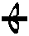 | 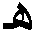 |   hate
alif |   wake | 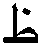  zoo |   tool | 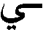 |  |  | 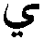  yates

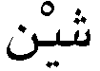  shain | 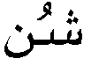  shun | shin | 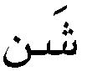  shan
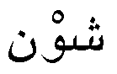  shawn | 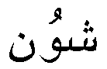  sh\s\up5(–)n | 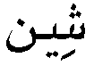  sh\s\up5(–)n | 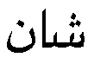  sh\s\up5(–)n
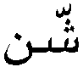  shshn | 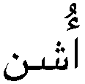  ushn | 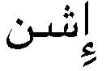  ishn | 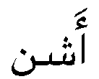  ashn

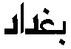  d – \s\up5(–) – d – g – b  (Baghdad) | 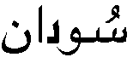  n – \s\up5(–) – d – s\s\up5(–)  (Sudan) | 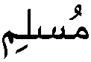  m – li – s – mu (Muslim) | 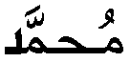  d – mma – h – mu (Muhammad)
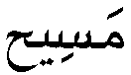  h –s\s\up5(–) – ma  (Masih = Messiah) | 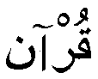  n – \s\up5(–) – r – qu (Qur’an) | r – b – k – a hu – lla – a  (Allah is great)
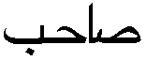  b – h – s\s\up5(–)  (sahib = sir) | 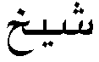  kh – \s\up5(–) – sh  (sheikh) | 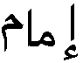  m – m\s\up5(–) – i  (Imam = Priest) | 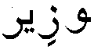  r – z\s\up5(–) – w  (Wzir = Minister)
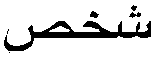  s – kh – sh  (shkhs) | 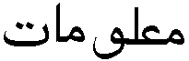  t – m\s\up5(–) – lo – m’  (malumat = information) | 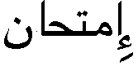  n – h\s\up5(–) – t – m – \s\up5(–)  (imtihan = examination) | 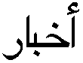  r – b\s\up5(–) – kh – a  (akhbar = newspaper)

