Yugoslavia
By Dejan Anastasijevic

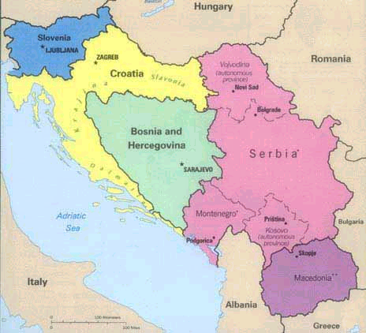

The six Yugoslav Republics were a patchwork of ethnicities and religious groups. In the 15th century, after the Ottomans completed their conquest of the territory, many Orthodox Christian Serbs migrated and scattered across the Balkans, with substantial minorities settling in Bosnia and Croatia. This mix of peoples was one of the reasons Yugoslav leader Josip Broz, known as Tito, insisted that religious and ethnic differences be played down to prevent conflict. This was the price of a unified Yugoslavia.

Slovenia was the first to leave the Yugoslav fold. The Yugoslav army withdrew after 10 days of skirmishes following Slovenia's declaration of independence on 26 June 1991.

Croatia was a much more complicated matter because of the large Serbian minority. When Croatia (capital Zagreb) declared its independence from Yugoslavia on same day as Slovenia, Serbs in the Krajina region in southwestern Croatia refused to accept the decision. War broke out between the Croats and the Yugoslav-backed Croatian Serbs. Eventually in 1995, Croatia overwhelmed Serb forces in Krajina and Slavonia, and then expelled almost the entire Serb population from the region.

Bosnia declared independence on 5 April 1992. But Yugoslav-backed Bosnian Serb militias carved out several autonomous regions in Bosnia, which they declared Republika Srpska (main city Banja Luka). Sarajevo, the once-beautiful Bosnian capital, host of the 1984 Winter Olympics, was besieged and shelled by Serb forces for over three years. Bosnian Serb leaders Radovan Karadzic and General Ratko Mladic began obliterating non-Serb residents in an "ethnic cleansing" campaign. The United Nations condemned Serbia’s involvement in the war and imposed economic sanctions on Yugoslavia in 1992. The massacre of thousands of Bosnian Muslims by Bosnian Serbs in Srebrenica in July 1995 was perceived as the worst war crime in Europe since World War II. NATO-led U.N. forces eventually defeated Serbia. On 21 November 1995, Yugoslav President Slobodan Milosevic agreed to the Dayton Peace Treaty, on behalf of the Bosnian Serbs, in exchange for the lifting of economic sanctions against Yugoslavia.

In 1992, Serbia and Montenegro announced the formation of the Federal Republic of Yugoslavia as successor to the Socialist Republic of Yugoslavia. Montenegro's economic basis is weak but the fact that Montenegro possesses a coast makes the country of vital importance for landlocked Serbia. Since the rise of Montenegro's President, Milo Djukanovic, conflicts between Serbia and Montenegro have increased.

In the southern Serbian province of Kosovo (provincial capital Pristina), ethnic Albanians had been seeking independence since the early 1980s. Most Serbs regarded Kosovo as historic Serb soil, and as the cradle of the Serb nation, despite 90 percent of the population being Albanian. In 1998 a new guerrilla group, the Kosovo Liberation Army (K.L.A.), declared its intention to achieve independence through armed resistance. The K.L.A.'s attacks on Serbian police and military patrols led to massive reprisals by the Serbian security forces. On 24 March 1999, NATO started a bombing campaign against Serbia. Milosevic responded by intensifying the ethnic cleansing campaign in Kosovo, expelling hundreds of thousands of ethnic Albanians into neighbouring Macedonia and Albania. The first war in NATO's history continued until 9 June 1999, when the Serb forces agreed to withdraw. After the war, the Kosovo Liberation Army carried out its own campaign to drive the remaining Serbs out of Kosovo.

In Vojvodina — one of the richer regions in northern Serbia — ethnic tensions had not run very high, despite the presence of large numbers of non-Serbs, most notably Hungarians (15 percent of the population). The Serb majority (59 percent) advocated a measure of autonomy, in contrast to Milosevic's suggestion that all political opposition in Serbia was of ethnic origin.

There were also signs that Milosevic was losing popular support at home. In September 2000 he called for early municipal, parliamentary and presidential elections, hoping both to subdue Montenegro and confirm himself as leader. But Vojislav Kostunica, leader of the Democratic Opposition of Serbia (DOS), won the elections held on 24 September. Milosevic tried every trick to stay on and ordered to annul the elections. Opposition-led popular protests culminated in a massive rally in Belgrade on 5 October which succeeded in installing Kostunica as FRY Federal President. Zoran Djindjic was elected Prime Minister on 23 December.

From the beginning of Yugoslavia’s violent dissolution a decade ago, the feared endpoint was war in the Former Yugoslav Republic of Macedonia (capital Skopje). Experts said the conflict that first grabbed the international community's attention in Slovenia in June 1991 would roll inexorably eastward. A new guerrilla force calling itself the National Liberation Army and claiming to represent Macedonia's Albanian minority was asking for self-rule for Albanians in Macedonia. Despite the efforts of NATO and the Macedonian security forces to tamp down the Albanian insurgency along the Kosovo border, there were new clashes on 14 March 2001 at Tetovo, deep inside Macedonia. The latest fighting is the opening scene of yet another Balkan tragedy.

www.time.com/time/europe/timetrails/serbia/ “TIME Europe TIME Trail Serbia”
www.snu.edu/syllabi/history/f96projects/bosnia/index2.htm “The Deep Roots of the War in Bosnia”
www.abcnews.go.com/reference/countries/SR.html “ABCNEWS.com Country Profile Yugoslavia”
www.abcnews.go.com/reference/countries/BK.html “ABCNEWS.com Country Profile Bosnia and Herzegovina”
www.time.com/time/europe/eu/magazine/0,9868,103998,00.html “TIME.com: Europe -- The Next Nightmare”
www.time.com/time/world/article/0,8599,102505,00.html “TIME.com World -- 'Macedonia Is Going the Way of Kosovo and Bosnia'”

