Japan
Aichi 爱知 (Nagoya City 名古屋)  A white stylised hiragana character of A of Aichi on a wine red field. | 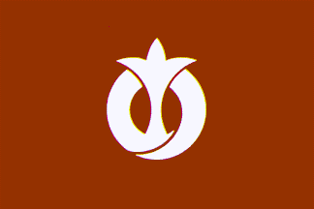 |  | Akita 秋田  A white stylised katakana character of A of Akita on a wine red field. The emblem represents the rapid progress of Akita.
Aomori 青森  A stylised map of the prefecture in green on a white field. | 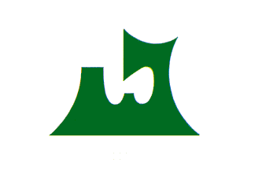 | 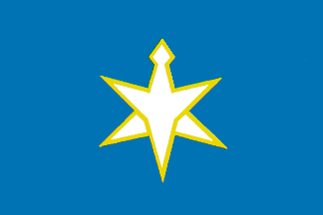 | Chiba 千叶  The emblem is made up of the stylised katakana characters of Chiba.
Ehime 爱媛 (Matsuyama City 松山)  Three horizontal stripes of yellow, green and yellow with a white orange flower. | 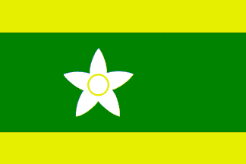 | 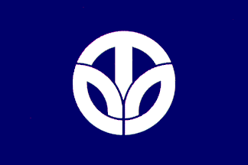 | Fukui 福井  White stylised katakana characters of Fukui in a round shape on a dark blue field.
Fukuoka 福冈  A white plum flower emblem on a light blue field. Plum is the prefecture's flower. | 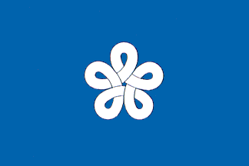 | 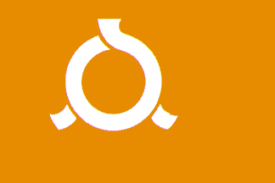 | Fukushima 福岛  A white stylised hiragana character of Fu of Fukushima on an orange field.
Gifu 岐阜  A green stylised kanji character of Gi of Gifu in a green circle on a white field. |  | 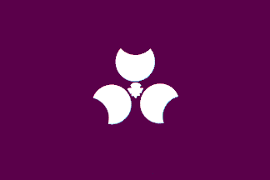 | Gunma 群马 (Maebashi City 前桥)  A white stylised kanji character of Gun of Gunma and three white crescents which stand for three mountains Mt. Akagi, Mt. Haruna and Mt. Myougi on a purple field.
Hiroshima 广岛  A white stylised katakana character of Hi of Hiroshima on a wine red field. | 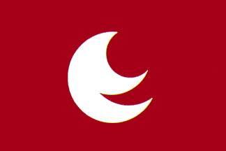 | 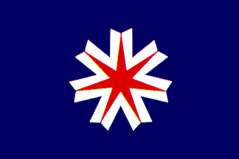 | Hokkaido 北海道  (Sapporo City 札幌)  A white-fringed red 7-point star on a blue field. Blue represents the sea and sky of Hokkaido, red stands for the people's energy and white for light and snow.
Hyogo 兵库 (Kobe City 神户)  A white stylised kanji character of Hyo of Hyogo in wavy shape on a blue field. Blue stands for the Japan Sea and Setouchi Sea. | 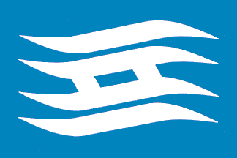 | 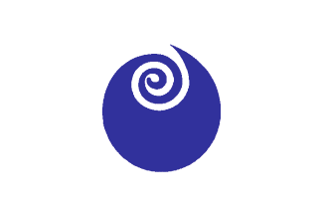 | Ibaraki 茨城 (Mito City 水户)  A blue rose bud on a white field. The rose is the prefecture's flower. Blue stands for the Pacific Ocean and Mt. Tsukuba.
Ishikawa 石川 (Kanazawa City 金氵尺)  White stylised kanji characters of Ishikawa on a light blue field. |  | 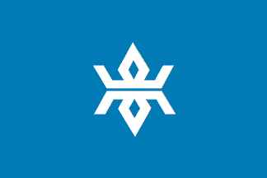 | Iwate 岩手 (Morioka City 盛冈)  A white stylised kanji character of Iwa of Iwate on a blue field.
Kagawa 香川 (Takamatsu City 高松)  A white stylised katakana character of Ka of Kagawa on a green field. | 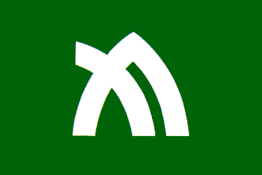 | 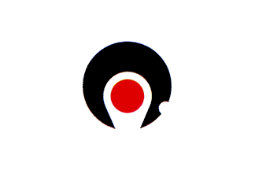 | Kagoshima 鹿儿岛  A white flag with the emblem of a stylised map of Kagoshima, land part in black and Sakurajima island in red.
Kanagawa 神奈川  (Yokohama City 横浜)  A red stylised kanji character of Ka of Kanagawa on a white field. | 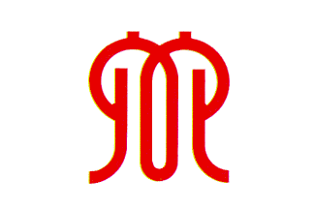 | 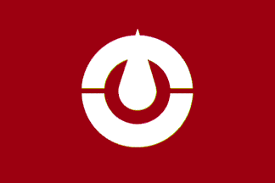 | Kochi 高知  The emblem is a combination of a wine red stylised katakana character of Ko of Kochi and kanji character of To of Tosa (old name of Kochi) on a wine red field.
Kumamoto 熊本  A white stylised katakana character of Ku of Kumamoto on a wine red field. The emblem represents a map of Kyushu island in white of which Kumamoto is a part. | 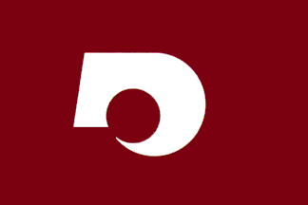 | 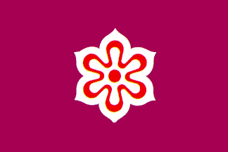 | Kyoto 京都  A white-fringed red-outlined kanji character of Kyo of Kyoto on a wine red field.
Mie 三重 (Tsu City 津)  A white stylised hiragana character of Mi of Mie on a green field. Green stands for green mountains. The emblem also represents a popular product of Mie, pearl. | 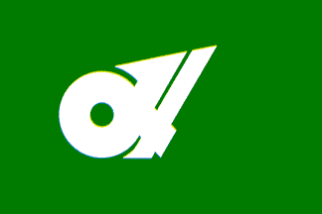 | 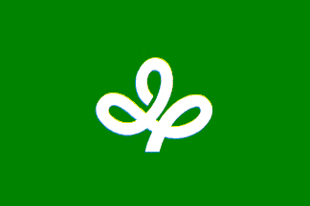 | Miyagi 宫城 (Sendai City 仙台)  A white stylised bush clover as the prefecture's tree on a green field. Bush clover is also a stylised hiragana character of Mi of Miyagi.
Miyazaki 宫崎  A yellow stylised katakana character of Mi of Miyazaki on a light green field. The emblem is shaped like steps symbolising progress of Miyazaki. | 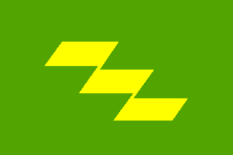 | 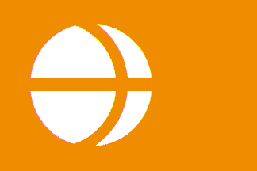 | Nagano 长野  Orange stylised katakana character of Na of Nagano in a white disc on an orange field. The emblem represents a mountain reflected in a lake as well.
Nagasaki 长崎  A light blue stylised prefecture initial N on a white field. Blue stands for the sky and sea surrounding Nagasaki and N shaped like a dove for world peace. |  | 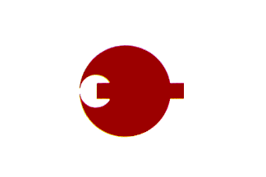 | Nara 奈良  A wine red stylised katakana character of Na of Nara on a white field.
Niigata 新 氵舄  A gold stylised kanji character of Nii of Niigata and the katakana characters of Gata of Niigata on a red field. | 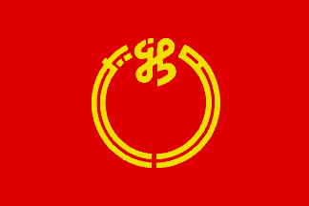 | 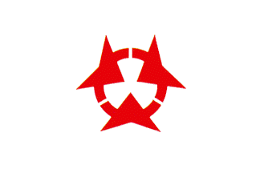 | Oita 大分  Three red stylised kanji characters of O of Oita in a circle on a white field.
Okayama 冈山  A gold stylised kanji character of Oka of Okayama on a dark purple field. | 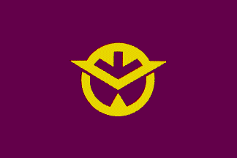 | 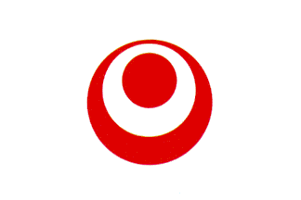 | Okinawa 冲绳 (Naha City 那霸)  A white O letter in a red disc on a white field. The inner small red disc stands for progress of Okinawa and outer red circle for the sea surrounding Okinawa.
Osaka 大阪  Blue represents the international city of Osaka. Osaka is called water city in Japan because it has a lot of rivers and faces two seas which blue also represents. | 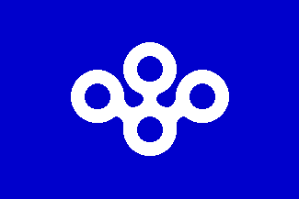 | 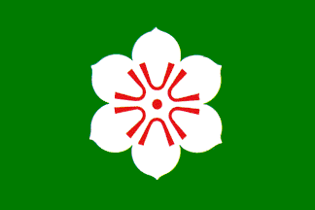 | Saga 佐贺  A white camphor tree flower with red stamen on a dark green field. Camphor tree is the prefecture's tree.
Saitama 土奇 玉 (Urawa City 浦和)  16 red ornamental beads on a white field. Saitama means ornamental bead and 16 beads in a circle represent the sun, development and strength. | 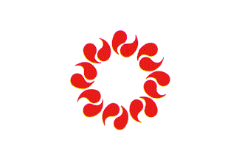 | 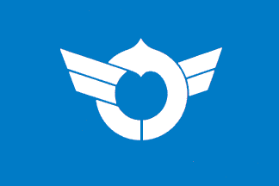 | Shiga 滋贺 (Otsu City 大津)  White stylised katakana characters of Shiga on a light blue field. The emblem represents Japan's largest lake, the Biwako, in light blue.
Shimane 岛根 (Matsue City 松江)  Four gold stylised katakana characters of Ma of Shimane in a circle on a wine red field. | 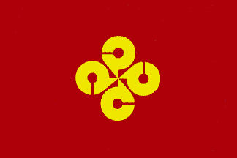 | 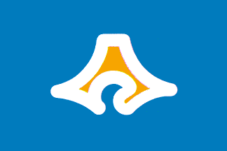 | Shizuoka 静冈  A white stylised map of Shizuoka with an orange Mt. Fuji inside on a blue field. Blue stands for the sky and the Pacific Ocean.
Tochigi 木厉木  (Utsunomiya City 宇都宫)  A white stylised kanji character of Tochi of Tochigi and an ancient Chinese character of Gi with three arrows on a light green field. |  | 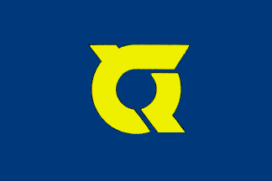 | Tokushima 德岛  Yellow stylised hiragana characters of Toku of Tokushima on an indigo blue field. The emblem is shaped like a flying bird.
Tokyo 东京  A white sun with 6 rays on a dark purple field. The sun is a stylised kanji character of To of Tokyo. | 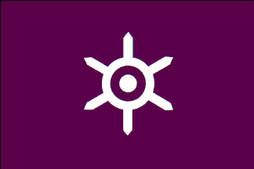 | 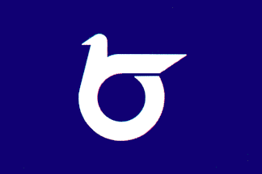 | Tottori 鸟取  A white stylised hiragana character of To of Tottori in a bird shape on a dark blue field. Tottori means many birds.
Toyama 富山  Combination of a brilliant green stylised hiragana character of To of Toyama and shape of Mt. Tateyama (a famous mountain in Toyama) on a white field. | 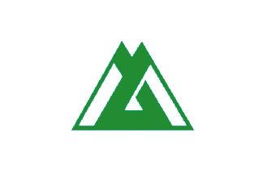 |  | Wakayama 和歌山  A marine blue stylised katakana character of Wa of Wakayama on a white field.
Yamagata 山形  Three white stylised mountains on a blue field. Yamagata means a shape of mountain. These also represents the Mogami river running through Yamagata. |  | 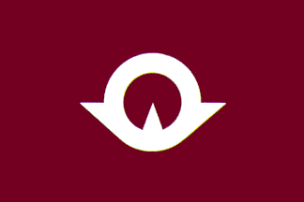 | Yamaguchi 山口  White stylised kanji characters of Yamaguchi on a dark wine red field. The emblem is shaped like a bird fluttering towards the sun.
Yamanashi 山梨 (Kofu City 甲府)  Yellow stylised kanji character of Yama of Yamanashi in the centre of a white outlined Mt. Fuji on a purple field. Purple is chosen because grape is a popular product of Yamanashi. | 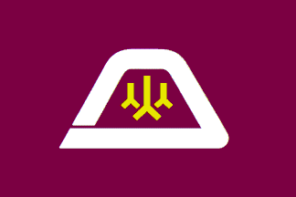
http://flags-by-swi.com/fotw/flags/jp-prefe.html “Flags of the World: Japanese Prefectures”

