 |  | Dinosaurs
 | Saurischia |  | Ornithischia
Theropods  “beast-footed” | Sauropodomorphs  “lizard-foot form” | Thyreophorans  “shield-bearer” | Marginocephalians  “fringed-headed” | Ornithopods  “bird-footed”
Ceratosaurs (eg ceratosaurus, coelophysis, dilophosaurus)  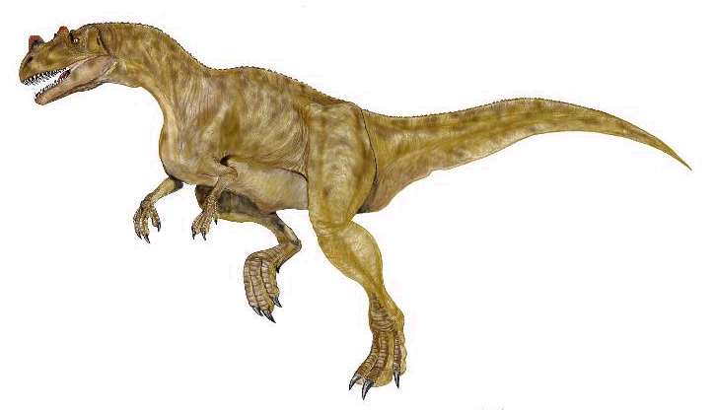 | Prosauropods (eg plateosaurus)  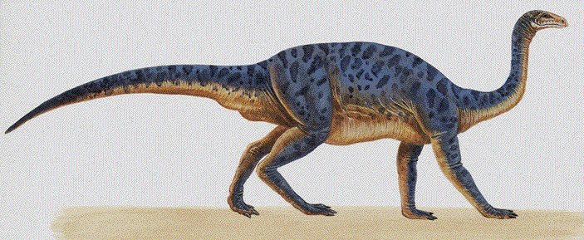 | Stegosaurs (eg stegosaurus)  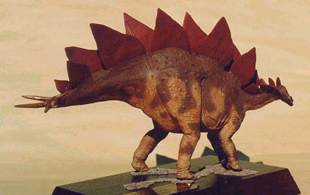 | Pachycephalosaurs (eg pachycephalosaurus)  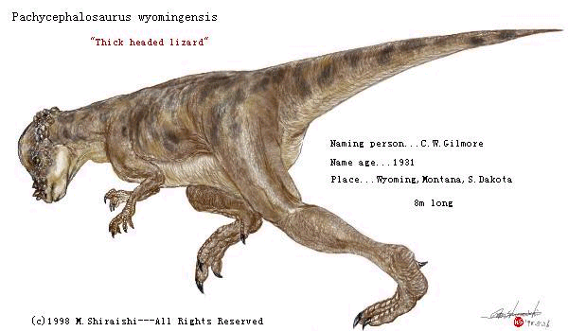 | Heterodontosaurs (eg heterodontosaurus)  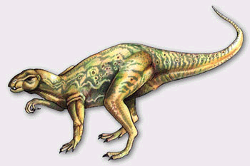
Carnosaurs (eg allosaurus)  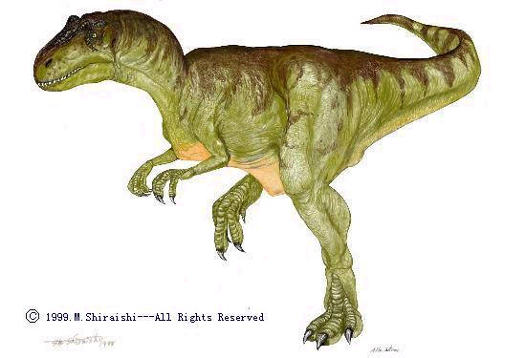 | Diplodocoidea (eg diplodocus, apatosaurus)  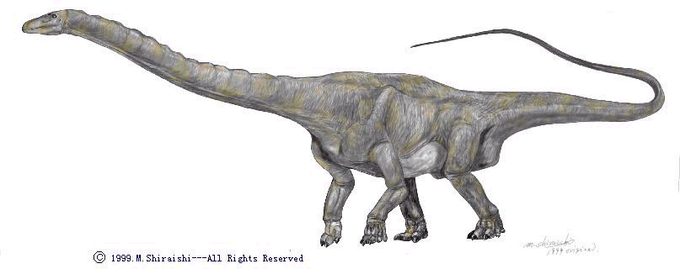 | Ankylosaurs (eg ankylosaurus)  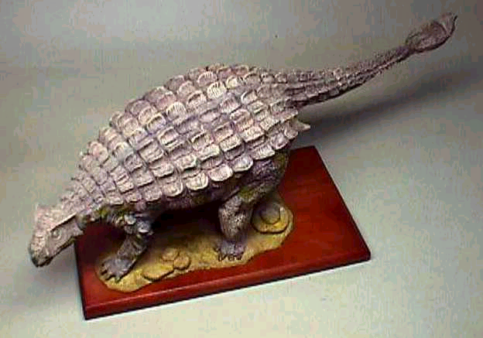 | Ceratopsians (eg triceratop, styracosaurus, chasmosaurus)  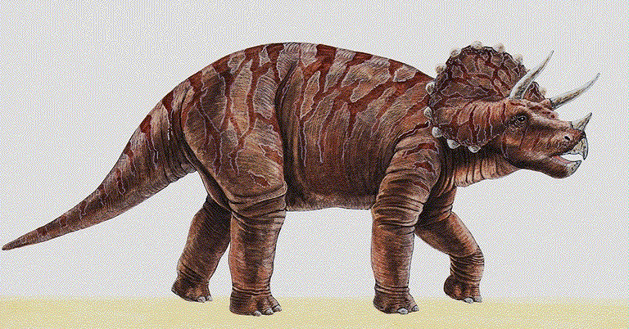 | Hypsilophodontia (eg hypsilophodon)  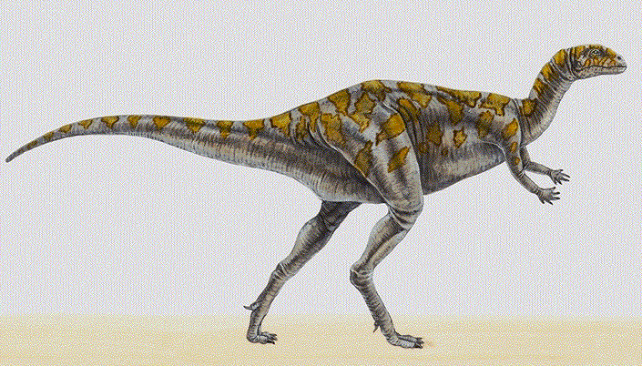
Ornithomimosaurs (eg ornithomimus, struthiomimus, gallimimus)  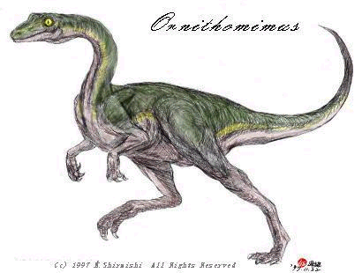 | Macronaria (eg brachiosaurus, camarasaurus )  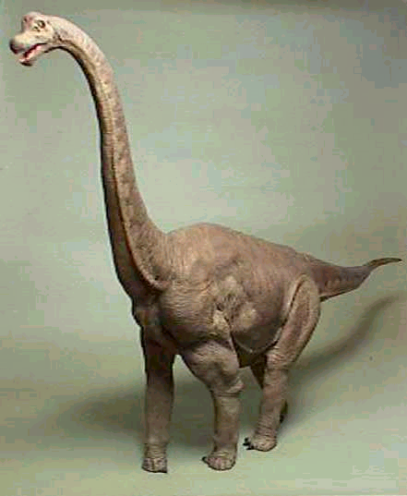 | Nodosaurs (eg nodosaurus)  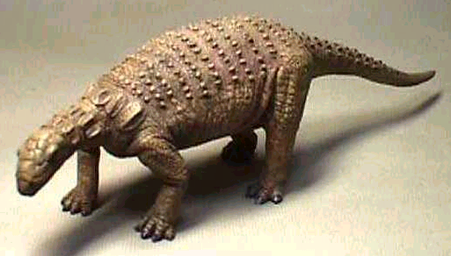 |  | Iguanodons (eg iguanodon)  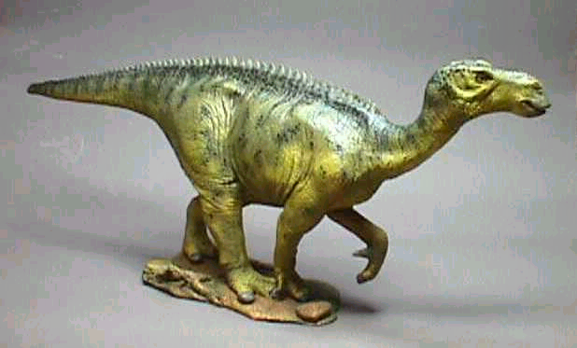
Tyrannosaurs (eg tyrannosaurus)  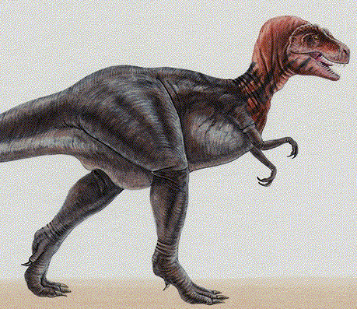 |  |  |  | Hadrosaurs (eg parasaurolophus, corythosaurus, lambeosaurus)  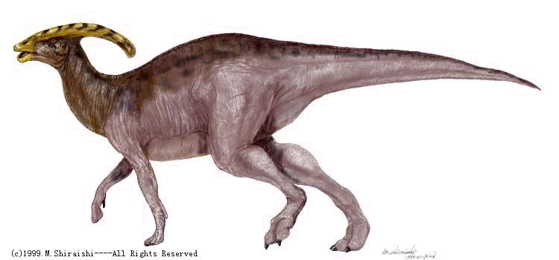
Maniraptors (eg dromeosaurus, oviraptor, troodon)
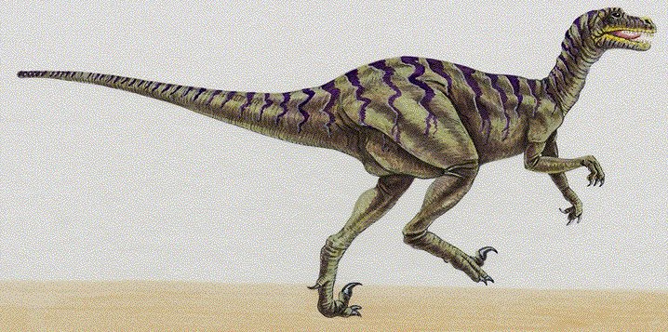

- www.frii.com/~persing/dinosaur.html “Persing’s Pieces”
- www.cyberspacemuseum.com/dinohall.html “The Cyberspace Museum of Natural History & Exploration Technology's Dinosaur Hall”
- dinosauricon.com/taxa/index.html “The DinosaurIcon”

