
EL Civics Objective 46 (Nutrition) • Int/Adv
Task 1: Analyze Eating Habits
Language & Literacy Objectives:
- Identify a healthy diet as recommended by USDA.
- Identify the relationship between nutrition and good health.

INTRODUCTION
In this lesson, students will learn about the USDA food pyramid, food groups represented, and what is considered a healthy American diet. Students will also learn vocabulary for common American foods.

ASSESSMENT TASK
Given a short case study, students will list 6 unhealthy eating habits/food choices of the person in the case study. They will also recommend changes the person can make to improve his diet and health. 12 points possible.

SUGGESTED ACTIVITIES
Introduce the USDA food recommendations (“Food Pyramid”)
- Use PowerPoint presentation to highlight main ideas
- Emphasize different needs for ages, genders

Compare US Food Pyramid to students’ native cultures

Keep a nutrition journal and analyze own eating habits and food choices

Invite a nurse or nutritionist as a guest speaker in your class

Organize a nutrition and health fair and/or food drive for charity

Watch & discuss the DVD “Super Size Me” with your class – educationally-enhanced version available, including teaching materials

HANDOUTS PROVIDED
Information for Teachers: New USDA Food Pyramid and Dietary Guidelines
(READ BEFORE INTRODUCING FOOD PYRAMID TO STUDENTS)

Handout 1: Related Vocabulary
Handout 2: Discussion Questions
Handout 3: New USDA Food Pyramid (color transparency)
Handout 4: My Pyramid Plan (Internet Activity)
Handout 5: What Counts as One Serving? (Internet Activiity)
Handout 6: Case Studies: Healthy or Unhealthy Diets w/Worksheet
Handout 7: Food for One Day: A Nutrition Journal
Handout 8: Nutrition Facts Label

Binder Pocket: Sample Menus/Nutrition Information
- TUSD School Lunch Menus: www.tusd.org/vnews/display.v/ART/2006/05/28/4028112088132
- Chili’s: www.chilis.com/chilis_nutrition_menu.pdf
- Subway: subway.com/subwayroot/MenuNutrition/Nutrition/pdf/NutritionValues.pdf
- McDonald’s: www.mcdonalds.com/usa/eat/nutrition_info.html

COMPUTER LAB IDEAS
- Create a personalized eating plan at www.mypyramid.gov
- Work in groups to create a menu for a fictional healthy restaurant. Present menus to the class; class discussion regarding menu items. Are they healthy? (Can use menu templates in Publisher: Publications to Print → Menus.)
- Look up nutritional information on restaurant websites and/or Calorie King.
- Research healthy food choices based on USDA recommendations. Create a presentation & share information with class. Compare US diet to other cultures?
- Conduct online searches for healthy recipes. Compare different recipes of same dish and determine healthiest choice. Explain why.
- Create a presentation about the USDA food groups and present to class. Note the different recommendations for different genders, age groups, etc.

- Research eating disorders online (e.g. anorexia, bulimia).

INFORMATION FOR TEACHERS:
NEW USDA FOOD PYRAMID & DIETARY GUIDELINES
adapted from http://www.husd.k12.ca.us/Nutrition/pyramid.htm

Eating is one of life's greatest pleasures. There are so many choices - and so many ways to build a healthy diet through good nutrition and an active lifestyle. To make nutrition easier to understand and its guidelines easier to follow, the United States Department of Agriculture (USDA) redesigned the Food Guide Pyramid to demonstrate the proportions of each food type we should be eating every day.

But ONE SIZE DOESN'T FIT ALL!

Visit www.mypyramid.gov, the USDA's NEW Food Pyramid Website, for a nutrition plan tailored to each individual.

Recommended Daily Selections
The USDA's OLD PLAN (see picture below) specified how many servings of each type of food should be eaten each day, with grains in largest quantities, then vegetables, fruit, protein foods and dairy. But it made no allowances for differences in activity levels, age and gender, and it was determined that individuals have quite different needs. The 2005 Food Guide Pyramid asks for specifics and then gives you a plan tailored to an individual’s needs (see next page).

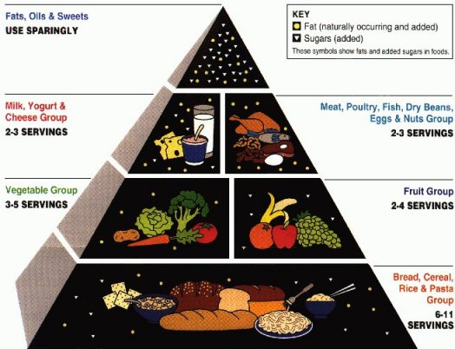

INFORMATION FOR TEACHERS (cont.)

The New Dietary Guidelines for 2005 recommend different amounts of the various food types, depending on age, gender, and activity level, in the PROPORTIONS demonstrated by the color bands on the Pyramid.

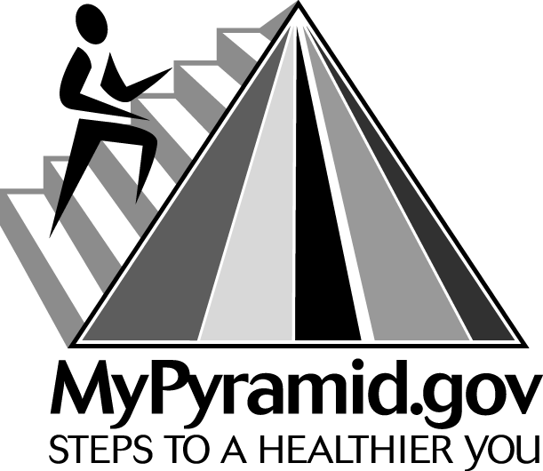

THE NEW FOOD GUIDE PYRAMID (see transparency, page 5)
It shows that GRAINS (orange) should be the largest single part of our diets, following closely by VEGETABLES (green) and MILK products (blue). Next, FRUITS (red) are needed a bit less, and PROTEIN (purple) is needed in smaller quantities than most people realize. Last, OILS (yellow) are a tiny but essential part of our daily dietary needs. Here are the USDA’s TIPS for healthy eating:
Make Half your Grains Whole!
We need those complex carbohydrates.
Vary your Veggies!
And choose DARK green and BRIGHT orange.
Focus on Fruits, go Easy on Juices!
Eat a variety - fresh, frozen, canned or dried.
Get those Calcium-Rich Foods!
Go low-fat or fat-free with milk products.
Go Lean with Protein!
Bake, broil or grill it - avoid frying.

INFORMATION FOR TEACHERS (cont.)

Anatomy of MyPyramid
To see an animation demonstrating the notes below, go to: http://www.mypyramid.gov/global_nav/media_animation.html

One size doesn't fit all
USDA's new MyPyramid symbolizes a personalized approach to healthy eating and physical activity. The symbol has been designed to be simple. It has been developed to remind consumers to make healthy food choices and to be active every day. The different parts of the symbol are described below.
Activity
Activity is represented by the steps and the person climbing them, as a reminder of the importance of daily physical activity.
Moderation
Moderation is represented by the narrowing of each food group from bottom to top. The wider base stands for foods with little or no solid fats or added sugars. These should be selected more often. The narrower top area stands for foods containing more added sugars and solid fats. The more active you are, the more of these foods can fit into your diet.
Personalization
Personalization is shown by the person on the steps, the slogan, and the URL. Find the kinds of amounts of food to eat each day at MyPyramid.gov
Proportionality
Proportionality is shown by the different widths of the food group bands. The widths suggest how much food a person should choose from each group. The widths are just a general guide, not exact proportions. Check the Web site for how much is right for you.
Variety
Variety is symbolized by the 6 color bands representing the 5 food groups of the Pyramid and oils. This illustrates that foods from all groups are needed each day for good health.
Gradual Improvement
Gradual improvement is encouraged by the slogan. It suggests that individuals can benefit from taking small steps to improve their diet and lifestyle each day.
This page intentionally blank.
Task 1 – Handout #1

Related Vocabulary
adapted from www.dictionary.com

food choice: options or preferences.

eating habit: pattern of behavior.

USDA: United States Department of Agriculture.

food pyramid: graphical representation of human nutritional needs.

food group: a group of foods that have similar nutritional properties and is part of the hierarchy of the food pyramid, such as grains, dairy, protein, fruit & vegetables, fats & sweets.

recommendation: a course of action that is advisable.

journal: a personal record of occurrences, experiences, observations and reflections kept on a regular basis.

diet: foods eaten by a particular person or group.

analyze: to study or examine carefully (and in detail) to identify causes, possible results, etc.

balanced: a balanced diet is one that has the proper proportion of food groups represented.

This page intentionally blank.
Task 1 – Handout #2

Discussion Questions
Some questions adapted from “Talk Your Head Off,” by Brana Rish West. Prentice Hall Regents.

- Describe the typical diet in your native country. Do you continue to eat those foods here in the United States?
- How has your diet changed since moving to the U.S.? What about your kids’ diet?

- Compare the typical diet in your culture to the typical U.S. diet. How are they similar? How are they different?
- What is a balanced diet? Give an example.
- What nutritious foods do you eat? Talk about a healthy meal that you have eaten recently.
- Do you eat any low-fat foods? If so, what are they? If not, why not?
- What junk foods and snacks do you like to eat? When do you eat them?
- What fast foods do you eat? Do you think fast foods are junk foods? Why or why not?
- What is a vegetarian? Name three reasons people are or become vegetarians. Do you think it is healthy to be a vegetarian? Why or why not?
- What did your parents tell you to do to stay healthy? Did they tell you to “eat your vegetables!”? What do you tell your own children?
- What is an eating disorder? Which ones are most common in the U.S.? In your home country? Why do you think people have them?

This page intentionally blank.
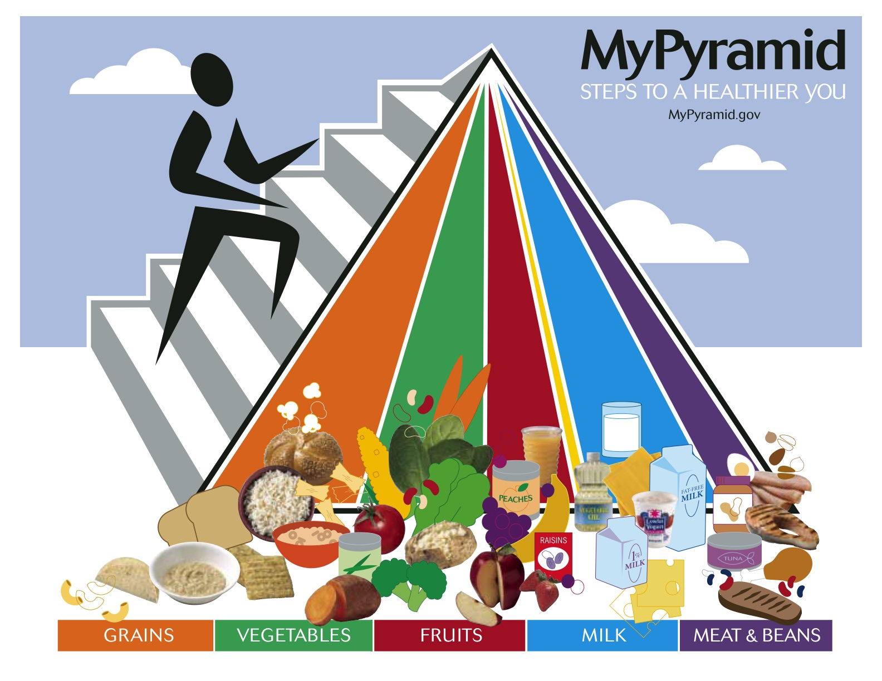
This page intentionally blank.
Task 1 – Handout #4

MyPyramid Plan (Internet Activity)

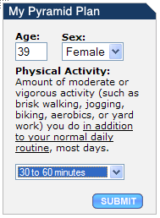
- Go to the Internet.

- In the address box, type:
http://mypyramid.gov and click GO.

- Look for My Pyramid Plan on the right side.
Fill in the information about yourself: age, sex & amount of physical activity.

- Click the SUBMIT button.

Directions: Read the information provided for you. Answer the following questions:
- How many total calories should you have each day? _____________.
- How many servings of GRAINS should you eat every day? ___________.

- How many servings of VEGETABLES should you eat? _______________.

- How many servings of FRUITS should you eat? _______________.

- How many servings of MILK should you have? ____________.

- How many servings of MEAT & BEANS should you eat? _____________.

- How many teaspoons of OILS should you have? _____________.

- How many DISCRETIONARY CALORIES (extra fats & sweets) are OK for you? _____________.
This page intentionally blank.
Task 1 – Handout #5

What Counts as One Serving? (Internet Activity)


- Go to the Internet.

- In the address box, type: http://www.mypyramid.gov/pyramid and click GO.

      - Click on the orange triangle. Click on “What Counts as an Ounce?”
What is one serving of GRAINS? 1 slice of bread

      - Under Related Topics, click on “Vegetables.” Click on “What Counts as a Cup?”
What is one serving of VEGETABLES? ____________________________

      - Under Related Topics, click on “Fruits.” Click on “What Counts as a Cup?”
What is one serving of FRUITS? __________________________________

      - Under Related Topics, click on “Milk.” Click on “What Counts as a Cup?”
What is one serving of MILK? ____________________________________

      - Under Related Topics, click on “Meat & Beans.” Click on “What Counts as an Ounce?”
What is one serving of MEAT & BEANS? ___________________________

      - Which one is a good, healthy lunch? (circle)
- McDonald’s hamburger, fries, a Coke, and a bag of candy.
- Tuna sandwich with lettuce and tomato, a glass of milk, and an orange.
- 4 donuts and a beer.
- 1 egg, 1 piece of chicken, 10 nuts, a large steak & a glass of tomato juice.
- 1 carrot, 1 egg, and a glass of milk.

What is your favorite food? _____________________________________

What food group(s) is it in? _____________________________________
This page intentionally blank.
Task 1 – Handout #6

Case Studies: Healthy and Unhealthy Diets

Directions: Read the case studies below, then answer the questions on page 19.

Case Study 1:
Linda Carter is 16 years old. She usually gets up late, so she doesn’t have time for breakfast. She grabs a donut and eats it on her way to school. At her school break, she has a soda and some chips. Lunch is served in the school cafeteria, and Linda orders a hot dog or hamburger and french fries. For dessert she has a pack of oreos or chocolate chip cookies. On her way home from school, she and her friends stop at a mini-mart and get an ice cream cone or a candy bar. For dinner, Mrs. Carter serves spaghetti with meat sauce and garlic bread. Linda needs to improve her diet! Give some examples of healthy food choices she can make for better nutrition.

Case Study 2:
Mrs. Lee is a homemaker. She doesn’t work outside her home, but she is very busy all day. She doesn’t take time to eat proper meals. After the children and her husband leave in the morning, she pours herself a large cup of black coffee and munches on some leftover pizza from last night’s dinner. At noon, she has to pick up her youngest child from pre-school, and after she picks him up, she stops at a fast food restaurant and buys him a children’s meal. She orders a cheeseburger and a coke for herself. She runs some errands, picks up her other children from school, and drives them to swimming lessons. While she’s waiting for them, she buys a package of M&M’s from the candy machine. It’s late, so on the way home from swimming, they stop and take out some fried chicken and fries for dinner. They also have leftover birthday cake at home, so they have that for dessert. What are some healthier choices Mrs. Lee can make to improve her nutrition?

Case Study 3:
Mr. Lopez has lived in the United States for about one year, and he loves all the new foods that are available. He works at the airport, so he has a lot of choices for food. He buys an Egg McMuffin for his breakfast. With that he has a sweet coffee with whipped cream he gets at the coffee shop. When it’s time for lunch, he usually gets a large order of nachos with extra cheese, three enchiladas, and a large ice cream for dessert. In the afternoon buys two or three large cookies and a soda at his break time. He stops on his way home for his dinner—a double half-pound burger, fries, and chocolate milkshake. At bedtime he has a beer and some chips. His doctor has told him his weight and his cholesterol are too high, and he has to change his eating habits. What suggestions do you have for Mr. Lopez?

This page intentionally blank.
Task 1 – Handout #6 (cont.)

Case Studies: Healthy and Unhealthy Diets - Worksheet

Directions: Choose one of the case studies on page 17 and answer the following questions:

Number of case study: _________

List 6 unhealthy choices made by the person in the case study:

List 6 recommendations to improve this person’s diet and health:

This page intentionally blank.
Task 1 – Handout #7

Food for One Day: A Nutrition Journal

Directions: Write down what you eat during a typical day. Think about the servings. For example: 1 cup milk; 1 orange; 1 ounce cereal.

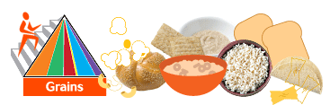

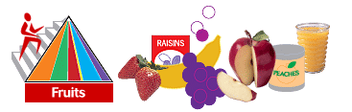

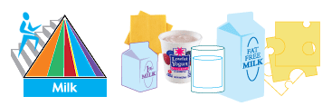
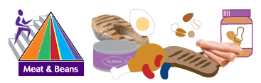

This page intentionally blank.
Task 1 – Handout #7 (cont.)

Food for One Day: A Nutrition Journal (cont.)

Directions: Now plan a healthy menu for yourself for another day.

BREAKFAST
SNACK
LUNCH
SNACK
DINNER

This page intentionally blank.
Task 1 – Handout #8

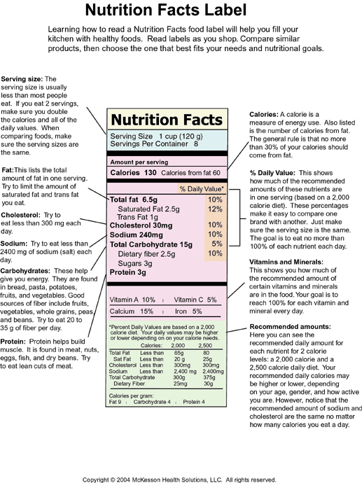

From University of Michigan:
http://www.med.umich.edu/1libr/aha/aha_nutrlabe_art.htm

