
EL Civics Objective 46 (Nutrition) • Beginning
Task 1: Eating Habits
Language & Literacy Objectives:
- Identify a healthy diet as recommended by USDA.
- Identify the relationship between nutrition and good health.
INTRODUCTION
In this lesson, students will learn about the USDA food pyramid and what is considered a
healthy American diet. Students will also learn vocabulary for common American foods.

ASSESSMENT TASK
Given picture prompts, students will circle and/or list the healthy choices in a family’s
diet. 12 points possible.

SUGGESTED ACTIVITIES
Introduce students to USDA Food Pyramid and food groups
- Use overhead or LCD projector or handout to show food pyramid and define food groups
- Bring in various food products; Ss work in groups to sort products into food groups
- Take a field trip to a grocery store or the Torrance Farmer’s Market

Identify healthy and unhealthy food choices using picture prompts
- Teacher uses pictures available in textbook or PowerPoint presentation (see website)

Have students keep a nutrition journal
- Jot down what they eat and what they feed their family for one week (or more);
bring notes to class and compare with other students
- Discuss eating habits in U.S. & eating habits in home country

Organize a cooking lesson (adapted with permission from Lucia Hernandez)
- Students bring in recipes and decide in groups which ones to cook
- Teacher from any site reserves Room 12 (cooking classroom) @ HAC – contact Faye @
x. 8400 (NOTE: class brings ingredients, utensils, etc. and responsible for cleanup)
- Students work in groups to create dishes from the recipes, using English to communicate
with each other throughout the process

HANDOUTS PROVIDED
Information for Teachers - New Food Pyramid & Dietary Guidelines
(READ BEFORE INTRODUCING STUDENTS TO FOOD PYRAMID)

Handout 1: Related Vocabulary & Discussion Questions
Handout 2: USDA Food Pyramid (color transparency)
Handout 3: Healthy Foods
Handout 4: Food Groups
Handout 5: Unhealthy Foods
Handout 6: Healthy and Unhealthy Foods
Handout 7: Healthy and Unhealthy Foods #2
Handout 8: Practice/Review: Plan a Menu
Handout 9: Food for One Day: Food Journal

Graphics courtesy of:
www.mypyramid.gov
office.microsoft.com/clipart

COMPUTER LAB IDEAS
- Go to MyPyramid.gov where students can put in their age, sex, and level of activity to see a personalized eating plan (Internet)
- Create “picture dictionary” of healthy & unhealthy food choices (Word or PowerPoint) – use Google Images to find pictures
- Have students keep a nutrition journal, in which they write down everything they eat for a few days. Then have them evaluate what is healthy and what is unhealthy. Have them plan a weekly menu that includes healthy foods from the food pyramid. They can type up all or part of the journal & plan, using pictures as well (Word)
- Write about personal eating habits in U.S, in home country, either or both (Word or PowerPoint)
- Conduct Internet searches to find healthy recipes at sites such as allrecipes.com, cookinglight.com, etc. (Internet)
INFORMATION FOR TEACHERS:
NEW USDA FOOD PYRAMID & DIETARY GUIDELINES
adapted from http://www.husd.k12.ca.us/Nutrition/pyramid.htm

Eating is one of life's greatest pleasures. There are so many choices - and so many ways to build a healthy diet through good nutrition and an active lifestyle. To make nutrition easier to understand and its guidelines easier to follow, the United States Department of Agriculture (USDA) redesigned the Food Guide Pyramid to demonstrate the proportions of each food type we should be eating every day.

But ONE SIZE DOESN'T FIT ALL!

Visit www.mypyramid.gov, the USDA's NEW Food Pyramid Website, for a nutrition plan tailored to each individual.

Recommended Daily Selections
The USDA's OLD PLAN (see picture below) specified how many servings of each type of food should be eaten each day, with grains in largest quantities, then vegetables, fruit, protein foods and dairy. But it made no allowances for differences in activity levels, age and gender, and it was determined that individuals have quite different needs. The 2005 Food Guide Pyramid asks for specifics and then gives you a plan tailored to an individual’s needs (see next page).

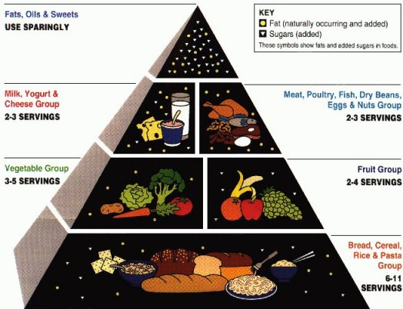

INFORMATION FOR TEACHERS (cont.)

The New Dietary Guidelines for 2005 recommend different amounts of the various food types, depending on age, gender, and activity level, in the PROPORTIONS demonstrated by the color bands on the Pyramid.

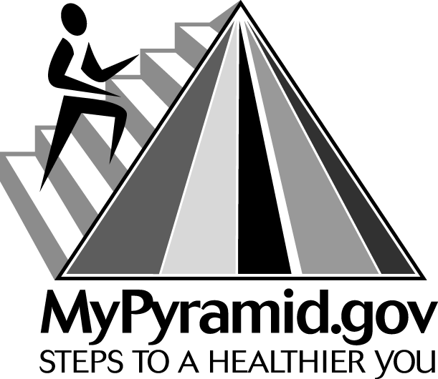

THE NEW FOOD GUIDE PYRAMID (see transparency, page 5)
It shows that GRAINS (orange) should be the largest single part of our diets, following closely by VEGETABLES (green) and MILK products (blue). Next, FRUITS (red) are needed a bit less, and PROTEIN (purple) is needed in smaller quantities than most people realize. Last, OILS (yellow) are a tiny but essential part of our daily dietary needs. Here are the USDA’s TIPS for healthy eating:
Make Half your Grains Whole!
We need those complex carbohydrates.
Vary your Veggies!
And choose DARK green and BRIGHT orange.
Focus on Fruits, go Easy on Juices!
Eat a variety - fresh, frozen, canned or dried.
Get those Calcium-Rich Foods!
Go low-fat or fat-free with milk products.
Go Lean with Protein!
Bake, broil or grill it - avoid frying.
TASK 1 – Handout #1

VOCABULARY

food pyramid: diagram of human nutritional needs.

food group: a group of foods that have similar nutritional properties and is part of the hierarchy of the food pyramid, such as grains, dairy, protein, fruit & vegetables, fats & sweets.

USDA: United States Department of Agriculture; government office that regulates food.

healthy: nutritious

unhealthy: bad or harmful

healthier: a better, more-nutritious choice (e.g. an apple is a healthier choice than a cookie for a snack)

healthiest: the most healthy choice (e.g. You are given an apple, a cookie, and a soda. The apple is the healthiest choice for a snack.)

diet: foods eaten by a particular person or group (e.g. family).

DISCUSSION QUESTIONS

- What are some healthy foods you eat?

- What are some unhealthy foods you eat?

- Who cooks the food in your family?

- What is a typical diet in your home country?

- Has your diet changed since living in the U.S.?

This page intentionally blank.
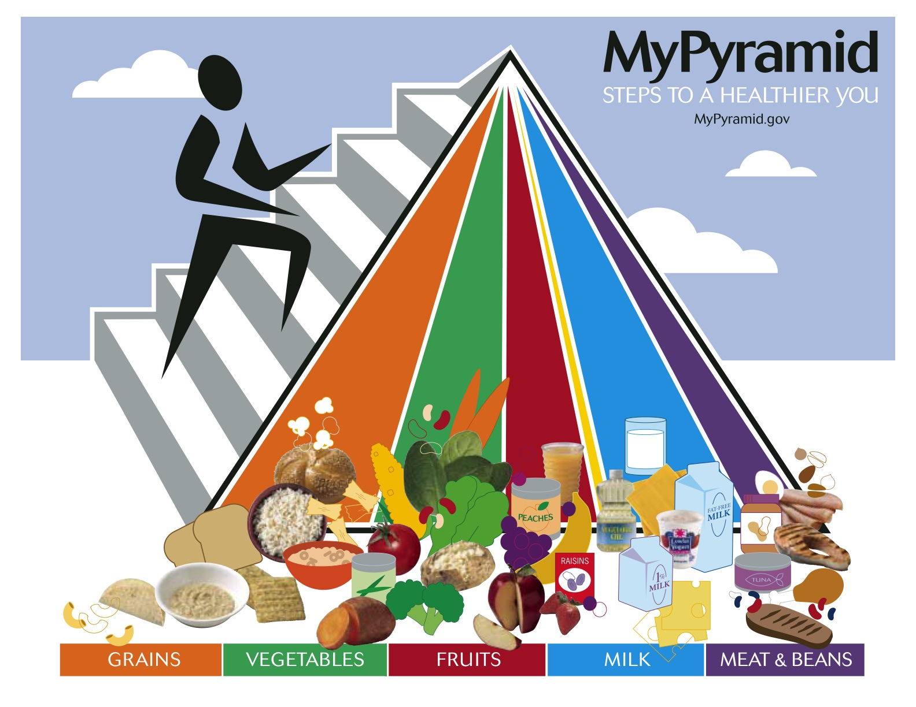
This page intentionally blank.

TASK 1 - Handout #3

Healthy Foods

Directions: Can you write the names of these healthy foods?

__________ | __________ | __________ | __________ | __________

__________ | __________ | __________ | __________ | __________

__________ | __________ | __________ | __________ | __________

__________ | __________ | __________ | __________ | __________

This page intentionally blank.
TASK 1 - Handout #4

Food Groups

Directions: With a partner, write each healthy food from Handout #3 under the correct Food Group.

Grains | Vegetables | Fruits
1. _________________  2. _________________  3. _________________  4. _________________  5. _________________  6. _________________ | 1. _________________  2. _________________  3. _________________  4. _________________  5. _________________  6. _________________  7. _________________ | 1. _________________  2. _________________  3. _________________  4. _________________  5. _________________  6. _________________  7. _________________  8. _________________
Milk | Meat & Beans
1. _________________  2. _________________  3. _________________  4. _________________  5. _________________  6. _________________ | 1. _________________  2. _________________  3. _________________  4. _________________  5. _________________  6. _________________  7. _________________  8. _________________

Directions: Can you add three more healthy foods to each list?
This page intentionally blank.
TASK 1 - Handout #5

Unhealthy Foods

Directions: Can you name these unhealthy foods? Why are they unhealthy?

___________________ | ___________________ | ___________________

____________________ | ____________________ | ___________________

____________________ | ____________________ | ___________________

Directions: What are some other unhealthy foods?

_________________ __________________ __________________ _________________
This page intentionally blank.
TASK 1 - Handout #6

Healthy and Unhealthy Foods

Directions: Circle the healthiest foods. (Hint: You should find 10.)

This page intentionally blank.
TASK 1 - Handout #7

Healthy and Unhealthy Foods #2

Directions: Look at the Smith Family diet. Circle the healthy food words.

BREAKFAST
doughnuts
milk
banana
bacon
eggs

LUNCH
hot dog
broccoli
lettuce
strawberries
chips
ice cream

DINNER
hamburger
tomato
apple
french fries
cookies
fish

Directions: Think about a better diet for the Smith family. Write the names of foods they could eat for a healthier Breakfast, Lunch, and Dinner. (You may include any foods you know.)

Breakfast | Lunch | Dinner
_______________________  _______________________  _______________________  ________________________ | ________________________  ________________________  ________________________  ________________________  ________________________ | ______________________  ______________________  ______________________  ________________________  ________________________
This page intentionally blank.
TASK 1 - Handout #8

Practice/Review: Plan a Menu

DIRECTIONS: Circle the 10 healthiest foods. Write a list at the bottom of the page.

banana | green beans | cake | chips
turkey | chocolate | cookies | doughnuts
mushrooms | eggs | fish | fries
rice | bacon | popsicle | apple
pear | watermelon | sausage | hamburger

1. _______________________  2. _______________________  3. _______________________  4. _______________________ | 5. ________________________  6. ________________________  7. ________________________  8. ________________________ | 9. ______________________  10. ______________________
This page intentionally blank.
Task 1 – Handout 9: Nutrition Journal

Food for One Day: Food Journal

Directions: Write down what you usually eat for one day. Think about the servings. For example: 1 cup milk; 1 orange; 1 ounce cereal.

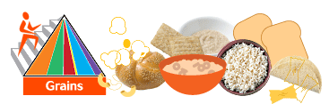
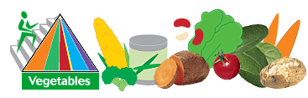
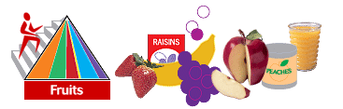
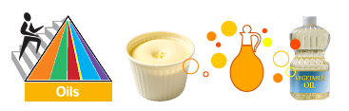
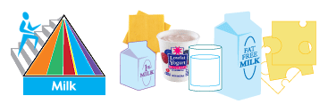
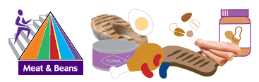
This page intentionally blank.
Task 1 – Handout 9: Nutrition Journal

Food for One Day (continued)

Directions: Now plan a healthy menu for yourself for another day.

BREAKFAST
SNACK
LUNCH
SNACK
DINNER

