
EL Civics Objective 13 (Education) - Intermediate
Task 3: Successful Learner Strategies
Language & Literacy Objective:
Label pictures, identify vocabulary and/or describe some things that adult learners can do to help their children or themselves be successful learners.

INTRODUCTION
Students will learn strategies for successful learning for themselves and their children (if applicable). They will also develop an understanding of individual learning styles among learners.

SUGGESTED ACTIVITIES
Successful Learning Strategies
- Introduce students to concepts of individual learning styles
- Help students develop an understanding of how they learn best & match their study habits to their learning styles
- Brainstorm ways to help others (especially children) learn as well

over …

HANDOUTS PROVIDED
- Related Vocabulary
- Discussion Questions
- Reading: Learning Styles
- Ideas: Successful Learner Strategies
- Worksheet: How to Be a Successful Learner
- Key: How to Be a Successful Learner
- Worksheet: Ways to Be a Successful Learner
- Worksheet: Ways to Help Your Children Be Successful Learners

ASSESSMENT
The related task on the assessment requires students to label (BL) or list in level-appropriate writing (BH-A) 5 things students can do—or parents can help their children do—to be successful learners.

POSSIBLE COMPUTER LAB ACTIVITIES
- Complete a learning style self-assessment online
- Students write or create a presentation about their individual learning style

Related Vocabulary
from Dictionary.com

success: the achievement of something desired, planned or attempted

learner: one who gains knowledge through experience or study

strategy: a plan of action to accomplish a specific goal

learning style: the way in which someone learns

multiple intelligence: the ability to learn and apply knowledge in more than one area

practice: to do something repeatedly in order to learn

model: to display behavior for someone else

study habit: a pattern of behavior when studying

Discussion Questions:
Successful Learning Strategies

- What does it mean to be a “successful learner?”

- What are some strategies you use to learn English?

- Do you practice English outside of the classroom? Where? When?

- Which study habits do you model for your children?

Reading: What’s Your Learning Style?
adapted from EverythingESL.net
Directions: People learn in different ways. Read the descriptions below. Which is your learning style? Do you have more than one learning style? Which ones?

Auditory Learners
Students with this style will be able to remember what they hear and will prefer oral instructions. They learn by listening and speaking. They learn best by doing the following:
- interviewing, debating
- participating on a panel
- giving oral reports
- participating in oral discussions of written material

Visual Learners
Visual learners remember what they see and prefer written instructions. They learn from information presented to them in a video. They learn by observing and enjoy working with:
- computer graphics
- maps, graphs, charts and other graphic organizers
- cartoons, posters, diagrams
- text with a lot of pictures

Tactile Learners
Students with this strength learn best by touching. They understand directions that they write, and learn through doing. They’ll learn best by:
- drawing
- playing board games
- making models or diagrams
- following instructions to make something

Kinesthetic Learners
Kinesthetic learners also learn by touching or manipulating objects. They need to involve their whole body in learning. They remember material best if they act it out, such as:
- playing games that involve their whole body
- movement activities
- making models
- following instructions to make something
- setting up experiments

What’s Your Learning Style? (cont.)

Global Learners
Global learners are spontaneous and intuitive. They do not like to be bored. Information needs to be presented in an interesting manner using attractive materials, such as:
- reading out loud
- recorded books
- story writing
- computer programs
- games
- group activities

Analytic Learners
Analytic learners plan and organize their work. They focus on details and are logical. They prefer to work individually and learn best when:
- information is presented in sequential steps
- lessons are structured and teacher-directed
- goals are clear
- requirements are spelled out

Directions: Answer the following questions about learning styles.

  - What is your learning style? Do you have more than one?

  - Do you typically study in a way that supports your learning style? Please explain.

  - What are your children’s learning styles? Are they similar to yours?

Ideas: Successful Learner Strategies

Worksheet: How to Be a Successful Learner

Directions: How can you be a successful learner? Write your ideas below to describe each picture.

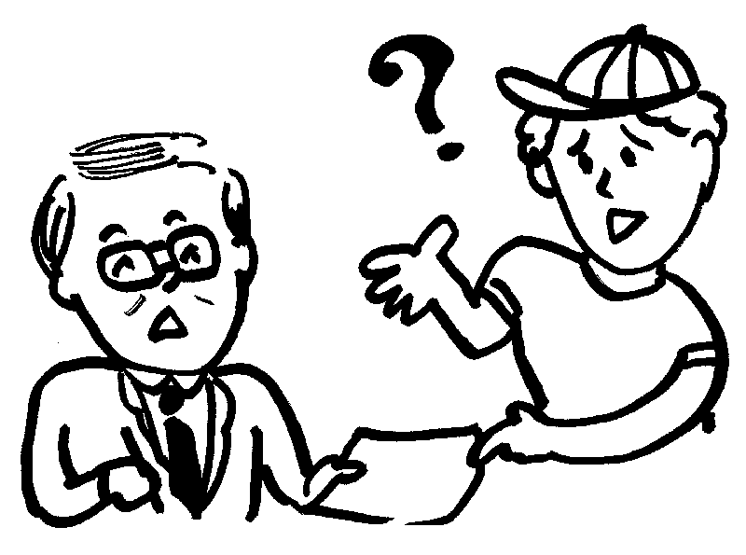 |  | 
_____________________ | _____________________ | _____________________
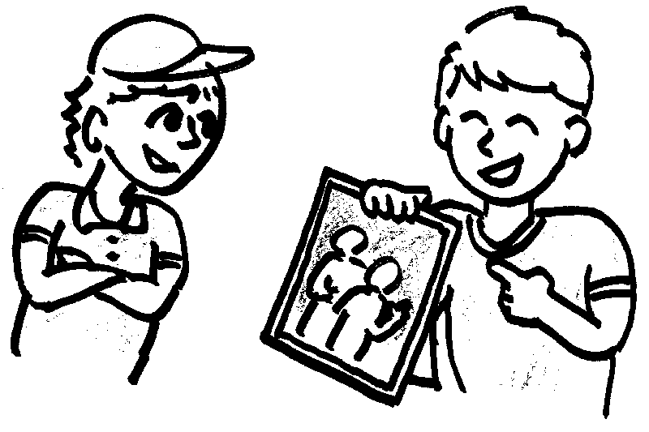 | 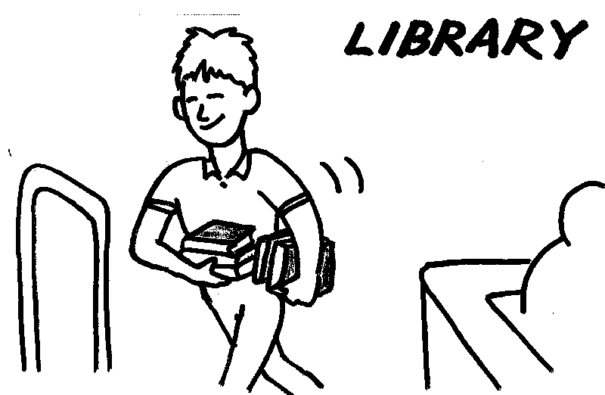 | 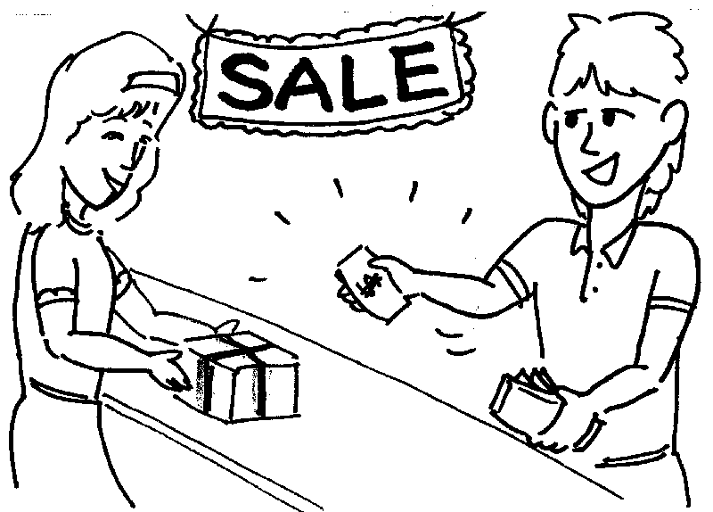
_____________________ | _____________________ | _____________________
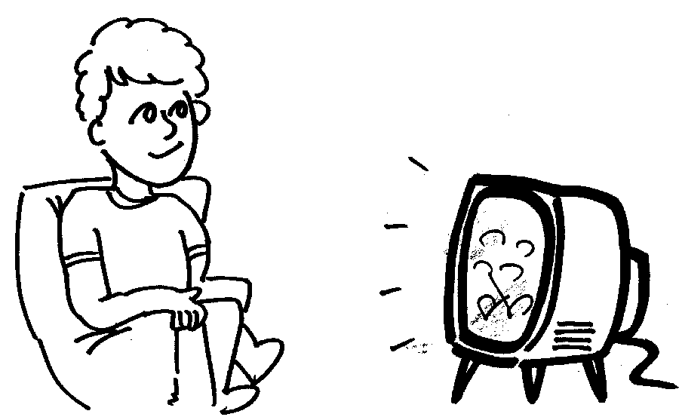 |  | 
_____________________ | _____________________ | _____________________
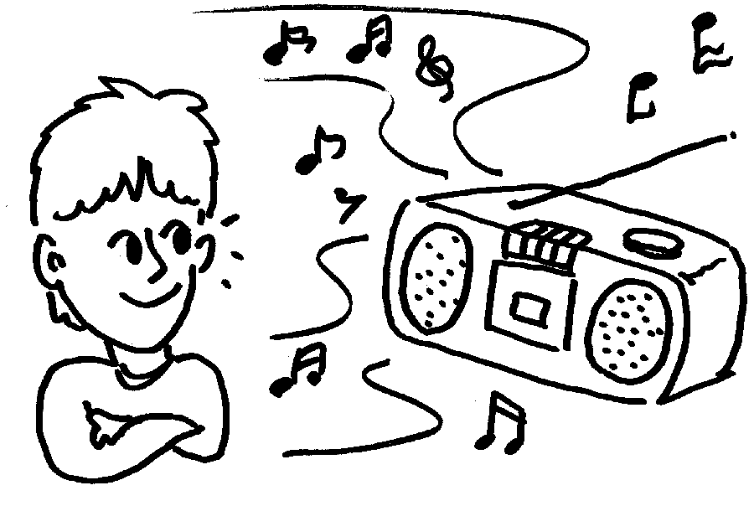 | 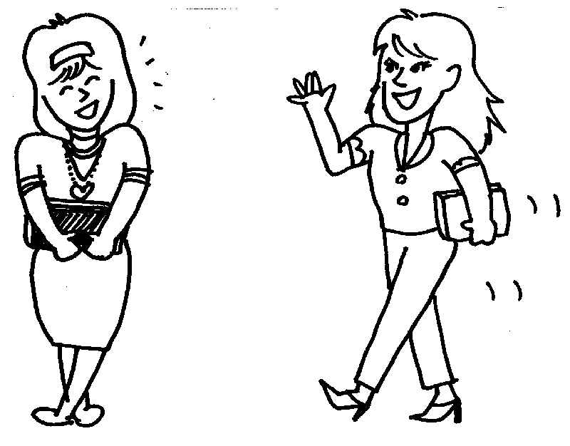 | 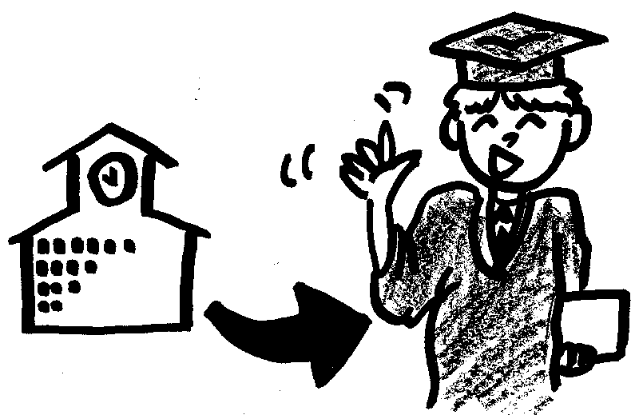
_____________________ | _____________________ | _____________________

KEY: How to Be a Successful Learner

Directions: How can you be a successful learner? Write your ideas below to describe each picture.

ask a question | read a book |  | write
share about your family |  | go to the library |  | talk to the salesperson
watch TV | read a newspaper |  | talk on the telephone
listen to the radio | talk to friends |  | go to school

Worksheet: Ways to Be a Successful Learner

Directions: Work with a group to come up with 5 ways to be successful learners. Write your ideas below.

1. ___________________________________________________
___________________________________________________

2. ___________________________________________________
___________________________________________________

3. ___________________________________________________
___________________________________________________

4. ___________________________________________________
___________________________________________________

5. ___________________________________________________
___________________________________________________

Worksheet: Ways to Help Your Children Be Successful Learners

Directions: Work with a group to come up with 5 ways to help your children be successful learners. Write your ideas below.

1. ___________________________________________________
___________________________________________________

2. ___________________________________________________
___________________________________________________

3. ___________________________________________________
___________________________________________________

4. ___________________________________________________
___________________________________________________

5. ___________________________________________________
___________________________________________________

