
EL Civics Objective 13 (Education) - Beginning
Task 3: Successful Learner Strategies
Language & Literacy Objective:
Label pictures, identify vocabulary and/or describe some things that adult learners can do to help their children or themselves be successful learners.

INTRODUCTION
Students will learn strategies for successful learning.

SUGGESTED ACTIVITIES
Successful Learning Strategies
- Help students identify and develop effective study habits

HANDOUTS PROVIDED
- Related Vocabulary
- How can you learn English?
- Matching: Learn English (pictures)
- Matching: Learn English (words)
- Worksheet: How to Learn English
- Key: How to Learn English
- Worksheet: Ways to Learn English

ASSESSMENT
The related task on the assessment requires students to label (BL) or list in level-appropriate writing (BH-A) 5 things students can do to be successful learners.

POSSIBLE COMPUTER LAB ACTIVITIES
- Students write about or create a presentation about good study habits

Related Vocabulary
adapted from Dictionary.com

success: to achieve a goal

learner: one who gains knowledge through experience or study

strategy: a plan of action to reach a goal

practice: to repeat something in order to learn

study habit: a pattern of behavior when studying

How can you learn English?

Matching: Learn English (pictures)

Directions: Cut out the pictures. Match with the words.

 |  | 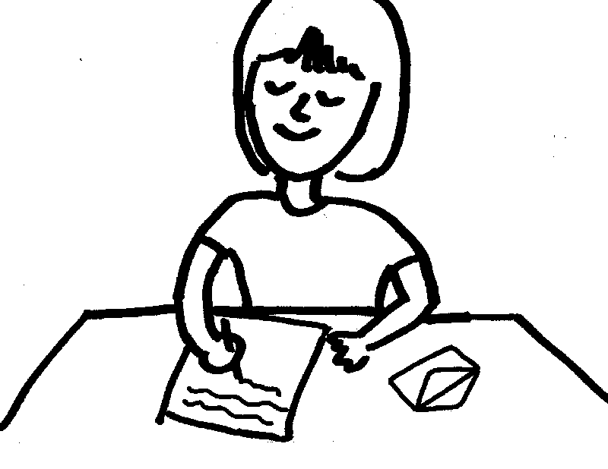
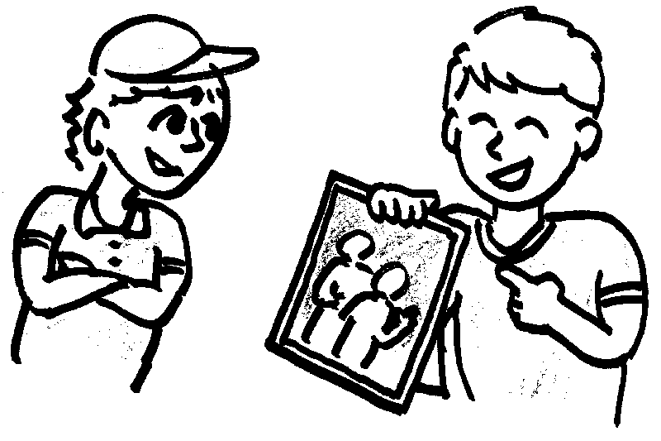 | 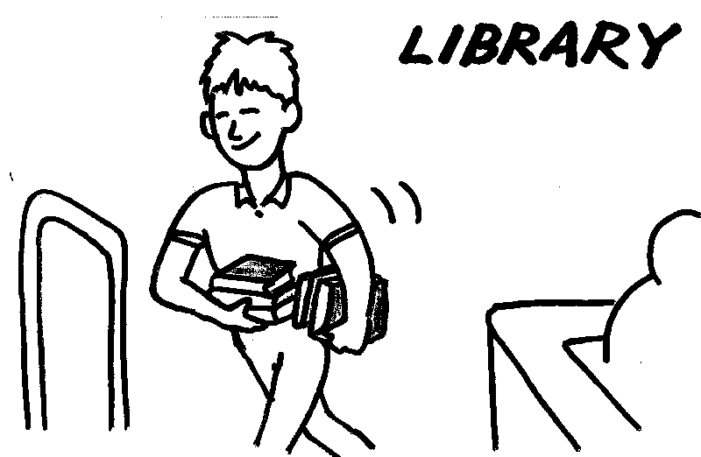 | 
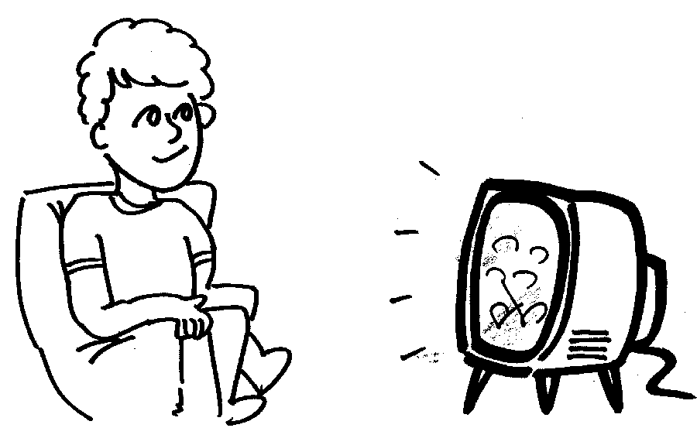 |  | 
 | 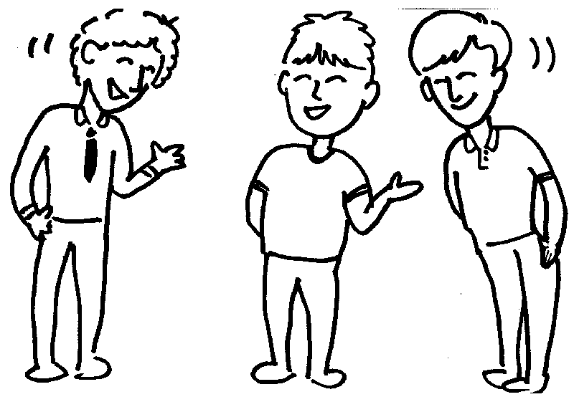 | 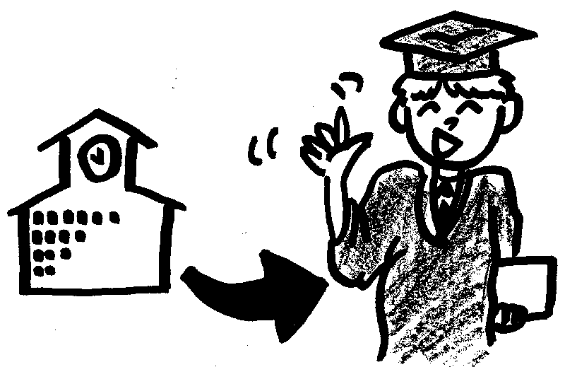

Matching: Learn English (words)

Directions: Cut out the words. Match with the pictures.

ask a  question | read a book | write
share about your family | go to the  library | talk to the salesperson
watch TV | read a newspaper | talk on the telephone
listen to the radio | talk to friends | go to school

Worksheet: How to Learn English

Directions: How can you learn English? Write words under the pictures.

____________________ | go to the library | ___________________

___________________ | ____________________ | ____________________

____________________ | ____________________ | ____________________

Key: How to Learn English

Directions: How can you learn English? Write words under the pictures.

read the newspaper | go to the library | talk on the telephone

write a letter | talk with friends | ask a question

watch TV | listen to the radio | go to school

Worksheet: Ways to Learn English

Directions: Work with a group. Think of 5 ways to learn English. Write them here:

1. ___________________________________________________

2. ___________________________________________________

3. ___________________________________________________

4. ___________________________________________________

5. ___________________________________________________

