
EL Civics Objective 13 (Education) - Advanced
Task 3: Successful Learner Strategies
Language & Literacy Objective:
Label pictures, identify vocabulary and/or describe some things that adult learners can do to help their children or themselves be successful learners.

INTRODUCTION
Students will learn strategies for successful learning for themselves and their children (if applicable). They will also develop an understanding of individual learning styles and varied intelligences or abilities among learners.

SUGGESTED ACTIVITIES
Successful Learning Strategies
- Introduce students to concepts of individual learning styles and multiple intelligences
- Help students develop an understanding of how they learn best & match their study habits to their learning styles and abilities
- Brainstorm ways to help others (especially children) learn as well

over …

HANDOUTS PROVIDED
- Related Vocabulary
- Discussion Questions
- Reading: Learning Styles
- Reading: Multiple Intelligences
- Ideas: Successful Learner Strategies
- Worksheet: How to Be a Successful Learner
- Key: How to Be a Successful Learner
- Worksheet: Ways to Be a Successful Learner
- Worksheet: Ways to Help Your Children Be Successful Learners

ASSESSMENT
The related task on the assessment requires students to label (BL) or list in level-appropriate writing (BH-A) 5 things students can do—or parents can help their children do—to be successful learners.

POSSIBLE COMPUTER LAB ACTIVITIES
- Complete a learning style self-assessment online
- Interview other students in class; create a graph, chart or presentation about the learning styles or intelligences of the class

Related Vocabulary
from Dictionary.com

success: the achievement of something desired, planned or attempted

learner: one who gains knowledge, comprehension, or mastery of something through experience or study

strategy: a plan of action intended to accomplish a specific goal

learning style: the way in which someone learns

multiple intelligence: the ability to acquire and apply knowledge in more than one area, especially toward a purposeful goal

practice: to do or perform something repeatedly in order to acquire knowledge or learn a skill

model: to display behavior for someone else

study habit: a pattern of behavior when studying

Discussion Questions:
Successful Learning Strategies

- What does it mean to be a “successful learner?”

- What are some strategies you use to learn English?

- Do you practice English outside of the classroom? If so, where and when? If not, why not?

- Which study habits do you model for your children?

- Compare learning a language in your home country and the U.S. How is it similar? How is it different?

Reading: What’s Your Learning Style?
adapted from EverythingESL.net
Directions: People learn in different ways. Read the descriptions below. Which is your learning style? Do you have more than one learning style? Which ones?

Auditory Learners
Students with this style will be able to remember what they hear and will prefer oral instructions. They learn by listening and speaking. These students enjoy talking and interviewing. They learn best by doing the following:
- interviewing, debating
- participating on a panel
- giving oral reports
- participating in oral discussions of written material

Visual Learners
Visual learners will be able to remember what they see and will prefer written instructions. These students are sight readers who enjoy reading silently. They learn from information presented to them in a video. They will learn by observing and enjoy working with:
- computer graphics
- maps, graphs, charts and other graphic organizers
- cartoons, posters, diagrams
- text with a lot of pictures

Tactile Learners
Students with this strength learn best by touching. They understand directions that they write and will learn through doing. They’ll learn best by:
- drawing
- playing board games
- making models or diagrams
- following instructions to make something

Kinesthetic Learners
Kinesthetic learners also learn by touching or manipulating objects. They need to involve their whole body in learning. They remember material best if they act it out,
such as:
- playing games that involve their whole body
- movement activities
- making models
- following instructions to make something
- setting up experiments

What’s Your Learning Style? (cont.)

Global Learners
Global learners are spontaneous and intuitive. They do not like to be bored. Information needs to be presented in an interesting manner using attractive materials, such as:
- reading out loud
- recorded books
- story writing
- computer programs
- games
- group activities

Analytic Learners
Analytic learners plan and organize their work. They focus on details and are logical. They prefer to work individually and learn best when:
- information is presented in sequential steps
- lessons are structure and teacher-directed
- goals are clear
- requirements are spelled out

Directions: Answer the following questions about learning styles.

  - What is your learning style? Do you have more than one?

  - Do you typically study in a way that supports your learning style? Please explain.

  - What are your children’s learning styles? Compare their learning styles to yours. Are they similar? Are they different?

Reading: Multiple Intelligences
adapted from www.infed.org/thinkers/gardner.htm
Directions: Learners have many different abilities, or “multiple intelligences” (Gardner, 1999). Read the following, then describe your own intelligences by answering the questions below.

Linguistic Intelligence involves sensitivity to spoken and written language, the ability to learn languages, and the capacity to use language to accomplish certain goals. This intelligence includes the ability to use language to express oneself, and as a means to remember information. Examples: writers, poets and lawyers.

Logical-mathematical intelligence consists of the capacity to analyze problems logically, carry out mathematical operations, and investigate issues scientifically. This entails the ability to detect patterns, reason deductively and think logically. This intelligence is most often associated with scientific and mathematical thinking.

Musical intelligence involves skills in the performance, composition and appreciation of musical patterns. It is the capacity to recognize and compose musical pitches, tones and rhythms. It is very similar to linguistic intelligence.

Bodily-kinesthetic intelligence entails the potential of using one’s whole body or parts of the body to solve problems. It is the ability to use mental abilities to coordinate bodily movements. Mental and physical activity are related.

Spatial intelligence involves the potential to recognize and use the patterns of wide space and more confined areas.

Interpersonal intelligence is the capacity to understand the intentions, motivations and desires of other people. It allows people to work effectively with others. Examples: educators, salespeople, religious and political leaders and counselors.

Intrapersonal intelligence entails the capacity to understand oneself, to appreciate one’s feelings, fears and motivations. It involves having an effective working model of ourselves, and to be able to use such information to regulate our lives.

- What are your intelligences?

- Do you feel your intelligences are represented in your classes, on tests, at work? Please describe.

Ideas: Successful Learner Strategies
from Santa Ana College School of Continuing Education

Worksheet: How to Be a Successful Learner
from Santa Ana College School of Continuing Education

Directions: How can you be a successful learner? Write your ideas below to describe each picture.
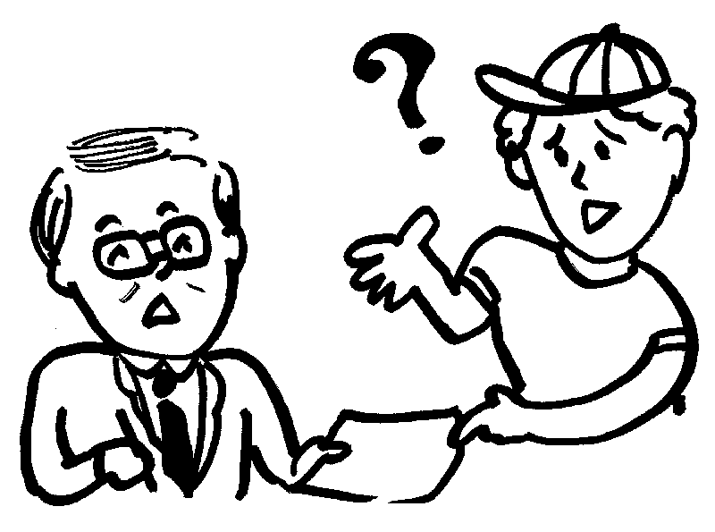 |  | 
_____________________ | _____________________ | _____________________
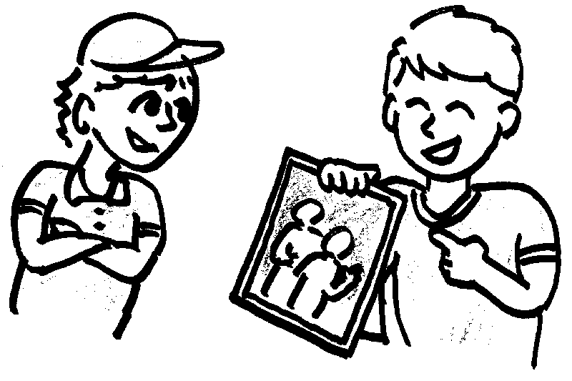 | 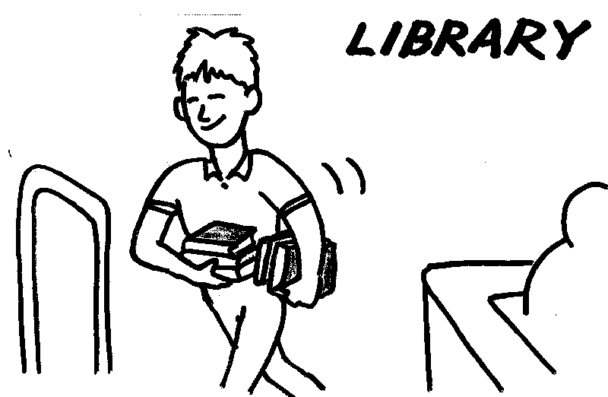 | 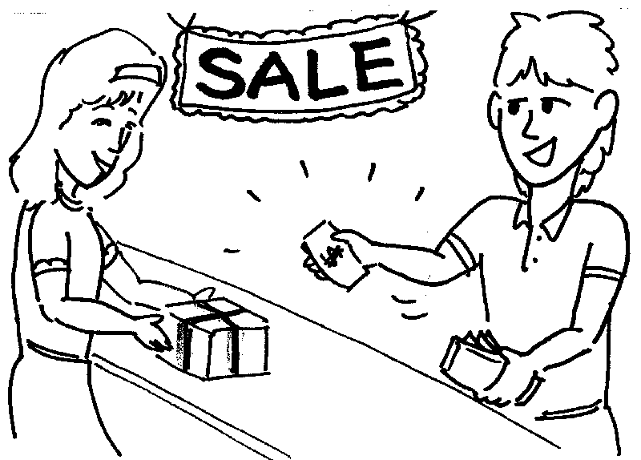
_____________________ | _____________________ | _____________________
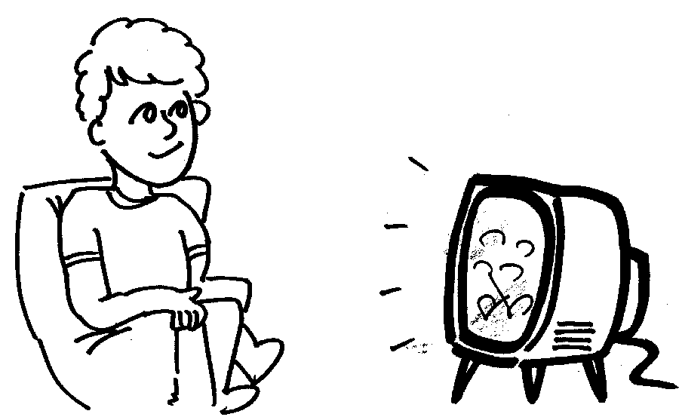 |  | 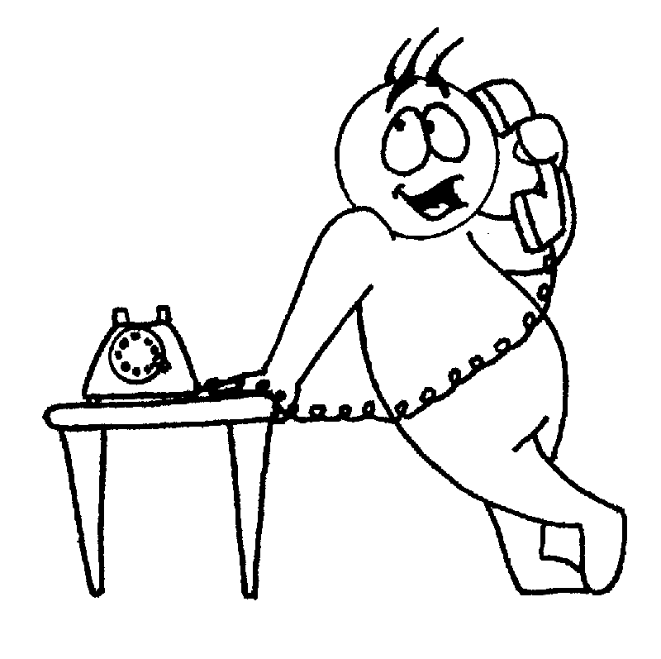
_____________________ | _____________________ | _____________________
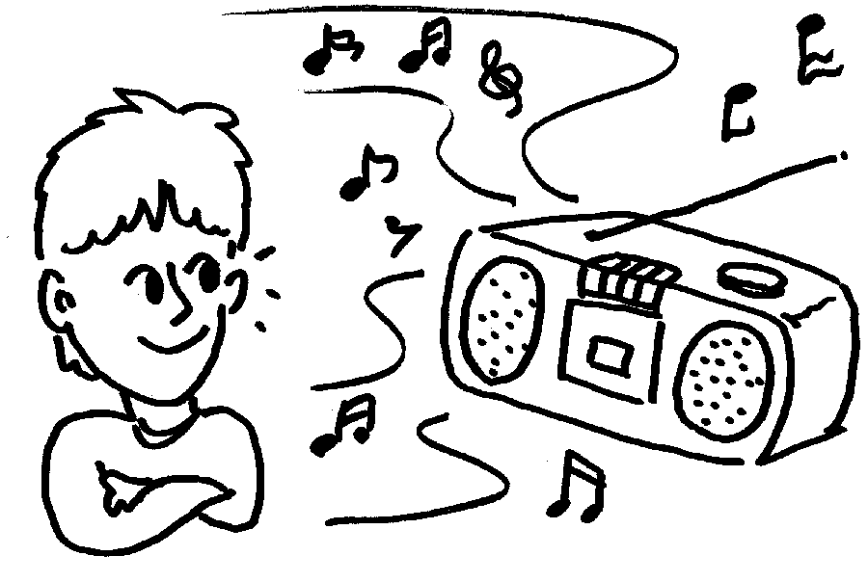 | 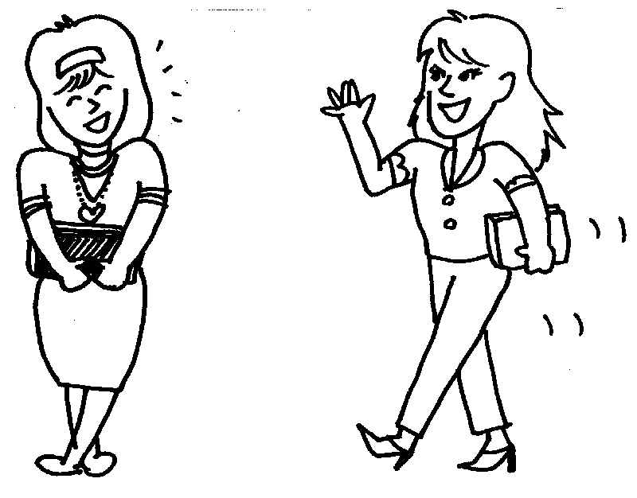 | 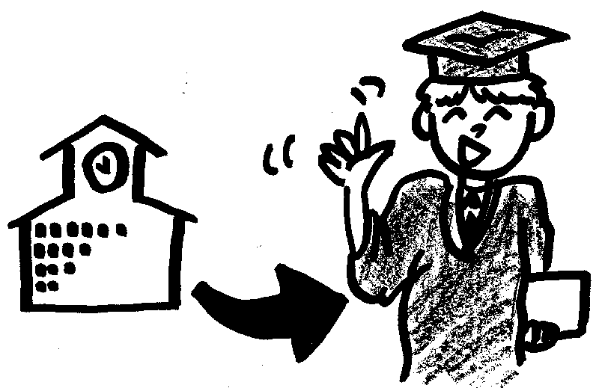
_____________________ | _____________________ | _____________________

KEY: How to Be a Successful Learner
from Santa Ana College School of Continuing Education

Directions: How can you be a successful learner? Write your ideas below to describe each picture.
ask a question | read a book |  | write
share about your family |  | go to the library |  | talk to the salesperson
watch TV | read a newspaper |  | talk on the telephone
listen to the radio | talk to friends |  | go to school

Worksheet: Ways to Be a Successful Learner
from Santa Ana College School of Continuing Education

Directions: Work with a group to come up with 5 ways to be successful learners. Write your ideas below.

1. ___________________________________________________
___________________________________________________

2. ___________________________________________________
___________________________________________________

3. ___________________________________________________
___________________________________________________

4. ___________________________________________________
___________________________________________________

5. ___________________________________________________
___________________________________________________

Worksheet: Ways to Help Your Children Be Successful Learners
from Santa Ana College School of Continuing Education

Directions: Work with a group to come up with 5 ways to help your children be successful learners. Write your ideas below.

1. ___________________________________________________
___________________________________________________

2. ___________________________________________________
___________________________________________________

3. ___________________________________________________
___________________________________________________

4. ___________________________________________________
___________________________________________________

5. ___________________________________________________
___________________________________________________

