Steps for creating a web page using Word and signing up with Geocities to upload.

First let up create a webpage using Microsoft Word

- Open a new document file using Microsoft Word
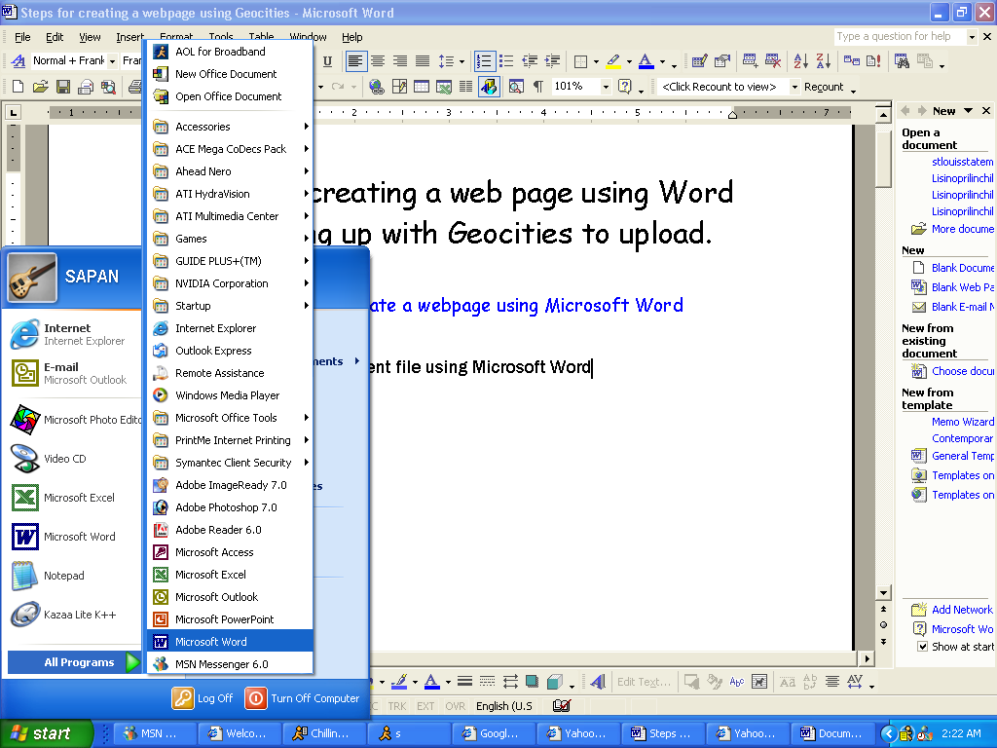
SCREEN ONE

- Now click on File on the top left corner, and then select save as webpage.
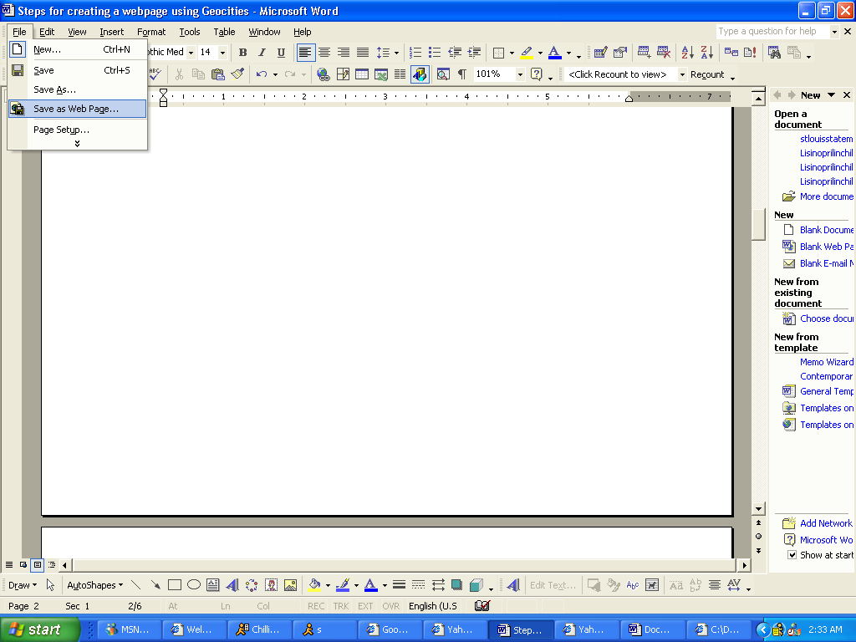
SCREEN TWO

- You just created your first simple webpage. Now you can add anything to this webpage that you may require, such as tables background, color, art, etc.
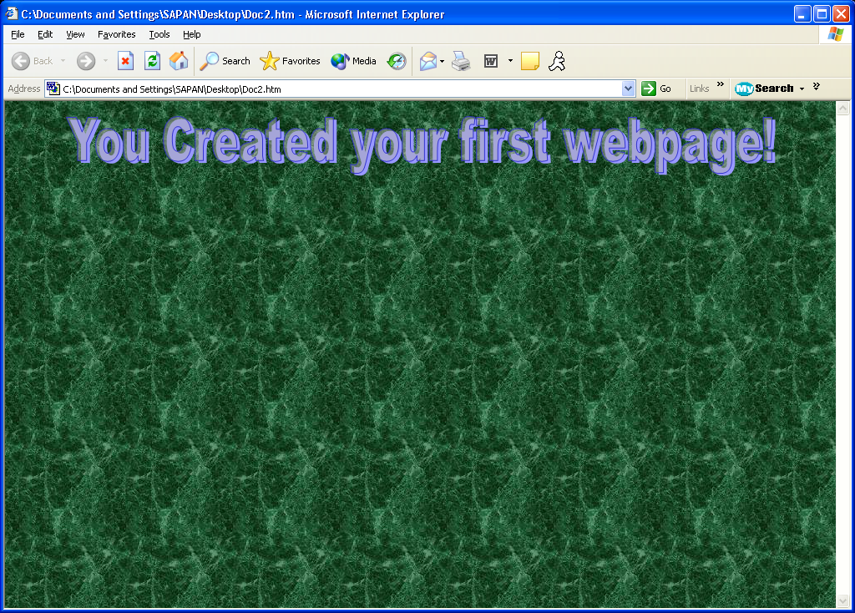
SCREEN THREE

Now let us create a Yahoo account so you can upload your webpage to the internet.

- Go to the link given below
http://geocities.yahoo.com
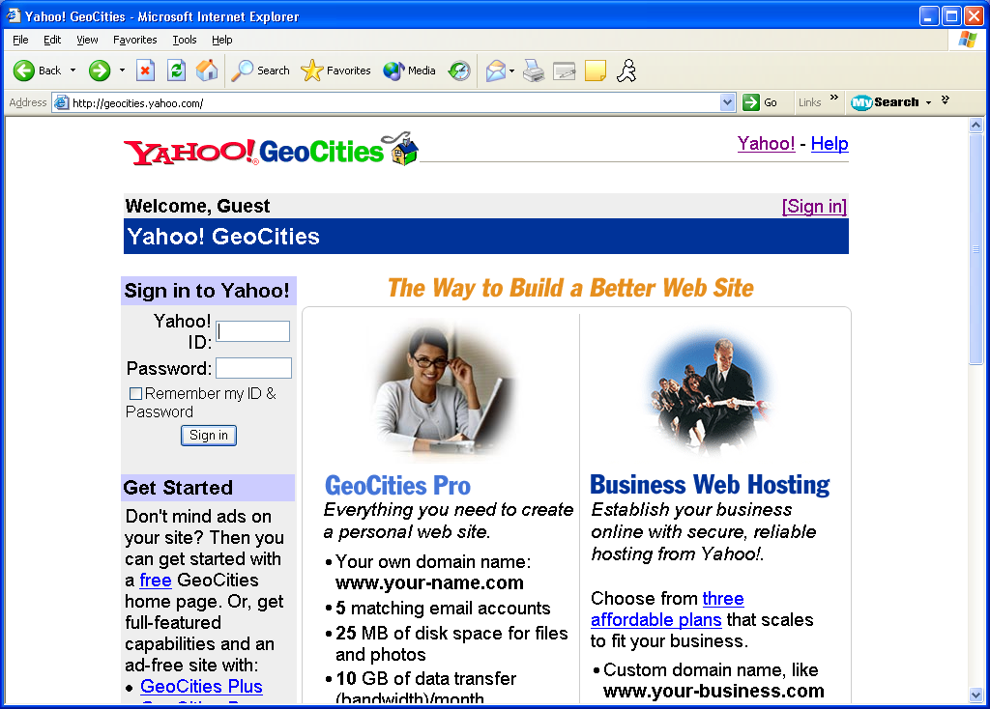
SCREEN FOUR

- Now enter your existing Yahoo ID and Password or click on Sign In (which is located on the top right).

- If you click on Sign In, it will lead to the following page.
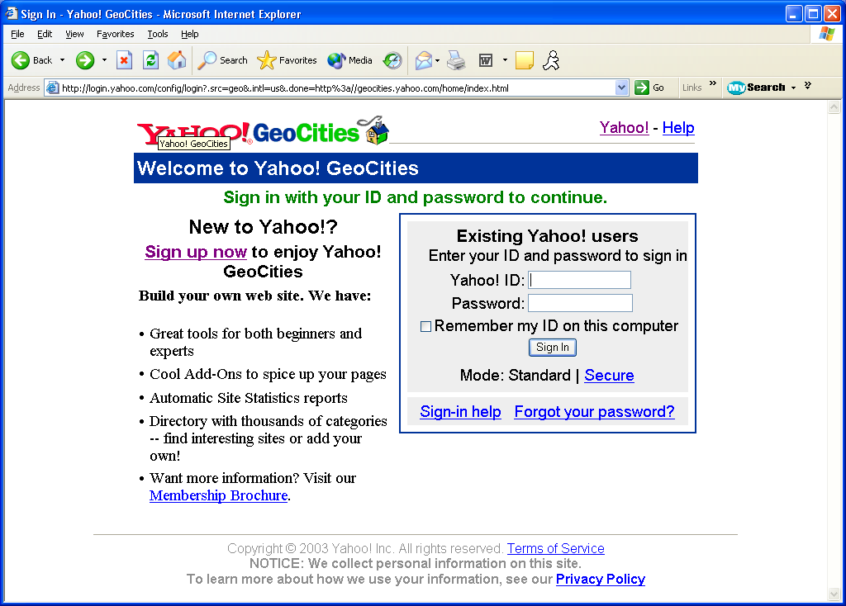
SCREEN FIVE

- Here Click on Sign up now and create your new yahoo account. After creating your new account come back to the following link.
http://geocities.yahoo.com

- At this time you should be at screen 4 of this manual.

- Now sign in with your existing login account, or your new account that we just created. Upon signing in you will see the following screen. Now click on the File Manager (located by the top right).
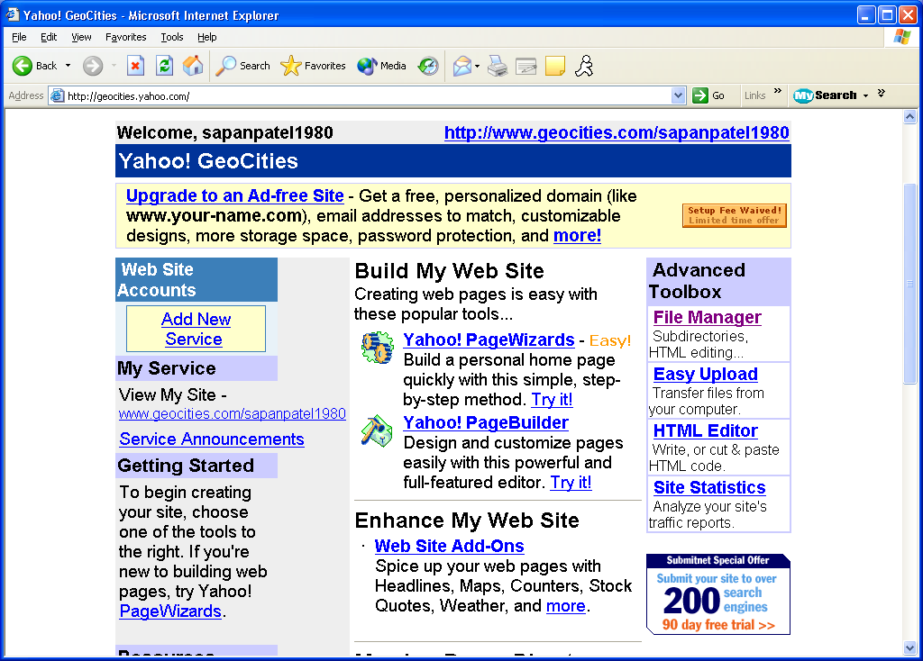
SCREEN SIX

- Now you should see the following screen. Now click on Open File Manager.
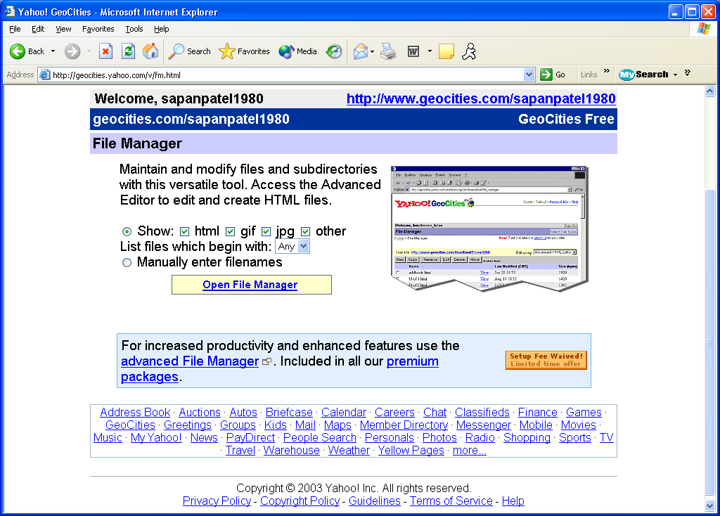
SCREEN SEVEN

- Now you should click on Upload Files.
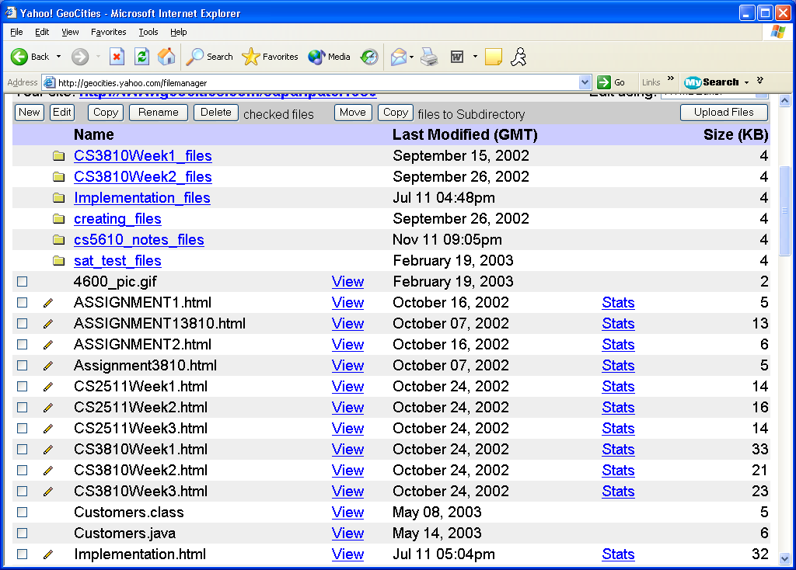
SCREEN EIGHT

- Now browse through your computer and select the webpage that you have want to upload.
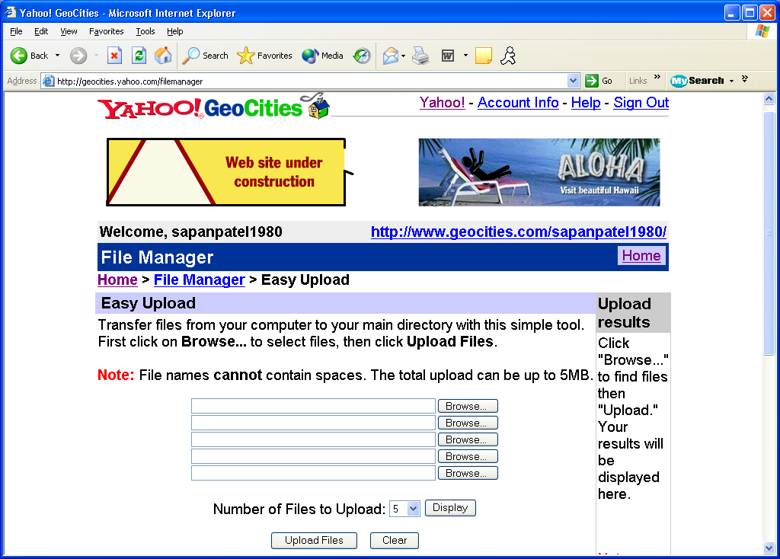
SCREEN NINE

- You have completed the manual showing you how to create a webpage and how to upload the webpage that you created.

