STOP THE BLOODSHED!
Rally for peace!
When: November 16, 2002 @ 11:00am
Where: The Prince George Courthouse
On November 16th, an international day of protest against the war on the people of Iraq, show your support for a peaceful solution!

War is costly, peace is priceless!
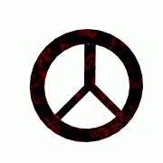
NO BLOOD FOR OIL!

Organized by the Prince George Collective of the Communist Party of Canada and the Popular Front of Concerned Citizens.

