RALLEY FOR PEACE
Nov. 16, 11:00am
Courthouse
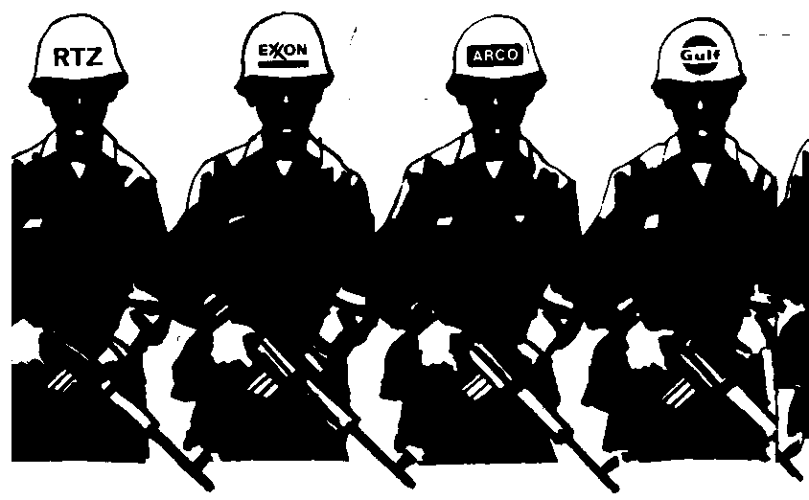
NO BLOOD FOR OIL PROFITS!
Organized by the Prince George Collective of the Communist Party of Canada and the Popular Front for the Defense of Community.

