STOP IMPERIALIST BLOODSHED!
RALLEY FOR PEACE
Nov. 16, 11:00am
Courthouse
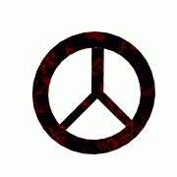
NO BLOOD FOR OIL!

Join an international day of protest against the war on the people of Iraq and show your support for a peaceful solution!

Organized by the Prince George Collective of the Communist Party of Canada and the Popular Front for the Defense of Community.

