FCC Statement:
This device complies with Part 15 of the FCC Rules. Operation is subject to the following two conditions:
- This device may not cause harmful interference.
- This device must accept any interference received, including interference that may cause undesired operation.

CE Marking Warning
This is a Class A product. In a domestic environment this product may cause radio interference in which case the user may be required to take adequate measures.

All trademarks and trade names are the properties of their respective owners.

Revision
PLANET Internet Gateway for models: IG-201, IG-401
Copyright ©1998. All Rights Reserved.
Document Version: 1.0
Part No. EM-IG201
Table of Contents
Chapter 1 Introduction 1
Internet Gateway Features 2
Package Contents 5
Description 5
IG-201 6
IG-401 8
Link/Error LEDs - All Models 10
DIP Switches - All Models 11
Chapter 2 Installation 13
Requirements 13
Procedure 13
Chapter 3 Configuration 15
Internet Gateway Configuration 15
Configuration Program 16
Chapter 4 Internet Access 19
Overview 19
Port Configuration 20
PC Configuration 24
DHCP Server Configuration 28
Operation - Internet Access 30
Accessing AOL 30
Chapter 5 Advanced Port Settings 31
Overview 31
Advanced Port Screen 31
Port Settings 33
Modem/ISDN Settings 34
Script File 35
CompuServe Script 37
Chapter 6 Device Settings 39
Overview 39
Device Password 40
Bandwidth Utilization 41
LAN Settings 41
DHCP Server 42
Chapter 7 Access Control 46
Overview 46
Security Groups 48
Workstations 51
Administrator Defined Filters 53
Chapter 8 Dial-In Access 55
Overview 55
Port Configuration for Dial-In 56
User Configuration for Dial-in 57
Remote User Configuration 60
Chapter 9 E-Mail 61
Overview 61
Account Information 62
User Information 63
DNS Address 66
E-Mail Program Configuration 67
Sharing E-Mail Example 69
Management of Shared E-Mail 71
Chapter 10 Routing 74
Overview 74
Internet Gateway Configuration 74
Router Configuration 76
Routing Example 78
Chapter 11 Status & Monitoring 80
Overview 80
Status Screen 80
Port Status/Test Screen 84
Appendix A Troubleshooting 90
Overview 90
Problems 90
Appendix B AT Commands 94
Required Settings 94
Finding the current Initial String 95
AT Commands 97
Appendix C Specifications 102
IG-201 102
IG-401 103

This page was deliberately left blank.

Chapter 1
Introduction
1
This Chapter provides an overview of the Internet Gateway's features and capabilities.
Congratulations on the purchase of your new Internet Gateway. The Internet Gateway will allow multiple SOHO (Small Office Home Office) users to share Internet user accounts. It provides a low-cost method of giving users of your network access to the vast resources available on the Internet. Once the Internet Gateway is installed and configured, the Internet is just a click away.

Figure 1: Office to Internet
The Internet Gateway is able to use your modem(s) to connect to your ISP (Internet Service Provider), providing the required log-in information.
You can seamlessly connect to the Internet as if you had a permanent connection.

Internet Gateway Features
The Internet Gateway model family incorporates many advanced features, carefully designed to provided sophisticated functions while being easy to use.

LAN Features
- Hassle-free LAN Installation. An auto-sensing LAN connection eliminates the need for configuration during installation in a 10Base2 or 10BaseT network.
- DHCP Server Support. Dynamic Host Configuration Protocol provides a dynamic IP address to PCs and other devices upon request.
The Internet Gateway can act as a DHCP Server.
- Multi Segment LAN Support. If you have a Router, PCs on other LAN segments can use the Internet Gateway to access the Internet.

Internet Access Features
- Shared Internet Accounts. All users on the LAN can share Internet Accounts. You need only 1 account for each modem, not 1 account for each user.
- Dial-On-Demand & Auto-Disconnect. A connection is established to the Internet as required, and automatically disconnected when no longer needed. This reduces on-line charges to the minimum possible level.
- PPP Authentication. This is used to validate the log-on to your Internet Service Provider.
- User-Configurable Bandwidth Utilization. Users can choose “Time Saving Mode” for maximum performance or “Money Saving Mode” for lower costs.

Configuration & Management
- Easy Setup. Use your WEB browser from anywhere on the LAN for configuration.
- Remote Management. The Internet Gateway can be managed from a workstation anywhere on the LAN, using a WEB browser.
- Remote Monitoring. The modems and Internet connections can be monitored from any workstation on the LAN.

Advanced Functions
- E-Mail Gateway. The Internet Gateway can act as a Gateway for incoming E-Mail, allowing LAN users to share E-Mail accounts. Up to 4 accounts and 50 users are supported.
- Dial-in Remote Access. Remote users can dial the modem and use the Internet Gateway to connect to the LAN and access LAN resources.

Security Features
- Configuration Data. Optional password protection is provided to prevent unauthorized users from modifying the configuration.
- Access Control Features. The LAN Administrator can limit Internet Access by individual workstations.
- Firewall Protection. All incoming data packets are monitored and all incoming server requests are filtered, thus protecting your network from malicious attacks from external sources.

Firewall Protection
The firewall protection provided by the Internet Gateway is an intrinsic side effect of IP sharing. All users on the LAN share a single external IP address. From the external viewpoint, there is no network, only a single device.
For internal users, the Internet Gateway acts as a “transparent proxy server”, translating the multiple internal IP addresses into a single external IP address.
For external requests, any attempt to connect to local resources are blocked. The Internet Gateway will not “reverse translate” from a global IP address to a local IP address.
This type of “natural” firewall provides an impregnable barrier against malicious attacks.

Package Contents
The following items should be included:
- The Internet Gateway Unit
- Power Adapter
- This User’s Manual / Installation Guide
If any of the above items are damaged or missing, please contact your dealer as soon as possible.

Description
This section describes the different models. Please take a few minutes to familiarize yourself with your new Internet Gateway.
Both models have identical cases; the following pages show details of each model.

IG-201
Internet Gateway

Figure 2: IG-201 - 2-port IP Sharing Device
For the cover panel printing of "Serial port" LED indicators, IG-201 will use Port A and Port B. IG-401 will use Port 1, to Port 4.

LED Indicators
A | Error LED | Indicates an error, but normally lights up briefly during power On. See page 11 for more details.
B | Link LED | Flashes during normal operation. See page 11 for more details.
C | Serial Port  Indicators | Flashes on and off when the port is in use.

Connectors & Switches
1 | Power port | Connect the power adapter here.
2 | 10Base2 port | Connect 10Base2 cabling here.
3 | 10BaseT LED indicator. | This will light when the 10BaseT connector is in use.
4 | 10BaseT port | Connect 10BaseT cabling here.
5 | DIP switches | Refer to DIP Switches - All Models on page 12.
6 | Serial Ports | Connect the modems here.

Only ONE (1) LAN connection (either 10Base2 or 10BaseT) can be used.

IG-401
Internet Gateway

Figure 3: IG-401 - 4-port IP Sharing Device

LED Indicators
A | Error LED | Indicates an error, but normally lights up briefly during power On. See page 11 for more details.
B | Link LED | Flashes during normal operation. See page 11 for more details.
C | Serial Port  Indicators | Flashes on and off when the port is in use.

Connectors & Switches
1 | Power port | Connect the power adapter here.
2 | 10Base2 port | Connect 10Base2 cabling here.
3 | 10BaseT LED indicator. | This will light when the 10BaseT connector is in use.
4 | 10BaseT port | Connect 10BaseT cabling here.
5 | DIP switches | Refer to DIP Switches - All Models on page 12.
6 | Serial Ports | Connect the modems here.

Only ONE (1) LAN connection (either 10Base2 or 10BaseT) can be used.

Link/Error LEDs - All Models
The following table details the operation of the Link and Error LEDs.
Link | Error | Description
On | On | During power On, both LEDs should light, then the Red LED should go off. If both LEDs stay on, there is a hardware problem.
On | Off | Power On Self Test OK.
Flashing | Off | Normal Operation (Receiving Packets from LAN)
Rapid intermittent flashing of each LED |  | Hardware error. Contact your dealer for technical support.

DIP Switches - All Models
DIP Switch Setting |  |  | Description
A |  | 1=off  2=off | Normal Operation
B |  | 1=off  2=on | Normal Operation
C |  | 1=on  2=off | Restore Default IP Address and clear Password (See below)
D |  | 1=on  2=on | Normal Operation.

Restore Default IP Address
and Clear Password
If the Internet Gateway's IP Address or password is lost, the following procedure can be used to recover from this situation.
- Turn the power to the Internet Gateway OFF.
- Set the DIP switches to position C.
- Turn the power to the Internet Gateway ON.
- Operate the DIP switches in the following sequence (you have 15 seconds to complete the sequence):
- Set to A
- Set to C
- Set to A
- The Internet Gateway will now reset, and the Red LED flash. The following changes will have been made. (Other configuration data is unchanged.)
- IP Address set to its default value of 192.168.0.1
- Network Mask set to 255.255.255.0
- The password cleared (no password).
- You can now connect to the Internet Gateway and make any configuration changes required.

If the DIP-switches are simply left at position "C", the Internet Gateway will function normally.

Chapter 2
Installation
2
This Chapter explains how to install the Internet Gateway in your TCP/IP LAN.

Requirements
- Ethernet Network employing 10BaseT or 10Base2 cable and the TCP/IP protocol.
- External modem(s) or ISDN TA (Terminal Adapter).
- Internet Access account with a local ISP (Internet Service Provider).

Procedure

1. Choose an Installation Site
Select a place on the network to install the Internet Gateway. Remember that you need phone jacks and power outlets near your chosen location.

2. Connect Network Cable
The Internet Gateway supports two types of network cables:
- Thin Ethernet (10Base2, BNC connector)
- Twisted Pair Ethernet (10BaseT, RJ-45 connector).
During power up, the unit automatically detects the type of network cable and adjusts to that environment. Simply connect the cable to the Internet Gateway in the normal manner.
Do not connect both types of cable or change the network cable while the Internet Gateway is powered On.

3. Connect Modem & Phone Line
Connect the modem(s), using standard serial cable(s), to the Internet Gateway’s serial ports. Connect the modem to the phone line.

4. Connect Power Adapter
Connect the modem’s power adapter to the modem and the Internet Gateway’s power adapter to the Internet Gateway. Power both devices On.
Only use the power adapter provided. Using a different one may cause hardware damage.

5. Check the LEDs
When the Internet Gateway is powered On, both the Error and Link LEDs should light, then the Error LED should go off. The Link and Port LEDs will flash during normal operation.
If the Error LED stays on, there is a hardware problem. For more information on the LEDs, refer to Link/Error LEDs - All Models on page .11

Chapter 3
Configuration
3
This Chapter contains an overview of the configuration process.

Internet Gateway Configuration
The required configuration depends on which features of the Internet Gateway you wish to use. Use the table below to locate detailed instructions for the required functions.
To Do this | Refer to
Provide Internet Access to all LAN users | Chapter 4:  Internet Access
Configure for:  - A non-standard modem  - Proprietary log-in with your ISP | Chapter 5:  Advanced Port Settings
Change Internet Gateway defaults:  - LAN settings (IP Address etc)  - Bandwidth Utilization  - Use the DHCP Server function | Chapter 6:  Device  Settings
Limit Internet Access by individual workstations | Chapter 7:  Access Control
Provide Dial-in Access for some users | Chapter 8:  Dial-in access
Allow many users to share Internet E-Mail Accounts | Chapter 9:  E-Mail
Configure the Internet Gateway and routers for a LAN which has 1 or more routers. | Chapter 10:  Routing
Check the Internet Gateway's settings or operation:  - Device status  - Port settings  - Monitor the port while in use | Chapter 11:  Status &  Monitoring

Where use of a certain feature requires that PCs or other LAN devices be configured, this is also explained in the relevant chapter.

Configuration Program
The Internet Gateway contains a HTTP server. This enables you to connect to it, and configure it, using your Web Browser.
Most Browsers should work, provided they support HTML tables and forms.

Preparation
Before attempting to configure the Internet Gateway, please check the following:
- Since configuration uses the LAN connection, the Internet Gateway must be installed on your LAN first, and powered ON.
- If the Internet Gateway's default IP Address (192.168.0.1) is already used by another device, the other device must be turned OFF until the Internet Gateway is allocated a new IP Address during configuration.

Connecting to the Internet Gateway
To establish a connection from your PC to the device:
- Start your WEB browser
- In the Address box, enter "HTTP://" and the IP Address of the Internet Gateway, as in the following example:
HTTP://192.168.0.1
- You should then see the Home screen. Select the desired option from the navigation bar.
If you can't connect
If the Internet Gateway does not respond, check the following:
- The Internet Gateway is properly installed, LAN connections are OK, and it is powered ON.
- Ensure that your PC and the Internet Gateway are on the same network segment. (If you don't have a router, this must be the case.)
- Ensure that your PC is using an IP Address within the range 192.168.0.2 to 192.168.0.254 and thus compatible with the Internet Gateway's default IP Address of 192.168.0.1. Also, check that the Network Mask is set to 255.255.255.0
In Windows, the IP Address can be checked by using Control Panel-Network to check the Properties for the TCP/IP protocol.

Password
If a password has be set for the device, you will be prompted for the password, as shown below
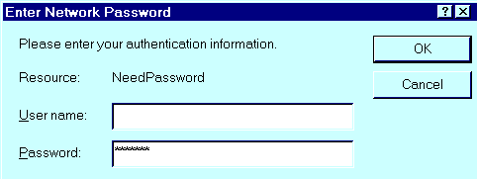
Figure 4: Password Prompt
Leave the User Name blank, and enter the password for the Internet Gateway.
If no password has been set, you will not see this prompt.
Instead, you will immediately see the Home screen, which contains helpful information for first-time users.

Navigation & Data Input
Most screens contain a navigation bar on the left of the screen allows you to move about. You can also use the "Back" button on your Browser.
Remember that changing to another screen without clicking "Save" does NOT save any changes you may have made. HTML uses "forms based input" which means you must send (submit) the form (by clicking a button) or your data will be ignored.

Chapter 4
Internet Access
4
This Chapter explains how to configure the Internet Gateway and your LAN for Internet Access.

Overview
To use the Internet Gateway for Internet Access, the following operations are required:
- The Internet Gateway's Ports screen must be configured with details of the attached modem(s) or ISDN TA(s), and the Internet Account to which each modem or ISDN TA will connect. Details are in this chapter.
- If you choose not to use the Internet Gateway's default IP Address, the LAN settings on the Device screen must be set correctly. Refer to LAN Settings on page 41 for details.
- PC's on the LAN may require configuration, as explained in this chapter.
- If you have an existing DHCP (Dynamic Host Configuration Protocol) Server, it may require configuration. Details are in this chapter.
- If you have a router, it needs to be configured. Refer to Chapter 10 - Routing for details.

Port Configuration
Selecting the Ports hyperlink will take you to the Port Configuration screen. An example screen is shown below.
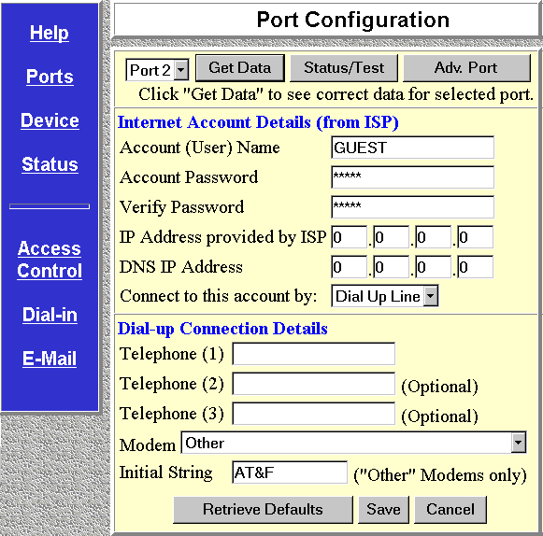

Figure 5: Port Configuration

Operations
- To enter data for a port:
Select the desired port, enter the data as described in the following section, and click Save.
- To change data for a port:
Select the desired port, click Get Data to view the current information, and make any desired changes.
Click Save when finished.
- To copy data from one port to another:
Select the first port, click Get Data to retrieve its data.
Then select the second port, and click Save. The data shown on screen is saved to the port selected.
- To move to the Advanced Port Screen:
Click the Adv. Port button. Any changes you have made on this screen will NOT be saved.
- To move to the Port Status/Test Screen:
Click the Status/Test button. Any changes you have made on this screen will NOT be saved.
- To Save the Configuration Data:
Click the Save button.
- To have any Data entered ignored:
Click the Cancel button. Any changes since the last Save operation will be ignored. The previous data will reappear on screen.
- To retrieve the default values:
Click the Get Defaults button. Note that this does NOT change the configuration. The data shown on screen is not saved until you click the Save button.

Internet Connection Data
The following data is available from your ISP (Internet Service Provider).
Account (User) Name | Enter the account name provided by your ISP. This name will be used to log in to the ISP’s server.
Account Password | Enter the current password for the above account.
Verify Password | Re-enter the password to ensure it is correct.
IP Address  provided by ISP | Enter the IP address assigned to you by your ISP. If the ISP issues dynamic IP addresses, leave this field as 0.0.0.0. (With dynamic IP addresses, a valid address is provided upon connection.)
DNS IP Address | The DNS (Domain Name Server) translates names (e.g. microsoft.com) to IP Addresses.  Enter the DNS IP address supplied or recommended by your ISP.
Connect to this  Account by | Select Dial up line if you connect by Modem or ISDN TA.  Select Leased Line(Null modem) if you have a continuous connection. You can then ignore the Dial-up Connection section.

Dial-up Connection Details
If you are using a dial-up connection, the following data must also be provided.
Telephone | One (1) number is essential. Use the format described in your modem's user manual.
Modem | If your Modem or ISDN TA is listed, simply select it. Otherwise, try "Hayes compatible".  If this does not work, select "Other" and enter the required "Initial String", as described below

Initial String (AT Commands)
For the Internet Gateway to function, the modem or ISDN TA must be configured correctly. The table below shows the required settings, and the usual AT command to achieve this.
Setting | AT Command
Fixed baud rate setting | AT&B1
RTS/CTS flow control | AT&K3
DCD to track the presence of a carrier | AT&C1
DTR off to hang-up modem | AT&D2
DSR always on | AT&S0
Modem to return modem-to-modem data link speed | ATX4
Using these commands, the Initial String would be as follows:

AT&F&B1&K3&C1&D2&S0X4
The first command (AT&F) sets the modem to its factory defaults. See Appendix B - AT Commands for further details.

PC Configuration

Simple LANs
If your PC is NOT using DHCP and your LAN does NOT contain a router, check the following TCP/IP settings:
- IP Address
- Network Mask
- Gateway IP Address
- DNS (Domain Name Server) Address

IP Address
Ensure that the IP Address for each PC is unique, and is from the same address range as the Internet Gateway's Device IP Address.
For example, if the Internet Gateway uses the default IP Address (192.168.0.1) and Network Mask (255.255.255.0), the PCs must use addresses from 192.168.0.2 to 192.168.0.254.

Network Mask
All PCs, and the Internet Gateway, need to use the same value for the Network Mask. The default value is 255.255.255.0.

Gateway IP Address
Set the Default Gateway Address to the Internet Gateway's IP address (Device IP Address). The default value is 192.168.0.1.

DNS (Domain Name Server) Address
Enter the DNS address entered into the DNS IP Address field of the Internet Gateway during configuration.

If your PC is using DHCP
In this case, no configuration is required. The DHCP server will provide the following information when your PC (the DHCP client) boots up:
- IP Address
- Gateway IP Address
- DNS (Domain Name Server)
- If you wish to use the DHCP Server built into the Internet Gateway, refer to DHCP Server on page 42.
- The Configuration of the DHCP server should be checked. See page 29 for details.

To check if your PC is using DHCP
Under Windows 95, you can check if your PC is acting as a DHCP client by using the following procedure. For other operating systems, check your system documentation.
- Select Control Panel - Network
- Select the TCP/IP protocol for your network card.
- Click on the Properties button. You should then see a screen like the following.
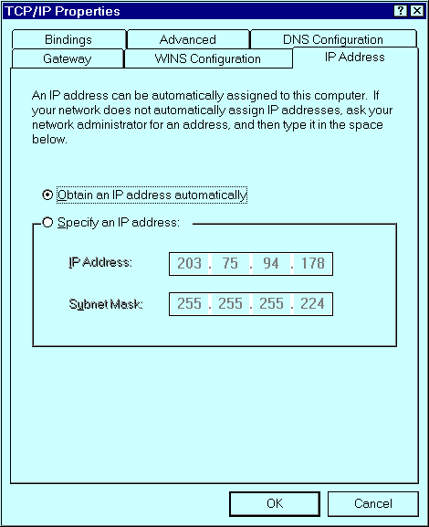

Figure 6: IP Address (Win 95)
- If the radio button for "Obtain an IP address automatically" is checked, as shown above, then your PC is acting as a DHCP client.

If your LAN has a Router
If your LAN contains 1 or more Routers, do NOT change any TCP/IP settings unless advised to do so by your LAN Administrator.
The Router itself must be configured. Refer to Chapter 10 - Routing for details.

DHCP Server Configuration
To use the Internet Gateway's DHCP Server, refer to page 42. If you already have a DHCP server, check the following:

IP Addresses assigned to PCs
The Internet Gateway's Device IP Address needs to be from the same address range as IP Addresses assigned to PCs.
For example, if the Internet Gateway uses the default IP Address (192.168.0.1) and Network Mask (255.255.255.0), the PCs must use addresses from 192.168.0.2 to 192.168.0.254.

Network Mask
All PCs, and the Internet Gateway, need to use the same value for the Network Mask. The default value is 255.255.255.0.

Gateway IP Address
This depends on whether your LAN has a router:
No Router | Set the Default Gateway Address to the IP address (Device IP Address) assigned to the Internet Gateway during configuration. The default IP Address is 192.168.0.1.
Router | Do not change the Default Gateway Address. Instead, the router must be configured as explained in Chapter 10 - Routing.

DNS (Domain Name Server) Address
This should match the DNS address entered into the DNS IP Address field of the Internet Gateway during configuration.

Operation - Internet Access
Simply use your Browser as if you had a permanent connection. If no connection currently exists, there will be a short delay while the modem connects to your ISP.

Accessing AOL
To access AOL (America On Line) through the Internet Gateway requires the following:
- Internet account with an ISP.
The details of this account must be entered in the Internet Gateway like any other Internet Access Account.
- The AOL for Windows software (Version 2.5, 3.0) or later must be configured to use TCP/IP network access, rather than a dial-up connection. This procedure is described below.

AOL for Windows Configuration
- Start the AOL for Windows communication software (Version 2.5, 3.0 or later). Click the Setup button
- Select Create Location, and change the location name from "New Locality" to "Internet Gateway".
- Click Edit Location. Select TCP/IP for the Network field. (Leave the Phone Number blank.)
- Click Save, then OK.
Configuration is now complete.
- Before clicking Sign On, always ensure that you are using the "Internet Gateway" location.

Chapter 5
Advanced Port
Settings
5
This Chapter details the settings on the Internet Gateway's "Advanced Port Settings" screen.

Overview
Most users should not have to change these settings. They are provided for the following situations:
- You wish to use the port for dial-in access by remote users. (See Chapter 8 - Dial-In Access for further details)
- Your modem uses non-standard AT commands.
- Your ISP does not use the standard PPP connection, and requires a special log-in procedure.
- You wish to change the "Time-out" period after which an inactive connection will be terminated.
- You need to temporarily disable the port.

Advanced Port Screen
The Advanced Port Screen is reached by clicking the Adv. Port button on the Port Configuration screen.
You will then see a screen like the example below.
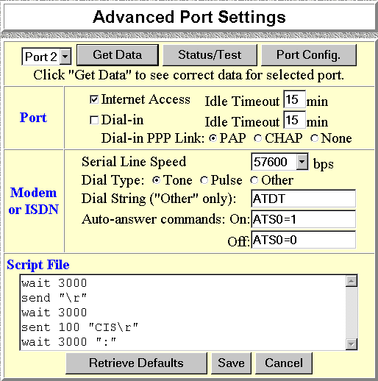

Figure 7: Advanced Port Settings

Port Settings
Internet Access | If checked, a connection to the Internet will be made as needed.
Idle Timeout | If a connection remains inactive, it is terminated after this time period. Allowable range is 0-99 minutes. For a leased line, set this value to 0.
Dial-in | If checked, this port is available for dial-in access. Otherwise, any attempt to dial-in will be blocked.
Idle Timeout | If a dial-in connection remains inactive, it is terminated after this time period. Allowable range is 0-99 minutes.
Dial-in PPP Link | Select the desired option. CHAP is more secure. If it is selected, the dial-in clients must also support CHAP in order to connect.  PAP is less secure, but more common.  Warning! If you choose "None", no User Name/Password authentication is performed on dial-in

If neither "Internet Access" nor "Dial-in" is checked, the port is disabled and cannot be used at all.

Modem/ISDN Settings

Serial Line Speed | Select the speed which is equal to or below the fastest SERIAL line speed (NOT phone line speed) of your modem. Available speeds range from 4.8K to 230.4.K (bps).
Dial Type | Select "Tone", "Pulse" or "Other" to match your system. For "Other", you must provide the Dial String below.
Dial String | Only required if you are NOT using Tone or Pulse dialing.  Enter the command (sometimes called the "Dial Prefix String") your modem requires to precede the phone number.
Auto Answer Commands | Enter the command strings which turn the "auto-answer" function in your modem or ISDN TA ON and OFF.

Script File
If your ISP uses a standard PPP connection and authentication, you do NOT need a script file.
Script files are used to automate the log-in process for ISPs that use non-standard log-ins or proprietary security measures. For example, if you connect to the Internet via CompuServe, you DO need a script file. (This script is on page 37.)

Script File Commands
Three commands, listed below, can be used within a script file. Note the following points:
- Items in [ ] are optional, and the [ ] themselves are NOT used. Parameters are shown in italics.
- There must be spaces between commands and parameters (times and strings).
- Strings must be enclosed in double quotes.
Send [msec] string | Send the characters in string, with a. msec (milliseconds) delay between the sending of each character.
Wait msec | Wait for msec milliseconds before executing the next script line.
Wait [msec] string | Wait for msec milliseconds to receive the string. If the string is not received within the specified time, the connection is reset.  If msec is not specified and the string is not received immediately, an error condition will arise.

Script File Variables
Eleven string variables can be used within the string above. These are used to include special characters within the string.
Variable | Description
\a | alert (normally creates a beep)
\b | backspace
\f | form feed
\n | new line
\r | carriage return
\t | horizontal tab
\v | vertical tab
\? | Literal question mark
\’ | literal single quotation mark
\” | literal double quotation mark
\\ | literal back slash
- Quote characters are special characters.
- Because each of these variables starts with a backslash, the backslash character ( \ ) is also a special character.
As an example, to send the string "User Name" (including the quotes), the script file entry should be as follows:
send "\"User Name\""

CompuServe Script
The following script file could be used to log on to CompuServe, and can be used as an example for other situations.
wait 3000
send “\r”
wait 3000
send 100 “CIS\r”
wait 3000 “:”
send 100 “user id\r”
wait 3000
send 100 “password\r”
wait 60000 “!”
send 100 “GO PPPCONNECT\r”
Command | Explanation
wait 3000 | Pause for 3 seconds
send “\r” | Send the carriage return character.
wait 3000 | Pause for 3 seconds
send 100 “CIS\r” | Send the string “CIS”, then a carriage return character. Pause for 100 ms between characters.
wait 3000 “:” | Wait for 3 seconds to receive the character “:” If not received in time, the connection is dropped.
send 100 “user id\r” | Send the string user id, where user id is your log-in name, then a carriage return. Pause for 100 ms between each character.
wait 3000 | Pause for 3 seconds
send 100 “password\r” | Send the string password, where password is your password, then a carriage return. Pause for 100 ms between each character.
wait 60000 “!” | Wait for 60 seconds to receive the character “!”.  If not received in this time, the connection will be dropped.
Send 100  “GO PPPCONNECT\r” | Send the string “GO PPPCONNECT”, then a carriage return character. Pause for 100 ms between each character.  This command tells the server to switch to a PPP connection.

Chapter 6
Device Settings
6
This Chapter details the options available on the "Device Settings" screen.

Overview
The Device screen is reached by selecting the Device option on the navigation bar.
The options available on this screen are:
- Password
- Bandwidth Utilization
- LAN Settings
- DHCP Server Settings
There is also a link to the Routing screen.
An example screen is shown below. Note that the Routing link in the Navigation bar appears ONLY on this screen.
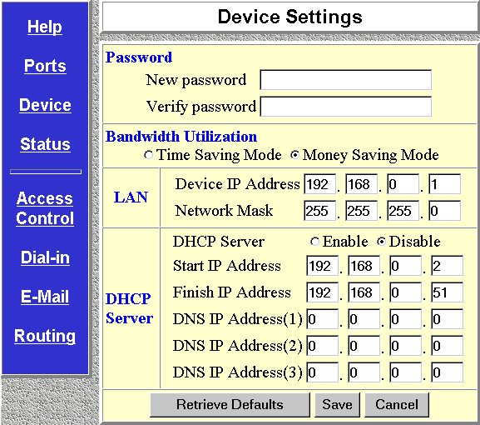

Figure 8: Device Screen

Device Password
Once a password is entered, it is required in order to change the device configuration. Passwords are case sensitive and can be up to 8 alphanumeric characters (no spaces or punctuation).
To create or change the password, enter the required password in both the New Password and Verify Password input fields.
If the password is lost, a DIP switch setting is available to clear the password. See the DIP Switch table on page 12 for details.

Bandwidth Utilization
This feature determines how multiple serial port connections are handled. The options are Money Saving Mode (the default) and Time Saving Mode.
In Money Saving Mode, additional serial ports will only be connected when bandwidth utilization is high.
In Time Saving Mode, whenever a connection is required, all serial ports will always be used, even for a single user.
The default value is Money Saving Mode.

LAN Settings
For most users, the default values for these fields should be satisfactory.
Device IP Address | IP address for the Internet Gateway. Use the default value of 192.168.0.1 unless:  - The address is already in use.  - Your LAN is using a different IP address range (not 192.168.0.1 to 192.168.0.254). In this case, use an IP Address from within the range used by your LAN.
Network Mask | The default value 255.255.255.0 is standard for small (class "C") networks. For other networks, use the same value as PCs on the same LAN segment as the Internet Gateway.

DHCP Server
A DHCP (Dynamic Host Configuration Protocol) server provides a valid IP address (and the Gateway and DNS addresses) to a DHCP client (PC or device) upon request. The Internet Gateway can act as a DHCP server.
To use this feature:
- The Internet Gateway must be configured with the following data.
- The PCs must be configured to act a DHCP clients. This procedure is explained in the next section.

Configuration Data
Enable/Disable | If Enabled, the Internet Gateway will function as a DHCP server. The default value is Disabled.
Start IP Address  Finish IP Address | The IP Start Address and IP Finish Address fields set the values used by the DHCP server.  This range also determines the number of DHCP clients supported. (Maximum number of clients is 253.)
DNS IP Address | Enter the IP Address or Addresses provided by your ISP. Multiple entries should be entered in the order you want them accessed. (The first available DNS will be used.)

The DNS field will display the DNS entered in the Port Configuration screen.

PC Configuration
To use DHCP, you must also configure your PCs to act as DHCP clients.
Client support for DHCP is provided in Win 95’s TCP/IP stack. The procedure for enabling this is detailed below.
For operating systems other than Win 95, check your system documentation.

Windows 95 Configuration
- Select the Control Panel - Network option on the Start Menu. You should see a screen like the one following.
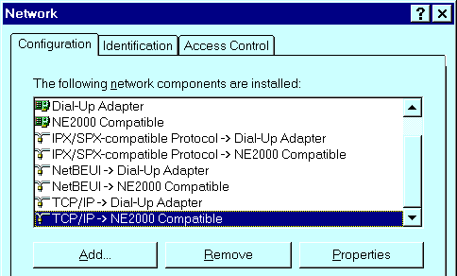

Figure 9: Network Configuration
- Select the TCP/IP protocol for your network card. Then click on the Properties button. You should then see a screen like the following.

Figure 10: IP Address (Win 95)
- Click on the radio button to obtain an IP address automatically, as shown above.
- Click on the Gateway tab.
The Default Gateway Address should be left blank. The DHCP server will provide this information.
- Click on the DNS Configuration tab
The DNS (Domain Name Server) should be “Disabled”. The DHCP server will provide this information also.
- Information provided by the DHCP Server will not be visible on this screen. Use the "Run" dialog to start the WinIPcfg program to see the addresses allocated by the DHCP Server.
- To reserve an IP Address for a particular DHCP client, so that it always receives the same IP Address, refer to Workstations on page 50.

Chapter 7
Access Control
7
This Chapter explains how to configure and use the "Access Control" feature.

Overview
The Access Control feature allows administrators to restrict Internet Access by individual workstations. The process uses "Packet Filtering" to block or discard data packets. By default, no packets are blocked or discarded.

To use this feature:
- Set the desired restrictions on the "Everyone" group. By default, all PCs are in the "Everyone" group unless explicitly moved to another group, using the Workstation screen.
- Set the desired restrictions on the other groups ("Group 1", "Group 2", etc ) as needed.
- For each Workstation you wish to move from the "Everyone" group, enter their details on the Workstation screen, and assign them to the desired group
You can limit Internet access for ALL PCs without entering ANY workstation data. Simply apply the desired restrictions to the "Everyone" group.
It is also possible to define your own packet filters, and use these filters in addition to the pre-defined filters. Defining your own filters is optional.

Security Groups
The Security Groups screen is reached from the Access Control link on the navigation bar. An example screen is shown below.
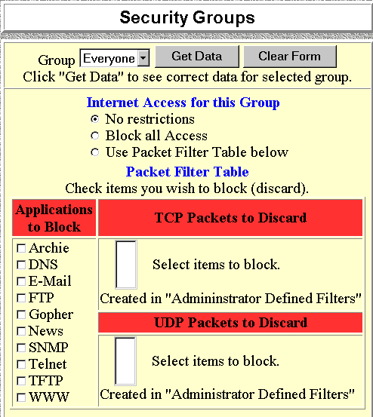

Figure 11: Security Groups Screen
Note that the Security groups are pre-named "Everyone", "Group 1", "Group 2", "Group 3", and "Group 4".

Operations
- To Define a Security Group:
Select the group from the drop-down box, then enter the required data. If necessary, click Clear Form to remove the existing information shown on screen.
Click the Save button when finished.
- To Change Access for an Existing Group:
Select the group from the drop-down box, click Get Details to view their information, then change any fields you wish.
Click Save when finished.
- To Assign Workstations to a Security Group
All Workstations are automatically in the "Everyone" group. Use the Workstations screen to move them to another group if required.

Data
The following data is required.

Internet Access for this Group
There are 3 options:
- No restrictions - No packets are blocked. Use this to create an "Unlimited Access" group, or to temporarily remove restrictions from a group.
- Block all Access - Groups members cannot access the Internet at all. Use this to create the most restrictive group.
- Use Packet Filter Table below - Use this to define intermediate levels of access. Using the Packet Filter table gives you fine control over Internet access.

Packet Filter Table
Simply select the items you wish to block. You can choose from the pre-defined filters in the Applications to Block column, or your own filters in the TCP Packets to Discard and UPD Packets to Discard column.
Applications to Block | Any items checked will be blocked. Users will not be able to use the application.
TCP Packets to Discard | This lists any TCP filters you have defined on the Administrator Defined Filters screen. If no filters have been defined, this is empty.  Multiple items can be selected (or deselected) by holding down the Ctrl key while selecting items.  Selected items can NOT be accessed by members of this group.
UPD Packets to Discard | This lists any UDP filters you have defined on the Administrator Defined Filters screen. If no filters have been defined, this is empty.  Multiple items can be selected (or deselected) by holding down the Ctrl key while selecting items.  Selected items can NOT be accessed by members of this group.

If you have not defined your own filters, but wish to do so, refer to "Administrator Defined Filters" on page 52.

Workstations
The Workstations screen is reached from the Access Control link on the navigation bar. An example screen is shown below.
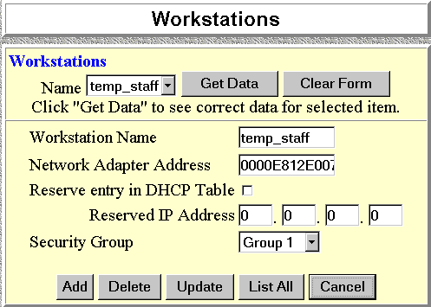

Figure 12: Workstations Screen
Note that the drop-down box lists all Workstations previously entered. If none have been entered, this box will be empty.

Operations
- To Add a New Workstation:
Ignore the drop-down box, click the Clear Form button, and enter the Workstation details in the fields provided.
Click Add when finished.
- To Delete an Existing Workstation:
Select the Workstation from the drop-down box, click Get Details to view the information and confirm that this is the correct Workstation, then click the Delete button.
- To Change an Existing Workstation's Details:
Select the Workstation from the drop-down box, click Get Details to view their information, then change any fields you wish.
Click Update when finished.
- To Generate a List of all Workstations:
Just click on the List All button.

Data
Workstation Name | Enter a name to identify this workstation.
Network Adapter Address | Hardware address for this workstation. You can use the Windows "Winipcfg" program or your LAN management program to find this address.
Reserve entry in DHCP Table | Check this if you wish to reserve an IP address for this workstation. This is useful if you have to provide the IP Address for other programs or users  If this is left unchecked, the following entry can be ignored.
Reserved  IP Address | This relates to the entry above. Enter the reserved address here. This MUST be within the range used by the DHCP server (set on the "Device" screen).
Security Group | Select the security group for this workstation. If you only wish to reserve an IP Address, and are not using the security (access control) features, simply leave this at "Everyone".

Administrator Defined Filters
The Administrator Defined Filters screen is reached from the Access Control link on the navigation bar. An example screen is shown below.
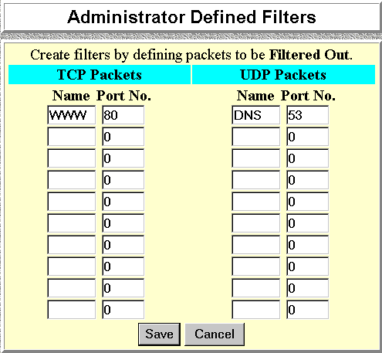

Figure 13: Administrator Defined Filters
This screen allows you to define packet filters. After you define packet filters, they will appear on the "Security Groups" screen. You can select them, as well as the pre-defined filters, when applying restrictions to a Security Group.

Data

TCP Packets
Define the packets you wish to be filtered out, by entering the following data.
Name | Enter a descriptive name for this entry.
Port No. | Enter an integer representing the Port Number for this type of packet. A Network Analyzer or Packet Sniffer can be used to determine the correct port number.

UDP Packets
Define the packets you wish to be filtered out, by entering the following data.
Name | Enter a descriptive name for this entry.
Port No. | Enter an integer representing the Port Number for this type of packet. A Network Analyzer or Packet Sniffer can be used to determine the correct port number.

Chapter 8
Dial-In Access
8
This Chapter details the operation of the Internet Gateway's Dial-in feature.

Overview
The Internet Gateway's dial-in feature allows remote users to:
- Dial the modem connected to theInternet Gateway, using the same PPP communication software (e.g. Dial-up Networking) that they use for dial-in Internet access.
- Have their user name and password verified by the Internet Gateway.
- Access the LAN resources as if they were a local user.
For additional security, the dial-back function can be used. In this situation, the Internet Gateway will hang-up the user's incoming connection, and then call them back.

To use the Dial-in Feature:
- The relevant port must be configured for dial-in operation. The required settings are on the Advanced Port Settings screen.
- User data must be entered on the Users screen for each person requiring dial-in access.
If you wish, you can reserve a port for dial-in access by enabling "Dial-in" and disabling "Internet Access".

Port Configuration for Dial-In
To use dial-in access, the relevant port must have the following data entered on the Advanced Port Settings screen. This screen is reached by the Adv. Port button on the Port Configuration screen.
Dial-in | If checked, this port is available for dial-in access. Otherwise, any attempt to dial-in will be blocked.
Idle Timeout | If a dial-in connection remains inactive, it is terminated after this time period. Allowable range is 0-99 minutes.
Dial-in PPP Link | Select the desired option. CHAP is more secure. If it is selected, the dial-in clients must also support CHAP in order to connect.  PAP is less secure, but more common.  Warning! If you choose "None", no User Name/Password authentication is performed on dial-in

User Configuration for Dial-in
The Users screen contains data for both Dial-in access and/or E-Mail Account sharing.
To enter information about the users who wish to have dial-in access:
- Select Dial-in from the navigation bar, then Users.
- You will then see a screen like the following:
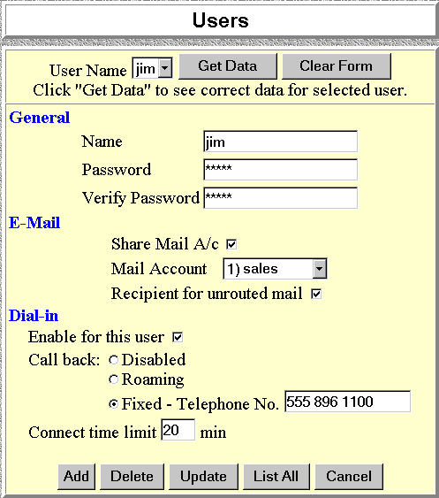

Figure 14: Users Screen
Note that existing users are listed in a drop-down box. If no users have been entered, this box will be empty.
This screen is also used provide user information for "E-Mail Account Sharing". For Dial-in use only, simply ignore the "E-Mail" section of the screen.

Operations
- To Delete an Existing User:
Select the user from the drop-down box, click Get Details to view their information and confirm that this is the correct user, then click the Delete button.
- To Change an Existing User's Details:
Select the user from the drop-down box, click Get Details to view their information, then change any fields you wish.
Click Update when finished.
- To Add a New User:
Ignore the drop-down box, click the Clear Form button, and enter the user details in the fields provided.
Click Add when finished.
- To Generate a List of all Users:
Just click on the List All button.

User Data
For each user requiring Dial-in access, the following data is required.

General
User Name | Existing users are shown in a drop-down list. You can select a user from this list to change their details.  When adding a new user, the drop-down list is ignored; just enter the details for the new user.  Note the limitations on user names:  - Multiple words are NOT allowed  - Punctuation and special characters should NOT be used.  - User names are case insensitive (case is ignored).
Password | The password for the current user. Passwords are case sensitive.

Dial-in
Enable for  this user | Use this to suspend or enable dial-in access.
Call Back | Disabled:- User can simply dial-in; the device will not hang-up and call back.  Roaming:- After providing their name and password, the user is prompted for the call-back number.  Fixed:- The number entered in the Tel field is always used as the call-back number.
Connect  Time limit | After this time period, the user is disconnected. Allowable values are 0 (default) to 999 minutes. Zero means no time limit.

Remote User Configuration
The remote user can use the same dial-up software they use for Internet access. They should check the following:
- Their program must dial the telephone number of the modem connected to the port used for dial-in access.
- When prompted for user name and password, they must enter the name and password stored in the Internet Gateway.
Once connected, they can access LAN resources as they normally would. They will appear to other LAN devices as a normal PC on the LAN, using the IP Address allocated by the Internet Gateway.

Chapter 9
E-Mail
9
This Chapter explains how to use the E-Mail Account Sharing feature of the Internet Gateway.

Overview
The Internet Gateway allows many users to share the E-Mail Account(s) provided by your ISP. Up to 4 E-Mail accounts and 50 users are supported. The E-mail address is formed by combining the "User Name" with the E-Mail Account, as shown by the following example. Note that the quotes (" ") and braces ( < > ) ARE included in the E-mail address.
"user_name"<mail_account@mail_address>
e.g. "jim"<sales@company.com>

To use this feature:
- Account data must be entered into the E-Mail Account screen for each E-Mail account you wish to share.
- Data for each user who wishes to share an E-Mail Account must be entered in the Users screen
- A DNS IP Address must be entered either on the Port Configuration screen or on the Device screen.
- Users must configure their E-Mail program so that their incoming mail is retrieved through the Internet Gateway, as explained on page 67.

Account Information
To enter data about the E-Mail accounts you wish to share:
- Select E-Mail - E-Mail Accounts from the navigation bar.
- You will then see a screen like the following:
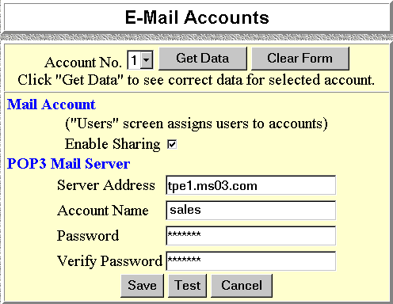

Figure 15: E-Mail Accounts Screen
Account No. | Select the desired account (1..4)
Enable Sharing | Use this to suspend or enable sharing.
POP3 Mail Server Address | Enter the address of the POP3 Mail Server, as provided by your ISP.
POP3 Mail Server Account Name | This name is provided by your ISP. Using a Department name (e.g. Sales) is recommended.
Password | The password for the above account.

User Information
The Users screen contains data for either or both Dial-in access and E-Mail Account sharing.
To enter information about the users who wish to share E-Mail accounts:
- Select E-Mail from the navigation bar, then Users.
- You will then see a screen like the following:

Figure 16: Users Screen
Note that existing users are listed in a drop-down box. If no users have been entered, this box will be empty.
This screen is also used provide user information for "Dial-in" Access. For E-Mail use only, simply ignore the "Dial-in" section of the screen.

Operations
- To Delete an Existing User:
Select the user from the drop-down box, click Get Details to view their information and confirm that this is the correct user, then click the Delete button.
- To Change an Existing User's Details:
Select the user from the drop-down box, click Get Details to view their information, then change any fields you wish.
Click Update when finished.
- To Add a New User:
Ignore the drop-down box, click the Clear Form button, and enter the user details in the fields provided.
Click Add when finished.
- To Generate a List of all Users:
Just click on the List All button.

User Data
For each user wishing to share an E-Mail account, the following data is required.

General
User Name | Existing users are shown in a drop-down list. You can select a user from this list to change their details.  When adding a new user, the drop-down list is ignored; just enter the details for the new user.  Note the limitations on user names:  - Multiple words are NOT allowed  - Punctuation and special characters should NOT be used.  - User names are case insensitive (case is ignored).
Password | The password for the current user. This password will be entered into their E-Mail program. Passwords are case sensitive.

E-Mail
Share Mail A/c | Use this to suspend or enable sharing.
Mail Account | Select the E-Mail account that this user is going to share. Account information should have been previously entered.
Set as Recipient for  Unrouted Mail | If this setting is ON (Checked), then when this user retrieves their E-mail, they will also receive all E-mail sent to this mail account when there is no user name, or the user name is invalid.  More than one user can be set.

DNS Address
A DNS (Domain Name Server) Address is required to enable the Internet Gateway to locate the Mail Server.
This address is on the Port Configuration and on the Device screen.
Ensure that this data has been provided.

E-Mail Program Configuration
Each user wishing to share an E-Mail account must configure their E-Mail program with the following data.
Name | The User Name entered in the E-Mail User Screen of the Internet Gateway.
E-Mail Address | The full name of the E-Mail account which is being shared, as provided by your ISP.  e.g. sales@provider.com
SMTP Server  (Outgoing Mail) | The SMTP Server address as provided by your ISP
POP3 Server  (Incoming Mail) | Set this to the IP Address of the Internet Gateway
POP3 Account | The User Name entered in the E-Mail User Screen of the Internet Gateway.
Password | The user password entered in the User screen of the Internet Gateway.
- Note that outgoing E-mail is sent normally; only incoming E-mail is processed by the Internet Gateway.
- If some of your incoming E-mail does not include your name, and thus becomes "Unrouted Mail", ask those senders to record your E-Mail Address in the following format. Note that quotes ( " " ) and braces ( < > ) ARE typed in.

"user_name"<mail_account@mail_address>
e.g.
"jim"<sales@company.com>
Your printed E-Mail Address (e.g. on your business card) should also show your E-Mail address in the format above.

Sharing E-Mail Example
Say your name was B. Jones, the Internet Gateway uses its default IP Address (192.168.0.1) and other information was as follows:
E-Mail Address  as provided by your ISP | greatco@ms02.com
SMTP Server  as provided by your ISP | smtp09.com
POP3 Server  as provided by your ISP | ms02.com
POP3 Account Name  as provided by your ISP | greatco
POP3 Account password  as provided by your ISP | 9087654
To share this E Mail Account, the following entries are required. Your E-Mail Address would become:
"bjones"<greatco@ms02.com>

Internet Gateway "Mail Account"
Account No. | 1
Enable Sharing | ON (Yes)
POP3 Mail Server Address | ms02.com
POP3 Mail Server  Account Name | greatco
Password | 9087654

Internet Gateway "Mail User"
User Name | bjones
Password | Secret064
Mail Account | 1
Set as Recipient for  Unrouted Mail | ON (Yes)

E-Mail Program
Name | bjones
E-Mail Address | greatco@ms02.com
SMTP Server  (Outgoing Mail) | smtp09.com
POP3 Server  (Incoming Mail) | 192.168.0.1
POP3 Account | bjones
Password | Secret064

Management of Shared E-Mail
This section describes some common operations which may be required at some time.

Changing User Details
You can change any data at any time. For example, to move a user from 1 account to another:
- Navigate to the Users screen.
- Select the desired user, and click Get Data to view their information.
- Select the desired account for this user.
- Click Update
Any mail sent to this user at their "old" account will now be considered "unrouted mail".
You can modify any user data in a similar fashion.

Deleting a User
To delete a user from the database:
- Navigate to the Users screen.
- Select the desired user.
- Click Delete to remove them from the database.
Any mail sent to this user will now be considered "unrouted mail".

Retrieving ALL Mail
If you wish to retrieve all mail for the shared account, regardless of who it is addressed to:
- Run your E-Mail program, and navigate to the screen showing the details of the shared E-Mail account.
- Modify the account configuration so that the following fields match the data provided by your ISP:
- POP3 account
- POP3 Server address
- Account password
- The other configuration data is already correct.
When you retrieve your mail with these settings, you will receive all the E-mail sent to this account.

Stop Sharing the Account
If you wish to cease sharing this account:
- On the E-Mail Accounts screen, set Enable Sharing for this account OFF.
- To retrieve mail from this account, you will now have to configure your E-Mail program to access the account directly, as described above.
- You will receive all mail intended for users who have been sharing this account.
- Users who previously used this account need to configure their E-Mail programs to use a different account.

This page was deliberately left blank.

Chapter 10
Routing
10
This Chapter explains the Routing features of the Internet Gateway.

Overview
While the Internet Gateway includes a standard routing table, this feature can be completely ignored if you do not have a router in your LAN.
If you DO have a router, it is necessary to configure BOTH the Router and the Routing table in the Internet Gateway correctly, as described in the following sections.

See page 77 for an example of configuring both the Internet Gateway and the Router.

Internet Gateway Configuration
The routing table is accessed by the Routing link on the navigation bar. This link appears only on the Device Screen. An example screen is shown below.

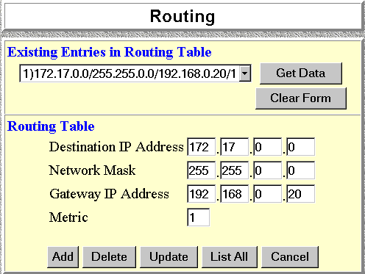
Figure 17: Routing Screen

Routing Table Data
An entry in the routing table is required for each LAN segment on your Network, other than the segment to which this device is attached. The data in the Routing Table is as follows.
Destination  IP Address | The network address of the remote LAN segment. For standard class "C" LANs, the network address is the first 3 fields of this Destination IP Address. The 4th (last) field can be left at 0.
Network Mask | The Network Mask used on the remote LAN segment. For class "C" networks, the standard Network Mask is 255.255.255.0
Gateway  IP Address | The IP Address of the Router on the LAN segment to which this device is attached. (NOT the router on the remote LAN segment.)
Metric | The number routers which must be navigated to reach the remote LAN segment. The default value is 1.

Routing tables normally have an "Interface" field. Here, all entries are for the LAN Interface, so this field is absent.

Router Configuration
It is essential that all IP packets for devices not on the local LAN be passed to the Internet Gateway, so that they can be forwarded to the Internet. To achieve this, the Routers must be configured to use the Internet Gateway as the Default Route or Default Gateway.

Local Router
The local router is the Router installed on the same LAN segment as the Internet Gateway. This router requires that the Default Route is the Internet Gateway itself. Typically, routers have a special entry for the Default Route. It should be configured as follows.

Destination IP Address | Normally 0.0.0.0, but check your router documentation.
Network Mask | Normally 0.0.0.0, but check your router documentation.
Gateway IP Address | The IP Address of the Internet Gateway.
Metric | 1

Other Routers
Other routers must use the Internet Gateway's Local Router as the Default Route. The entries will be the same as the Internet Gateway's local router, with the exception of the Gateway IP Address.
- For a router with a direct connection to the Internet Gateway's local Router, the Gateway IP Address is the address of the Internet Gateway's local router.
- For routers which must forward packets to another router before reaching the Internet Gateway's local router, the Gateway IP Address is the address of the intermediate router.

Routing Example
Figure 18: Routing Example
For the LAN shown above, with 2 routers and 3 LAN segments, the required entries would be as follows.

For the Internet Gateway's Routing Table
The Internet Gateway requires 2 entries as follows.
Entry 1 (Segment 1)
Destination IP Address | 192.168.1.0
Network Mask | 255.255.255.0  (Standard Class C)
Gateway IP Address | 192.168.0.100 (Internet Gateway's local Router)
Entry 2 (Segment 2)
Destination IP Address | 192.168.2.0
Network Mask | 255.255.255.0
Gateway IP Address | 192.168.0.100

For Router A's Default Route
Destination IP Address | 0.0.0.0
Network Mask | 0.0.0.0
Gateway IP Address | 192.168.0.1  (Internet Gateway's IP Address)

For Router B's Default Route
Destination IP Address | 0.0.0.0
Network Mask | 0.0.0.0
Gateway IP Address | 192.168.1.80  (Internet Gateway's local router)

Chapter 11
Status &
Monitoring
11
This Chapter explains the Status and Monitoring features of the Internet Gateway.

Overview
The Internet Gateway allows you to connect to it through the LAN while it is operating, and view the device status, and monitor the operation of each port.

Status Screen
The Status screen can be reached with the hyperlink on the navigation bar. An example screen is shown below.
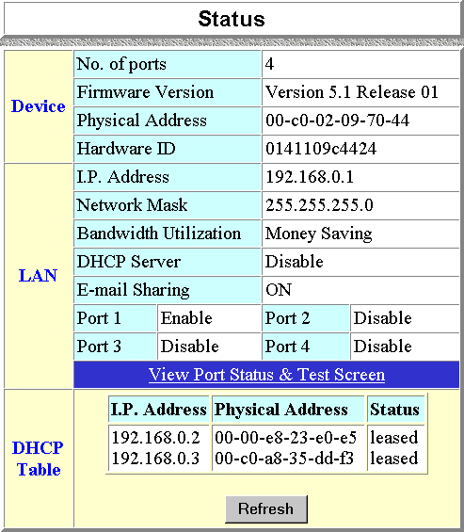

Figure 19: Status Screen

Data

Device
No. of Ports | The number of serial ports on this device.
Firmware Version | Version of the firmware (embedded software) which is currently installed. Technical support staff may ask for this information.
Physical Address | The hardware address of this device.
Hardware ID | The hardware ID of this device, used by the manufacturer for identification.

LAN
IP Address | The IP Address of this device.
Network Mask | The Network Mask value stored in this device. This must match the Network Mask for the LAN segment to which this device is connected.
Bandwidth  Utilization | This will show "Time Saving Mode" or "Money Saving Mode".
DHCP | This shows the status of the DHCP Server function. The value will be "Enabled" or "Disabled".
E-Mail Sharing | If E-mail sharing is used on any E-mail account, this will display "ON". Otherwise, the status will be "OFF".
Port | Each port will show "Enabled" or "Disabled". Ports are initially Disabled, but are automatically Enabled when data is entered.

DHCP Table
This table will be empty unless DHCP has been "Enabled". If DHCP is being used, this table lists the devices which have been allocated IP Addresses by the DHCP server function. Only IP Addresses in use will be listed.
IP Address | The IP Address which has been allocated by the DHCP server to the other device.
Physical Address | The Physical Address (Hardware Address) of the device which has been allocated a IP Address.
Status | Possible Status values are "Leased" (the IP Address is allocated to the device shown) or "Reserved" (the IP Address is not available).

Port Status/Test Screen
This screen is reached by clicking the Status/Test button on the Port Configuration or Advanced Port Settings screen.
An example screen is shown below.
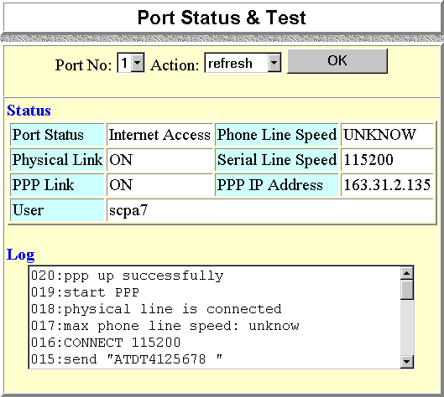

Figure 20: Port Status &Test

Operation
- Select the port you wish to monitor or test.
- Select the action you wish to perform:
- Hang-up will hang up the modem, if it is currently connected
- Dial will dial the ISP, if not currently connected.
- Clear Log will remove all data in the Log window, making new data easier to read.
- Refresh will update the display with fresh data.
- Click the OK button.

Status Data
Port Status | This shows the current port operation. Possible values are:  - Internet Access  - Dial-in  - Idle  - Disabled
Physical Link | If operating, the link will show ON. This means the modem was able to connect to the number dialed.
PPP Link | If ON, a PPP connection was successfully negotiated.
User | - For Dial-in operations, this shows the current user.  - For Internet Access, this shows the Internet Account name.
Phone Line Speed | The connection speed over the phone line, between your modem and the number dialed.
Serial Line Speed | The connection speed between this device and the modem.
PPP IP Address | Internet Access - The IP Address used by this device. This address is provided by the ISP on connection.  Dial-in - The IP Address used by the remote user. This IP Address is normally allocated by the DHCP Server function in this device.

Modem Log
This shows the commands sent to the modem, and any status messages returned by the modem. Note that you must select Refresh and then click OK to update the information.
The following table lists the common messages, and their meaning.
Message | Description
Dialing | Dialing the ISP
Try to establish physical connection. | The device is trying to connect with the ISP, using the modem.
Busy error | The number dialed was busy.
Physical line is  connected | Physical connection to ISP has been established.
CONNECT nnnnnn | Physical connection was successful; nnnnnn indicates the speed of the serial link as currently configured.
Max phone line speed nnnnnn bps | nnnnnn is the maximum speed of the modem, according to the current configuration.
DCD low,  DSR low | Physical line break, connection lost.
send “-----“  wait “-----“ | “AT” commands sent to the modem are displayed as they are sent.  Commands in the Script file are also displayed as they are executed.
Start PPP | Having established a physical connection, a PPP connection is now being established.
PPP up fail | The PPP connection could not be established.
PPP up successfully | The PPP connection was established successfully.
Stop PPP | The PPP connection was terminated. This will occur at the end of a session, or an error condition.
Try to hang up | Attempting to get the modem to hang up.
Time out | There was no response from the modem
No carrier  No answer | The number dialed did not answer.
Idle timer expires | The time period (in the configuration) to disconnect if the link is not used is up.
No dial tone | The modem could not obtain a dial tone.
Set baudrate nnnn | The serial line speed is being set to the speed set in the configuration.

Normal Operation
The following sequence of messages is typical of normal operation.
send “ATDT 0123456789”
CONNECT 115200
max phone line speed 28800 bps
physical line is connected
start PPP
ppp up successfully

Error Conditions
The following table shows messages which indicate an error condition, and the suggested corrective action.
No dial tone | The modem could not obtain a dial tone. Check your connections on the phone line and the modem.
Busy error | The number dialed was busy. Check that the number is correct. If it is, try dialing later. If this occurs regularly, check with your ISP.
DCD low  DSR low | The connection was lost. This could indicate a bad line or poor connection. Normally, if a connection is lost, it will automatically be re-established.
PPP up fail | The ISP rejected the attempt at connection. Check that your username and password is correct. If it is, check with your ISP to see why the connection is being rejected.
Time out | No response. Check that the modem is ON and properly connected to the Internet Gateway.
No carrier  No answer | There was no response from the phone number dialed. Check that the phone number is correct, and the modem is working. If both of these are OK, check with your ISP.

Appendix A
Troubleshooting
A
This Appendix covers the most likely problems and their solutions.

Overview
This chapter covers some common problems that may be encountered while using the Internet Gateway and some possible solutions to them. If you follow the suggested steps and the Internet Gateway still does not function properly, contact your dealer for further advice.

Problems
Problem 1: | Can’t connect to the Internet Gateway to configure it.
Solution 1: | Check the following:  - The Internet Gateway is properly installed, LAN connections are OK, and it is powered ON.  - Ensure that your PC and the Internet Gateway are on the same network segment. (If you don't have a router, this must be the case.)  - Ensure that your PC is using an IP Address within the range 192.168.0.2 to 192.168.0.254 and thus compatible with the Internet Gateway's default IP Address of 192.168.0.1. In Windows, this is done by using Control Panel-Network to check the Properties for the TCP/IP protocol.
Problem 2: | When I enter a URL or IP address I get a time out error.
Solution 2: | A number of things could be causing this. Try the following troubleshooting steps.  - If this is first time you have used your browser, ensure that your workstations IP settings are correct, including IP address, default gateway and DNS.  - Ping the Internet Gateway. Use the “Run” command to enter the following command:  Ping xxx.xxx.xxx.xxx  where xxx.xxx.xxx.xxx is the IP address assigned to the Internet Gateway’s LAN interface.  - If the ping command fails, check that the Internet Gateway is connected and ON. If it is connected and on, there is a problem with your LAN.  - Check that Port is "Enabled" (Advanced Port Settings). If not, you need to use the HTML program to establish a connection.  - Run your Browser and connect to the Internet Gateway.  - Switch to the “Status” screen, and examine the Log. For details of the Log messages refer to Modem Log on page 85
Problem 3: | My Modem/ISDN TA is working fine with a dial-up connection. How do I find what "Initial String" it is using?
Solution 3: | Use the procedure described in Finding the current Initial String on page 94.
Problem 4: | Data Transmissions are very slow.
Solution 4: | Check and ensure that the Initial String is configured to RTS/CTS flow control.
Problem 5: | Some applications do not run properly when using the Internet Gateway.
Solution 5: | The Internet Gateway processes the data passing through it, so it is not transparent. Some programs may have limited functionality when used with the Internet Gateway.  The number of supported applications is being expanded as rapidly as possible. The following applications and protocols are supported by firmware V5.0:  Telnet, FTP, HTTP, ping  POP/SMTP, Archie, NNTP  TFTP, IRC, Gopher  DNS, SNMP, Real Audio

This page was deliberately left blank.

Appendix B
AT Commands
B

Required Settings
For the Internet Gateway to function correctly, the modem or ISDN TA must be set as follows.
Setting | AT Command
Fixed baud rate setting | AT&B1
RTS/CTS flow control | AT&K3
DCD to track the presence of a carrier | AT&C1
DTR off to hang-up modem | AT&D2
DSR always on | AT&S0
Modem to return modem-to-modem data link speed | ATX4  (see Note below)

- For some Mircocom and other modems, the “ATX4” command is not sufficient - a “W2” command (no “AT”) must be used as well.
- For an ISDN TA, the above commands may not be sufficient. Please check the following section or your ISDN TA's user manual.
For a modem which uses the standard AT commands shown above, the Initial String would look like the following:

AT&F&B1&K3&C1&D2&S0X4
The first command (AT&F) sets the modem to the factory defaults, to ensure a consistent starting point.

Finding the current Initial String
If your modem or ISDN TA is already working correctly using the PC's serial port, but you don’t know what the initialization string is, you can use the following procedure to find out.
- Select My Computer, then Dial-Up Networking.
- Select the icon for your connection, then Properties.
- Click the Configure button, then the Connection tab, as shown below.
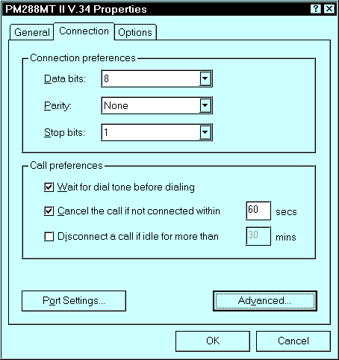

Figure 21:- Connection Properties (W95)
- Select Advanced to see the screen below.
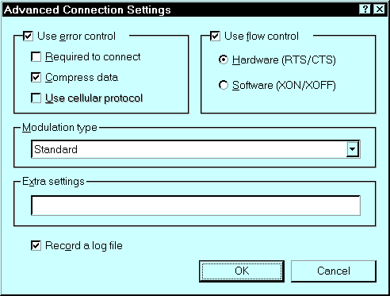

Figure 22:- Advanced Connection (W95)
- Check the option Record a log file. Then click OK and exit.
- Use Dial-up Networking to make your on-line connection normally. A log file MODEMLOG.TXT will be created in your Windows directory.
- Use Notepad or another editor to read and print the file MODEMLOG.TXT.
- Examine the file to determine the Initial String value.

AT Commands
Most modems use the standard AT commands, as shown in the following tables. Consult the manual for your modem to set what AT commands it supports.

Basic AT Command Set
Command |  | Description
<any key> |  | Terminate current connection attempt
+++ |  | Escape sequence code, entered in data state, wait for modem to return to command state
ATA |  | Force answer mode on-line
ATBn |  | Handshake operation
 | B0 | Select ITU-T V.22 for 1200 bps communication
 | B1 | Select Bell 212A for 1200 bps communication
ATD |  | Dial number and options that follow
 | P | Pulse dial
 | T | Tone dial
 | , | Pause for a specified time
 | ; | Return to command state after dialing
 | ! | Hook flash, call transfer
 | W | Wait for second dial tone
 | @ | Wait for 5-second silence before proceeding, otherwise return O ANSWER”
 | R | Reverse Dial (Originate a call in answer mode)
ATDL |  | Dial last number
ATDSn |  | Dial number stored in NVRAM at position n. n=0-9
ATEn |  | Command mode local echo of keyboard commands
 | E0 | Echo off
 | E1 | Echo on
ATHn |  | On/Off hook control
 | H | Hang up modem
 | H0 | Hang up (on hook), same as ATH
 | H1 | Get off hook
ATIn |  | Display inquired information
 | I0 | Display product code
 | I1 | Display product information and ROM checksum
 | I2 | Link status report
ATLn |  | Speaker volume control. n=0-7
ATMn |  | Speaker control
 | M0 | Speaker always off
 | M1 | Speaker on until carrier is detected
 | M2 | Speaker always on
 | M3 | Speaker on after last digit dialed, off at carrier detect
ATNn |  | Ring volume control, n=0 disables ring function. n=0-7
ATO |  | Return to on-line state
ATP |  | Pulse dial
ATQn |  | Result code displayed
 | Q0 | Modem returns result code
 | Q1 | Modem does not return result code
 | Q2 | Return result code but quiet in answer mode (will not show in AT&Vn)
ATS0=n |  | Number of rings required before modem answers. n=0 disables auto-answer.
ATSr.b=n |  | Set bit b of S-register r to n. (0 or 1)
ATSr.b? |  | Inquiry bit b of S-register r
ATSr=n |  | Set S-register r to value n, where n is a decimal number between 0-255
ATSr? |  | Display value stored in S-register r
ATT |  | Tone dial
ATVn |  | Verbal/Numeric result codes
 | V0 | Display result codes in numeric form
 | V1 | Display result codes in verbose form
ATXn |  | Result code options. n=0-7
ATZn |  | Reset the modem and set power-on profile. n=0-4
 | Zn | Reset modem and load user profile n (0-3)
 | Z4 | Reset modem and load factory settings
AT$ |  | Help, Basic command summary
AT&$ |  | Help, Extended AT& command summary
AT*$ |  | Help, Extended AT* command summary

Extended “AT&” Commands
(Includes RTS/CTS Flow Control Commands)
Command |  | Description
&Bn |  | Data rate, terminal-to-modem
 | &B1 | DTE/DCE rate fixed at DTE setting
&Cn |  | Carrier Detect operations
 | &C1 | Carrier Detect tracks presence of carrier
&Dn |  | Data Terminal Ready (DTR) operations
 | &D2 | DTR off causes modem to hang up
&F |  | Load the default factory settings,
&Kn |  | Data flow control, DTE/DCE, n=0,3,4
 | &K0 | Flow control disabled
 | &K3 | Hardware (RTS/CTS) flow control
 | &K4 | Software (XON/XOFF) flow control
&Sn |  | Data Set Ready (DSR)
 | &S0 | DSR overridden, DSR always on

Appendix C
Specifications
C

IG-201
Model No.: | IG-201
Dimensions | 255mm(W) * 140mm(D) * 40mm(H)
Operating  Temperature | 0° C to 40° C
Storage  Temperature | -10° C to 70° C
Network Protocol: | TCP/IP
Network Interface: | Ethernet 10Base2(BNC)  10BaseT (UTP)
Serial Ports: | 2 male DB-9 connector
Max. Asyn. Speed | 230.4 Kbps
LEDS | 2 general status, 1 transmission status for each serial port
External Power Adapter | 12 V DC

IG-401
Model No.: | IG-401
Dimensions | 255mm(W) * 140mm(D) * 40mm(H)
Operating  Temperature | 0° C to 40° C
Storage  Temperature | -10° C to 70° C
Network Protocol: | TCP/IP
Network Interface: | Ethernet 10Base2(BNC)  10BaseT (UTP)
Serial Ports: | 4 male DB-9 connector
Max. Asyn. Speed | 230.4 Kbps
LEDS | 2 general status, 1 transmission status for each serial port
External Power Adapter | 12 V DC

