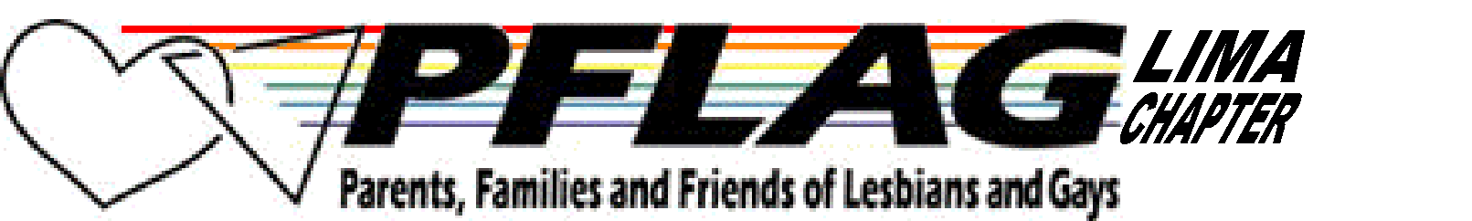______________________________________________________________________
PFLAG-Lima, P. O. Box 5571. Lima, Ohio 45802-5571
pflag_lima@yahoo.com Phone: 419.222.4954
www.geocities.com/pflag_lima

NEXT MEETING JULY 18---7:30 PM
Dayton author Katrina Kittle will be the speaker. One of the books Katrina wrote is called Traveling Light about a man dying of AIDS. Come and learn about this book and other books Katrina has written. Also check www.katrinakittle.com or read the book before the meeting.

PRIDE PICNIC
Approximately 20 people attended the annual picnic in June. We hope those who took pictures will share them at our July meeting. Marquis and Kerry received a certificate of recognition for their work with the group and many good wishes on their upcoming move to Michigan. Awards were also given to Don and David for all their work for PFLAG Lima. Congratulations to all!

BRINGING THE MESSAGE HOME
This summer, PFLAG members from around the country will be Bringing the Message Home to elected leaders about important issues facing the LGBT community. Some of our own members went to a lobby day in May. National PFLAG has produced a revised grassroots handbook on in-district meetings to help members who want to encourage their representatives to stand up for families and vote for equality.

The new Bringing the Message Home guide includes background information and talking points on seven pieces of pending legislation: The Employment Non-Discrimination Act; The Local Law Enforcement Hate Crimes Prevention Act; The Military Readiness Enhancement Act; The Safe Schools Improvement Act; The Real ID Act; The Uniting American Families Act; and The Responsible Education About Life (REAL) Act. It also includes a comprehensive section on transgender issues, and highlights PFLAG's commitment to only supporting legislation which is transgender-inclusive. The guide will be helpful whether you are visiting legislators in person, calling them, writing them, or just want more information about the above pieces of legislation so you can talk with people you meet everyday.

To get more information and read an online copy of the handbook go to www.PFLAG.com, click on the “Education and Programs” link, and then click on the “Bringing the Message Home” link. Or if you find it easier, use the following address (copy and paste it) to go directly to the correct webpage. http://community.pflag.org/NETCOMMUNITY/Page.aspx?pid=906&srcid=194.

RAINBOW FLAG HISTORY (information from internet sources)
You’ve all seen it. Some of you have flown it. We display it at the door at our meetings. The rainbow flag has become the easily-recognized colors of pride for the gay community. Here is some interesting information that you might not have known. The multicultural symbolism of the rainbow plays a part in many myths and stories related to gender and sexuality issues in Greek, Native American, African, and other cultures. Use of the rainbow flag by the gay community began in 1978 when it first appeared in the San Francisco Gay and Lesbian Freedom Day Parade.

San Francisco artist Gilbert Baker designed the rainbow flag in response to a need for a symbol that could be used year after year. The original flag had eight stripes, each color representing a component of the community: hot pink for sex, red for life, orange for healing, yellow for sun, green for nature, turquoise for art, indigo for harmony, and violet for spirit. Baker approached San Francisco's Paramount Flag Company about mass producing and selling his flag. Unfortunately, Baker had hand dyed all the colors, and since the color "hot pink" was not commercially available, mass production of his eight striped version became impossible. The flag was reduced to seven stripes.
In November 1978, San Francisco's gay community was stunned when the city's first openly gay supervisor, Harvey Milk, was assassinated. Wishing to demonstrate the gay community's strength and solidarity in the aftermath of this tragedy, the 1979 Pride Parade Committee decided to use Baker's flag. The committee eliminated the indigo stripe so they could divide the colors evenly along the parade route, three colors on one side of the street, and three on the other. Soon the six colors were incorporated into a six striped version that became popularized and is recognized today by the International Congress of Flag Makers.

Coming Events
(Contact Dave at davbro65@verizon.net for more info)
August 15, 6:30 PM PFLAG Lima social event--Robert/David will host a pool picnic. Bring side dish, chairs, and drinks. They will provide the meat. We may go swimming if we wish. More details to follow.

Stay Informed
National PFLAG: www.pflag.org You can sign up for e-news (the latest news via email).

Latest information on area events See calendar at http://www.geocities.com/pflag_lima

Equality Ohio www.equalityohio.org You can sign up to get the latest news via email.

Human Rights Campaign www.hrc.org

For GLBT Issues and Headlines in the News:
www.pflag.org www.planetout.com
www.advocate.com www.365gay.com

