E-Gen: Zimmerman
12/19/03
Introduction to the Zimmerman Families of Somerset County
By
Larry Pearce

My wife Susan’s great-great grandmother was Elizabeth C. Zimmerman, and there is some confusion over just which Elizabeth Zimmerman she was. We know that she married Noah J. Miller (1826-1881), a farmer and Civil War veteran. Her remains lie along with his in the largest of the three Stoystown cemeteries, located just south of that town. The dates on her stone read 1826-1895. She would have been 29 years old when Susan’s Great grandfather Dibert Miller (1855-1889) was born. However, the 1962 Laurel Messenger, a genealogical newsletter of the Casselman Valley Historical and Genealogical Society, list an Elizabeth Zimmerman (b.1783) who married twice, David Shaffer and Noah Miller. That Elizabeth would have had to have been 72 years old when Dibert was born. Given the commonality of the Zimmerman and Miller names in all parts of Somerset County and the territory covered by the Casselman group, the earlier Elizabeth and Noah are probably different ones than our ancestors. This article simply serves to outline some of the possible early Zimmerman connections in this part of Pennsylvania and introduce some of the more famous namesakes, such as the wealthy coal, timber, and cattleman Daniel Burnside Zimmerman, whose grand mansion still stands overlooking Somerset. Now a bed and breakfast and showpiece for the Georgian Place Outlet Mall, it greets millions of travelers along the Pennsylvania Turnpike and thousands of shoppers and tourists who enter “America’s County.” But, let’s begin our investigation in the Old World.
Our research offers the proverbial “Good news and bad news.” The good news is that we have lots of information; the bad news is that the names are very similar and confusing and some of the dates just don’t match up. More good news, according to Koontz, “The Zimmerman family is one of the oldest and most prominent in Quemahoning Township.” But the bad news is that the 1884 Waterman edition and the two Laurel Messengers (LM) simply don’t agree, so we will try here to make sense out of this and identify our sources along the way. Cockley (LM ’70) says that Johnann Jacob Zimmerman (1644-93) of Duchy Wurtemberg died on his voyage to America. He held a Masters of Philosophy from Tuebigen University and was a Lutheran minister at Bietigheim from 1684-89. A professor at the famous Heidelberg University, he wrote 18 books on theology and astronomy. His wife, Mary Margaret, survived the trip to the new land and her will is dated 1725 in Philadelphia. The couple and their four children, ages 10 to 18, sailed from Rotterdam in late summer 1693 but were forced to spend the winter in London. In February of 1694 they headed out again aboard the Santa Maria, which in light of ongoing troubles between England and France, was armed with 14 canon. They arrived in Deal [exact location unknown] and lingered for nearly two months while they awaited a protective convoy from Plymouth. Finally underway, they encountered the enemy on May 10. After a battle that lasted 24 hours, the convoy captured some 30 guns, between the French frigate and a merchant ship. It’s not certain when Johann died. He may have been killed in the melay, but he was undoubtedly buried at sea, Their party finally sailed up the Chesapeake Bay on June 14 and landed at Bohemian Manor, in Germantown, Philadelphia, on the 23rd.
Johann and Mary’s youngest child, Jacob Christopher, had a son named Arnold (1716-1803) who married Mary Engle (1719-1803). Most of that family is buried at Skippack Church, Philadelphia. The fourth generation of Zimmermans in the new land, and second named Jacob (1740-1819) fought in the American Revolution. He married Elizabeth Supplee (1738-97) and they had four children.
Another Philadelphia Zimmerman was nicknamed “Der Schwartz” [or “The black”] Heinreich Zimmerman (b.1673), after the place of his birth, the Black Forest near Bern, Switzerland. This was also called The Zimmerwald, or “Forest of Carpenters.” This name could also be translated “woodsman” and may be spelled “Cimmerman,” “Simmerman,” or “Timmerman.” Heinreich was a practicing physician who between 1716 and 1720 acquired over 3200 acres in Lancaster County. In settling a dispute over a land claim where a creek divided upstream, he agreed with his opponent, Hans Graff, that each should take a fork. Today, one branch is known as Graff’s Run while the other is Carpenter’s Run.
Heinreich’s fourth child, Henry (b.1714), had eight children, two of whom were medical doctors and one, Daniel, had another distinction: he was 6 feet 6 inches tall.
Hans Zimmerman (b.1702), yet another notable namesake, arrived in Philadelphia in 1732 aboard the “Pink Plaisance and settled in Berks County. Nearly all of his grandchildren were Revolutionary War veterans, meaning that they were Lutherans rather than Anabaptists, who generally are pacifists.
Closer to home and sometime in the late 18th century, a Peter Zimmerman, son of John of Oberguembach, Prussia, was sent by his father at age 14 to live with the Pletcher family in Berlin, Somerset County. But the first Zimmermans in the county belonged to Yost [or Joseph] in 1783. Tax records show 100 acres and the census records 5 family members
If any Zimmerman ancestors could be connected to us, it would begin with Hans Michael (d. 1740). [He should not be confused with Michael (1705-1741) who married Anna Elizabeth Dotterer (1709-1741) who also had a Michael, Jr., Anna Elizabeth, Veronica, and a George, although some birth dates are very similar.] According to Cockley, the Michael Zimmerman family Bible in Stoystown, Quemahoning Township, contains Hans Michael’s descendants (7). The writing by Jacob Brant on the research of Harvey J. Zimmerman confirms what we are about to say (4). As we indicated earlier, our Zimmermans resided in Quemahoning Township and are buried in Stoystown. Hans Michael lived in Germany married a woman named Anna, who bore two sons, [Johannes] Michael (1732-1802) and George (b.1740) and three daughters, Veronica (b.1734), Catherine (1736), and Elizabeth (b.1738).
[Johannes] Michael was born in Germany but sailed from Rotterdam to America aboard the “Edinburgh,” arriving in Philadelphia in mid September 1753. He was just 21. He married Maria Magdelena Sauter in 1756, according to the records at the First Reformed Church in Lancaster, and she bore eight daughters Catherine (1757), Elizabeth (1759), and Catherine Elizabeth (1761), Magdelena (1765), Eva (1772 and died in infancy), a second Eva (1774), and Christina (1780).and three sons, Michael, Jr.(1763-1823), Jacob (1768), and John Adam (1777). This gets interesting because of the duplication of names. Sometimes in those days Parents would reuse names after the demise of children, either in honor of the dead, as a way of moving on with their lives, or because they truly liked a particular name. Sometimes, I imagine, all three reasons. Furthermore, Catherine Elizabeth later married a Michael Kimmel, the same surname as our Michael, Jr.’s wife, Elizabeth Kimmel (1766-1823). Were these Kimmel’s brother and sister? Catherine and Michael’s 305 acre farm was located adjacent to her parents’ estate. Also, notice the duplicatioin of first names.
[Johannes] Michael had purchased 100 acres in Windsor Township, York County, under the patent name “Buck’s Park,” the year before Michael, Jr., was born. His name appears on the constitution of the Union Reformed & Lutheran congregation at Canadochly where his children had been baptized. They apparently lived in that community happily for twenty years, but in 1784, the year of the Ft. Stanwix Treaty and the opening of Western Pennsylvania to settlers, they moved to Quemahoning, Somerset County, like so many other of our German and English ancestors. Ben Franklin and the State and Continental legislatures had come up with a plan to pay their Revolutionary War veterans in lands beyond the Alleghenies. Many of the Zimmermans above accepted this free land, while others traded for or purchased it outright. [Johannes] Michael was a veteran, according to his grave marker in the family cemetery on the homstead farm (Brant 4). That farm, located about three miles west of Stoystown, consisted of 424 acres and was patented under the name “Richland.”
[Johannes] Michael is identified as an elder of the Union Lutheran and Reformed congregation in Stoystown, 1790, before there was even a pastor or church building. Most pioneer settlers held regular meetings in each other’s cabins. Church records indicate that occasionally Rev. John Weber would ride over the mountain from Westmoreland County to officiate or Rev. Henry Giese would ride up from Berlin. The communion role of July, 1799, lists the names of 53 persons in attendance.
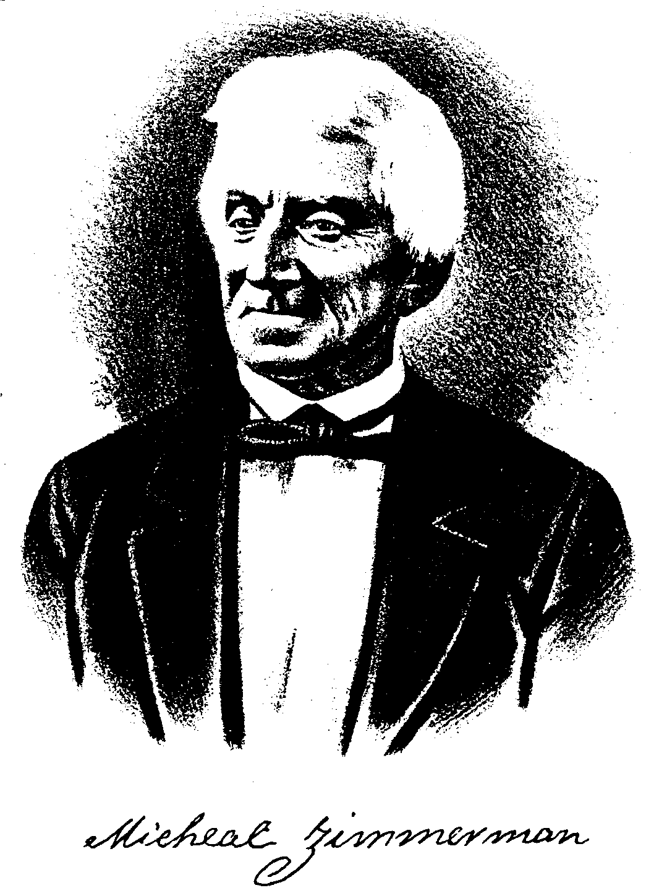
As a sidelight, according to Cockley, Jacob Zimmerman (d. 1835) had settled in Berlin, southern Somerset County in 1793. He may have been the family link between the Berlin and Stoystown congregations. This bricklayer bought the Henry Beam farm near Somerset under the patent name “Carpenter Hall” in 1801 for 110 pounds sterling. He. His wife Mary, and some of the 10 children are buried in the Horner Farm Cemetery. According to Welfley, this Jacob and his brothers [John?] Adam and Michael, Jr., were sons of [Johannes] Michael and had come to Somerset County from Juniata County. Unless they had come “through” Juniata, which is considered the “northern route” [now U.S. Rt. 22] to Pittsburgh and the west, this seems to conflict with Brant, who implies that the brothers came directly to Somerset from eastern Pennsylvania via the “southern route” [U.S. Rt. 30/31]. Jacob was the great-grandfather of one of Somerset County’s most famous sons, Daniel Burnside Zimmerman, whom we will cover in a minute. He was a “42nd cousin” to our Great-great grandmother Elizabeth.
Our Michael, Jr., born in Lancaster County, and wife Elizabeth were married in York before moving to Quemahoning Township where they raised nine children: Elizabeth (1783), the relative in question, Magdalena (1785), Susannah (1790), Nancy (1794), Michael III (1798-1879) [although sometimes referred to as “Jr.” because of his grandfather being Johannes Michael], David (1800), Joseph (1802), Daniel (1805), and Catherine (1808). According to Koontz, Michael, Jr. purchased “a large tract of land” from pioneer Daniel Stoy Their farm consisted of 300 acres adjoining his father’s “Richland.”
We know very little at this time of the oldest child and possibly our great-great grandmother, Elizabeth. We know that her middle name could have been Catherine, after family tradition, although her youngest sister is Catherine. Koontz writes in some detail about her brother Michael III, saying that he married Catherine Koontz [relative?] in 1820 of Brothersvalley Township, near Berlin, and they moved to their own farm in Quemahoning Township, which went to his son, John H. (b. 1830). In his lifetime, Michael III was a magistrate, a county commissioner, a state legislator, and a county judge. He also had a daughter Elizabeth, but she died prior to Koontz’ publication, 1906. Could she, having died in 1895, have been our Elizabeth C. [Zimmerman] Miller?
Finally, a word about cousin Daniel Burnside Zimmerman. The Waterman publication describes him as, “One of the most enterprising and successful men of affairs in western Pennsylvania, perhaps [contributing] in a larger degree than any other to the industrial and commercial development of Somerset County through his labors as one of the pioeers and principle factors in the opening up of its vast coal fields” (535). His grandfather, John, was the grandson of our Hans Michael (c. 1680-1740). His grandmother was Susanna Blough, and her father, Christian Blough, was known as “Big Christ” for his faith and stature. Daniel’s father was Jacob J. and his mother was Sarah J. Stuft, the daughter of Daniel Stuft, county superintendent of schools and judge, for whom he was named. The younger Daniel attended Easton Business College in Poughkeepsie, New York, and taught public school at the tender age of 17. He became engaged in the livestock business, cattle, horses, and sheep. In 1892, while visiting the prairies and Badlands of the Dakotas and Montana he negotiated with the Native Americans to begin cattle ranching on a large scale. Waterman calls him “one of the most extensive and successful rangers in the West. For more than 10 years he has numbered his cattle and sheep by the thousands, extending his operations from his original field, North Dakota and Montana, to Idaho, Washington, Oregon, California, Nevada, Utah, Wyoming, Nebraska, and Texas” (538).
By 1899 he had was the first Somerset County man to open a coalmine locally. For years he employed hundreds of men in deep mines and expanded his business operations to include timber, grist milling, and farming. In 1915 he commissioned an enormous personal residence on a hill adjacent to the Somerset County courthouse, the highest one in the Commonwealth. The Georgia manor still stands today as the showpiece at the entrance to an outlet mall and is on the National Registry of Historic Places. While some call it “pretentious,” others call it a national treasure. Its façade is available as a “Cat’s Meow Village” ornament. One can tour the dozens of rooms and see the elegant bathrooms and elaborate fireplaces at the mansion by either reserving a room through the “Inn at Georgian Place” or arranging a visit at WWW.EXPERIENCEPA.
This visit with the various Zimmermans has taken us from rural Germany of the 17th through the opulence of the early 20th century to the pride in our heritage of the 21st century. Not all the pieces have come together just yet, but that’s what makes genealogy exciting. Someday we’ll find the correct placement of Great-great grandmother Elizabeth C. Zimmerman in our family history, but until then, the fun is in the discovery.

Works Cited

Brant, Jacob. “Michael Zimmerman, the Pioneer.” Laurel Messenger May 1962: 4.

Cockley, Eber. “Notes on Johann Jacob Zimmerman.” Laurel Messenger May 1970: 6.

History of Bedford, Somerset, and Fulton Counties, PA. Chicago: Waterman, Watkins, and Co, 1884.

Koontz, William H. History of Bedford and Somerset Counties, PA. (3 vols.). New York: Lewis Publishing Co., 1906.

Welfley. History of Somerset County. [Publisher unknown], 1906.

