E-Gen: Baer
12/18/03
Somerset County, PA’s Famous Baers
By
Larry Pearce

In our introduction to this series [see Introduction to the Christian and Elisabeth Baer Family], we categorized the Baers of Somerset County, Pennsylvania, into the northern Baers of Conemaugh Township, from whom my wife Susan is descended, and the southern Baers of Berlin, Brothersvalley Township, about whom this article is written. We concluded by saying that research is ongoing and that we believe a familial connection will eventually be made when pre-1800 German and Swiss sources can be consulted. In this story, however, I’d like to go beyond the abstract of the introduction and share the information of two fascinating sources: History of Bedford, Somerset, and Fulton Counties, PA (1884) and William H. Koontz’ History of Bedford and Somerset Counties, PA (1906). Fortunately, they are both still available in rebound editions in many public libraries in the Commonwealth. I am happy to include a sketch of perhaps our most famous Baer.
The earliest Somerset County Baer was Christopher, of Zweibrucken, Germany. His wife, Catherine Wingert, was from the small village of Brockweiler in the same district. Together they sailed to America from Rotterdam aboard the “Phoenix” in 1743. Christopher took the oath of allegiance in the colonies to England’s King George on the last day of September that same year, after he had settled in White Hall Township, Lehigh County, Pennsylvania (near Unionville). According to Koontz, “He purchased some eight tracts of land, [including] one for each of his children, who were married, as follows: Melchoir, John, Henry, Salome, Appolonica, and Jacob” (26). The youngest, Jacob (b.1761), who had married a Miss Findlay (who died before 1790) and raised four children, eventually moved west to Mount Savage, Allegany County, Maryland, around 1800. By then he had remarried, Mary Elizabeth Hersch, to whom he had four more children. Mount Savage is almost directly south of Berlin, Somerset County, perhaps 25 miles, so it’s not hard to imagine that Jacob and Mary’s second son, Solomon (1795-1882), would find his way north to Brothersvalley Township, another prominent German-American settlement and one of the sites of the Whiskey Rebellion, which President George Washington was forced to quell by calling his newly organized federal troops. Ironically, Solomon served many positions in the local militia from captain to brigade inspector. This, according to tradition, was one of the same units against whom Washington’s men fought to enforce the corn whiskey tax forty years earlier.
Solomon married Anna Maria Baker in 1820 and they raised nine children on a carpenter/cabinetmaker’s wages. According to the autobiography of their fourth child, Herman Ludwig (b.1828), Solomon moved his family in1842 further north to a farm about four miles from Somerset, the county seat. Solomon was to sell that farm within the next decade and move even closer to Somerset. Perhaps it was his advancing in years, but Herman says, “The idea of [my] going to college was frequently talked of and when it was finally decided that I should go, I left the plough standing in the field where I had been ploughing on Saturday evening and left for Franklin and Marshall College, Mercersburg, in 1848” (Koontz 27). So, it seems that education was important to the Baer family. We know that later Solomon served his community as constable and justice of the peace. This was a fitting prelude to the service that several of his sons would pay to the legal profession. Solomon lived to be 87 years old. Anna Maria died in 1888 at the age of 91.
Herman graduated in 1853 after taking several winters off to teach back home and “raise some funds.” His first full time charge was the Elmwood Institute in Norristown, PA. After several years he returned to Somerset to study law under his brother William Jacob (1826-1908). He was admitted to the bar in 1856 and they formed the partnership of Baer & Baer, which ended with the election of his brother to the 16th Judicial District of Pennsylvania in 1881. Herman married Lucy Schall, whom he had met while working in Norristown. Her father, General William Schall, was an ironmaster and leader in the state militia. Herman’s wife died the year his brother was elected judge, and he remained a widower, raising his five children for eight years before marrying his sister-in-law, Annie. He described himself as a “Jeffersonian Democrat and was never an aspirant for office, but could always give a reason for my faith religiously and politically. I have always tired to do my duty conscientiously” (Koontz 28). His family belonged to the German Reformed Church where he was a Sunday school superintendent and elder for 50 years. His oldest daughter, Caroline Trexler Baer, married George Scull, a well known Somerset newspaperman, attorney, and banker. Herman’s son George was a newspaperman, postmaster, and mine superintendent. Another son, Rueben, became a printer, while the youngest son, Hermanus studied to become a pharmacist but, after graduating from Philadelphia’s Jefferson Medical College, moved to New York to become a physician and professor of anatomy. He married Mabel McKinley, whom may have been a niece of U.S. President William McKinley, since his brother lived in Somerset.
Herman’s oldest brother, William Jacob (1826- ) was born in Berlin. According to the Waterman account, which was written by fellow judiciary G. H. Spang, Judge Baer moved “with his parents from the town to the country” at age 12 (419). This confirms Herman’s autobiographical story of locating closer to Somerset. In his most flowery language, Spang relates, “He did not, however, like [Noah?] Webster, when told to hand his scythe, hang it upon a tree, but swung it as other laborers did when called upon to cut a fair swath in an open field.”
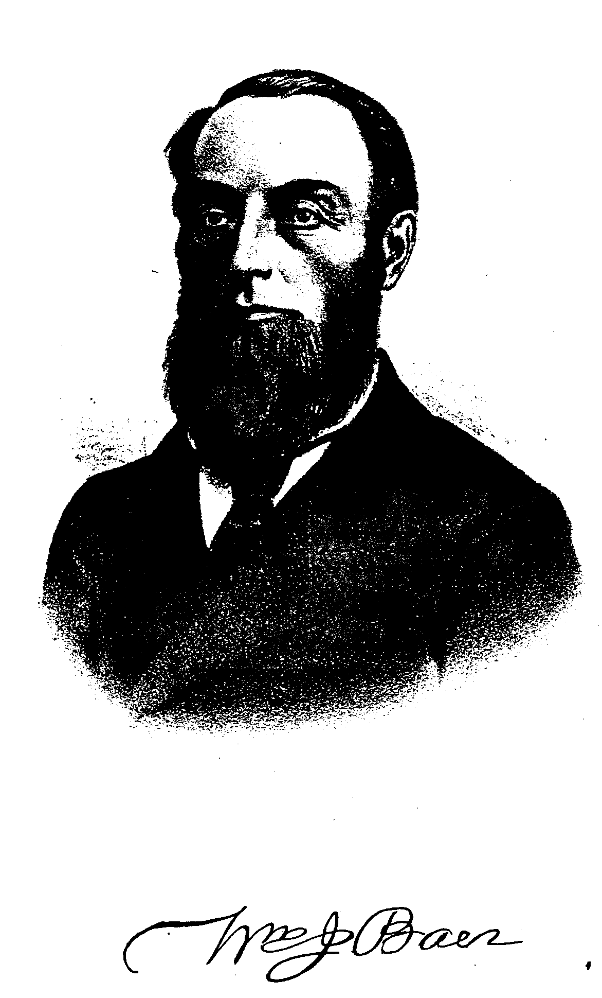
This 1884 account reveals much about the everyday life of young men in late 19th century rural Pennsylvania:
Judge Baer received his early education in the common schools of the county. He was a regular attendant at these in the locality where he lived; but they afforded comparatively limited opportunities for study as neither the classics nor even the higher branches of an English education were prescribed in the course of instruction. Before coming of age he taught school for two terms, and again engaged in teaching for one year after he attained his majority. During these periods he diligently availed himself of all the means of improvements within his reach and thus added continually to his scanty stock of knowledge. His habits of study in those days were methodically and accurately formed and in a large degree aided in the development of his naturally vigorous mind. The motto of a once celebrated painter, Nulla dies sine linea, was the one adopted by him for his daily practice. For two years he served as clerk in a country store at a meager salary. Subsequently he began his academic studies as astudent at [Franklin and] Marshall College, then located at Mercersburg. (Koontz 420)
William had to drop our of F & M for what Spang says were “home duties and life’s immediate demands.” His biographer believed that this caused him great “conflict” but that he somehow felt responsible to help with his large family back at the farm. But his studies of the law continued almost immediately in Somerset under F.M. Kimmell, and it wasn’t long before he passed the bar exam and he was admitted to the courts of the county.
William partnered with his teacher, but when Kimmell was elevated to judgeship, he found himself alone at the firm. Spang describes his abilities this way:
He had a most accurate perception of the bearing of all testimony offered, and rare powers for the examination and cross-examination of witnesses. One of the most searching, exhaustive and annihilating cross-examinations it was ever the writer’s privilege to listen to, in an experience of nearly thirty years, was his of a couple of imported perjured thieves brought up from Baltimore to testify for the defendant in a case of the Commonwealth vs. Robert Morris, indicted for burglary, many years ago in Bedford County. Before he was done with them the jury and everybody else in the courtroom were satisfied that the rascals were lying. The quick verdict of guilty which followed was the result of his effort then, His plain statement of facts, close attention to the law, logical reasoning, and clear, clarion voice, made hi with almost supreme power before a jury. (Koontz 420)
Some historians believe that Somerset County in that time and place was of almost 90% German origin, and both German and English were commonly spoken in the streets. One of William’s unusual abilities that Spang points out is his equal command of both languages:
By diligent study [he] made himself master of the [German] language so that he could write and speak it with ease and fluency. This, in a community where the German language was generally spoken, gave him another strong hold upon the hearts of the people, and a decided advantage over others of his English-speaking brethren of the bar. (Koontz 420)
William was often engaged by other courts, including the Supreme Court of the Commonwealth. Furthermore, Spang praises him as a “valued, generous, and public-spirited man.” Another source indicates that he had an interest in the timberlands of Ogle and Paint Townships around 1848. This area near Ashtola Mills was later purchased by Babcock Lumber and today is named for that philanthropist.
Perhaps one of the most dramatic accounts involves his election to the 16th District Court in 1881. A Democrat, he had been selected as a delegate to the state’s constitutional convention that met in Philadelphia nine years earlier. As is the case today, Somerset County was primarily Republican, so Democrats were the minority. His Republican opponent in the race for the judgeship was considered “invincible.” Spang recalls:
The election of Judge Baer was scarcely hoped for, and yet, with his own county usually republican by from ten to twelve hundred majority, he so greatly reduced it and the opposition vote in other parts of the district as to secure his election and win a victory which was little less than a surprise to his most sanguine friends. (Koontz 421)
William went on to become the President Judge of the district and retired with honor. He died in 1908 and is buried in the large Union Cemetery on the hill overlooking his beloved Somerset County courthouse, the highest such building in Pennsylvania.
Many other famous Baers contribute to live in our Commonwealth and country, although we are not aware of any family relationship. Max Baer won the judgeship of State Superior Court in November 2003. He is from the eastern part of the state. And another William J. Baer just retired as Secretary of the Federal Trade Commission. We have seen these men often in the news are proud of the public service they have accomplished and the honor they have brought to our families. We will continue to research other Baers.

Works Cited

History of Bedford, Somerset, and Fulton Counties, PA. Chicago: Waterman, Watkins, and Co, 1884.

Koontz, William H. History of Bedford and Somerset Counties, PA. (3 vols.). New York: Lewis Publishing Co., 1906.

