Michael Zhao (Peng Zhao)

Tel: (416)363-2279 (H)

E-mail: michaelzhao@hotmail.com
Website: www.mikezhao.com

Professional Objective

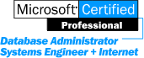
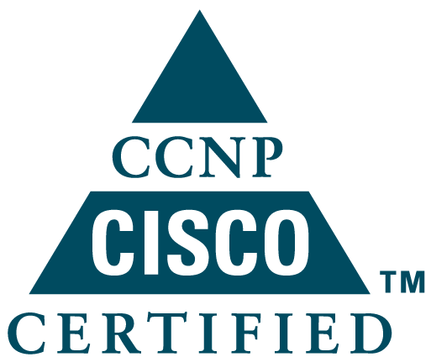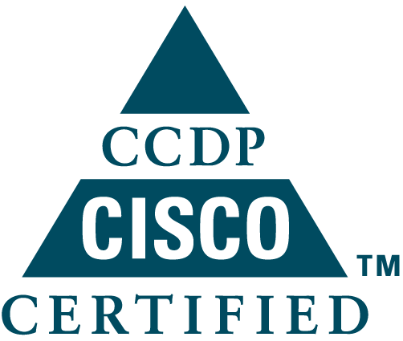Seeking further challenges as Network Engineer or related position.

Career Summary
8 years work experience in IT area, Microsoft Certified System Engineer + Internet (MCSE+I) & Microsoft Certified Database Administrator (MCDBA), Cisco Certified Network Professional (CCNP), Cisco Certified Design Professional (CCDP), good at installing, configuring, and operating LAN, WAN, and dial access services with Cisco productions, good at designing, implementing and supporting solutions with Microsoft & SUN products, expert in LAN and WAN administration. A team player with strong skills and abilities to work independently with minimal supervision.

Work Experience
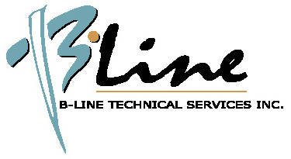

B-Line Technical Services Inc.
—— Toronto, Canada, 1999.10 ~ Present
Company Profiles
BTSI (B-Line Technical Services Inc.) currently has technical presence in more than 70 cities across Canada, delivering fast, reliable, and cost effective IT solutions that contribute to customers' success, servicing clients such as, Bridge Information Systems Canada, Translux Canada, and Versus Brokerage.

Remote Support Engineer (1999.10 ~ Present)
- Technical support Dow Jones Telerate products and Network equipment. (RSL, XMC, PDX, CPX, etc.)
- Technical support and troubleshooting based on X.25, Frame Relay and other WAN network. (SNA, SDLC, X.25, TCP/IP, Datapac, etc.)
- Technical support and troubleshooting based on Microsoft Windows NT/Windows 95 & SUN Solaris system on Ethernet or Token Ring LAN network.
- Remote support technicians on site doing troubleshooting and new installation.
- Remote support customs fixing general computer problem and providing operation training.
- Create department documentation.




Bridge Information Systems Canada Inc. (formerly Dow Jones Markets Canada Inc.)
—— Toronto, Canada, 1997.12 ~ 1999.09
Company Profiles
Bridge is the largest provider of financial information and related services in North America, and the second largest, fastest growing provider in the world.
Dow Jones Markets, Inc. is a leading supplier of real-time prices, news, market commentary, trading room systems and decision-support products to traders, dealers, brokers and other market professionals around the world.

Remote Support Team Leader (3 months experience, 1999.07 ~ 1999.09)
- Training team members.
- Escalation point for trouble tickets and sales orders.
- Administer team inbox.
- Assign work to team members when required.
- Assist field technicians.
- Maintain working knowledge of company products.
- Create department documentation.

Intermediate Remote Support Engineer (2 years experience, 1997.12 ~ 1999.06)
- Extensive knowledge of all Dow Jones products and Network equipment. (RSL, XMC, PDX, CPX, etc.)
- Technical support and troubleshooting based on X.25, Frame Relay and other WAN network.
- Technical support and troubleshooting based on Microsoft Windows NT, Windows 95 system on Ethernet or Token Ring LAN network.
- In depth knowledge and familiarity of 3270 addressing control units and devices.
- In depth knowledge of SNA host addressing, Pu’s and Lu’s.
- In depth knowledge of ATM, Frame Relay, 3270, X.25 and ASYNC protocols.
- In depth knowledge of and use of various gateways, bridges and routers.
- In depth knowledge of various terminal emulators and communications software and their applications.
- Perform new installation projects for client.
- Remote support technicians on site doing troubleshooting and new installation.
- Remote support customs fixing general computer problem and providing operation training.


Science & Technology Development Department of Beijing University of Aeronautics & Astronautics (BUAA)
—— Beijing, China, 1993.4 ~ 1997.7
Company Profiles
This company is responsible for developing and providing leading technologies for the applications on airspace and aircraft. It provides advanced computing environment for teachers and students to proceed with project development and science calculation.

Network Administrator & Engineer (3 years experience, 1994.6 ~ 1997.7)
- Computer hardware & other peripherals purchase, assemble, configuration and repairs (motherboard level).
- Designing network's layout, cable construction and connecting network components.
- Full support of network equipment including network adapters, hubs and modems with driver installation and system configuration.
- Performed system software installation, configuration, upgrades and technical supports of Novell (3.11), Windows for Workgroups (3.11), Windows NT (3.5, 3.51 and 4.0), Windows (3.0, 3.1 and 95), MS Mail, IIS (2.0 and 3.0), Internet applications and Desktop applications.
- Testing network connections, providing advanced performance tuning, troubleshooting and diagnostics.
- User Account administration, securing the system and configuring the system environment.
- Provided high standards of technical support services and training to clients over the phone or in person.
- Administration of MS SQL Server, performed backup and archived critical data for the clients.
- Internet Web Site Server (IIS Server 2.0 and 3.0) setup, administration and DNS Server configuration.
- Home Page development in HTML, Java Script and VB Script.
- Support the following products and technologies: TCP/IP, IPX/SPX, NWLink, NetBEUI, Hub, Modem (Hayes), Scanners (HP) and Printers (HP & Epson).
- Strong knowledge of Linear Bus, Token Ring, Star Bus, Star Ring, X.25, Frame Relay, ATM, ISDN and FDDI.
Computer System analyst (1 year experience, 1993.4 ~ 1994.5)
- User requirement definition and application analysis.
- Write requirement specifications for computer programs and program.
- Test and debug the programs.
- Provide user training and maintain the databases and programs.
- Experience in design and development with following technologies: Visual Basic, FoxPro and FoxBASE+.

Education
1990.9 ~ 1993.3
- Master of Science, major in Computational Fluid Mechanics, Department of Flight Vehicle Design and Applied Mechanics, Graduate school of BUAA.
- Bachelor of Science, major in Applied Mechanics, Department of Mathematics, Jilin University.
1986.9 ~ 1990.7

Certifications
- Cisco Certified Network Professional (CCNP) certification achieved July 19, 2001.
(Cisco ID: csco10171682)
- Cisco Certified Design Professional (CCDP) certification achieved Jun 20, 2001.
(Cisco ID: csco10171682)
- Microsoft Certified Database Administrator (MCDBA) certification achieved Dec 28, 1999. (Microsoft Certified Professional ID: 414838)
- Microsoft Certified System Engineer+Internet (MCSE+Internet) certification achieved May 28, 1999. (Microsoft Certified Professional ID: 414838)
- Microsoft Certified System Engineer (MCSE) certification achieved April 28, 1997.
(Microsoft Certified Professional ID: 414838)
- Computer System Engineer conferred by BUAA in December 1994.

Computer Experience
- Kasten Chase X.25 Gateway XMC, PDX and switch CPX.
- VT100, 3270DSP, 3287DSI, 3270DSP83 and 3270SNA emulation.
- IBM 3270 main frame, VAX machine and SUN Solaris.
- CISCO, 3Com, Bay Network, Linksys Router and Hub.
- Windows NT 2000/4.0/3.51, Windows for Workgroup 3.11, Novell 3.11, Windows 95/98, Windows 3.1, MS-DOS.
- Microsoft Internet Information Server/FTP Server, Microsoft Index Server, Microsoft FrontPage, Microsoft Proxy Server, Microsoft Exchange Server, Microsoft DNS Server, Microsoft Terminal Services Server.
- Sun Solaris SunOS 5.6, 5.7, 5.8.
- HTML Language, Java Script, VB Script.
- Visual Basic 5.0, FoxPro 3.0, SQL Language, FoxBASE+ 2.10, FORTRAN.
- Microsoft Office, WordPerfect, PhotoShop, Microsoft Internet Explorer, Netscape Navigator.

Professional Training
I have finished following professional training and passed the following Cisco certification exams:
- Interconnecting Cisco Network Devices
- Designing Cisco Networks
- Building Cisco Multilayer Switched Networks
- Building Scalable Cisco Networks
- Building Cisco Remote Access Networks
- Cisco Internetworking Design
- Cisco Internetworking Troubleshooting Support

I have finished following professional training and passed the following Microsoft certification exams:
- Implementing and Supporting Microsoft® Windows NT™ Workstation 3.51
- Implementing and Supporting Microsoft® Windows NT™ Server 3.51
- Implementing and Supporting Microsoft® Windows®95
- Networking with Microsoft® Windows™ 3.1 Exam
- System Administration of Microsoft® SQL Server™ 6.5
- Microsoft® TCP/IP for Microsoft Windows NT™ Exam
- Implementing and Supporting Microsoft Internet Information Server 3.0 and Index Server 1.1
- Implementing and Supporting Microsoft Internet Information Server 4.0
- Networking Essentials
- Implementing and Supporting the Microsoft® Internet Explorer Administration Kit for Microsoft® Internet Explorer 4.0
- Internetworking with Microsoft® TCP/IP on Microsoft® Windows NT™ 4.0
- Implementing and Supporting NT™ Server 4.0
- Implementing and Supporting NT™ 4.0 Workstation
- Implementing and Supporting NT™ Server 4.0 in the Enterprise
- Implementing and Supporting Microsoft® Proxy Server 2.0
- Implementing and Supporting Microsoft® Exchange Server 5.5
- Administering Microsoft® SQL Server™ 7.0
- Designing and Implementing Databases with Microsoft® SQL Server™ 7.0

