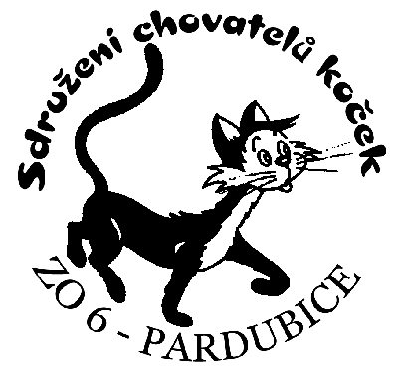

Féderation Internationale Féline
ČSCH - SCHK ZO 6 Pardubice

We would like to invite you to the Pardubice (CZ) up to

Internacional cats show

Memorial Dagmar Winklerove
23. 10. 2004
in the Sokol house Na Olsinkach
(beside outdoor swimming pool)

Judges:
Mrs. MVDr. Kveta Mahelkova (CZ) I-IV, Mr. Ing. Bohumir Mahelka (CZ) I-IV, Mrs. Jitka Kytlerova (CZ) I-IV, Mrs. Berta Nemcova (CZ) I-IV, Mrs. MUDr. Marie Rihova (CZ) I-IV, Mr. PharmDr. Martin Kabina (CZ) I+III+IV, Mr. Louis Coste (F) I+III+IV, Mrs. Maria J. Rechowicz (PL) I

Please send your filled-in entry forms with a stamp from your organization and a cheque for the entry fee to the address below. You can enclose also the text of your advertisement. In such case add the cost of the advertisement to the entry fee. Please, observe the closing date for entries.

Mgr. Dagmar Pribylova
Ruska 244
565 01 Chocen
Czech Republik
tel./fax: +420 - 465 472 859
e-mail: adikia@sendme.cz

Closing date for entries: 6.10.2004
Cancel entry form only to the closing date.

Entry fee:
Class 03, 05, 07, 09 | 30,-EUR
Class 01, 02, 04, 06, 08, 10, 11, 12, 13 | 25,-EUR
Class 14, 15, 17 | 20,-EUR
Class 16 (double cage) | 30,-EUR

Féderation Internationale Féline
ČSCH - SCHK ZO 6 Pardubice

We would like to invite you to the Pardubice (CZ) up to

Internacional cats show

Memorial Dagmar Winklerove
23. 10. 2004
in the Sokol house Na Olsinkach
(beside outdoor swimming pool)

Judges:
Mrs. MVDr. Kveta Mahelkova (CZ) I-IV, Mr. Ing. Bohumir Mahelka (CZ) I-IV, Mrs. Jitka Kytlerova (CZ) I-IV, Mrs. Berta Nemcova (CZ) I-IV, Mrs. MUDr. Marie Rihova (CZ) I-IV, Mr. PharmDr. Martin Kabina (CZ) I+III+IV, Mr. Louis Coste (F) I+III+IV, Mrs. Maria J. Rechowicz (PL) I

Please send your filled-in entry forms with a stamp from your organization and a cheque for the entry fee to the address below. You can enclose also the text of your advertisement. In such case add the cost of the advertisement to the entry fee. Please, observe the closing date for entries.

Mgr. Dagmar Pribylova
Ruská 244
565 01 Chocen
Czech Republik
tel./fax: +420 - 465 472 859
e-mail: adikia@sendme.cz

Closing date for entries: 6.10.2004
Cancel entry form only to the closing date.

Entry fee:
Class 03, 05, 07, 09 | 30,-EUR
Class 01, 02, 04, 06, 08, 10, 11, 12, 13, 14, 15, 17 | 25,-EUR
Class 14, 15, 17 | 20,-EUR
Class 16 (double cage) | 30,-EUR

Price list for advertising in the show catalogue, format A5

full page | 20,-EUR | half page | 15,-EUR

Rules:
- Show rules are in accordance with the FIFE Exhibition Rules. Exhibitors shall present a veterinary certificate not older than 3 days and the vaccination certificate.
- Required vaccination includes rabbies, panleucopenia and rhinotracheititis not older than one year and not newer than one month.
- White cats must have a veterinary certificate of hearing.

Exhibition programme:

7.00 - | 8.30 | opening times
10.00 - | 15.00 | judging
16.00 - | 18.30 | Best in show
 | 18.30 | end of exhibition



SCHK ZO 6 Pardubice

online reservation
http://schk-pardubice.pc.cz/prihlaska.htm

Price list for advertising in the show catalogue, format A5

full page | 20,-EUR | half page | 15,-EUR

Rules:
- Show rules are in accordance with the FIFE Exhibition Rules. Exhibitors shall present a veterinary certificate not older than 3 days and the vaccination certificate.
- Required vaccination includes rabbies, panleucopenia and rhinotracheititis not older than one year and not newer than one month.
- White cats must have a veterinary certificate of hearing.

Exhibition programme:

7.00 - | 8.30 | opening times
10.00 - | 15.00 | judging
16.00 - | 18.30 | Best in show
 | 18.30 | end of exhibition

SCHK ZO 6 Pardubice

online reservation
http://schk-pardubice.pc.cz/prihlaska.htm

