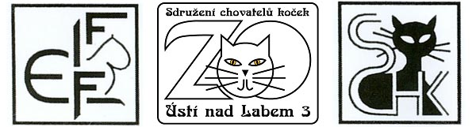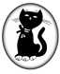
Basic Organisation of Cat Breeders LITVÍNOV
invites you to two

INTERNATIONAL CAT SHOWS
M O S T 2006
13th – 14th May
in the entertainment center “R E P R E“ Most

members of organisations not belonging to FIFe can also partake
classes 1-8 have to sustain certificates gained at FIFe
Application Closure on the 30th April 2006
Applications:
Applications should be filled in readably and confirmed by own organisation. Send them to the following address (as well as applications for stewards):
Jitka SLONČÍKOVÁ
Na Borku 1621
43111 Jirkov, CZ
tel.: +42077074644
fax: +420 474659725
email: sloncik@seznam.cz

Payment of Fees :
Eva PAPEŽÍKOVÁ
Pod Lajsníkem 524/5 / tel: +420731521783 /
434 01 MOST, CZ
Exhibitors from abroad can also pay their entry fee at their arrival.

Registration fees:
one cat / 1 day 30 €
EC / EP, veteran 25 €
homecat and unrecognized breed 15 €
application after dead line 5 €

Exhibiting Conditions
The rules are stated in the code of exhibiting of the SCHK. The exhibitioners themselves can present their cats to the judge. The stewards will be available as well. Participation at the show is at one’s own risk. We are not liable for possible harms. It is not allowed to leave the show earlier. The cages will be arranged in alphabetical order according to the last names of the exhibitioners.
Veterinary Duties
The exhibitioners will show the vaccinal certificate confirming the inoculation against rabies, panleukopenia, and rhino-trachitida. The cat had to undergo the inoculaion one year ago at most and maximally one month before the start of the show. The owners of white cats will show veterinary certificate of an examination of the cat’s hearing.
Judges
Jitka KYTLEROVÁ CZ (I-IV)
MVDr. Květa MAHELKOVÁ CZ (I -IV)
Ing. Bohumír MAHELKA CSc. CZ ( I – IV )
Mr. Louis COSTE F (I -IV)
Mr. Fabrice CALMÉS CH ( I-II)

Sign in: From 7:30am until 9:00 am

Accomodation is not provided – we can suggest Hotel CASCADE right next to the exhibiting hall. Address: Hotel Cascade, nám. VMS 3, 43401 Most, CZ, tel: +420476703250, fax: +420476703137.

We are looking forward to meeting you! The Council of the Show

