To: General Manager Administration
Pharmaceutical Society of Australia
CURTIN ACT

Good Afternoon,

Having taken a look at the criteria posted for your Deputy Editor/Journalist vacancy, I am confident my experience and skills are well-suited to the position. I can state without reservation that:

- I have tertiary qualifications in journalism and six years’ experience in writing (and editing) for magazines, journals and newspapers;
- I have plenty of experience in monthly magazine publishing to non-consumer, member-based markets;
- I have significant experience at both editing and sub-editing;
- I have scientific and health-related writing experience (see examples below);
- In my current position, I research articles on a regular basis, and face-to-face or telephone interviews are an everyday event;
- I have a proven ability to write, edit and organise page layout on screen; on-paper proofreading and editing has been a duty of mine throughout my career;
- I have done photographic work – using both 35mm and digital photographic equipment – for three employers;
- I have never had a problem with deadlines;
- Working co-operatively within small teams and good interpersonal skills have been a necessity throughout my career, as has regular liqaison with senior figures from those bodies we have published magazines for;

The skills and experience which meet your criteria are outlined in the attached resume. I have also included as many examples of my work as allowed by seek.com.au (see below) and can send additional magazine/journal extracts if you wish. In any case, I would very much like to apply for the position of Deputy Editor/Journalist. I look forward to hearing from you soon.

Best Regards,

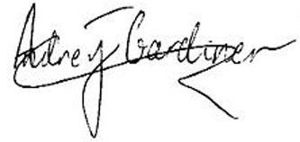25/03/2002

(A BRIEF FOLIO OF MY WORK IS BELOW)

