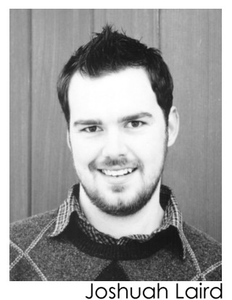
Joshuah Laird
Actor
126 Saint Albans Dr. Height: 6’0”
Henderson, NV 89015 Weight: 185
j_laird.actor@yahoo.com Hair/Eyes: Brown
Cell: 318-623-5916 Voice: Tenor

BA Theatre, Northwestern State University of Louisiana
www.geocities.com/joshuahlaird/actor
Las Vegas Theatre
Mesmerized Supporting Cast V Theater Planet Hollywood Casino
All My Sons Chris Keller CCSN
Adventures of Tom Sawyer Lanyard Bellamy Super Summer Theatre
Take Me Out Jason Chenier Las Vegas Little Theatre
Bells Are Ringing Ensemble Super Summer Theatre

Tours
Robin Hood Sherwood Missoula Children’s Theatre - Europe
Pinocchio Geppetto Missoula Children’s Theatre - USA
Red Riding Hood Big Bad Wolf Missoula Children’s Theatre - USA
Treasure Island Long John Silver Missoula Children’s Theatre - USA

Film
Skull Diamond Rick (Lead) Captured Entertainment, Las Vegas

Troupes
“Out on a Limb” Improv Troupe Natchitoches, LA
“Shakesperience” Tour Northwestern State University

Special Skills
Improvisation Skills Basic Stage Combat Moves Well
Quick with Dialects Photography Experience with Firearms and ATVs
Computer Skills Map Reading Valid Driver’s License and Passport

References available upon request.

