The Bateleur Eagle has stranded

The 27 June 2008 Zimbabwe 'Elections'

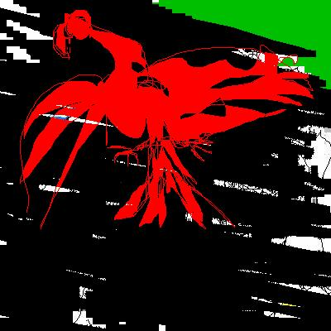

JOOP BERSEE

Contents

Mugabe, Time
War Veterans
Dog
What about Doreen Mapfumo
South Africa
Eric Matinenga
Godfrey Mashaka
26 June 2008
Emphatic
Impunity

COPYRIGHT © 2008 JOOP BERSEE

The author allows you to reproduce one copy for personal use only.
Not for further distribution as a whole or any part thereof.

Mugabe, Time

Soon you will be the target,
snails, ants sodomising you
in your glorious presidential
coffin suite, six feet below
torture level where bodies
multiply into rats, to eat.

Your face
with the arse crack ‘stache
is fading, your individuals urging you
to stay on as insurance against
the loss of their ill-gotten
wealth.

But first – Chipiro, wife of
the head of opposition party
in Mhondoro district,
they chopped off one of her hands,
both her feet. They threw her
into her hut, burned her alive.

Yes, at night there is plenty
of light. Flames walk a few metres,
become beacons where ideas,

Tsvangirai’s,
are born against
the tide,

lasting moments,
monuments. You,
disgrace.

War Veterans

War veterans
war veterans
youth militia
yesterday

war veterans
escorted by police
you raided
looting goods

war veterans
Nazi’s
war veterans
the word forever soiled

maize, cabbages
they steal our goods
then want us to vote
for Robert Mugabe

21 June 2008

Dog

Say it
Say it.

For 16 hrs
they made her call
the opposition leader
a dog a dog a dog

peeing
on her face
whipping sjamboks
raping her

in Teddy Garakara’s
house
Zanu-PF district
chairman.

Teddy will be taken,
sooner or later,
by the sound
of a hand
not knocking.

What about Doreen Mapfumo
What about Doreen Mapfumo,
8 months pregnant.
They beat her stomach,
burned her house
down, 'cause Amos
Midzi told them. That’s
how we and your great-
grandchildren will
remember you, Amos.
A woman. Unborn
child. Not by your hand,
but by your mouth.
Puppet. Mugabe’s
hand is up your arse.
And you smile and smile.

South Africa 32 seconds

the most powerful country in sub-Saharan Africa
quiet
q u i e t
q u i e t
q u i e t

MBEKI plays the xenophobic,
misreading Zimbabwe,
appallingly
out of tune.

Out of his office window
the smell of manure,
the green light
for Zanu-PF
green flies.

‘No, Thabo,
ANC and Zanu-PF
were never great allies.’

Silence
Ecnelis
(Fade)
(Fade)
(Lives)

(…………………………

Eric Matinenga

Eric Matinenga refused to bribe,, local officials
bars in a cold, cramped cell
without his glasses, shoes or socks
tattered beige prison uniform
wardens do not feed their prisoners
this is common. no money
relatives travel a two-hundred mile round trip almost daily
they carry more food than he needs so
he can share it with the other inmates
magistrates run from his case.

Godfrey Mashaka
Godfrey Mashaka’s 70
year old body
was dumped.
His wife and son were
beaten, heavily.
Chickens looted.
Chief Superintendent
Oliver Mandipaka
finds the situation
so good
and so calm.
He hopes
that the people of Zimbabwe
will maintain
the peace
even after
the elections.

26 June 2008
It is quiet
quiet, no more diplomacy.
South African President Thabo Mbeki's
office crumbles, faster than
rainforests can disappear.
It’s his impotence to be a force,
president, understand,
to be a country.
HIV/AIDS, Robert Mugabe.
Thabo is ignoring calls
for stronger regional diplomatic efforts.
Man and weak leader,
Robert is no longer your
broad bride. His tongue
has been unfaithful,
assassinating human rights, voting souls.
Stop sucking the arse of this
cunt, gangrene of depredatory veterans.
You refuse to admit,
to recognise, to see, to feel
as hunger and hope gather;
wives clean and cook rats,
roots in muddy water.
Grateful intestines flock together
sharing the love of the smell
of bread, milk and honey.

26 June 2008

Emphatic

The bruises

blood

on her body

were her permit

to vote again

for change.

Impunity
Dictators like Mugabe
do not step down.
Like Hitler, they
go on and on
till their country
is in ruins
and their people
are in rags,
dragging food
and soil and
people into their
stinking graves.
But foundations
of houses burned
to the ground
can slumber like
permafrost below the
sand, awaiting their
laborious, manual
resurrection.
28 June 2008

