Prepared for the Conference: Water Resources & Environmental Problems in Karst, Beograd & Kotor,
Serbia & Montenegro, 14-19 September 2005.

Ground Water Assessment in Karstic Environment of Planicie Costera Oriental of the Dominican Republic

Author: Dr. Jasminko Karanjac, Consultant Hydrogeologist and Professor (ret.)
e-mail: karanjac@eunet.yu

ABSTRACT

The Dominican Republic has about 8.7 million population. Most of this population lives in the coastal area in the south, from the capital city of Santo Domingo to prime tourist resorts Bavarό and Punto Cana in the south-east. This area is known as the Planicie Costera Oriental (PCO, Caribbean Coastal Plain)). This coastal plain is 10 to 40 km wide, up to 200 km long, and consists of a series of limestone terraces that gradually rise to a height of 100 to 120 m at the foothills of the Cordillera Oriental. A larger part of this plain has all the features of a karstic environment. The ground water system here is extremely vulnerable from (1) seawater intrusion due to excessive abstraction, and (2) contamination of ground water by sewage, industry (notably sugarcane fields irrigation), and tourism. This is the prime area for development of tourism, but there is also a heavy demand for water for agriculture, industry and domestic use.

The Ground Water Information System (GWIS) created for PCO in 2003 was used to analyze the impact of a proposed new groundwater development in the Brujuelas-Casui area, a project that calls for additional abstraction of about 1 m³/s from wells to be located within 20 km of the coast. This development is within the administrative unit known as Distrito Nacional in which alone there are reportedly more than 1200 wells. The GWIS points at nonsustainability of such a project due to already mentioned seawater intrusion, declining water levels which are at most about one meter above the sea level, and evidence of ground water contamination with pathogens (E.Coli and Pseudomonas). The latter results from karstic nature of the limestone aquifer, that is extremely transmissive, without protection from the surface. The entire environment is very vulnerable and fragile.

This paper results from the author’s study titled “Re-assessment of Ground Water Resources in the Dominican Republic,” which he prepared in 2003 under a US AID project "Dominican Republic Environmental Assessment.” The author worked in that country in 1991, 1994, and in 2002-03 periods.

1. Introduction

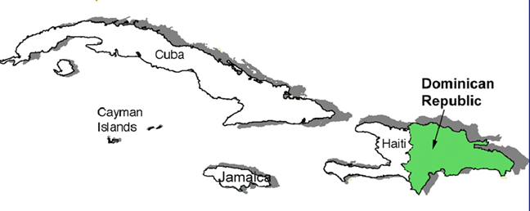
The Dominican Republic shares the island of Hispaniola with Haiti (Fig. 1). Water availability in the Dominican Republic per capita is estimated at about 2,500 m³/yr. One third of this is ground water. However, major aquifer systems, notably along the coast, are either overabstracted, polluted, or both. The map in Fig.2 shows the location of wells (red dots) currently in the GWIS established for the southern and eastern part of the Dominican Republic. The area shown is known as the Planicie Costera Oriental (PCO). In English, it translates to Oriental or Caribbean Coastal Plain. This plain is 10 by 40 km wide, 200 km long, and consists of a series of limestone terraces. It is a fragile coastal environment. The ground water system here is extremely vulnerable from (1) seawater intrusion due to excessive abstraction, and (2) contamination of ground water by sewage, industry (irrigation of sugarcane fields), and tourism.
Figure 1. Location of the Dominican Republic.

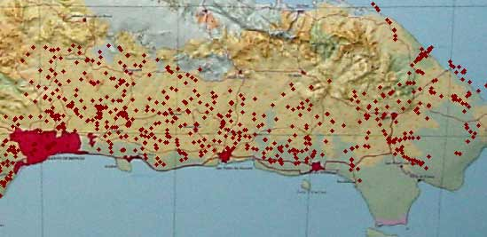
Figure 2. Wells in Planicie Costera Oriental.

In spite of evidence of seawater intrusion, fragile limestone environment that is “protected” with very thin soil cover, evidence of overabstraction and damage to limestone aquifers, CAASD, the metropolitan water and sewerage corporation of Santo Domingo, is pursuing a new ground water development project in the Brujuelas-Casui area, a project that calls for additional abstraction of about 1 m³/s from some 24 new wells to be located within 20 km of the coast.

The available information indicates that between years 1980 and 1998 the annual demand of the water resource for domestic uses became almost five times greater: from 287 million cubic meters (MCM) to 1,450 MCM. In the agricultural-fisheries sector the increase of the demand has been similar (from 2,123 MCM in 1980 to 7,700 MCM in 2000) in approximately the same period.

There are many thousand wells in the Dominican Republic. In Distrito Nacional alone, that is in the wider Santo Domingo area, there are over 1200 wells. Most of wells are located in the coastal areas (especially east of Sto Domingo, in Planicie Costera Oriental [PCO]).

In 1997, with financial assistance from the European Union a major ground water assessment project was undertaken by an Italian firm, AQUATER. The project, which lasted from May 1997 through February 2000, had the following objectives (not all are listed below):

- Better knowledge of hydrogeology in six selected areas including the PCO.
- Creation of basic instruments for a correct management of water resources.
- Definition of the magnitude and importance of the phenomena of seawater intrusion.
- Production of various thematic hydrogeological maps at scale 1:50,000 for each one of the six selected areas.
- Mathematical modeling of surface and ground water.
- Quantification of available water resources, of water supply and actual water demand balance.

Under another EU initiative and financial grant, the ground water assessment was extended to the remaining part of the country (north, north-west and north-east). By the end of 2005 it is expected that ground water information will be available for the whole country.

2. Geology and Hydrogeology of PCO

Violet areas, primarily along the coast, are the prime areas of fresh ground water occurrence and development (Fig. 3). Light-blue areas are Quaternary deposits. The most prominent aquifers are in the Planicie Oriental Costera to the east of Santo Domingo.
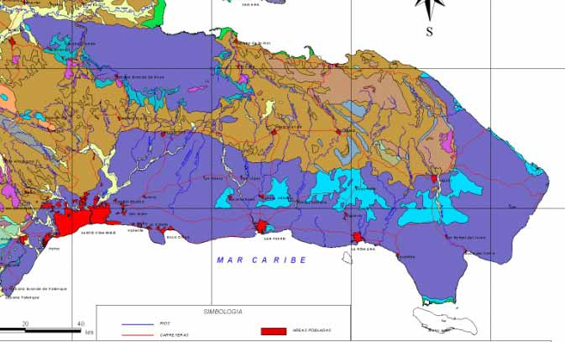
Figure 3. Geologic Map of Eastern Part of the Dominican Republic. Shown in dark blue and violet are limestone rocks.

In Fig. 4, dashed lines identify the areas of intensive karstification, while dotted areas show the extension of current seawater intrusion. Porosity of limestone is visible wherever one goes. Houses, roads, walls and street fences, etc. are all made of extremely porous limestone as shown in Fig. 5. The limestone reef along the entire coast is extremely well fractured and corroded, although this was enhanced by seawater abrasion.
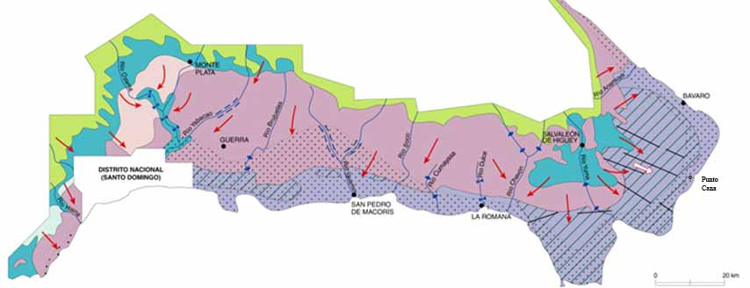
Figure 4. Hydrogeologic Features of Planicie Costera Oriental.

The country has both reef and karstic limestone as represented in Fig. 4. Karstic limestone allows water to move rapidly between the surface water and ground water environments via fractures, sinkholes, solution valleys, and caves which serve as conduits for potential contaminants. This rapid movement creates a high potential for surface contaminants to pollute large volumes of ground water in a short period of time. Any high fecal coliform levels in the groundwater are the result of untreated human waste or inadequate sewerage treatment facilities.
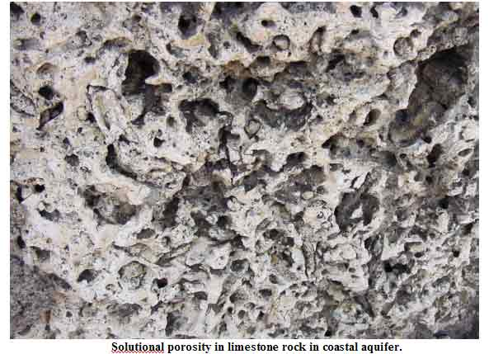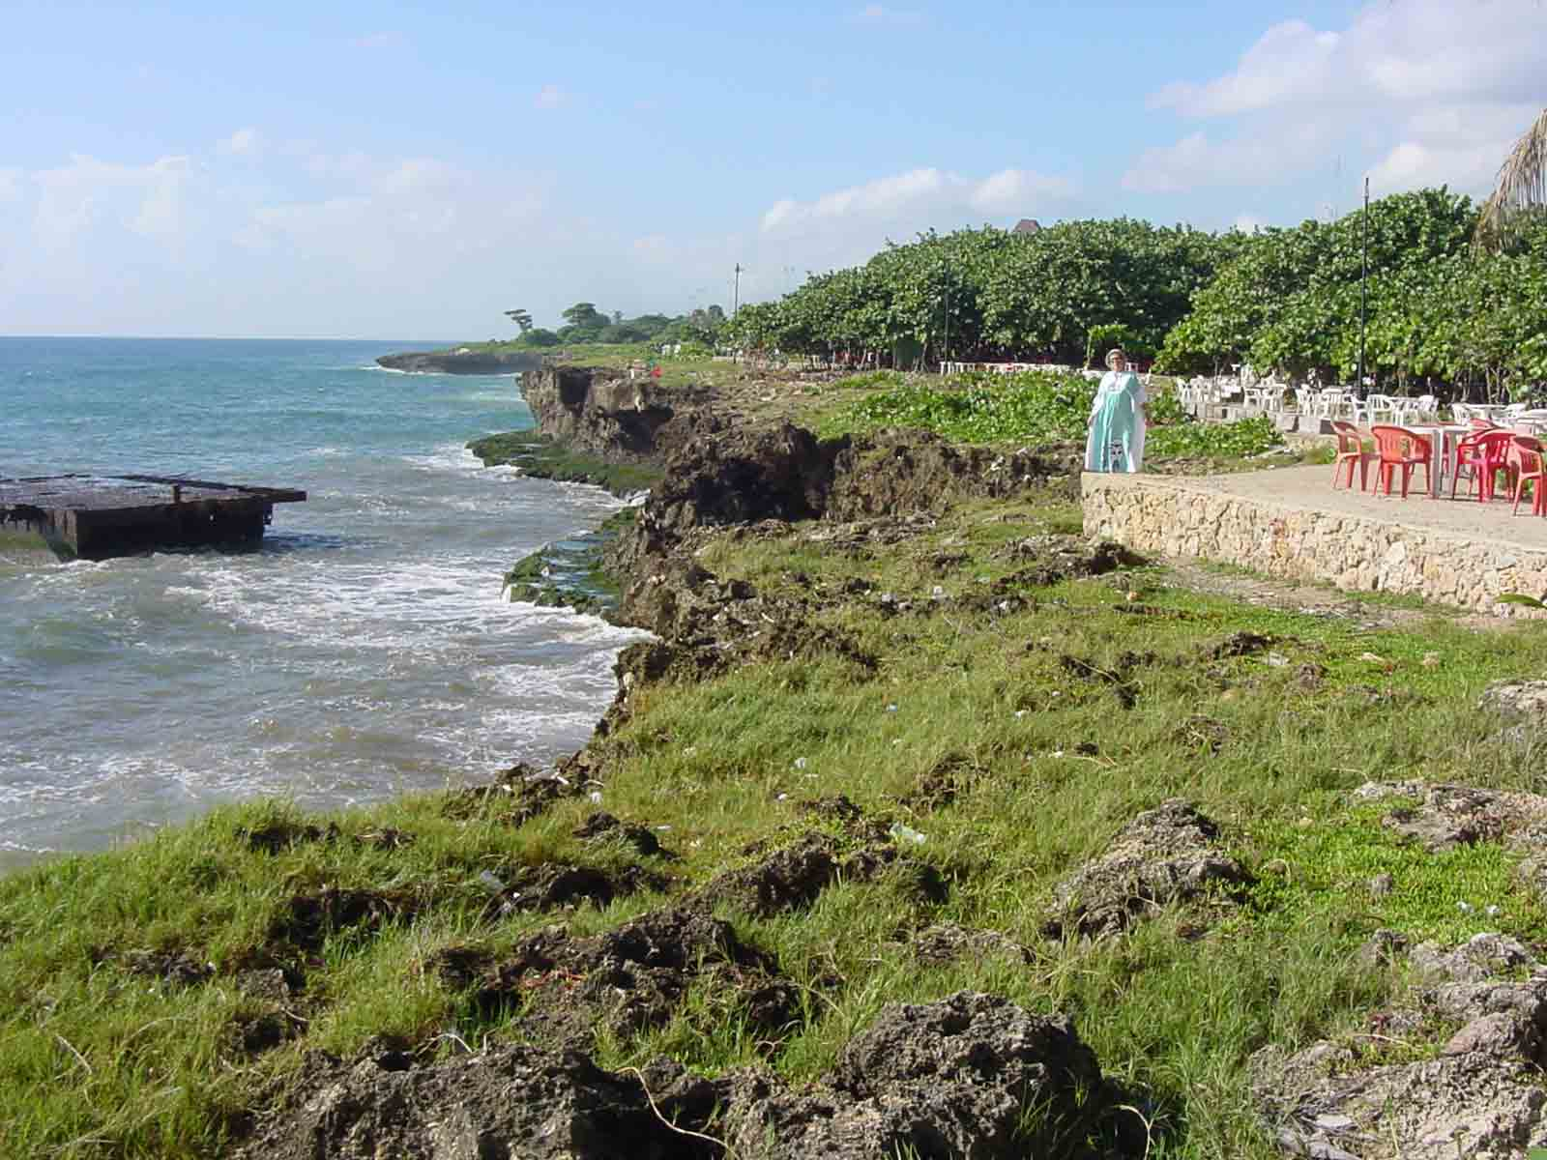
Figure 5. Porosity of coastal limestone (left). Coastal reef limestone in Santo Domingo.

Overabstraction resulted in seawater intrusion. Ambitious tourist developments are planned for PCO, especially in the eastern part (Punto Cana-Bavaró). Ground Water Information System (GWIS) established by this author in 2003 for the whole country currently contains information (water quality, lithology, abstractions, water levels, and salinity profiles) for about 1900 wells.

A seawater intrusion monitoring network is a part of government efforts to control ground water quality deterioration. The monitoring network in the Planicie Costera Oriental consists of about 20 wells strategically located along the coast, extending to some 15 km far from the coastline. The coastal area is one of prime areas for tourist development, agriculture (sugarcane, mostly in La Romana), industry (Sto Domingo), and metropolitan urbanizations (Sto Domingo - Aeropuerto Las Americas - Boca Chica). Figure 6 displays a portion of this network and salinity with depth profiles in selected monitoring wells.

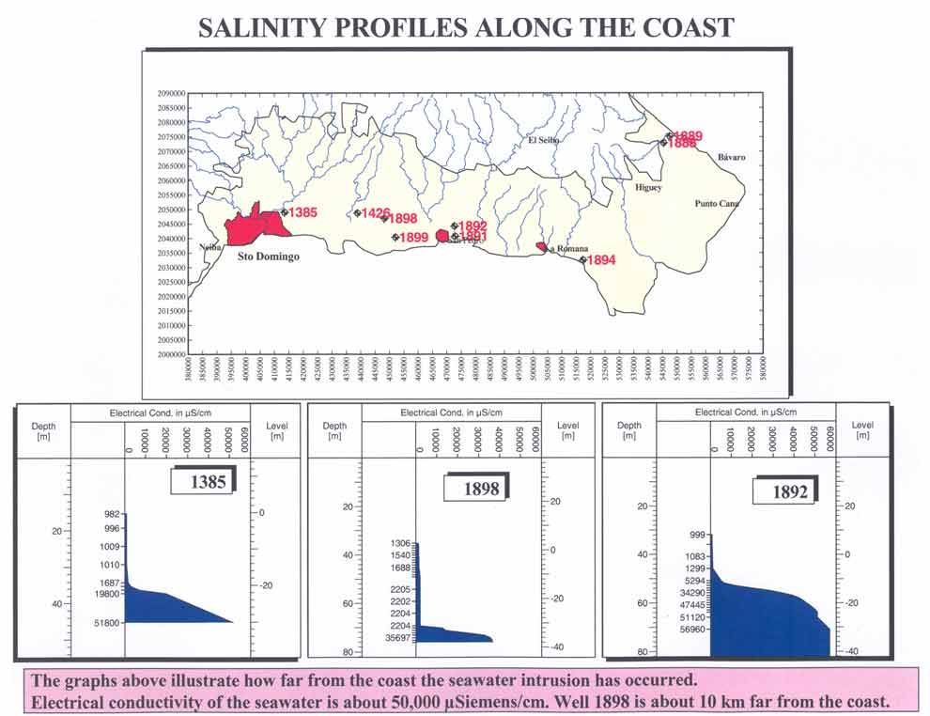
Figure 6. Seawater intrusion monitoring network.

Red numbers next to wells are their identifications. The salinity of ground water, expressed as electrical conductivity in μS/cm, is drawn against the depth of the well. In all three wells, the salinity sharply increases at depths of about -30 m (30 m below the sea level) and rather quickly reaches the salinity of the seawater. The salinity of ground water with depth of one monitoring well not too far from the proposed new ground water development scheme will be discussed in next chapter.

3. Current and Projected Ground Water Developments in PCO

One of the major ground water users in the country is CAASD (Water and Sanitation Corporation of Santo Domingo). It supplies with potable water the capital city of Santo Domingo (using both surface and ground water sources) and surroundings, especially to the east of the Rio Ozama. Major CAASD wellfields are shown in Figure 7. Pyramid signs are wells with electrical conductivity above the 2000 μS/cm mark. In many places along the coast the conductivity is above 4,000 μS/cm. CAASD is reportedly abstracting close to 100 MCM/yr from its existing wellfields within the Sto Domingo metropolitan area. These numbers are questionable. Actual exploitation could be higher or less than reported. The salinity profile at the well site 1426 is shown in Fig. 8.
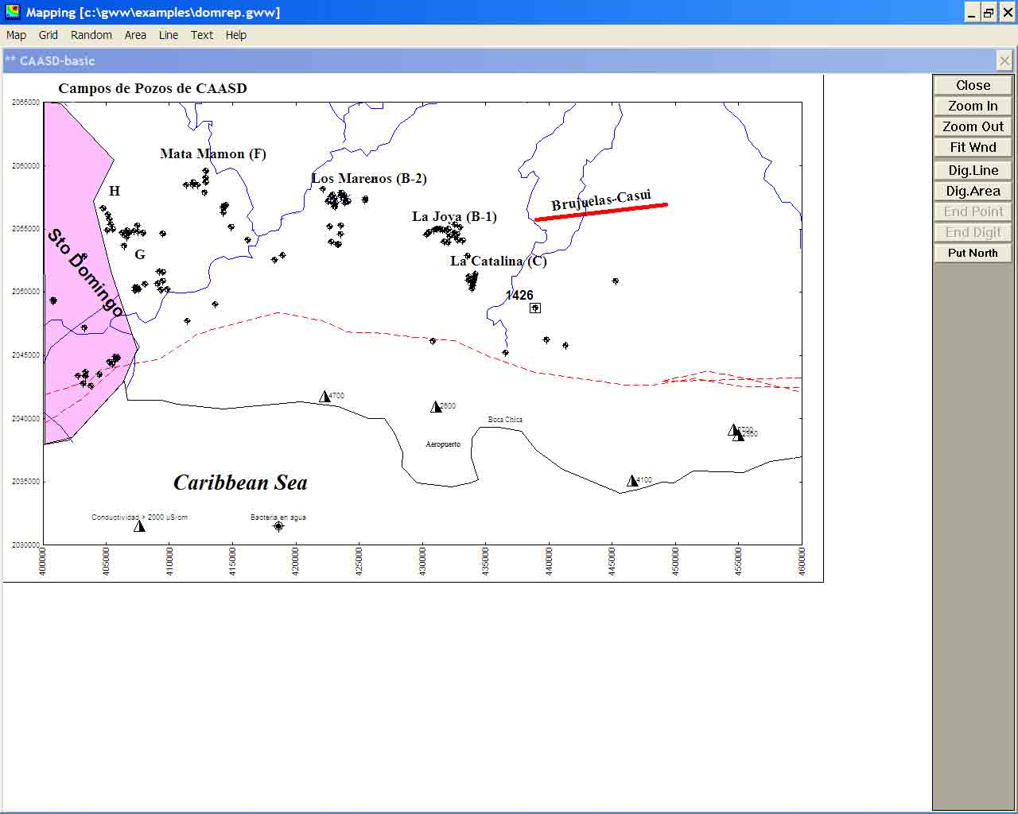
Figure 7. CAASD wellfields to the east of Sto Domingo. Brujuelas-Casui is a proposed new development.

In the zone where abstraction is most concentrated (La Joya-La Catalina), the abstraction appears to be very high, 16-21 MCM/yr for each one kilometer of the length of lines with production wells. There is no doubt that such a concentrated abstraction is the reason for most of the seawater intrusion into the coastal aquifer. Natural ground water flow toward the sea is intercepted by wells. The cone of depression, that is created by pumping, is filled from the south by slowly moving brackish water.

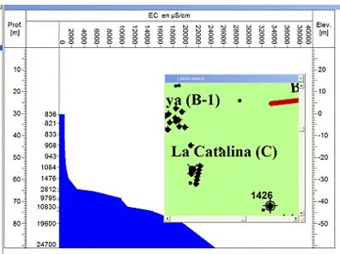
New water supply schemes are planned east of Sto Domingo (Brujuelas-Casui) with proposed abstraction of about 1 m³/sec (31 MCM/yr). It is almost certain that such development will result in additional seawater intrusion. Of interest is to note that the Rio Brujuelas disappears in karstic limestone (sinkholes) before reaching the coast. As shown in Fig. 8 (well no. 1426), some 5 km south-east of the existing La Catalina wellfield, the ground water level is already at about the sea level (0 m). There is a 30-m fresh water column (down to -30 m BSL). The fresh/seawater interface is at about 30 m below the sea level. Since this monitoring well is about 10 km far from the coast, it appears that the current ground water abstraction has lowered water levels to almost the sea level. One may expect dynamic water levels at the La Catalina site to be much below the sea level. With any additional exploitation one may expect that a large cone of depression will be created resulting in the seawater intrusion.

Figure 8. Salinity with depth at well 1426.

4. Modeling Developments East of Santo Domingo

A very simplified mathematical model of the ground water system within the PCO yielded the following results. There is currently an area in which the seawater has intruded the limestone aquifer, as shown in Figure 9 with green-yellow. This is a small peninsula with several urbanizations and Aeropuerto Las Americas, the international airport of Santo Domingo. The new ground water development is intended to supply water to exactly that area, including touristic resorts at Boca Chica to the east of the airport.
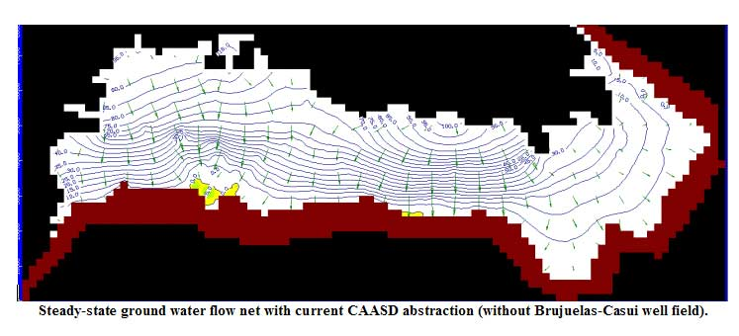
Figure 9. Steady-state ground water flow net with current CAASD abstraction (without Brujuelas-Casui system).

This zone will definitely expand to the north if and when additional 30 MCM/yr are abstracted, as shown schematically in Figure 10. Only a transient model would supply time-related parameters, such as when this will happen, at what rate, etc.

There is also abstraction in other parts of this ground water system, but its simulation was not attempted with this model.

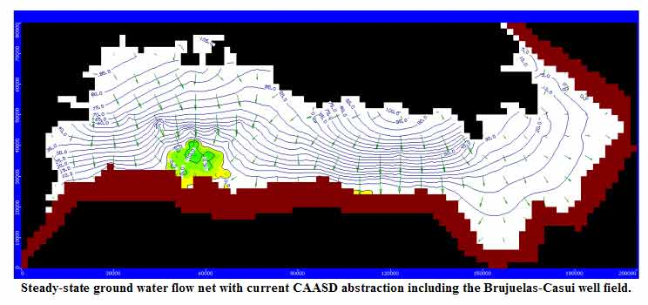
Figure 10. Steady-state flow net with additional development at Brujuelas-Casui simulated.

5. Environmental Issues in Planicie Costera Oriental

Many wells to the west and east of the Rio Ozama are contaminated, with coli and pseudomonas bacteria, including E.Coli. The source of this contamination is known but the cure is difficult to bring without legal regulations. If continued unabated, there is a real danger that a great part of otherwise very productive aquifer would be lost.

The presence of bacteria in ground water east and west of the Rio Ozama should be addressed. AQUATER has produced a map of aquifer vulnerability but it is obvious that at least three years later it had no effect on improving the situation in the area from Santo Domingo to San Pedro. If the situation is not improved and ground water protected from contamination from cesspits, cesspools and other waste disposals, the aquifers may become completely unusable.

As mentioned before, there is a competition among various water users, agriculture being the major one. Sugarcane fields, especially in La Romana area, are irrigated, fertilizers are applied in excessive amounts, drainage is insufficient, and all this results in increased concentrations of nitrates in ground water.

6. Recommendations and Conclusions

The recommendations below are some of suggestions that this author submitted to the Ministry of Environment & Natural Resources.

- Calibration of the model raised doubts that ground water abstractions in the Planicie Costera Oriental could be underestimated. Renewed attempts to arrive at more reasonable assessment of the abstractions are suggested. All operational entities, especially CAASD, should be instructed to submit periodically their reports on the past and current abstractions to Subsecretaria de Suelos y Aguas (Department of Land and Water). These numbers would be used to improve the simulations by mathematical models to be constructed in the future for processing various scenarios of future developments.
- Karstic limestone aquifers should be better quantified and assessed, with long-term pumping tests, extensive monitoring, water quality sampling, etc.
- The networks for monitoring water quality, water levels and saline intrusion should be made fully operational, the schedules of observations that were originally designed should be adhered to, and data copied to Subsecretaria de Suelos y Aguas and entered into computerized databases.
- Considering proposed extensions in CAASD operations and new drilling for tourist centers, and current situation with ground water in Costera Planicie Oriental, it is recommended that one or more seminars or workshops be organized with all stakeholders attending, presenting and defending their development plans, schedules, and the like. CAASD would be required to submit its scientific documentation (hydrogeologic assessment studies, eventual models and simulations, etc.) in support of its proposed extension program. Demands by tourist industry and CAASD should not be taken separately.
- The presence of bacteria in ground water east and west of the Rio Ozama should be addressed. It is recommended that a separate study be initiated addressing the issues such as domestic waste disposal practices, monitoring for bacteria, and nitrogen (as nitrates, nitrites or ammonia). CAASD may be asked to submit its plans for protection of ground water currently being pumped from their wellfields.
- Subsecretaria de Suelos y Aguas may be advised to prepare a set of pamphlets and brochures intended to educate general public as a part of an outreach project. The education would cover the need for water demand management, conservation of ground water as a vulnerable resource, explanation of coastal hydrogeology and risk of saline intrusion.
- Re-use of domestic, industrial and agricultural water and its tertiary treatment may be studied on a pilot scale within Planicie Costera Oriental. Hotels may benefit from re-use of water for watering golf courses, lawns and gardens. This would lessen the demand imposed on public water supply systems.
- New drilling and pumping ground water must be subjected to a rigorously endorsed licensing and permitting program. The new Water Law (Ley 64, from August 2000) should specify this to be a mandatory regulation. The permitting procedure should be specific to coastal zones in which ground water must be protected against saline intrusion. General public may also be involved and asked to comment. For the permitting process to be transparent and not creating conflict of interest and lead to possible corruption cases, the ground water databases must be complete, brought to a high level of efficiency, be comprehensive and multi-disciplinary. Each response to a permit request must be professionally elaborated and defendable.

